Project 2: Quadratic

Option 1: Killing Osama!

1. You are standing on top of a building at 500 meters, and you are trying to hit an helicopter whose coordinates are (1100,600), (1200,600), (1200,700) and (1100,700). However you have two obstacles in front of you, one is an helicopter, transporting children, whose coordinates are (500,500), (800,500), (800,800) and (500,800), and another one, transporting your favorite professor, whose coordinates are (600,1000), (700,1000), (700,1300) and (600,1300) as shown below.

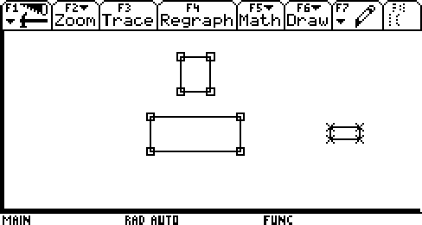

2. Using your knowledge of shifting quadratic equations of the h-k forms, construct a formula that will avoid the ‘good’ helicopter and hit the ‘bad’ one as shown below.

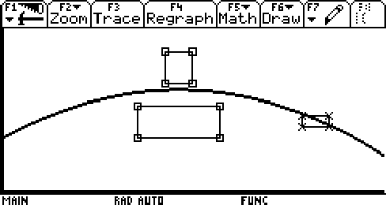

3. Using your knowledge of shifting quadratic equations of the h-k forms, construct a formula that will avoid the ‘good’ helicopter and hit the ‘bad’ one as shown below.

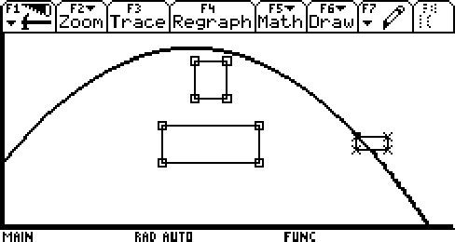

4. Using your knowledge of shifting quadratic equations of the h-k forms, construct a formula that will avoid the ‘good’ helicopter and hit the ‘bad’ one as shown below.

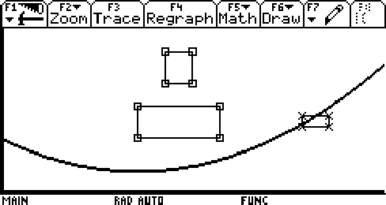

When all three functions have been created, your plots should look like the one below.

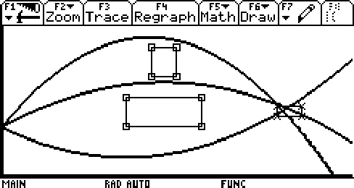

- Now, using points that you have selected, construct a best-fit quadratic function that follow the patter of the first plot.
- Now, using points that you have selected, construct a best-fit quadratic function that follow the patter of the second plot.
- Now, using points that you have selected, construct a best-fit quadratic function that follow the patter of the third plot.

Option 2: Pipe Cleaners and Area

Objectives:

1. To explore functions in Geometry
2. To investigate the relationship between area and height
3. To develop an intuitive feel for the behavior of related variable quantities
4. To understand maximum area, and upper and lower bounds
on the value of height
5. To make connections between the mathematical world and the real-world
6. To make connections between the geometric representation,(the graph), of the real-world phenomenon and the algebraic representation, (the function)

Initial Investigation:

I.
1. Using graph paper of 1x1 unit size, measure the length of the pipe cleaner.

2. Bend each end of the pipe cleaner upward so that each piece bent upward is one unit long. Each upward bent piece is called the height of the pipe cleaner.

3. The bottom part of the pipe cleaner is called the base . Using the graph paper, what is the length of the base when the height is 1 unit long?
Length of Base:______

4. The area (of the figure made from the pipe cleaner), is the number of squares above the pipe cleaner, but no higher then the tops fo the pieces that are bent upward. What is the area of the figure when the height is 1 unit long?
Area:_____________

II.
Now, straighten the pipe cleaner out. This time, turn th eend pieces upward so that the height of the figure is 2 units long.

a. Find the length of the base.
b. Find the area of the figure

Option 3: The Aids question
Click here: http://www-math.bgsu.edu/~dalew/math122/m122_f03_notes/m122_f03_ne8_3.pdf

Option 4: Price of Gas, data from 1950 to today, tables, scatter plots, line plot, best-fit linear equation, prediction for 2010, least and most expensive countries ($ per gallon), define OPEC, how much gasoline does the US consume in one year, and pick 10 countries in Europe to compare
Option 5: The Euro, compare the Euro with US dollar, French franc, Italian lira, Deutsche mark, Spanish peseta, Austrian schilling, Swedish crown, data from beginning (when?) to today compared to US dollars, tables, scatter plots, line plots, best-fit linear equation, prediction for 2010, where did the idea come from?, advantages and disadvantages of the Euro, prices of 10 items in US in US dollars, and price of the same items in Europe in Euro, tables and plots, interpretation.
Option 6: Diamond Engagement Rings, price per carat, data from 1950 to today, tables, scatter plots, line plots, best-fit linear equation, prediction for when you're planning to get engaged, one paragraph about diamonds and carats, the diamonds of Sierra Leone (Africa).
Option 7: More to come.
Option 8: Your idea (but check with me first to make sure it's related to the topics and meets the standards).

