Office of
Planning and Institutional Effectiveness
Institutional Research



Hope, Knowledge, and Opportunity

Research Report 2001-05
Employee Inventory Survey
Spring 2001

University Park Campus
PC 543
Miami, FL 33199
Telephone: (305) 348-2731 Fax: (305) 348-1908
www.fiu.edu/~opie/cqis/index.htm

Office of Planning & Institutional Effectiveness

The Employee Inventory is one survey in the series of Continuous Quality Improvement Surveys instituted by Florida International University’s Office of Planning and Institutional Effectiveness. This is the first survey report from the Employee Inventory Survey, and the fourth Continuous Quality Improvement Survey report. The information in these Continuous Quality Improvement Survey Reports will be distributed to members of the university community and will be used by the appropriate departments to enhance continuous quality improvement efforts.

Every effort has been made to ensure that the data contained in this document is accurate. For further information about this and other Continuous Quality Improvement Survey Reports, visit our website at www.fiu.edu/~opie/cqis/index.htm, or contact Clarice D. Evans at evansc@fiu.edu or the Vice Provost for Planning and Institutional Effectiveness at 305-348-2731, (FAX) 305-348-1908. You may also visit the Office of Planning and Institutional Effectiveness at University Park PC 543.

TABLE OF CONTENTS
Table of Contents |  |  |  |  |  |  |  | 1
Executive Summary |  |  |  |  |  |  |  | 3
Summary of the 2001 Employee Inventory Survey:
Introduction |  |  |  |  |  |  |  | 5
Methodology:
Sampling Design |  |  |  |  |  |  |  | 5
Statistics |  |  |  |  |  |  |  | 5
Response Rates 6
Table 1. Respondents By Race, Gender and Employee Type 6
Table 2. Respondents By Employee Type |  |  |  |  |  |  |  | 7
Table 3. Responses By College/School, Division or Department |  |  |  |  |  |  |  | 7
Primary Findings from the 2001 Survey:
Survey Item Analyses
Items With the Highest Positive Response |  |  |  |  |  |  |  | 8
Items With the Lowest Positive Response |  |  |  |  |  |  |  | 8
Items With the Highest Positive Response In Each Topic Area |  |  |  |  |  |  |  | 9
Means For Each Topic Area |  |  |  |  |  |  |  | 9
Table 4. Means For Formal Influence Items |  |  |  |  |  |  |  | 10
Table 5. Means For Communication Items |  |  |  |  |  |  |  | 10
Table 6. Means For Collaboration Items |  |  |  |  |  |  |  | 10
Table 7. Means For Organizational Structure |  |  |  |  |  |  |  | 10
Table 8. Means For Work Design |  |  |  |  |  |  |  | 11
Examples Of Bivariate Relationships Showing Strong Associations |  |  |  |  |  |  |  | 11
Graphical Analyses
Items With the Highest Positive Response |  |  |  |  |  |  |  | 12
Accuracy Expected |  |  |  |  |  |  |  | 12
Job Skills Are Appropriate |  |  |  |  |  |  |  | 12
Work Relevant To University Mission |  |  |  |  |  |  |  | 13
Responsible For Completing Meaningful Tasks |  |  |  |  |  |  |  | 13
Flexibility To Organize Workday |  |  |  |  |  |  |  | 14
Items With the Lowest Positive Response |  |  |  |  |  |  |  | 14
Changes In Board of Regents Structure Will Bring Positive Changes to FIU |  |  |  |  |  |  |  | 14
Successful Influence On Positive Attitudes In Employees |  |  |  |  |  |  |  | 15
Cooperation Between Departments Exists At FIU |  |  |  |  |  |  |  | 15
Information Is Shared Within The University |  |  |  |  |  |  |  | 16
Opportunity For Advancement Within The University |  |  |  |  |  |  |  | 16
Differences In Survey Item Responses
Gender |  |  |  |  |  |  |  | 17
Race/Ethnicity |  |  |  |  |  |  |  | 17
Table 9. Differences Among Mean Findings For Racial/Ethnic Groups: Demographic Information |  |  |  |  |  |  |  | 19
Table 10. Selected Significant Mean Differences For Racial/Ethnic Groups 20
Employment Type |  |  |  |  |  |  |  | 21
Table 11. Differences Among Mean Findings For Employment Type: Demographic Information 22
Table 12. Selected Significant Mean Differences For Employment Type |  |  |  |  |  |  |  | 23
Age Group |  |  |  |  |  |  |  | 24
Table 13. Differences Among Mean Findings For Age Group: Demographic Information |  |  |  |  |  |  |  | 25
Table 14. Selected Significant Mean Differences For Age Group |  |  |  |  |  |  |  | 26
I Work In… |  |  |  |  |  |  |  | 27
Table 15. Differences Among Mean Findings For “Where I Work”: Demographic Information |  |  |  |  |  |  |  | 28
Table 16. Selected Significant Mean Differences For “Where I Work” |  |  |  |  |  |  |  | 29
Campus |  |  |  |  |  |  |  | 30
Table 17. Differences Among Mean Findings For Campus: Demographic Information |  |  |  |  |  |  |  | 31
Table 18. Selected Significant Mean Differences For Campus |  |  |  |  |  |  |  | 32
Conclusions |  |  |  |  |  |  |  | 32
Appendix A |  |  |  |  |  |  |  | 34

EXECUTIVE SUMMARY OF THE SPRING 2001 EMPLOYEE INVENTORY SURVEY

This report summarizes the main findings from the Spring 2001 Florida International University Employee Inventory Survey, a Continuous Quality Improvement study conducted by the Office of Planning and Institutional Effectiveness. This survey was adapted for FIU from a survey developed by the University of Central Florida. The survey was designed to measure employees’ satisfaction with and attitudes about the work environment at Florida International University.

The Employee Inventory Survey was placed online at www.fiu.edu/~irsurvey/employee/htm and a notice was placed (three times over a three month period of time) in a university-wide mailing (univmail) which is sent daily via e-mail to all faculty and staff members with an FIU e-mail address. The survey was returned by 585 employees, for a response rate of at least 24%. This year (2001) was the initial implementation of this particular Continuous Quality Improvement Survey; therefore, we did not have comparative data for FIU from previous years.

Employees were asked to rate their level of agreement with 40 survey items. These statements ranged from items specific to each individual’s job (I am given the opportunity to be creative in my work) to items that were of a more global nature (At FIU, an ethnically and culturally diverse environment is valued). The survey encompassed five topic areas: Formal Influence, Communication, Collaboration, Organizational Structure and Work Design. An item regarding employees’ attitudes toward the upcoming (at that time) changes in the Board of Regents structure was also included at the end of the survey.

Ten survey items have been singled out to demonstrate employees’ satisfaction, or lack thereof, with FIU. These particular items were selected because they garnered the most positive responses (top 5) and the lowest positive responses (lowest 5). Graphical analyses of these ten items appear on pages 12-16.

ITEMS WITH THE HIGHEST POSITIVE RESPONSE

- Accuracy is expected in my work: Approximately 94% of employees agreed with this statement (55% strongly agreed, 39% agreed).
- My job skills are appropriate for the work that I am expected to complete: Approximately 93% of employees agreed with this statement (54% strongly agreed, 39% agreed).
- I feel that my work is relevant to the university mission: Approximately 90% of employees agreed with this statement (52% strongly agreed, 38% agreed).
- I am responsible for completing meaningful tasks: Approximately 89% of employees agreed with this statement (48% strongly agreed, 41% agreed).
- I have the flexibility to organize my workday: Approximately 85% of employees agreed with this statement (35% strongly agreed, 50% agreed).

ITEMS WITH THE LOWEST POSITIVE RESPONSE

- I feel that the upcoming changes in the Board of Regents structure will bring positive changes to FIU. Approximately 9% of employees agreed with this statement (1% strongly agreed, 8% agreed).
- The university has been successful in influencing positive attitudes in its employees. Approximately 25% of employees agreed with this statement (3% strongly agreed, 22% agreed).
- A spirit of cooperation between departments exists at FIU. Approximately 28% of employees agreed with this statement (2% strongly agreed, 26% agreed).
- Information is shared within the university so that those who make decisions have access to accurate/current information. Approximately 31% of employees agreed with this statement (5% strongly agreed, 26% agreed).
- I have the opportunity for advancement within the university. Approximately 35% of employees agreed with this statement (12% strongly agreed, 23% agreed).

The results of this Continuous Quality Improvement Survey are mixed. While positive responses (at least 65% of respondents selected a response of Strongly Agree or Agree) were reported on 37.5% of the survey items (15 out of 40), there were a number of responses that show some cause for concern. Of the fifteen items that received positive responses, about 67% (10/15) of the items had positive responses between 65.0% and 79.9%. The remaining five items (5/15) had positive responses of higher than 80%. (See Tables 4-8; pages 10-11).

They were several very strong relationships detected between certain items on the survey: employees who agreed that they received quality feedback in their work, also agreed that they received sufficient feedback in their work; employees who agreed that their ideas are seriously considered by their supervisor, also agreed that their ideas are actively sought by their supervisor/chairperson; employees who agreed that they are satisfied with the amount of information about their job that they receive, also agreed that the information they receive is useful in their work; employees who agreed that they receive adequate information about policy decisions at FIU, also agreed that information is shared within the university so that those who make policy decisions have access to accurate/current information; employees who agreed that they are given quality guidance regarding their work they also agreed that their supervisor helps them to improve their work.

FIU employee respondents seemed more satisfied with their supervisor and their department than with the university as a whole. In addition, 93% of respondents reported that their job skills are appropriate for the work that they are expected to complete. However, respondents were significantly less positive about their workload, only 67% of respondents reported that their workload is appropriate.

There is some cause for concern in regard to the university climate as a whole. Only 25% of employee respondents believe that the university has been successful in influencing positive attitudes in employees. Barely 50% of employee respondents believe that they have the opportunity to express their ideas in appropriate forums, 28% believe that there exists a spirit of cooperation between departments at FIU and only 35% of respondents believe that they have an opportunity for (career) advancement at the university.
SUMMARY OF THE 2001 EMPLOYEE INVENTORY SURVEY

INTRODUCTION

It is necessary for the employer to help foster positive attitudes in employees, not only toward co-workers in their own departments but also toward the global work environment, in this case the university as a whole. A positive campus climate for employees enables a positive environment for students and increases productivity.

Therefore, it is vitally important that the University systematically elicit employee feedback in an attempt to measure employee morale and to identify areas in the work environment that need improvement as part of President Maidique’s mandate of “Operational Excellence.” One such avenue of feedback is to request employees to provide survey responses describing their thoughts and attitudes about their work experiences at Florida International University.

This report summarizes the main findings from the Spring 2001 Florida International University Employee Inventory Survey, a Continuous Quality Improvement study conducted by the Office of Planning and Institutional Effectiveness. This survey was adapted for FIU from a survey developed by the University of Central Florida. The survey was designed to measure employees’ satisfaction with and attitudes about the work environment at Florida International University.

METHODOLOGY

Sampling Design.

The Employee Inventory Survey was placed online at www.fiu.edu/~irsurvey/employee/htm and a notice was placed (three times over a three month period of time) in a university-wide mailing (univmail) which is sent daily via e-mail to all faculty and staff members with an FIU e-mail address. According to the 2000-2001 IPEDS Fall Staff Survey, there are 2,459 full-time employees; however, not all employees have daily access to e-mail. The survey was returned by 585 employees, for a response rate of at least 24%. Seventeen surveys had to be discarded because most of the responses were blank. This is possibly due to technical glitches that occurred during data submission to the computer server. This year (2001) was the initial implementation of this particular Continuous Quality Improvement Survey; therefore, we did not have comparative data for FIU from previous years.

The survey included items that were categorized into five topic areas: Formal Influence, Communication, Collaboration, Organizational Structure and Work Design. Employees were asked to rate their level of agreement with each item on a five point Likert scale. An additional item on the changing Board of Regents structure was added to the end of the survey.

Statistics. The data were analyzed using the Statistical Package for Social Sciences (SPSS) version 10.0.05. A five-point Likert scale was used for the survey items, with higher scores indicating more positive attitudes. A variety of simple statistics are reported such as percentages and mean findings (arithmetic averages). Correlations (also called bivariate relationships) are used to describe the relationship between two variables and can range between –1.0 to 1.0. In this report, the degree of correlation is denoted by “r” (Pearson Product Moment Correlation). A positive correlation indicates that as scores increase for one variable they also increase for a second variable (or both scores decrease). Analysis of Variance (ANOVA) tests were performed and reported by using the “F” statistic. Games-Howell significant tests are also reported for certain variables. The Games-Howell test is a post-hoc test, used to determine significant relationships between two groups of a categorical variable such as gender, race or age. This particular test was used in an effort to control the overall error rate (the Games-Howell test was used instead of the traditional t –test because it can test all possible pairs simultaneously using a preset overall error rate -- this is a more stringent test than a t - test) and because it was believed that the variances of the categorical variables were heterogeneous.

Response Rates. It is not possible to determine whether the respondents were representative of all full-time employees. Nearly 44% of the respondents did not respond to the demographic items. The respondents who indicated their gender were overwhelmingly female (73%), about 20% higher than the percentage of females employed at FIU (54%). For respondents who indicated their race/ethnicity, Asian employees were underrepresented (1.5% in the sample versus 5.0% of employees), Black/African American employees were proportionately represented (11% in the sample and 12.6% in the employee population), Hispanic employees were slightly underrepresented (34% in the sample and 37.6% in the employee population) and White employees were slightly overrepresented (47% in sample versus 44.1% of population). Of the respondents who indicated their employee type, Administrative and Professional employees were proportionately represented in the survey sample (30% versus 31.6% in the employee population), Faculty were underrepresented (14% of the sample versus 35.2% in the employee population) and USPS employees were also overrepresented (56% of the sample versus 33.2% of the employee population).

Tables one through three provide more information about the response rates for the Employee Inventory Survey. Table one provides information on the gender, race/ethnicity and employee type of the respondents who provided this information. Table two compares the respondents’ employee type with the employee type of all university employees. Table three provides information on the respondents’ college/school, division or department.

TABLE 1

RESPONDENTS BY RACE, GENDER AND EMPLOYEE TYPE (only about 56% of respondents indicated their employee type, race and gender)

______________________________________________________________________________
 |  |  | MALE |  |  |  |  |  | FEMALE
 | Asian | Black | Hispanic | White | Other |  | Asian | Black | Hispanic | White | Other | Totals
Employee Type
A&P | 0 | 3 | 6 | 9 | 0 |  | 2 | 5 | 25 | 30 | 2 | 82
Faculty | 2 | 0 | 2 | 17 | 4 |  | 0 | 2 | 2 | 14 | 0 | 43
USPS | 0 | 0 | 5 | 23 | 1 |  | 1 | 18 | 62 | 46 | 14 | 170
A&P and Faculty | 0 | 0 | 2 | 5 | 0 |  | 0 | 0 | 4 | 2 | 0 | 13
Totals | 2 | 3 | 15 | 54 | 5 |  | 3 | 25 | 93 | 92 | 16 | 308
______________________________________________________________________________
TABLE 2
 | # of FIU  Respondents* | % of FIU  Respondents* |  |  | # of FIU  Employees** | % of FIU  Employees**
A&P | 85 | 26.4 |  |  | 777 | 31.6
Faculty | 45 | 14.0 |  |  | 866 | 35.2
USPS | 179 | 55.6 |  |  | 816 | 33.2
A&P and Faculty | 13 | 4.0 |  |  | ---- | ----
Totals | 322 | 100.0 |  |  | 2,459 | 100
RESPONDENTS BY EMPLOYEE TYPE
_____________________________________________________________________________________________

____________________________________________________________________________
*that indicated their employee type
**According to 2000-2001 IPEDS Fall Staff Survey

TABLE 3
RESPONDENTS BY COLLEGE/SCHOOL, DIVISION OR DEPARTMENT
_____________________________________________________________________________________________

 | # of  Respondents | % of  Respondents
Architecture | 2 | .4
Arts & Sciences | 54 | 9.5
Business | 15 | 2.6
Education | 12 | 2.1
Engineering | 17 | 3.0
Health & Urban Affairs | 37 | 6.5
Hospitality Management | 4 | .7
Journalism & Mass Communication | 2 | .4
Academic Affairs or Business and Finance | 50 | 8.8
Athletics | 4 | .7
Campus Support Services | 10 | 1.8
Student Affairs/Student Support Services | 47 | 8.3
Other | 64 | 11.3
Missing | 249 | 43.8
Totals | 568 | 100.0

_____________________________________________________________________________________________

PRIMARY FINDINGS FROM THE 2001 SURVEY

A) SURVEY ITEM ANALYSES

Introduction. Ten survey items have been singled out to demonstrate employees’ satisfaction, or lack thereof, with FIU. These particular items were selected because they garnered the most positive responses (top 5) and the lowest positive responses (lowest 5). For the five items with the highest positive responses, the top four items fall under the Work Design topic area. The fifth item is from the Organizational Structure topic area. For the five items with the lowest positive responses, the top item regarded the changes in the Board of Regents structure and does not fall under the five topic areas. The item with the second lowest positive response is from the Formal Influence topic area, the third item falls under Collaboration, the item with the fourth lowest positive response falls under Communication and the last item is from the Work Design topic area. Graphical analyses of these ten items appear on pages 12-16.

(The responses were rounded to the nearest percent.)

ITEMS WITH THE HIGHEST POSITIVE RESPONSE

- Accuracy is expected in my work: Approximately 94% of employees agreed with this statement (55% strongly agreed, 39% agreed).

- My job skills are appropriate for the work that I am expected to complete: Approximately 93% of employees agreed with this statement (54% strongly agreed, 39% agreed).

- I feel that my work is relevant to the university mission: Approximately 90% of employees agreed with this statement (52% strongly agreed, 38% agreed).

- I am responsible for completing meaningful tasks: Approximately 89% of employees agreed with this statement (48% strongly agreed, 41% agreed).

- I have the flexibility to organize my workday: Approximately 85% of employees agreed with this statement (35% strongly agreed, 50% agreed).

ITEMS WITH THE LOWEST POSITIVE RESPONSE

- I feel that the upcoming changes in the Board of Regents structure will bring positive changes to FIU. Approximately 9% of employees agreed with this statement (1% strongly agreed, 8% agreed).

- The university has been successful in influencing positive attitudes in its employees. Approximately 25% of employees agreed with this statement (3% strongly agreed, 22% agreed).

- A spirit of cooperation between departments exists at FIU. Approximately 28% of employees agreed with this statement (2% strongly agreed, 26% agreed).

- Information is shared within the university so that those who make decisions have access to accurate/current information. Approximately 31% of employees agreed with this statement (5% strongly agreed, 26% agreed).

- I have the opportunity for advancement within the university. Approximately 35% of employees agreed with this statement (12% strongly agreed, 23% agreed).

ITEMS WITH THE HIGHEST POSITIVE RESPONSE IN EACH TOPIC AREA

- Formal Influence: My supervisor expresses confidence in my work. Approximately 78% of employees agreed with this statement (45% strongly agreed, 33% agreed).

- Communication: I receive adequate information about events that are taking place at FIU. Approximately 77% of employees agreed with this statement (21% strongly agreed, 56% agreed).

- Collaboration: I have an opportunity to work jointly with others within my department. Approximately 77% of employees agreed with this statement (24% strongly agreed, 53% agreed).

- Organizational Structure: I have the flexibility to organize my workday. Approximately 85% of employees agreed with this statement (35% strongly agreed, 50% agreed).

- Work Design: Accuracy is expected in my work. Approximately 94% of employees agreed with this statement (55% strongly agreed, 39% agreed).

MEANS FOR EACH TOPIC AREA

The employee respondents reacted most positively toward the items under the Work Design topic area (eight items). As noted earlier, four of the top five most positive responses to the survey items were in this area. The average response to items in this topic area was 3.98, with a large range of mean responses from 2.94-4.47 to each individual item. The average response to items in the topic area of Organizational Structure (five items) was 3.58, with a smaller range of mean responses from 3.36-4.10 to each individual item. The Formal Influence items (ten items) had the next highest average response of 3.54, with a range of mean responses from 2.69-4.11 to each individual item. The average response to the Communication items (11 items) was 3.49, with a range of mean responses from 2.92-3.87 to each individual item. Finally, the Collaboration items (five items) had an average response of 3.42, with a range of mean responses from 2.77-3.90 to each individual item. The topic areas and survey items are presented on pages 10-11, in the order in which they appeared in the survey. In the last column the response to each item is listed. If 65% of the respondents agreed with the item (Strongly Agreed, Agreed), then the response is denoted as positive. If less than 65% of respondents disagreed with the item, then the response is denoted as negative.

TABLE 4
MEANS FOR FORMAL INFLUENCE ITEMS: |  | Means | Response
I believe that the actions of the university reflect the FIU mission |  | 3.50 | negative
My supervisor/chairperson expresses confidence in my work |  | 4.11 | positive
I am given quality guidance regarding my work |  | 3.53 | negative
I am given the opportunity to be creative in my work |  | 3.97 | positive
My supervisor/chairperson emphasizes my personal development |  | 3.71 | negative
My ideas are seriously considered by my supervisor/chairperson |  | 3.81 | positive
At FIU I have the opportunity to express my ideas in appropriate forums |  | 3.35 | negative
My ideas are actively sought by my supervisor/chairperson |  | 3.50 | negative
I am able to appropriately influence the direction of my department |  | 3.22 | negative
The university has been successful in influencing positive attitudes in its employees |  | 2.69 | negative
Average response to FORMAL INFLUENCE items: |  | 3.54

TABLE 5
MEANS FOR COMMUNICATION ITEMS: |  | Means | Response
I am satisfied with the amount of information about my job that I receive |  | 3.28 | negative
This information that I receive is useful in my work |  | 3.52 | negative
The information I generate at work is shared with others |  | 3.87 | positive
Positive work expectations are communicated to me |  | 3.67 | positive
Unacceptable behaviors are identified and communicated to me |  | 3.66 | positive
Work expectations are clarified for me |  | 3.54 | negative
At FIU, an ethnically and culturally diverse environment is valued |  | 3.75 | positive
I receive adequate information about events that are taking place at FIU |  | 3.83 | positive
I receive adequate job information at FIU |  | 3.32 | negative
I receive adequate information about policy decisions at FIU |  | 3.00 | negative
Information is shared within the university so that those who make decisions have access to accurate/current information |  | 2.92 | negative
Average response to COMMUNICATION items: |  | 3.49

TABLE 6
MEANS FOR COLLABORATION ITEMS: |  | Means | Response
A spirit of cooperation exists within my department |  | 3.55 | negative
A spirit of cooperation between departments exists at FIU |  | 2.77 | negative
There is an opportunity in my department for all ideas to be exchanged |  | 3.48 | negative
I have an opportunity to work jointly with others within my department |  | 3.90 | positive
I have an opportunity to work jointly with FIU employees outside of my department |  | 3.41 | negative
Average response to COLLABORATION items: |  | 3.42

TABLE 7
MEANS FOR ORGANIZATIONAL STRUCTURE ITEMS: |  | Means | Response
University-wide policies guide my work |  | 3.43 | negative
I receive quality feedback in my work |  | 3.40 | negative
I receive sufficient feedback in my work |  | 3.36 | negative
The amount of work I do is appropriate |  | 3.61 | positive
I have the flexibility to organize my work day |  | 4.10 | positive
Average response to ORGANIZATIONAL STRUCTURE items: |  | 3.58

TABLE 8
MEANS FOR WORK DESIGN ITEMS: |  | Means | Response
Accuracy is expected in my work |  | 4.47 | positive
My job skills are appropriate for the work that I am expected to complete |  | 4.41 | positive
I feel that my work is relevant to the university mission |  | 4.40 | positive
I am responsible for completing meaningful tasks |  | 4.34 | positive
I have the opportunity for advancement within the university |  | 2.94 | negative
I have an opportunity to succeed in my work |  | 3.84 | positive
My supervisor helps me to improve my work |  | 3.51 | negative
I feel comfortable working at FIU |  | 3.93 | negative
Average response to WORK DESIGN items: |  | 3.98

EXAMPLES OF BIVARIATE RELATIONSHIPS SHOWING STRONG ASSOCIATIONS

- To the extent that employees agreed that they received quality feedback in their work, they also agreed that they received sufficient feedback in their work (r = .88, p < .001)
- To the extent that employees agreed that their ideas are seriously considered by their supervisor, they also agreed that their ideas are actively sought by their supervisor/chairperson (r = .83, p < .001)
- To the extent that employees agreed that they are satisfied with the amount of information about their job that they receive, they also agreed that the information they receive is useful in their work (r = .78, p < .001)
- To the extent that employees agreed that they receive adequate information about policy decisions at FIU, they also agreed that information is shared within the university so that those who make policy decisions have access to accurate/current information (r = .77,
p < .001)
- To the extent that employees agreed that they are given quality guidance regarding their work they also agreed that their supervisor helps them to improve their work (r = .77, p < .001)

GRAPHICAL ANALYSES

ITEMS WITH THE HIGHEST POSITIVE RESPONSE

Accuracy Expected.
The findings in Figure 1 indicate that 94% of respondent employees agreed that accuracy is expected in their work: 55% of employees strongly agreed, 39% agreed. Only one percent of respondent employees reported that they did not agree that accuracy is expected in their work: 1% of employees disagreed and 0% strongly disagreed. Five percent of employees were neutral on this issue.

Correlations: To the extent that respondent employees agreed that accuracy was expected in their work, they also agreed that: their job skills are appropriate for the work they are expected to complete (r = .55, p < .001), they are responsible for completing meaningful tasks
(r = .54, p < .001), their work is relevant to the university mission (r = .50, p < .001), the information they generate is shared with others (r = .43, p < .001) and they feel that positive work expectations are communicated to them (r = .39, p < .001).

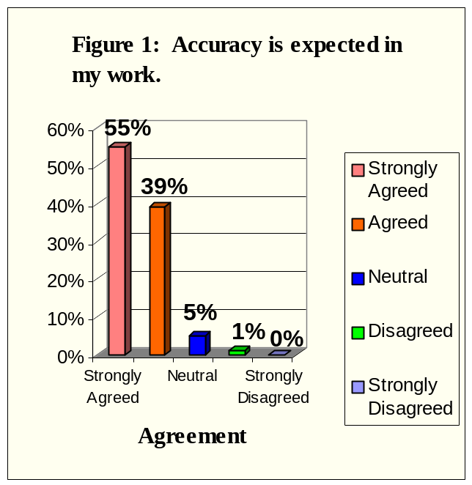

Job Skills Are Appropriate.
The findings in Figure 2 indicate that 93% of respondent employees agreed that their job skills are appropriate for the work they are expected to complete: 54% strongly agreed, while 39% agreed. Four percent of respondents disagreed that their job skills were appropriate: 3% disagreed, 1% strongly disagreed. Another three percent of employees were neutral on this issue.

Correlations: To the extent that respondent employees agreed that their job skills are appropriate for the work they are expected to complete, they also agreed that: their work is relevant to the university mission (r = .63,
p < .001), they are responsible for completing meaningful tasks (r = .61, p < .001), accuracy is expected in their work (r = .55, p < .001), they
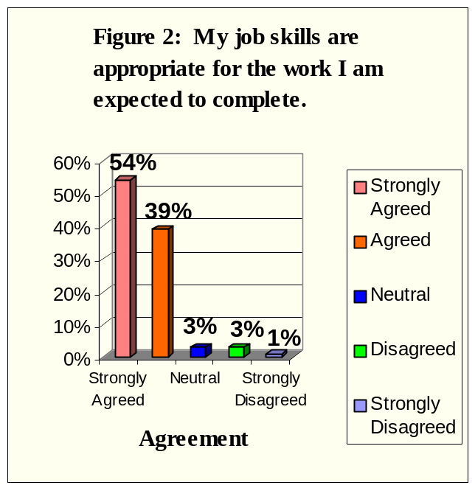
have an opportunity to succeed in their work (r = .40, p < .001) and their supervisor expresses confidence in their work (r = .35, p < .001).

Work Relevant To University Mission.

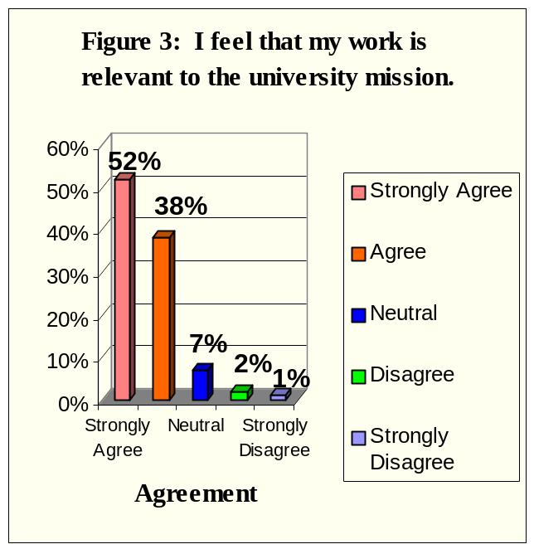
The findings depicted in Figure 3 indicate that 90% of respondent employees agreed that their work was relevant to the university mission: 52% strongly agreed, an additional 38% agreed. Three percent of respondents disagreed that their work was relevant to the university mission: 2% reported that they disagreed, 1% strongly disagreed. An additional 7% of respondent employees were neutral on this issue.

Correlations: To the extent that respondent employees believed that their work is relevant to the university mission, they also agreed that: they are responsible for completing meaningful tasks
(r = .70, p < .001), their job skills are appropriate for the work they are expected to complete
(r = .63, p < .001), accuracy is expected in their

work (r = .50, p < .001), they have an opportunity to succeed in their work (r = .40, p < .001) and they are given the opportunity to be creative in their work (r = .38, p < 001).

Responsible For Completing Meaningful Tasks.
The findings depicted in Figure 4 indicate that 89% of respondent employees agreed that they are responsible for completing meaningful tasks: 48% of employees strongly agreed that they are responsible for completing meaningful tasks, 41% agreed. Approximately 4% of respondents disagreed that they are responsible for completing meaningful tasks: 3% disagreed, 1% strongly disagreed. Another 7% of respondent employees were neutral on this issue.

Correlations: To the extent that respondent employees agreed that they are responsible for completing meaningful tasks, they also agreed that: their work is relevant to the university mission (r = .70, p < .001), their job skills are appropriate for the work that they are expected to
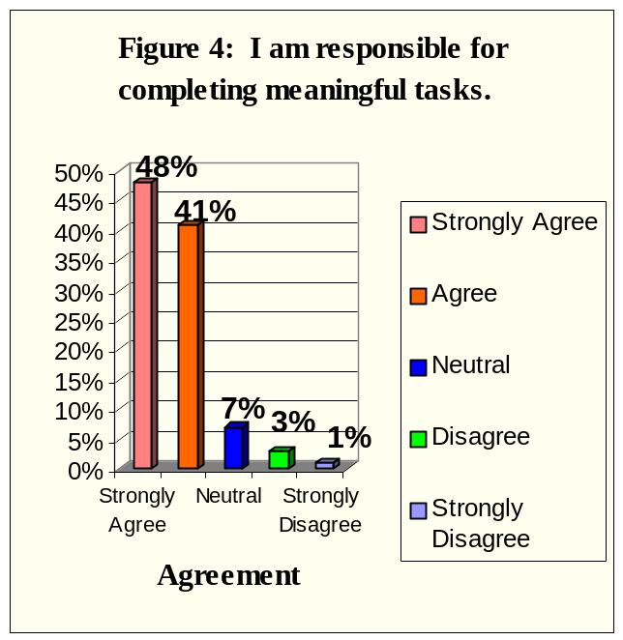
complete (r = .61, p < .001), accuracy is expected in their work (r = .54, p < .001), they are given the opportunity to be creative in their work (r = .51, p < .001) and they have the opportunity to succeed in their work (r = .51, p < .001).

Flexibility To Organize Workday.
The findings in Figure 5 indicate that 85% of respondent employees agreed that they have the flexibility to organize their workday: 35% of employees strongly agreed, 50% agreed. Seven percent of respondents disagreed that they have the flexibility to organize their workday at FIU: 4% of employees disagreed and 3% strongly disagreed. Another 8% of respondent employees were neutral on this issue.

Correlations: To the extent that respondent employees agreed that they have the flexibility to organize their workday, they also agreed that: they are given the opportunity to be creative in their work (r = .53, p < .001), positive work expectations are communicated to them (r = .45,
p < .001), the amount of work they do is appropriate (r = .44, p < .001), their supervisor
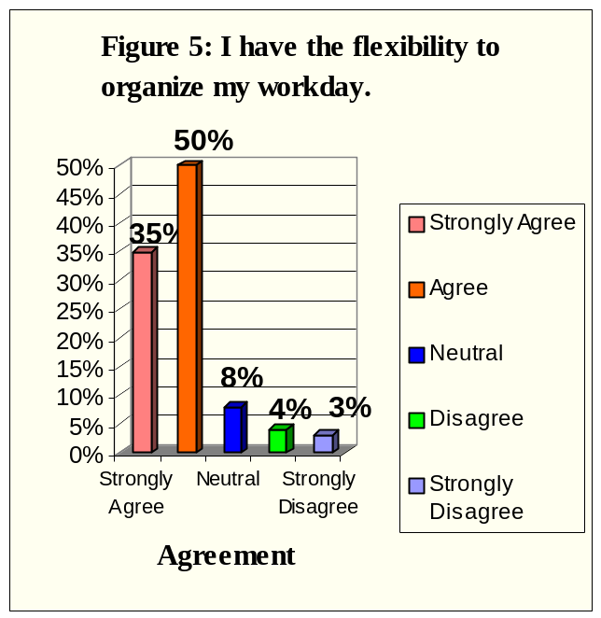
expresses confidence in their work (r = .44, p < .001) and they are responsible for completing meaningful tasks (r = .42, p < .001).

ITEMS WITH THE LOWEST POSITIVE RESPONSE

Changes In Board of Regents Structure Will Bring Positive Changes To FIU.
The findings in Figure 6 indicate that 9% of respondents agreed that the upcoming changes in the Board of Regents structure will bring positive changes to FIU: 1% of employees strongly agreed, another 8% agreed. Twenty five percent of respondents disagreed that the changes will bring positive changes to FIU: 9% of employees disagreed, 16% strongly disagreed. Twenty-five percent of respondent employees were neutral on this issue, and 41% of employees chose not to answer this question.

Correlations: To the extent that respondent employees agreed that the upcoming changes in the Board of Regents structure would bring positive changes to FIU, they also agreed that: the university has been successful in influencing positive attitudes in employees (r = .47, p < .001), they receive adequate information about policy decisions at FIU
(r = .45, p < .001) and they feel comfortable working at FIU (r = .43, p < .001).
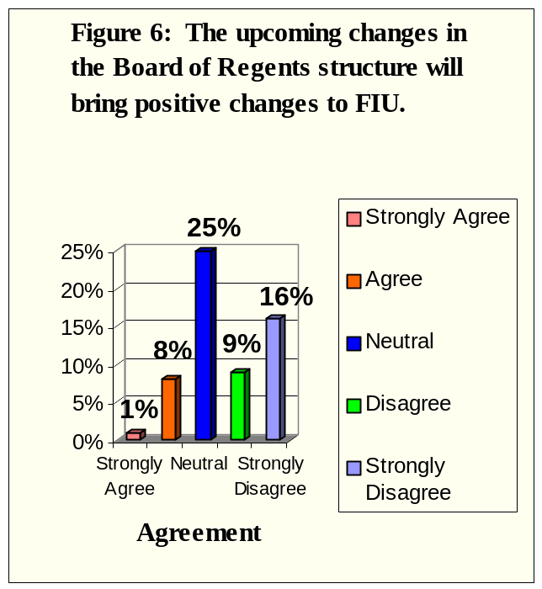

Successful Influence On Positive Attitudes In Employees.

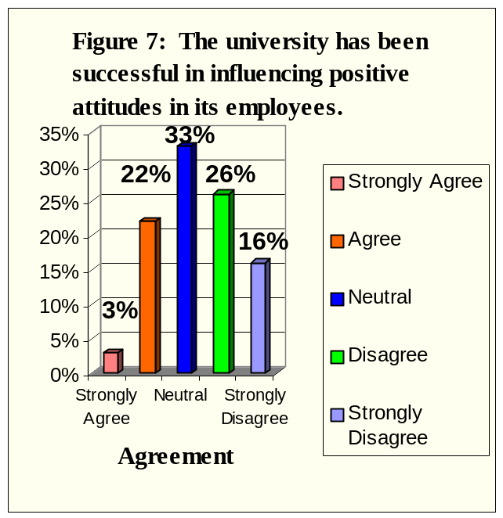
The findings in Figure 7 indicate that 25% of respondent employees agreed that the university has been successful in influencing positive attitudes in FIU employees: 3% of employees strongly agreed, an additional 22% agreed. Forty- two percent of respondents disagreed that the university has been successful: 26% of employees disagreed and 16% strongly disagreed. Another 33% of respondent employees were neutral on this issue.

Correlations: To the extent that employees agreed that the university has been successful in influencing positive attitudes in its employees, they also agreed that: information is shared within the university so that those who make decisions have access to accurate/current information
(r = .62, p < 001), at FIU they have the opportunity to express their ideas in appropriate forums (r = .58,
p < .001) and they receive adequate information about policy decisions at FIU (r = .58, p < .001).

Cooperation Between Departments Exists At FIU.

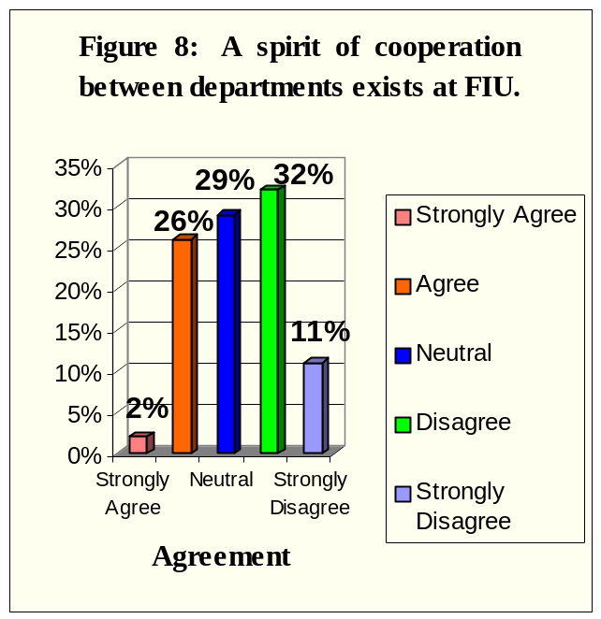
The findings in Figure 8 indicate that 28% of respondent employees agreed that a spirit of cooperation between departments exists at FIU: 2% strongly agreed, another 26% agreed. Forty- three percent of respondents disagreed that a spirit of cooperation exists between departments at FIU: 32% of respondents disagreed, while 11% strongly disagreed. Another 29% of respondents were neutral on this issue.

Correlations: To the extent that respondent employees agreed that a spirit of cooperation between departments exists at FIU, they also agreed that: the university has been successful in influencing positive attitudes in employees
(r = .55, p < .001), information is shared within the university so that those who make decisions
have access to accurate/current information (r = .49, p < .001) and at FIU they have the opportunity to express their ideas in appropriate forums (r = .45, p < .001).

Information Is Shared Within The University.
The findings in Figure 9 indicate that 31% of respondent employees agreed that information is shared within the university so that those who make decisions have access to accurate/current information: 5% strongly agreed, another 26% agreed. Thirty-three percent of respondents disagreed that information is shared within the university: 22% disagreed, 11% strongly disagreed. An additional 36% of respondents were neutral on this issue.

Correlations: To the extent that respondent employees agreed that information is shared within the university so that those who make decisions have access to accurate/current information, they also agreed that: they receive adequate information about policy decisions at FIU (r = .77, p < .001), the university has been
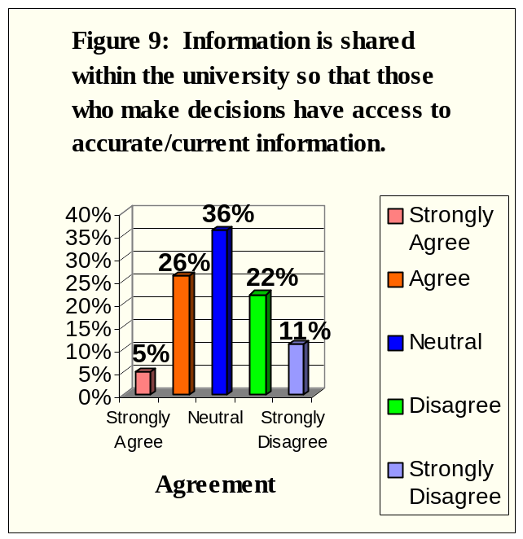
successful in influencing positive attitudes in its employees (r = .62, p < .001) and they have the opportunity for advancement within the university at FIU (r = .55, p < .001).

Opportunity For Advancement Within The University.
The findings in Figure 10 indicate that 35% of employee respondents agreed that they have the opportunity for advancement within the university: 12% strongly agreed, another 23% agreed. Thirty-six percent of employee respondents disagreed that they have an opportunity for advancement within the university: 20% disagreed, 16% strongly disagreed. An additional 29% of employee respondents were neutral on this issue.

Correlations: Employee respondents who agreed that they have an opportunity for advancement within the university also agreed that: information is shared within the university so that those who make decisions have access to accurate/current information (r = .55, p < .001), the university has
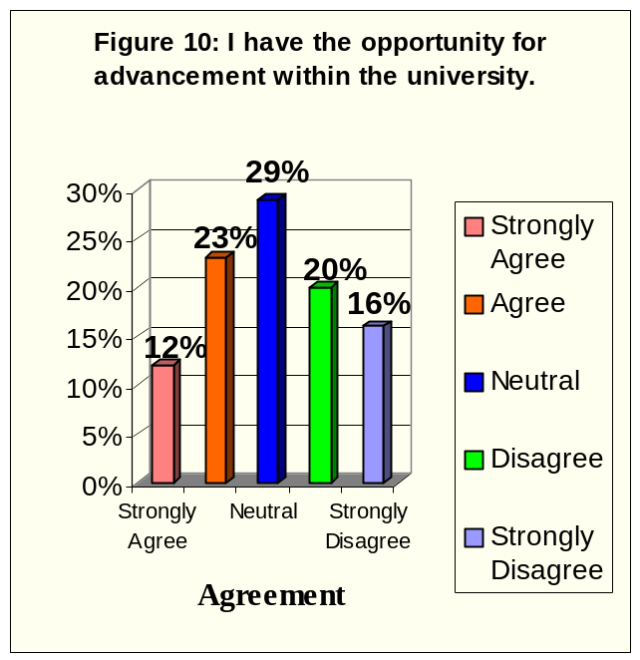
been successful in influencing positive attitudes in its employees (r = .55, p < .001) and they have an opportunity to succeed in their work (r = .53, p < .001).

DIFFERENCES IN SURVEY ITEM RESPONSES

It is important to note that a large number of employee respondents did not answer some or all of the demographic items in the survey. This makes it somewhat difficult to generalize differences in survey item responses to the entire respondent population.

Gender.

Two hundred thirty-seven respondents indicated that they were female, 87 respondents indicated that they were male. There were significant differences between male and female respondents on the following items.

Females were more likely to agree that:
- They are given quality guidance regarding their work (M = 3.78 versus M = 3.46, p < .05).
- Information is shared within the university so that those who make decisions have access to accurate/current information (M = 3.04 versus M = 2.76, p < .05).
- They receive sufficient feedback in their work (M = 3.54 versus M = 3.28, p < .05).
- They feel comfortable working at FIU (M = 4.01 versus M = 3.75, p < .05).

Males were more likely to agree that:
- At FIU they have the opportunity to express their ideas in appropriate forums (M = 3.60 versus M = 3.34, p < .05).
- They were satisfied with the amount of information about their job that they receive
(M = 3.63 versus M = 3.33, p < .05).
- A spirit of cooperation between departments exists at FIU (M = 2.99 versus M = 2.72,
p < .05).
- There is an opportunity in their department for all ideas to be exchanged (M = 3.78 versus
M = 3.50, p < .05).
- They have the flexibility to organize their workday (M = 4.33 versus M = 4.07, p < .05).

Race/Ethnicity.

The respondents who self-reported their race included 5 Asians, 39 Blacks/African Americans, 112 Hispanics, 156 Whites, 3 Non-Residents and 25 Others. There were many significant differences in the item responses by race/ethnicity. However, Asians and Non-Residents were excluded from further analyses because of the small number of respondents. Post-hoc analyses were performed for Black/African American, Hispanic, White and Other respondents. A written summary of the ten items that the racial/ethnic groups differed the most on appears below, followed by Tables 9-10 (p. 19-20) that further details these differences.

- Hispanic employee respondents were more likely than White or Other respondents to agree that they are given quality guidance regarding their work (M = 4.09 versus M = 3.46 and 3.55, respectively).
- Hispanic employee respondents were more likely than Black/African American or White respondents to agree that their supervisor/chairperson emphasizes their personal development
(M = 4.16 versus M = 3.43 and 3.58, respectively).

- Hispanic employee respondents were more likely than Black/African American or White respondents to agree that their ideas are actively sought by their supervisor/chairperson
(M = 3.99 versus M = 3.29 and 3.42, respectively).
- Hispanic employee respondents were more likely than Black/African American or White respondents to agree that the university has been successful in influencing positive attitudes in its employees (M = 3.13 versus M = 2.50 and 2.57, respectively).
- Hispanic employee respondents were more likely than White or Other respondents to agree that this (job) information that they receive is useful in their work (M = 3.93 versus M = 3.49 and 3.20, respectively).
- Hispanic employee respondents were more likely than White or Other respondents to agree that information is shared within the university so that those who make decisions have access to accurate/current information (M = 3.34 versus M = 2.75 and 2.75, respectively).
- Hispanic employee respondents were more likely than Black/African American or White respondents to agree that they receive quality feedback in their work (M = 3.85 versus
M = 3.06 and 3.42, respectively).
- Hispanic employee respondents were more likely than Black/African American, White or Other respondents to agree that their supervisor helps them to improve their work (M = 4.05 versus M = 3.37, 3.47 and 3.30, respectively).
- Other employee respondents were more likely than Black/African American, Hispanic or White respondents to agree that they feel that the upcoming changes in the Board of Regents structure will bring positive changes to FIU (M = 3.10 versus M = 1.80, 2.87 and 2.27, respectively).

TABLE 9
DIFFERENCES AMONG MEAN FINDINGS FOR RACIAL/ETHNIC GROUPS: DEMOGRAPHIC INFORMATION
______________________________________________________________________________

 |  | Number of Responses
 |  | Asian | Black/AA  American | Hispanic | White | Non-Resident | Other | Totals
1. Gender
Female |  | 3 | 25 | 96 | 92 | 3 | 15 | 234
Male |  | 2 | 6 | 15 | 57 | 0 | 5 | 85
Totals |  | 5 | 31 | 111 | 149 | 3 | 20 | 319
2. Employee Type
A & P |  | 2 | 8 | 31 | 39 | 1 | 1 | 82
Faculty |  | 2 | 2 | 4 | 33 | 0 | 4 | 45
USPS |  | 1 | 22 | 68 | 71 | 2 | 13 | 177
A & P and Faculty |  | 0 | 0 | 6 | 7 | 0 | 0 | 13
Totals |  | 5 | 32 | 109 | 150 | 3 | 18 | 317
3. Age Group
Under 25 |  | 0 | 0 | 11 | 3 | 0 | 2 | 16
26 – 30 |  | 1 | 4 | 12 | 20 | 3 | 0 | 40
31 – 35 |  | 0 | 4 | 16 | 12 | 0 | 6 | 38
36 – 40 |  | 2 | 8 | 7 | 13 | 0 | 2 | 32
41 – 45 |  | 0 | 5 | 12 | 20 | 0 | 2 | 39
46 – 50 |  | 2 | 4 | 16 | 36 | 0 | 6 | 64
51 – 55 |  | 0 | 8 | 17 | 22 | 0 | 2 | 49
56 – 64 |  | 0 | 2 | 14 | 22 | 0 | 0 | 38
65 or older |  | 0 | 0 | 6 | 1 | 0 | 0 | 7
Totals |  | 5 | 35 | 111 | 149 | 3 | 20 | 323
4. Employment Status
Part-time Or  Adjunct Employee |  | 0 | 3 | 4 | 3 | 2 | 2 | 14
Full-time Employee |  | 5 | 30 | 103 | 147 | 1 | 16 | 302
Totals |  | 5 | 33 | 107 | 150 | 3 | 18 | 316
5. I work in
Architecture |  | 0 | 0 | 0 | 2 | 0 | 0 | 2
Arts & Sciences |  | 1 | 2 | 18 | 29 | 0 | 4 | 54
Business |  | 0 | 2 | 3 | 8 | 0 | 2 | 15
Education |  | 0 | 2 | 4 | 6 | 0 | 0 | 12
Engineering |  | 2 | 0 | 4 | 9 | 0 | 2 | 17
Health & Urban Affairs |  | 0 | 9 | 11 | 17 | 0 | 0 | 37
Hospitality Management |  | 0 | 2 | 2 | 0 | 0 | 0 | 4
Journalism & Mass  Communication |  | 0 | 0 | 0 | 2 | 0 | 0 | 2
Academic Affairs or  Business & Finance |  | 0 | 9 | 24 | 12 | 2 | 3 | 50
Campus Support Services |  | 0 | 0 | 3 | 7 | 0 | 0 | 10
Student Affairs/Student  Support Services |  | 0 | 4 | 18 | 19 | 0 | 4 | 45
Athletics |  | 0 | 2 | 0 | 2 | 0 | 0 | 4
Other |  | 2 | 3 | 19 | 33 | 1 | 4 | 62
Totals |  | 5 | 35 | 106 | 146 | 3 | 19 | 314
6. I work at
Biscayne Bay Campus |  | 2 | 9 | 20 | 26 | 1 | 10 | 68
University Park Campus |  | 3 | 22 | 88 | 120 | 2 | 7 | 242
Total |  | 5 | 31 | 108 | 146 | 3 | 17 | 310
_________________________________________________________________________________
TABLE 10
SELECTED SIGNIFICANT MEAN DIFFERENCES FOR RACIAL/ETHNIC GROUPS

There were a number of overall significant differences among the mean findings for the different racial/ethnic groups at FIU. Further post-hoc analyses were performed using Games-Howell tests between each pair of groups. (Note - Asians and Non-Residents were excluded from further analyses because of the small number of respondents).
_____________________________________________________________________________________________

 |  |  | Overall F | Games-
ITEM |  | Means | (degrees of freedom) | Howell  Significance (p)
I am given quality guidance regarding my work |  |  | 7.61 (3, 316)
Hispanic |  | 4.09 (more likely to agree)
White |  | 3.46 |  | < .001
Other |  | 3.55 |  | < .05
My supervisor/chairperson emphasizes my personal development |  |  | 6.95 (3, 316)
Black/AA |  | 3.43 |  | < .05
Hispanic |  | 4.16 (more likely to agree)
White |  | 3.58 |  | < .001
My ideas are actively sought by my supervisor/ chairperson |  |  | 7.22 (3, 312)
Black/AA |  | 3.29 |  | < .01
Hispanic |  | 3.99 (more likely to agree)
White |  | 3.42 |  | < .001
The university has been successful in influencing positive attitudes in its employees |  |  | 7.07 (3, 312)
Black/AA |  | 2.50 |  | < .05
Hispanic |  | 3.13 (more likely to agree)
White |  | 2.57 |  | < .001
This information that I receive (job information) is useful in my work |  |  | 7.41 (3, 314)
Hispanic |  | 3.93 (more likely to agree)
White |  | 3.49 |  | < .001
Other |  | 3.20 |  | < .05
Information is shared within the university so that those who make decisions have access to accurate/ current information |  |  | 7.53 (3, 313)
Hispanic |  | 3.34 (more likely to agree)
White |  | 2.75 |  | < .001
Other |  | 2.75 |  | < .05
I receive quality feedback in my work |  |  | 7.83 (3, 313)
Black/AA |  | 3.06 |  | < .001
Hispanic |  | 3.85 (more likely to agree)
White |  | 3.42 |  | < .01
My supervisor helps me to improve my work |  |  | 8.40 (3, 313)
Black/AA |  | 3.37 |  | < .05
Hispanic |  | 4.05 (more likely to agree)
White |  | 3.47 |  | < .001
Other |  | 3.30 |  | = .001
I feel that the upcoming changes in the Board of Regents structure will bring positive changes to FIU |  |  | 14.68 (3, 315)
Black |  | 1.80 |  | < .001 (H, O); < .05 (W)
Hispanic |  | 2.87 (more likely to agree than B/AA, W)
White |  | 2.27 |  | < .001 (H); < .01 (O)
Other |  | 3.10 (more likely to agree than B/AA and W)
_____________________________________________________________________________________________
Employment Type.

Respondents who indicated their employment type included 85 A&P employees, 45 faculty members, 179 USPS employees and 13 employees who classified themselves as A&P and Faculty. There were some significant differences in the item responses by employment type. Those respondents who indicated that they were both A&P and Faculty were included in the A&P category to allow further post-hoc analyses. A written summary of the top items that the employment type groups differed the most on appears below, followed by Tables 11-12 (p. 22-23) that further details these differences.

- Faculty member respondents were less likely than A&P and USPS respondents to agree that they are given quality guidance regarding their work (M = 3.20 versus M = 3.88 and 3.74, respectively).
- USPS employee respondents were less likely than A&P and Faculty respondents to agree that they are able to appropriately influence the direction of their department (M = 3.10 versus
M = 3.68 and 3.58, respectively).
- USPS employee respondents were more likely than Faculty respondents to agree that unacceptable behaviors are identified and communicated to them (M = 3.81 versus M = 3.31).
- A&P and USPS employee respondents were more likely than Faculty respondents to agree that work expectations are clarified for them (M = 3.75 and 3.75 versus M = 3.29).
- USPS employee respondents were less likely than A&P employees and Faculty respondents to agree that they receive adequate information about events that are taking place at FIU
(M = 3.59 versus M = 3.95 and 4.11, respectively).
- USPS employee respondents were less likely than A&P employees and Faculty respondents to agree that they have the flexibility to organize their workday (M = 3.94 versus M = 4.32 and 4.51, respectively).
- Faculty member respondents were less likely than A&P and USPS employee respondents to agree that accuracy is expected in their work (M = 4.04 versus M = 4.65 and 4.53, respectively).
- A&P employee respondents were more likely than USPS respondents to agree that they have an opportunity to succeed in their work (M = 4.31 versus M = 3.72).

TABLE 11
DIFFERENCES AMONG MEAN FINDINGS FOR EMPLOYMENT TYPES: DEMOGRAPHIC INFORMATION
____________________________________________________________________________

 |  | A&P | Faculty | USPS | A&P and  Faculty | Total
1. Gender
Female |  | 67 | 18 | 141 | 6 | 232
Male |  | 18 | 25 | 31 | 7 | 81
Totals |  | 85 | 43 | 172 | 13 | 313
2. Race
Asian |  | 2 | 2 | 1 | 0 | 5
Black/African American |  | 8 | 2 | 22 | 0 | 32
Hispanic |  | 31 | 4 | 68 | 6 | 109
White |  | 39 | 33 | 71 | 7 | 150
Non-Resident |  | 1 | 0 | 2 | 0 | 3
Other |  | 1 | 4 | 13 | 0 | 18
Totals |  | 82 | 45 | 177 | 13 | 317
3. Age Group
Under 25 |  | 5 | 0 | 11 | 0 | 16
26 – 30 |  | 19 | 2 | 20 | 1 | 42
31 – 35 |  | 12 | 4 | 17 | 3 | 36
36 – 40 |  | 16 | 2 | 13 | 0 | 31
41 – 45 |  | 4 | 11 | 21 | 4 | 40
46 - 50 |  | 12 | 17 | 32 | 2 | 63
51 – 55 |  | 15 | 4 | 26 | 1 | 46
56 – 64 |  | 2 | 2 | 30 | 2 | 36
65 or older |  | 0 | 1 | 6 | 0 | 7
Totals |  | 85 | 43 | 176 | 13 | 317
4. Employment Status
Part-time Or Adjunct Employee |  | 2 | 5 | 4 | 0 | 11
Full-time Employee |  | 82 | 40 | 168 | 11 | 301
Totals |  | 84 | 45 | 172 | 11 | 312
5. I work in
Architecture |  | 0 | 0 | 2 | 0 | 2
Arts & Sciences |  | 6 | 12 | 35 | 0 | 53
Business |  | 4 | 7 | 4 | 0 | 15
Education |  | 2 | 2 | 4 | 2 | 10
Engineering |  | 0 | 5 | 12 | 0 | 17
Health & Urban Affairs |  | 9 | 9 | 14 | 4 | 36
Hospitality Management |  | 4 | 0 | 0 | 0 | 4
Journalism & Mass  Communication |  | 0 | 2 | 0 | 0 | 2
Academic Affairs or Business & Finance |  | 12 | 0 | 34 | 4 | 50
Campus Support Services |  | 0 | 0 | 9 | 0 | 9
Student Affairs/Student Support Services |  | 16 | 2 | 26 | 1 | 45
Athletics |  | 4 | 0 | 0 | 0 | 4
Other |  | 23 | 4 | 32 | 2 | 61
Totals |  | 80 | 43 | 172 | 13 | 308
6. I work at
Biscayne Bay Campus |  | 22 | 12 | 28 | 3 | 65
University Park Campus |  | 59 | 29 | 141 | 10 | 239
Totals |  | 81 | 41 | 169 | 13 | 304

__________________________________________________________________________________________

TABLE 12
SELECTED SIGNIFICANT MEAN DIFFERENCES FOR EMPLOYMENT TYPES

There were a number of overall significant differences among the mean findings for the various employment types at FIU. Further post-hoc analyses were performed using Games-Howell tests between each pair of groups. _____________________________________________________________________________________________

 |  |  |  | Games-
 |  |  | Overall F-value | Howell
ITEM |  | Means_ | (degrees of freedom) | Significance (p)
I am given quality guidance regarding my work |  |  | 6.09 (2, 319)
A&P |  | 3.88 |  | < .001
Faculty |  | 3.20 (less likely to agree)
USPS |  | 3.74 |  | < .01
I am able to appropriately influence the direction of my department |  |  | 10.51 (2, 315)
A&P |  | 3.68 |  | < .001
Faculty |  | 3.58 |  | < .05
USPS |  | 3.10 (less likely to agree)
Unacceptable behaviors are identified and communicated to me |  |  | 6.16 (2, 316)
Faculty |  | 3.31 |  | < .01
USPS |  | 3.81 (more likely to agree)
Work expectations are clarified for me |  |  | 4.79 (2, 318)
A&P |  | 3.75 (more likely to agree)
Faculty |  | 3.29 |  | < .05
USPS |  | 3.75 (more likely to agree)
I have the flexibility to organize my work day |  |  | 9.37 (2, 317)
A&P |  | 4.26 |  | < .05
Faculty |  | 4.51 |  | < .001
USPS |  | 3.94 (less likely to agree)
I receive adequate information about events that are taking place at FIU |  |  | 7.26 (2, 318)
A&P |  | 3.95 |  | = .01
Faculty |  | 4.11 |  | < .001
USPS |  | 3.59 (less likely to agree)
I have the flexibility to organize my workday |  |  | 9.37 (2, 317)
A&P |  | 4.32 |  | < .01
Faculty |  | 4.51 |  | < .001
USPS |  | 3.94 (less likely to agree)
Accuracy is expected in my work |  |  | 15.34 (2, 319)
A&P |  | 4.65 |  | < .001
Faculty |  | 4.04 (less likely to agree)
USPS |  | 4.53 |  | < .01
I have an opportunity to succeed in my work |  |  | 10.67 (2, 317)
A&P |  | 4.31 (more likely to agree)
USPS |  | 3.72 |  | < .001
_____________________________________________________________________________________________________________________

Age Group.

Respondent employees who indicated their age group included 16 under the age of 25, 42 between the ages of 26–30, 38 between the ages of 31–35, 32 between the ages of 36-40, 41 between the ages of 41-45, 64 between the ages of 46-50, 49 between the ages of 51-55, 39 between the ages of 56-64 and 7 who were 65 or older. There were some significant differences in the item responses by age group. A written summary of the top items upon which the age groups most differed appears below, followed by Tables 13-14 (p. 25-26) that further details these differences.

- Respondents who are in the 46–50 year old range were less likely than respondents in the 26–30, 31 –35, and 36–40 age groups to agree that they are given quality guidance regarding their work (M = 3.17 versus M = 4.07, 3.84 and 3.97, respectively).
- Respondents who are in the 46–50 year old range were less likely than respondents in the under 25, 26–30, 31–35, and 36–40 age groups to agree that their supervisor/chairperson emphasizes their personal development (M = 3.19 versus M = 4.50, 4.26, 4.05 and 4.19, respectively).
- Respondents who are in the 41–45 year old range were less likely than respondents in the 36–40 and 56–64 age groups to agree that the information they generate at work is shared with others (M = 3.59 versus M = 4.19 and 4.26, respectively).
- Respondents who are in the 46–50 year old range were less likely than respondents in the 36–40 age group to agree that positive work expectations are communicated to them (M = 3.39 versus M = 4.24).
- Respondents in the 56 –64 year old range were less likely than respondents in the 41–45 age group to agree that they receive adequate information about events that are taking place at FIU (M = 3.28 versus M = 4.15).
- Respondents who are in the 46–50 year old range were less likely than respondents in the 26–30, 31 –35, 36–40 and 56–64 age groups to agree that they have an opportunity to work jointly with others within their department (M = 3.48 versus M = 4.02, 4.00, 4.34 and 4.21, respectively).
- Respondents who are in the 46–50 year old range were less likely than respondents in the 26–30 age group to agree that their supervisor helps them to improve their work (M = 3.28 versus M = 4.05).

TABLE 13
DIFFERENCES AMONG MEAN FINDINGS FOR AGE GROUPS: DEMOGRAPHIC INFORMATION
_____________________________________________________________________________________________

 |  | Under 25 | 26-30 | 31-35 | 36-40 | 41-45 | 46-50 | 51-55 | 56-64 | 65 or older | Total
1. Gender
Female |  | 13 | 36 | 27 | 20 | 21 | 42 | 43 | 25 | 7 | 234
Male |  | 3 | 4 | 9 | 10 | 18 | 21 | 6 | 14 | 0 | 85
Totals |  | 16 | 40 | 36 | 30 | 39 | 63 | 49 | 39 | 7 | 319
2. Race
Asian |  | 0 | 1 | 0 | 2 | 0 | 2 | 0 | 0 | 0 | 5
Black/African American |  | 0 | 4 | 4 | 8 | 5 | 4 | 8 | 2 | 0 | 35
Hispanic |  | 11 | 12 | 16 | 7 | 12 | 16 | 17 | 14 | 6 | 111
White |  | 3 | 20 | 12 | 13 | 20 | 36 | 22 | 22 | 1 | 149
Non-Resident |  | 0 | 3 | 0 | 0 | 0 | 0 | 0 | 0 | 0 | 3
Other |  | 2 | 0 | 6 | 2 | 2 | 6 | 2 | 0 | 0 | 20
Totals |  | 16 | 40 | 38 | 32 | 39 | 64 | 49 | 38 | 7 | 323
3. Employee Type
A&P |  | 5 | 19 | 12 | 16 | 4 | 12 | 15 | 2 | 0 | 85
Faculty |  | 0 | 2 | 4 | 2 | 11 | 17 | 4 | 2 | 1 | 43
USPS |  | 11 | 20 | 17 | 13 | 21 | 32 | 26 | 30 | 6 | 176
A&P and Faculty |  | 0 | 1 | 3 | 0 | 4 | 2 | 1 | 2 | 0 | 13
Totals |  | 16 | 42 | 36 | 31 | 40 | 63 | 46 | 36 | 7 | 317
4. Employment Status
Part-time Or  Adjunct Employee |  | 2 | 4 | 2 | 1 | 2 | 2 | 0 | 0 | 1 | 14
Full-time Employee |  | 14 | 38 | 36 | 28 | 35 | 60 | 49 | 37 | 5 | 302
Totals |  | 16 | 42 | 38 | 29 | 37 | 62 | 49 | 37 | 6 | 316
5. I work in
Architecture |  | 0 | 0 | 0 | 0 | 0 | 2 | 0 | 0 | 0 | 2
Arts & Sciences |  | 8 | 1 | 2 | 10 | 8 | 11 | 6 | 7 | 1 | 54
Business |  | 0 | 1 | 3 | 2 | 4 | 2 | 2 | 1 | 0 | 15
Education |  | 2 | 0 | 0 | 0 | 2 | 4 | 2 | 2 | 0 | 12
Engineering |  | 0 | 2 | 4 | 0 | 3 | 4 | 0 | 1 | 1 | 15
Health & Urban Affairs |  | 0 | 6 | 3 | 3 | 6 | 8 | 7 | 4 | 0 | 37
Hospitality Management |  | 0 | 1 | 0 | 1 | 0 | 2 | 0 | 0 | 0 | 4
Journalism & Mass  Communication |  | 0 | 0 | 0 | 0 | 2 | 0 | 0 | 0 | 0 | 2
Academic Affairs or  Business & Finance |  | 0 | 4 | 7 | 6 | 2 | 11 | 12 | 6 | 2 | 50
Campus Support Services |  | 0 | 2 | 0 | 0 | 1 | 6 | 0 | 1 | 0 | 10
Student Affairs/Student  Support Services |  | 3 | 11 | 8 | 1 | 3 | 4 | 9 | 8 | 0 | 47
Athletics |  | 0 | 4 | 0 | 0 | 0 | 0 | 0 | 0 | 0 | 4
Other |  | 3 | 8 | 11 | 8 | 7 | 5 | 10 | 8 | 3 | 63
Totals |  | 16 | 40 | 38 | 31 | 38 | 59 | 48 | 38 | 7 | 315
6. I work at
Biscayne Bay Campus |  | 2 | 8 | 17 | 12 | 6 | 9 | 7 | 6 | 1 | 68
University Park Campus |  | 13 | 32 | 21 | 16 | 33 | 50 | 42 | 31 | 6 | 244
Totals |  | 15 | 40 | 38 | 28 | 39 | 59 | 49 | 37 | 7 | 312

_____________________________________________________________________________________________

TABLE 14
SELECTED SIGNIFICANT MEAN DIFFERENCES FOR AGE GROUPS

There were a number of overall significant differences among the mean findings for the different employment types at FIU. Further post-hoc analyses were performed using Games-Howell tests between each pair of groups. (Note – Respondents who designated themselves as 65 or older were excluded from further analyses because of the small number of respondents).
_____________________________________________________________________________________________

 |  |  |  | Games-
 |  |  | Overall F-value | Howell
 |  | Means | (degrees of freedom) | Significance (p)
I am given quality guidance regarding my work |  |  | 3.64 (7, 313)
26-30 |  | 4.07 |  | < .01
31-35 |  | 3.84 |  | < .05
36-40 |  | 3.97 |  | < .05
46-50 |  | 3.17 (less likely to agree)
My supervisor/chairperson emphasizes my personal development |  |  | 5.70 (7, 313)
Under 25 |  | 4.50 |  | < .001
26-30 |  | 4.26 |  | < .001
31-35 |  | 4.05 |  | < .001
36-40 |  | 4.19 |  | < .001
46-50 |  | 3.19 (less likely to agree)
The information I generate at work is shared with others |  |  | 3.01 (7, 313)
36-40 |  | 4.19 |  | < .05
41-45 |  | 3.59 (less likely to agree)
56-64 |  | 4.26 |  | < .01
Positive work expectations are communicated to me |  |  | 2.93 (7, 309)
36-40 |  | 4.24 |  | < .001
46-50 |  | 3.39 (less likely to agree)
I receive adequate information about events that are taking place at FIU |  |  | 3.07 (7, 313)
41-45 |  | 4.15 |  | < .01
56-64 |  | 3.28 (less likely to agree)
I have an opportunity to work jointly with others within my department |  |  | 5.08 (7, 313)
26-30 |  | 4.02 |  | < .05
31-35 |  | 4.00 |  | < .01
36-40 |  | 4.34 |  | < .001
46-50 |  | 3.48 (less likely to agree)
56-64 |  | 4.21 |  | < .001
My supervisor helps me to improve my work |  |  | 2.78 (7, 310)
26-30 |  | 4.05 |  | < .01
46-50 |  | 3.28 (less likely to agree)
_____________________________________________________________________________________________

I work in…

Respondent employees who indicated where they worked included 2 from the School of Architecture, 54 from the College of Arts & Sciences, 15 from the College of Business, 12 from the College of Education, 17 from the College of Engineering, 37 from the College of Health & Urban Affairs, 4 from the School of Hospitality Management, 2 from the School of Journalism and Mass Communication, 50 from Academic Affairs or Business and Finance, 10 from Campus Support Services, 47 from Student Affairs/Student Support Services, 4 from the Athletics Department and 64 employees from other Departments. There were a number of significant differences in the item responses according to where the respondent works. Respondents from Architecture, Hospitality Management, Journalism & Mass Communication and Athletics were removed from further post-hoc analyses because of the small number of respondents. A written summary of the top items that the groups differed the most on appears below, followed by Tables 15-16 (p. 28-29) that further details these differences.

- Respondents who work in Student Affairs/Student Support Services were more likely than respondents who work in Campus Support Services and Other (not specified) to agree that they are given quality guidance regarding their work (M = 4.28 versus M = 3.00 and 3.44, respectively).
- Respondents who work in Engineering (M = 4.53) and Student Affairs/Student Support Services (M = 4.45) were more likely than respondents who work in Campus Support Services and Other to agree that they are given the opportunity to be creative in their work
(M = 3.00 and 3.62, respectively).
- Respondents who work in Campus Support Services were less likely than respondents who work in Arts & Sciences, Engineering, Health & Urban Affairs, Academic Affairs or Business and Finance and Student Affairs/Student Support Services to agree that their ideas are actively sought by their supervisor/chairperson (M = 2.50 versus M = 3.78, 3.76, 3.78, 3.70 and 3.91, respectively).
- Respondents who work in Education were less likely than respondents from Business, Engineering and Other to agree that they receive adequate job information at FIU (M = 2.83 versus M = 3.60, 3.88 and 3.45, respectively). Engineering respondents also were more likely to agree with this item than Arts & Sciences respondents (M = 3.06).
- Respondents who work in Engineering were more likely than respondents from Business and Other to agree that they receive quality feedback in their work (M = 4.00 versus M = 2.80 and 3.32, respectively). Student Affairs/Student Support Services respondents (M = 3.81) were also more likely to agree to this item than Business respondents.
- Respondents who work in Engineering were more likely than respondents from Arts & Sciences, Education, Health & Urban Affairs, Academic Affairs or Business and Finance, Student Affairs/Student Support Services and Other to agree that they have the opportunity for advancement within the university (M = 4.24 versus M = 2.94, 2.83, 2.80, 3.16, 3.04 and 3.11, respectively).

TABLE 15
DIFFERENCES AMONG MEAN FINDINGS FOR “WHERE I WORK”: DEMOGRAPHIC INFORMATION

 |  |  |  |  |  |  |  |  |  | AAor |  | SA/
 |  | Arch | A&S | Bus | Edu | Eng | Hua | HM | JMC | B&F | CSS | SSS | Ath | Other | Total
1. Gender
Female |  | 2 | 39 | 10 | 8 | 7 | 33 | 4 | 0 | 36 | 5 | 36 | 2 | 44 | 226
Male |  | 0 | 14 | 5 | 4 | 9 | 4 | 0 | 2 | 14 | 5 | 7 | 2 | 17 | 83
Totals |  | 2 | 53 | 15 | 12 | 16 | 37 | 4 | 2 | 50 | 10 | 43 | 4 | 61 | 309
2. Race
Asian |  | 0 | 1 | 0 | 0 | 2 | 0 | 0 | 0 | 0 | 0 | 0 | 0 | 2 | 5
Black/African American |  | 0 | 2 | 2 | 2 | 0 | 9 | 2 | 0 | 9 | 0 | 4 | 2 | 3 | 35
Hispanic |  | 0 | 18 | 3 | 4 | 4 | 11 | 2 | 0 | 24 | 3 | 18 | 0 | 19 | 106
White |  | 2 | 29 | 8 | 6 | 9 | 17 | 0 | 2 | 12 | 7 | 19 | 2 | 33 | 146
Non-Resident |  | 0 | 0 | 0 | 0 | 0 | 0 | 0 | 0 | 2 | 0 | 0 | 0 | 1 | 3
Other |  | 0 | 4 | 2 | 0 | 2 | 0 | 0 | 0 | 3 | 0 | 4 | 0 | 4 | 19
Totals |  | 2 | 54 | 15 | 12 | 17 | 37 | 4 | 2 | 50 | 10 | 45 | 4 | 62 | 314
3. Employee Type
A&P |  | 0 | 6 | 4 | 2 | 0 | 9 | 4 | 0 | 12 | 0 | 16 | 4 | 23 | 80
Faculty |  | 0 | 12 | 7 | 2 | 5 | 9 | 0 | 2 | 0 | 0 | 2 | 0 | 4 | 43
USPS |  | 2 | 35 | 4 | 4 | 12 | 14 | 0 | 0 | 34 | 9 | 26 | 0 | 32 | 172
A&P and Faculty |  | 0 | 0 | 0 | 2 | 0 | 4 | 0 | 0 | 4 | 0 | 1 | 0 | 2 | 13
Totals |  | 2 | 53 | 15 | 10 | 17 | 36 | 4 | 2 | 50 | 9 | 45 | 4 | 61 | 308
4. Age Group
Under 25 |  | 0 | 8 | 0 | 2 | 0 | 0 | 0 | 0 | 0 | 0 | 3 | 0 | 3 | 16
26 – 30 |  | 0 | 1 | 1 | 0 | 2 | 6 | 1 | 0 | 4 | 2 | 11 | 4 | 8 | 40
31 – 35 |  | 0 | 2 | 3 | 0 | 4 | 3 | 0 | 0 | 7 | 0 | 8 | 0 | 11 | 38
36 – 40 |  | 0 | 10 | 2 | 0 | 0 | 3 | 1 | 0 | 6 | 0 | 1 | 0 | 8 | 31
41 – 45 |  | 0 | 8 | 4 | 2 | 3 | 6 | 0 | 2 | 2 | 1 | 3 | 0 | 7 | 38
46 – 50 |  | 2 | 11 | 2 | 4 | 4 | 8 | 2 | 0 | 11 | 6 | 4 | 0 | 5 | 59
51 – 55 |  | 0 | 6 | 2 | 2 | 0 | 7 | 0 | 0 | 12 | 0 | 9 | 0 | 10 | 48
56 – 64 |  | 0 | 7 | 1 | 2 | 1 | 4 | 0 | 0 | 6 | 1 | 8 | 0 | 8 | 38
65 or older |  | 0 | 1 | 0 | 0 | 1 | 0 | 0 | 0 | 2 | 0 | 0 | 0 | 3 | 7
Totals |  | 2 | 54 | 15 | 12 | 15 | 37 | 4 | 2 | 50 | 10 | 47 | 4 | 63 | 315
5. Employment Status
Part-time or Adjunct Employee |  | 0 | 3 | 0 | 2 | 0 | 1 | 0 | 2 | 2 | 0 | 2 | 2 | 0 | 14
Full-time Employee |  | 2 | 49 | 15 | 6 | 16 | 36 | 4 | 0 | 45 | 10 | 45 | 2 | 64 | 294
Totals |  | 2 | 52 | 15 | 8 | 16 | 37 | 4 | 2 | 47 | 10 | 47 | 4 | 64 | 308
6. I work at
Biscayne Bay Campus |  | 0 | 11 | 1 | 0 | 0 | 17 | 4 | 2 | 11 | 0 | 6 | 0 | 16 | 68
University Park Campus |  | 2 | 42 | 14 | 12 | 16 | 14 | 0 | 0 | 36 | 10 | 41 | 4 | 44 | 235
Totals |  | 2 | 53 | 15 | 12 | 16 | 31 | 4 | 2 | 47 | 10 | 47 | 4 | 60 | 303

__________________________________________________________________________________________________________________________

TABLE 16
SELECTED SIGNIFICANT MEAN DIFFERENCES FOR “WHERE I WORK.”

There were a number of overall significant differences among the mean findings for the different groups at FIU. Further post-hoc analyses were performed using Games-Howell tests between each pair of groups.
__________________________________________________________________________________________________________________________

 |  |  | Overall F-value | Games-
 |  |  | (degrees of | Howell
 |  | Means | freedom) | Significance (p)
I am given quality guidance regarding my work |  |  | 3.15 (8, 297)
Campus Support Services |  | 3.00 |  | < .01
Other |  | 3.44 |  | < .001
Student Affairs/Student Support Services |  | 4.28 (more likely to agree)
I am given the opportunity to be creative in my work |  |  | 4.73 (8, 297)
Campus Support Services |  | 3.00 |  | < .01 (E, SA/SSS)
Engineering |  | 4.53 (more likely to agree than CSS, O)
Other |  | 3.62 |  | < .05 (E); < .001 (SA/SSS)
Student Affairs/Student Support Services |  | 4.45 (more likely to agree than CSS, O)
My ideas are actively sought by my supervisor/chairperson |  |  | 2.61 (8, 293)
Arts & Sciences |  | 3.78 |  | < .01
Campus Support Services |  | 2.50 (less likely to agree)
Engineering |  | 3.76 |  | < .01
Health & Urban Affairs |  | 3.78 |  | < .01
Academic Affairs or Business and Finance |  | 3.70 |  | < .01
Student Affairs/Student Support Services |  | 3.91 |  | < .001
I receive adequate job information at FIU |  |  | 2.42 (8, 297)
Arts & Sciences |  | 3.06 |  | < .01 (Eng)
Business |  | 3.60 |  | < .01 (Ed)
Education |  | 2.83 (less likely to agree than B, Eng, O)
Engineering |  | 3.88 (more likely to agree than A&S) |  | < .01 (A&S); < .001 (Ed)
Other |  | 3.45 |  | < .01
I receive quality feedback in my work |  |  | 3.80 (8, 294)
Business |  | 2.80 |  | < .01 (Eng);  < .01 (SA/SSS)
Engineering |  | 4.00 (more likely to agree then B & O)
Other |  | 3.32 |  | < .01 (Eng)
Student Affairs/Student Support Services |  | 3.81 (more likely to agree than B) |  | < .01
I have the opportunity for advancement within the university |  |  | 2.32 (8, 292)
Arts & Science |  | 2.94 |  | < .001
Education |  | 2.83 |  | < .05
Engineering |  | 4.24 (more likely to agree)
Health & Urban Affairs |  | 2.80 |  | < .001
Academic Affairs or Business and Finance |  | 3.16 |  | < .01
Other |  | 3.11 |  | < .001
Student Affairs/Student Support Services |  | 3.04 |  | < .01

__________________________________________________________________________________________________________________________

Campus.

Respondents who indicated their campus included 68 employees from the Biscayne Bay Campus and 247 employees from the University Park Campus. There were some significant differences in the item responses by campus. A written summary of the top items upon which respondents most differed appears below, followed by Tables 17-18 (p. 31-32) that further details these differences.

- Respondents who work at the University Park Campus were more likely than respondents from the Biscayne Bay Campus to agree that their supervisor expresses confidence in their work (M = 4.37 versus M = 3.91).
- Respondents who work at the University Park Campus were more likely than respondents from the Biscayne Bay Campus to agree that they are satisfied with the information about their job that they receive (M = 3.52 versus M = 3.00).
- Respondents who work at the University Park Campus were more likely than respondents from the Biscayne Bay Campus to agree that a spirit of cooperation exists within their department (M = 3.80 versus M = 3.29).
- Respondents who work at the University Park Campus were more likely than respondents from the Biscayne Bay Campus to agree that they are responsible for completing meaningful tasks (M = 4.47 versus M = 4.01).
- Respondents who work at the University Park Campus were more likely than respondents from the Biscayne Bay Campus to agree that they have an opportunity to succeed in their work (M = 4.04 versus M = 3.50).

TABLE 17
DIFFERENCES AMONG MEAN FINDINGS FOR CAMPUS: DEMOGRAPHIC INFORMATION
____________________________________________________________________________

 |  | Biscayne Bay Campus | University Park Campus | Totals
1. Gender
Female |  | 50 | 174 | 224
Male |  | 16 | 67 | 83
Totals |  | 66 | 241 | 307
2. Race
Asian |  | 2 | 3 | 5
Black/African American |  | 9 | 22 | 31
Hispanic |  | 20 | 88 | 108
White |  | 26 | 120 | 146
Non-Resident |  | 1 | 2 | 3
Other |  | 10 | 7 | 17
Totals |  | 68 | 242 | 310
3. Employee Type
A&P |  | 22 | 59 | 81
Faculty |  | 12 | 29 | 41
USPS |  | 28 | 141 | 169
A&P and Faculty |  | 3 | 10 | 13
Totals |  | 65 | 239 | 304
4. Age Group
Under 25 |  | 2 | 13 | 15
26 – 30 |  | 8 | 32 | 40
31 – 35 |  | 17 | 21 | 38
36 – 40 |  | 12 | 16 | 28
41 – 45 |  | 6 | 33 | 39
46 - 50 |  | 9 | 50 | 59
51 – 55 |  | 7 | 42 | 49
56 – 64 |  | 6 | 31 | 37
65 or older |  | 1 | 6 | 7
Totals |  | 68 | 244 | 312
5. Employment Status
Part-time or  Adjunct Employee |  | 6 | 8 | 14
Full-time Employee |  | 60 | 229 | 289
Totals |  | 66 | 237 | 303
6. I work in
Architecture |  | 0 | 2 | 2
Arts & Sciences |  | 11 | 42 | 53
Business |  | 1 | 14 | 15
Education |  | 0 | 12 | 12
Engineering |  | 0 | 16 | 16
Health & Urban Affairs |  | 17 | 14 | 31
Hospitality Management |  | 4 | 0 | 4
Journalism & Mass  Communication |  | 2 | 0 | 2
Academic Affairs or  Business & Finance |  | 11 | 36 | 47
Campus Support Services |  | 0 | 10 | 10
Student Affairs/Student  Support Services |  | 6 | 41 | 47
Athletics |  | 0 | 4 | 4
Other |  | 16 | 44 | 60
Totals |  | 68 | 235 | 303
_____________________________________________________________________________________________________________________

TABLE 18
SELECTED SIGNIFICANT MEAN DIFFERENCES FOR CAMPUS
____________________________________________________________________________________________________________________

 |  |  | Overall F-value
 |  |  | (degrees of | Overall
 |  | Means | freedom) | Significance (p)
My supervisor expresses confidence in my work |  |  | 11.98 (1, 309)
Biscayne Bay Campus |  | 3.91 |  | < .001
University Park Campus |  | 4.37 (more likely to agree)
I am satisfied with the amount of information about my job that I receive |  |  | 12.89 (1, 310)
Biscayne Bay Campus |  | 3.00 |  | < .001
University Park Campus |  | 3.52 (more likely to agree)
A spirit of cooperation exists within my department |  |  | 10.82 (1, 313)
Biscayne Bay Campus |  | 3.29 |  | < .001
University Park Campus |  | 3.80 (more likely to agree)
I am responsible for completing meaningful tasks |  |  | 18.09 (1, 309)
Biscayne Bay Campus |  | 4.01 |  | < .001
University Park Campus |  | 4.47 (more likely to agree)
I have an opportunity to succeed in my work |  |  | 14.39 (1, 313)
Biscayne Bay Campus |  | 3.50 |  | < .001
University Park Campus |  | 4.04 (more likely to agree)

_________________________________________________________________________________________________

CONCLUSIONS

The results of this Continuous Quality Improvement Survey are mixed. While positive responses (at least 65% of respondents selected a response of Strongly Agree or Agree) were reported on 37.5% of the survey items (15 out of 40), there were a number of responses that show some cause for concern. Of the fifteen items that received positive responses, about 67% (10/15) of the items had positive responses between 65.0% and 79.9%. The remaining five items (5/15) had positive responses of higher than 80%. It is somewhat difficult to interpret these results without prior comparative data. Overall, the campus atmosphere could be vastly improved over a few years ago, things could have deteriorated rapidly or things could be about the same. Since we do not have the luxury of comparative data at this time, we must look instead to the present survey results. In the future, we can compare the data collected at that time to this previous data, and a clearer picture will emerge.

In general, FIU employee respondents seemed more satisfied with their supervisor and their department than with the university as a whole. For example, 78% of respondents indicated that their supervisor expresses confidence in the respondent’s work. Sixty-seven percent report that their ideas are seriously considered by their supervisor/chairperson. Sixty-three percent of respondents reported that their supervisor/chairperson emphasizes the respondent’s personal growth. In addition, 93% of respondents reported that their job skills are appropriate for the work that they are expected to complete. However, respondents were significantly less positive about their workload, only 67% of respondents reported that their workload is appropriate. (Employee workload will be expected to increase in the next couple of years, if the current budget constraints continue. This is not good news for one-third of employees who already are presumably feeling overworked).

There is further cause for concern in regard to the university climate as a whole. A meager 25% of employee respondents believe that the university has been successful in influencing positive attitudes in employees. Only 58% of employee respondents reported that they believe the actions of the university reflect the FIU mission, and barely 50% of employee respondents believe that they have the opportunity to express their ideas in appropriate forums. Thirty-eight percent of employee respondents report that they receive adequate information about policy decisions at FIU. Additionally, while 60% of employees believe that a spirit of cooperation exists in their own department, only 28% believe that there exists a spirit of cooperation between departments at FIU. While 63% of respondents reported that their supervisor is concerned with their personal growth, only 35% of respondents believe that they have an opportunity for advancement at the university.

There were also many differences in responses by the various respondent employee sub-groups (gender, race/ethnicity, employment type, age, etc.) at FIU. Males were more likely to report that they have the opportunity to express their ideas in appropriate forums. Hispanic respondents were more likely to report that their supervisor helps them to improve their work. Faculty member respondents were less likely to report that they are given quality guidance regarding their work. Respondents ages 46-50 were less likely to agree that their supervisor emphasizes their personal development than younger employees.

It seems fairly evident that there are areas that need attention. Employee respondents are feeling, at the very least, unsure about the Board of Regents changes with only a few positive responses (9%); however, 41% of respondent employees chose not to answer this question, and another 25% of respondents were neutral. They are also very concerned about campus climate, the sharing of information between departments and the sharing of information between the administration and employees. It seems clear that while overall employees are fairly positive about FIU, there clearly are areas that need improvement.

APPENDIX A
EMPLOYEE INVENTORY SURVEY
Please note that percentages may not add up to 100%, because some respondents did not answer every question.
FORMAL INFLUENCE
1. I believe that the actions of the university reflect the FIU mission.
Strongly Agree | 13.0% |  | Disagree | 15.0%
Agree | 44.5% |  | Strongly Disagree | 3.0%
Neutral | 23.9%
2. My supervisor expresses confidence in my work
Strongly Agree | 45.2% |  | Disagree | 4.9%
Agree | 33.1% |  | Strongly Disagree | 4.2%
Neutral | 11.4%
3. I am given quality guidance regarding my work.
Strongly Agree | 20.6% |  | Disagree | 11.1%
Agree | 38.0% |  | Strongly Disagree | 7.7%
Neutral | 22.5%
4. I am given the opportunity to be creative in my work.
Strongly Agree | 37.0% |  | Disagree | 8.1%
Agree | 37.9% |  | Strongly Disagree | 3.3%
Neutral | 13.7%
5. My supervisor/chairperson emphasizes my personal development.
Strongly Agree | 31.9% |  | Disagree | 8.6%
Agree | 31.2% |  | Strongly Disagree | 7.7%
Neutral | 20.6%
6. My ideas are seriously considered by my supervisor/chairperson.
Strongly Agree | 31.7% |  | Disagree | 10.0%
Agree | 35.4% |  | Strongly Disagree | 4.0%
Neutral | 18.1%
7. At FIU I have the opportunity to express my ideas in appropriate forums.
Strongly Agree | 11.1% |  | Disagree | 15.8%
Agree | 38.4% |  | Strongly Disagree | 5.1%
Neutral | 28.7%
8. My ideas are actively sought by my supervisor/chairperson.
Strongly Agree | 19.4% |  | Disagree | 13.4%
Agree | 37.3% |  | Strongly Disagree | 6.7%
Neutral | 22.5%
9. I am able to appropriately influence the direction of my department.
Strongly Agree | 13.9% |  | Disagree | 18.7%
Agree | 28.2% |  | Strongly Disagree | 7.6%
Neutral | 30.5%
10. The university has been successful in influencing positive attitudes in its employees.
Strongly Agree | 2.5% |  | Disagree | 26.1%
Agree | 21.8% |  | Strongly Disagree | 15.8%
Neutral | 33.1%
COMMUNICATION
11. I am satisfied with the amount of information about my job that I receive.
Strongly Agree | 10.2% |  | Disagree | 19.5%
Agree | 40.1% |  | Strongly Disagree | 6.5%
Neutral | 22.7%
12. The information that I receive is useful in my work.
Strongly Agree | 12.0% |  | Disagree | 9.9%
Agree | 44.2% |  | Strongly Disagree | 3.2%
Neutral | 30.1%
13. The information I generate at work is shared with others.
Strongly Agree | 20.2% |  | Disagree | 6.0%
Agree | 55.6% |  | Strongly Disagree | 1.4%
Neutral | 16.7%
14. Positive work expectations are communicated to me.
Strongly Agree | 20.2% |  | Disagree | 8.8%
Agree | 46.7% |  | Strongly Disagree | 5.8%
Neutral | 17.4%
15. Unacceptable behaviors are identified and communicated to me.
Strongly Agree | 13.6% |  | Disagree | 8.6%
Agree | 50.9% |  | Strongly Disagree | 2.1%
Neutral | 23.6%
16. Work expectations are clarified for me.
Strongly Agree | 12.5% |  | Disagree | 11.1%
Agree | 48.8% |  | Strongly Disagree | 4.2%
Neutral | 23.2%
17. At FIU, an ethnically and culturally diverse environment is valued.
Strongly Agree | 23.4% |  | Disagree | 10.7%
Agree | 44.4% |  | Strongly Disagree | 3.0%
Neutral | 18.3%
18. I receive adequate information about events that are taking place at FIU.
Strongly Agree | 21.3% |  | Disagree | 10.0%
Agree | 56.0% |  | Strongly Disagree | 2.8%
Neutral | 9.3%
19. I receive adequate job information at FIU.
Strongly Agree | 8.5% |  | Disagree | 18.0%
Agree | 39.3% |  | Strongly Disagree | 3.0%
Neutral | 31.0%
20. I receive adequate information about policy decisions at FIU.
Strongly Agree | 4.4% |  | Disagree | 24.6%
Agree | 33.8% |  | Strongly Disagree | 9.2%
Neutral | 27.5%
21. Information is shared within the university so that those who make decisions have access to accurate/current information.
Strongly Agree | 5.3% |  | Disagree | 22.2%
Agree | 25.4% |  | Strongly Disagree | 10.9%
Neutral | 35.7%
COLLABORATION
22. A spirit of cooperation exists within my department.
Strongly Agree | 23.2% |  | Disagree | 14.3%
Agree | 36.6% |  | Strongly Disagree | 7.0%
Neutral | 18.8%
23. A spirit of cooperation between departments exists at FIU.
Strongly Agree | 2.1% |  | Disagree | 31.5%
Agree | 25.7% |  | Strongly Disagree | 10.7%
Neutral | 29.2%
24. There is an opportunity in my department for all ideas to be exchanged.
Strongly Agree | 16.4% |  | Disagree | 14.1%
Agree | 40.0% |  | Strongly Disagree | 5.5%
Neutral | 24.1%
25. I have an opportunity to work jointly with others within my department
Strongly Agree | 24.1% |  | Disagree | 4.9%
Agree | 52.6% |  | Strongly Disagree | 3.2%
Neutral | 14.8%
26. I have an opportunity to work jointly with FIU employees outside of my department.
Strongly Agree | 11.3% |  | Disagree | 15.7%
Agree | 40.8% |  | Strongly Disagree | 3.3%
Neutral | 28.7%
ORGANIZATIONAL STRUCTURE
27. University-wide policies guide my work.
Strongly Agree | 12.1% |  | Disagree | 12.0%
Agree | 37.0% |  | Strongly Disagree | 3.3%
Neutral | 34.7%
28. I receive quality feedback in my work.
Strongly Agree | 10.2% |  | Disagree | 14.8%
Agree | 42.3% |  | Strongly Disagree | 4.2%
Neutral | 27.8%
29. I receive sufficient feedback in my work.
Strongly Agree | 8.8% |  | Disagree | 16.0%
Agree | 41.7% |  | Strongly Disagree | 3.9%
Neutral | 28.7%
30. The amount of work I do is appropriate.
Strongly Agree | 19.0% |  | Disagree | 15.7%
Agree | 47.7% |  | Strongly Disagree | 4.9%
Neutral | 12.1%
31. I have the flexibility to organize my work day.
Strongly Agree | 34.5% |  | Disagree | 4.2%
Agree | 50.0% |  | Strongly Disagree | 3.0%
Neutral | 7.4%
WORK DESIGN
32. Accuracy is expected in my work.
Strongly Agree | 54.9% |  | Disagree | 1.1%
Agree | 38.6% |  | Strongly Disagree | 0.4%
Neutral | 5.1%
33. My job skills are appropriate for the work that I am expected to complete.
Strongly Agree | 53.9% |  | Disagree | 3.2%
Agree | 38.9% |  | Strongly Disagree | 1.4%
Neutral | 2.6%
34. I feel that my work is relevant to the university mission.
Strongly Agree | 51.4% |  | Disagree | 1.2%
Agree | 38.4% |  | Strongly Disagree | 0.9%
Neutral | 7.0%
35. I am responsible for completing meaningful tasks.
Strongly Agree | 48.1% |  | Disagree | 2.5%
Agree | 41.4% |  | Strongly Disagree | 1.1%
Neutral | 6.3%
36. I have the opportunity for advancement within the university.
Strongly Agree | 11.6% |  | Disagree | 19.4%
Agree | 23.1% |  | Strongly Disagree | 16.2%
Neutral | 28.9%
37. I have an opportunity to succeed in my work.
Strongly Agree | 26.8% |  | Disagree | 5.6%
Agree | 45.2% |  | Strongly Disagree | 4.8%
Neutral | 17.3%
38. My supervisor helps me to improve my work.
Strongly Agree | 19.9% |  | Disagree | 12.1%
Agree | 40.3% |  | Strongly Disagree | 8.5%
Neutral | 18.7%
39. I feel comfortable working at FIU.
Strongly Agree | 18.7% |  | Disagree | 4.6%
Agree | 26.4% |  | Strongly Disagree | 1.2%
Neutral | 10.0%
BOARD OF REGENTS
40. I feel that the upcoming changes in the Board of Regents structure will bring positive changes to FIU.
Strongly Agree | 1.4% |  | Disagree | 8.6%
Agree | 7.6% |  | Strongly Disagree | 15.5%
Neutral | 25.4%
DEMOGRAPHIC ITEMS
41. Gender
Male | 15.3%
Female | 41.7%
Missing | 43.0%
42. Ethnicity (Check all that apply)
Asian | 0.9%
Black | 6.9%
Hispanic | 19.7%
White | 27.5%
Non-Resident | 0.5%
Other | 4.4%
43. Employee Type
A&P | 15.0%
Faculty | 7.9%
USPS | 31.5%
A&P and Faculty | 2.3%
Missing | 43.3%
44. Age Group
under 25 | 2.8% |  | 46 - 50 | 11.3%
26 - 30 | 7.4% |  | 51 - 55 | 8.6%
31 - 35 | 6.7% |  | 56 - 64 | 6.9%
36 - 40 | 5.6% |  | 65 or older | 1.2%
41 - 45 | 7.2% |  | Missing | 42.3%
45. Employment Status
Part-time employee or
Adjunct Faculty | 2.5%
Full-time employee | 54.0%
Missing | 43.5%
46. I work in
Architecture | 0.4% |  | Journalism & Mass Communication | 0.4%
Arts & Sciences | 9.5% |  | Academic Affairs or Business and Finance | 8.8%
Business | 2.6% |  | Campus Support Services | 1.8%
Education | 2.1% |  | Student Affairs/Student Support Services | 8.3%
Engineering | 3.0% |  | Athletics | 0.7%
Health & Urban Affairs | 6.5% |  | Other | 11.3%
Hospitality Management | 0.7% |  | Missing | 43.8%
47. I work at
Biscayne Bay Campus | 12.0%
University Park Campus | 43.5%
Missing | 44.5%

