Office of
Planning and Institutional Research
Institutional Research



Hope, Knowledge, and Opportunity

Research Report 2008-2009
Survey of Graduating Master’s and Doctoral Students
Summer 2008 - Spring 2009

University Park Campus
PC 543
Miami, FL 33199
Telephone: (305) 348-2731 Fax: (305) 348-1008
http://w3.fiu.edu/irdata/portal/effectiveness.htm

Office of Planning & Institutional Effectiveness

The Graduating Master’s and Doctoral Student Survey is one of a series of Continuous Quality Improvement Surveys instituted by Florida International University’s Office of Planning and Institutional Research. This is the eighth survey report from the Graduating Master’s and Doctoral Student Survey. The information in these Continuous Quality Improvement Survey Reports will be distributed to members of the university community and will be used by the appropriate departments to enhance continuous quality improvement efforts.

Every effort has been made to ensure that the data contained in this document is accurate. For further information about this and other Continuous Quality Improvement Survey Reports, visit our website at http://w3.fiu.edu/irdata/portal/effectiveness.htm, or contact Noelle Laforest at nlafores@fiu.edu or 305-348-2731, (FAX) 305-348-1008, or visit us at Modesto Maidique Campus, PC 543.

TABLE OF CONTENTS
Table of Contents |  |  |  |  |  |  |  |  |  |  |  |  |  |  |  |  |  |  |  |  |  |  |  |  |  |  |  |  |  |  |  |  |  |  |  |  |  |  |  | 3
Executive Summary of the Graduating Master’s and Doctoral Student Survey  Summer 2008 – Spring 2009 |  |  |  |  |  |  |  |  |  |  |  |  |  |  |  |  |  |  |  |  |  |  |  |  |  |  |  |  |  |  |  |  |  |  |  |  |  |  |  | 4
I. Summary of the Responses to the Graduating Master’s and Doctoral Student Survey Summer 2008 – Spring 2009
Introduction |  |  |  |  |  |  |  |  |  |  |  |  |  |  |  |  |  |  |  |  |  |  |  |  |  |  |  |  |  |  |  |  |  |  |  |  | 6
Methodology: |  |  |  |  |  |  |  |  |  |  |  |  |  |  |  |  |  |  |  |  |  |  |  |  |  |  |  |  |  |  |  |  |  |  |  |  | 6
Sampling Design |  |  |  |  |  |  |  |  |  |  |  |  |  |  |  |  |  |  |  |  |  |  |  |  |  |  |  |  |  |  |  |  |  |  |  |  | 6
Statistics |  |  |  |  |  |  |  |  |  |  |  |  |  |  |  |  |  |  |  |  |  |  |  |  |  |  |  |  |  |  |  |  |  |  |  |  | 6
Table 1 Return Rates of Summer2008-2009 Graduating Master’s and Doctoral Students By College/School |  |  |  |  |  |  |  |  |  |  |  |  |  |  |  |  |  |  |  |  |  |  |  |  |  |  |  |  |  |  |  |  |  |  |  |  | 7
Table 2 Comparison of Response Rates By College/School 2004-2008 |  |  |  |  |  |  |  |  |  |  |  |  |  |  |  |  |  |  |  |  |  |  |  |  |  |  |  |  |  |  |  |  |  |  |  |  |  | 8
II. Primary Findings from the Summer 2008 – Spring 2009
A. Principal Indicators of Satisfaction with FIU |  |  |  |  |  |  |  |  |  |  |  |  |  |  |  |  |  |  |  |  |  |  |  |  |  |  |  |  |  |  |  |  |  |  |  |  | 9
B. Items With the Highest Correlations |  |  |  |  |  |  |  |  |  |  |  |  |  |  |  |  |  |  |  |  |  |  |  |  |  |  |  |  |  |  |  |  |  |  |  |  | 10
C. Strongest Predictors of Overall Academic Experience |  |  |  |  |  |  |  |  |  |  |  |  |  |  |  |  |  |  |  |  |  |  |  |  |  |  |  |  |  |  |  |  |  |  |  |  | 10
D. Strongest Correlates of Overall Satisfaction With Graduate Program |  |  |  |  |  |  |  |  |  |  |  |  |  |  |  |  |  |  |  |  |  |  |  |  |  |  |  |  |  |  |  |  |  |  |  |  | 10
III. Ten Principal Indicators of Overall Satisfaction With FIU (A graphical analysis) |  |  |  |  |  |  |  |  |  |  |  |  |  |  |  |  |  |  |  |  |  |  |  |  |  |  |  |  |  |  |  |  |  |  |  |  |  |  |  |  | 1111
Figure 1: Overall Satisfaction |  |  |  |  |  |  |  |  |  |  |  |  |  |  |  |  |  |  |  |  |  |  |  |  |  |  |  |  |  |  |  |  |  |  |  |  |  | 11
Figure 2: Overall Academic Experience |  |  |  |  |  |  |  |  |  |  |  |  |  |  |  |  |  |  |  |  |  |  |  |  |  |  |  |  |  |  |  |  |  |  |  |  | 11 11
Figure 3: Challenged to Do Best |  |  |  |  |  |  |  |  |  |  |  |  |  |  |  |  |  |  |  |  |  |  |  |  |  |  |  |  |  |  |  |  |  |  |  |  | 12
Figure 4: Recommend Graduate Program to Others |  |  |  |  |  |  |  |  |  |  |  |  |  |  |  |  |  |  |  |  |  |  |  |  |  |  |  |  |  |  |  |  |  |  |  |  | 12
Figure 5: Satisfaction With Department of Major |  |  |  |  |  |  |  |  |  |  |  |  |  |  |  |  |  |  |  |  |  |  |  |  |  |  |  |  |  |  |  |  |  |  |  |  | 13
Figure 6: Professors Were Good Teachers |  |  |  |  |  |  |  |  |  |  |  |  |  |  |  |  |  |  |  |  |  |  |  |  |  |  |  |  |  |  |  |  |  |  |  |  | 13
Figure 7: Availability of Research Facilities |  |  |  |  |  |  |  |  |  |  |  |  |  |  |  |  |  |  |  |  |  |  |  |  |  |  |  |  |  |  |  |  |  |  |  |  | 14
Figure 8: Professors Were Good Researchers |  |  |  |  |  |  |  |  |  |  |  |  |  |  |  |  |  |  |  |  |  |  |  |  |  |  |  |  |  |  |  |  |  |  |  |  | 14
Figure 9: Research Quality In Graduate Program |  |  |  |  |  |  |  |  |  |  |  |  |  |  |  |  |  |  |  |  |  |  |  |  |  |  |  |  |  |  |  |  |  |  |  |  | 15
Figure 10: Faculty Availability to Collaborate On Graduate Student Research |  |  |  |  |  |  |  |  |  |  |  |  |  |  |  |  |  |  |  |  |  |  |  |  |  |  |  |  |  |  |  |  |  |  |  |  | 15
IV. Six-Year Comparison of Ten Principal Indicators of the Graduating Master’s and Doctoral Students’ Satisfaction With FIU |  |  |  |  |  |  |  |  |  |  |  |  |  |  |  |  |  |  |  |  |  |  |  |  |  |  |  |  |  |  |  |  |  |  |  |  | 16
Figure 11: Overall Satisfaction With Graduate Program |  |  |  |  |  |  |  |  |  |  |  |  |  |  |  |  |  |  |  |  |  |  |  |  |  |  |  |  |  |  |  |  |  |  |  | 16
Figure 12: Overall Academic Experience |  |  |  |  |  |  |  |  |  |  |  |  |  |  |  |  |  |  |  |  |  |  |  |  |  |  |  |  |  |  |  |  |  |  |  | 17
Figure 13: Challenged To Do Best |  |  |  |  |  |  |  |  |  |  |  |  |  |  |  |  |  |  |  |  |  |  |  |  |  |  |  |  |  |  |  |  |  |  |  | 18
Figure 14: Recommend FIU |  |  |  |  |  |  |  |  |  |  |  |  |  |  |  |  |  |  |  |  |  |  |  |  |  |  |  |  |  |  |  |  |  |  |  | 19
Figure 15: Satisfaction With Department |  |  |  |  |  |  |  |  |  |  |  |  |  |  |  |  |  |  |  |  |  |  |  |  |  |  |  |  |  |  |  |  |  |  |  | 20
Figure 16: Professors Were Good Teachers |  |  |  |  |  |  |  |  |  |  |  |  |  |  |  |  |  |  |  |  |  |  |  |  |  |  |  |  |  |  |  |  |  |  |  |  |  |  | 21
Figure 17: Availability of Research Facilities |  |  |  |  |  |  |  |  |  |  |  |  |  |  |  |  |  |  |  |  |  |  |  |  |  |  |  |  |  |  |  |  |  |  |  |  |  |  | 22
Figure 18: Professors Were Good Researchers |  |  |  |  |  |  |  |  |  |  |  |  |  |  |  |  |  |  |  |  |  |  |  |  |  |  |  |  |  |  |  |  |  |  |  |  |  |  | 23
Figure 19: Research Quality In Graduate Program |  |  |  |  |  |  |  |  |  |  |  |  |  |  |  |  |  |  |  |  |  |  |  |  |  |  |  |  |  |  |  |  |  |  |  |  |  |  | 24
Figure 20: Faculty Available to Assist Research |  |  |  |  |  |  |  |  |  |  |  |  |  |  |  |  |  |  |  |  |  |  |  |  |  |  |  |  |  |  |  |  |  |  |  |  |  |  | 25
Conclusions |  |  |  |  |  |  |  |  |  |  |  |  |  |  |  |  |  |  |  |  |  |  |  |  |  |  |  |  |  |  |  |  |  |  |  | 26

EXECUTIVE SUMMARY OF THE GRADUATING MASTERS AND DOCTORAL STUDENT SURVEY SUMMER 2008 - SPRING 2009

This report summarizes the main findings from the Summer 2008 - Spring 2009 Florida International University Graduating Master’s and Doctoral Student Survey, a Continuous Quality Improvement study conducted by the Office of Planning and Institutional Effectiveness. This survey was adapted from a prototype survey developed by the SUS Accountability Committee on Survey Activity (Legg, Final Report, 1992). The survey was designed to measure graduates’ satisfaction with and attitudes about Florida International University. The survey design assured respondents of their anonymity in an attempt to facilitate candor.

The Graduating Master’s and Doctoral Student Survey was distributed to 2,506 individuals who were members of the graduating classes of Summer 2008, Fall 2008 and Spring 2009. The survey was returned by 70 graduates, for a response rate of approximately 3%. (The survey response rate decreased tremendously due to the migration of the new student email which was being implemented at the same time as the survey was being conducted. In result it is unknown whether every student received an email inviting them to partake in the survey.) The comprehensive survey asked questions about the graduates’ satisfaction with Florida International University in various domains such as the quality and availability of faculty in their major, the quality of research produced in the graduate program, the quality and availability of academic advising by university advising staff and faculty members, and the quality of the libraries. The survey also questioned graduates about the frequency of use and quality of services such as Counseling and Psychological Services, Recreational Services, and Health Services.

Ten principal indicators have been singled out as the most reliable measures of the graduates’ satisfaction with FIU and have been summarized below.

- Overall Satisfaction With Graduate Program: 75% of the graduates indicated that they were satisfied with their graduate program (32% very satisfied, 44% satisfied).

- Overall Academic Experience: 68% of the graduates rated positively their overall academic experience (38% excellent, 30% good ratings).

- Challenged: 75% of the graduates agreed that they had been challenged to do the best that they could (55% most of the time, 20% some of the time).

- Recommend FIU: 77% of the graduates reported that they would recommend FIU to a friend or relative considering their graduate program (36% without reservations, 41% with reservations).

- Satisfaction with Department of Major: 65% of the graduates were satisfied with the department of their major (23% strongly agreed, 42% agreed).

- Professors Were Good Teachers: 68% of the graduates agreed that their professors were good teachers (33% strongly agreed, 36% agreed).
- Research Facilities Available in Graduate Program: 62% of the graduates rated positively the availability of research facilities in their graduate program (26% excellent, 36% good).

- Professors Were Good Researchers: 71% of the graduates agreed that their professors were good researchers (33% strongly agreed, 38% agreed).

- Quality of Research in Graduate Program: 71% of the graduates rated positively the quality of research performed in their graduate program (28% excellent, 44% good).

- Faculty Available to Assist Graduate Student Research: 65% of the graduates rated positively the availability of the faculty to assist them in their research (39% excellent, 26% good).

Items With the Highest Correlations

- To the extent that graduating respondents rated highly the responsiveness of the administration towards graduate students, they were also satisfied with the advice they received in which they found it to be useful to their career (r = .96, p < .001).
- To the extent that graduating respondents overall agreed their courses were too large, they also agreed that their advisor was available when needed (r = .96, p < .001).
- To the extent that graduating respondents agreed the advice they received was useful to their career, they also believed their courses were too large (r = .94, p < .001).
- To the extent that graduating respondents agreed they would refer FIU, they also agreed they were satisfied with the grading policy in their program (r = .87, p < .001).

Strongest Predictors of Overall Academic Experience

- Extent of agreement they were satisfied with the responsiveness of support services to graduate students (r = .77, p < .001).

- Extent of agreement that they were satisfied with their quality of instruction in their program (r = .75, p < .001).

- Extent of agreement that they were satisfied with the availability of coursework in their program (r = .74, p < .001).

- Extent of agreement that they were satisfied with the opportunity for graduate assistantships(r = .69, p < .001).

Positive responses to the ten principal indicators of satisfaction are decreasing, with positive responses of over 70% for five of the principal indicators. Positive responses increased for one of the ten principal indicators of student satisfaction compared to the responses of students graduating in Summer 2007-Spring 2008. Positive responses to the ten principal indicators of student satisfaction fluctuated across the six-year period (2003-2009).

I. SUMMARY OF THE RESPONSES TO THE GRADUATING MASTERS AND DOCTORAL STUDENT SURVEY SUMMER 2008-SPRING 2009

INTRODUCTION

It is vitally important that student feedback is elicited by an institution of higher learning on a comprehensive range of topics involving the university community. One such avenue of feedback is to request graduates to look back on their time at Florida International University and to provide faculty and administrators feedback on their thoughts and attitudes about their experiences at FIU. Therefore, a Continuous Quality Improvement survey is distributed to graduating students each semester to give each individual an opportunity to have a voice in relaying his or her observations and experiences during his or her matriculation at FIU.

This report summarizes the main findings from the Florida International University Graduating Master’s and Doctoral Student Survey, a Continuous Quality Improvement study conducted by the Office of Planning and Institutional Effectiveness. This survey was adapted from a prototype survey developed by the SUS Accountability Committee on Survey Activity (Legg, Final Report, 1992). This survey was designed to measure graduate satisfaction with and attitudes about Florida International University. The survey design assured respondents of their anonymity in an attempt to facilitate candor.

METHODOLOGY

Sampling Design. The Registrar’s Office provided an exhaustive list of all graduate students who had filed intent to graduate forms for the Summer 2008, Fall 2008 and Spring 2009 semesters. These students were e-mailed a letter from the survey coordinator. Nine e-mail reminders followed up this initial letter before the end of the semester. Seventy graduate students who were expected to graduate at the end of the Summer 2008, Fall 2008 or Spring 2009 semesters responded to the survey out of a graduating class of 2,506 a response rate of 3%. The survey response rate decreased tremendously due to the migration of the new student email which was being implemented at the same time as the survey was being conducted. In result it is unknown whether every student received an email inviting them to partake in the Graduating Master’s and Doctoral Student survey.

Table 1 shows the number of graduates by college, percentage of graduates by college, and response rate by college. Table 2 shows the response rates for the Summer 2008 - Spring 2009 data collection compared to the Fall 2008- Spring 2009 data collection. Appendix A provides the Graduating Master’s and Doctoral Student Survey, with tabulated responses for each question.

Statistics. The data were analyzed using the Statistical Package for Social Sciences (SPSS) version 11.5. In general, a three to five point scale was used for the survey items, with higher scores indicating more positive attitudes. A variety of simple statistics are reported such as percentages and frequency. Correlations (also called bivariate relationships) are used to describe the relationships between two variables. The degree of correlation is denoted by “r” (Pearson Product Moment Correlation). A positive correlation indicates that as scores increase for one variable, they also increase for another variable (or both scores decrease).

Table 1: Return Rates of Summer 2008- Spring 2009 Graduating Master’s and Doctoral Students by College/School

 | Headcount Population of Graduating Class |  | Returned Surveys |  | Return Rate | (% of all returned) minus
 |  |  |  |  |  | (% of class)
College/School | # | % of graduating class | # | % of all returned | % | %
Architecture | 68 | 3% | 2 | 3% | 3% | 0%
Arts & Sciences | 338 | 13% | 17 | 24% | 5% | 11%
Business | 705 | 28% | 10 | 14% | 1% | -14%
Education | 369 | 15% | 4 | 6% | 1% | -9%
Engineering | 377 | 15% | 12 | 17% | 3% | 2%
Hospitality Management | 79 | 3% | 0 | 0% | 0% | -3%
Journalism | 38 | 2% | 2 | 3% | 5% | 1%
Nursing and Health Sciences | 205 | 8% | 3 | 4% | 1% | -4%
Public Health | 204 | 8% | 11 | 16% | 5% | 8%
Law | 123 | 5% | 9 | 13% | 7% | 8%
Not Reported | n/a | n/a | n/a | n/a | n/a | n/a
Totals | 2,506 | 100% | 70 | 100% | 3%

Based upon the response rate patterns, it is believed that the respondents were not representative of the 2008-2009 graduating class. The response rates from each college varied widely from 0% in the School of Hospitality Management to 24% for the College of Arts & Sciences. Respondents from the College of College of Arts & Sciences were over represented in the survey responses. These respondents returned 24% of all surveys, but they represented about 13% of the graduating class. Respondents from the School of Hospitality Management were under represented in the survey responses. These respondents constituted 3% of the graduating class, and returned 0% of all surveys.

Table 2: Comparison of Response Rates by College/School 2006-2009

FIU College/School | Return Rate of Surveys Summer 2008-Spring 2009 | Return Rate of Surveys Summer 2007-Spring 2008 | Return Rate of  Surveys Summer  2006-Spring 2007
 | % | % | %
Architecture | 3% | 7% | 5%
Arts & Sciences | 5% | 4% | 14%
Business | 1% | 3% | 4%
Education | 1% | 4% | 11%
Engineering | 3% | 2% | 6%
Hospitality Management | 0% | 0% | 6%
Journalism | 5% | 4% | 12%
Nursing and Health Sciences | 1% | 1% | n/a
Public Health | 5% | 7% | n/a
Social Work, Justice, Public Administration | * | 5% | n/a
Law | 7% | 0% | 7%
Totals | 3% | 3% | 9%

(* School no longer exists)

It should be noted that it is unclear whether every student filing an intent to graduate form received a graduating survey from the Office of Planning and Institutional Effectiveness as several emails were returned with error messages and the implementation of a new student email was being conducted during one of the semester in which the emails were being sent out to students. Therefore, the response rates that are indicated may be artificially low. The response rates were calculated by dividing the total number of responses to the survey by the number of graduating Master’s and Doctoral students for the pertinent semesters.

II. PRIMARY FINDINGS FROM THE SUMMER 2008 – SPRING 2009

A. Principal Indicators of Satisfaction with FIU

Introduction. Ten principal indicators have been singled out as the most reliable measures of the graduates’ satisfaction with FIU. These measures include: their overall satisfaction with their graduate program, whether or not they would recommend FIU to a friend or relative considering their graduate program, whether or not they felt challenged at FIU, their satisfaction with the department of their major, the quality of research in their program, and the quality of the research facilities in their program. In general, FIU graduates reported very positive attitudes toward the University.

(You will find the percentage change from the Spring 2009 survey findings in parentheses. The responses were rounded to the nearest percent.)

- Overall Satisfaction With Graduate Program: 75% of the graduates indicated that they were satisfied with their graduate program (32% very satisfied, 44% satisfied). (-6 )

- Overall Academic Experience: 68% of the graduates rated positively their overall academic experience (38% excellent, 30% good ratings). ( -14 )

- Challenged: 75% of the graduates agreed that they had been challenged to do the best that they could (55% most of the time, 20% some of the time). ( -11 )

- Recommend FIU: 77% of the graduates reported that they would recommend FIU to a friend or relative considering their graduate program (36% without reservations, 41% with reservations). ( -7 )

- Satisfaction with Department of Major: 65% of the graduates were satisfied with the department of their major (23% strongly agreed, 42% agreed). (+6 )

- Professors Were Good Teachers: 68% of the graduates agreed that their professors were good teachers (33% strongly agreed, 36% agreed). ( -14)

- Research Facilities Available in Graduate Program: 62% of the graduates rated positively the availability of research facilities in their graduate program (26% excellent, 36% good). ( -1 )

- Professors Were Good Researchers: 71% of the graduates agreed that their professors were good researchers (33% strongly agreed, 38% agreed). ( -1 )

- Quality of Research in Graduate Program: 71% of the graduates rated positively the quality of research performed in their graduate program (28% excellent, 44% good). ( -2 )

- Faculty Available to Assist Graduate Student Research: 65% of the graduates rated positively the availability of the faculty to assist them in their research (39% excellent, 26% good). ( -18 )

B. Items with the Highest Correlations

- To the extent that graduating respondents agreed that their advisors were available when needed they also agreed that their classes were too large (r = .96, p < .001).
- To the extent that graduating respondents overall rated highly the responsiveness of the support services to graduate student needs, they also agreed that the advice they received was useful for their career goals (r = .96, p < .001).
- To the extent that graduating respondents agreed their was sufficient time available during their advising session, they also believed their classes were too large
(r = .94, p < .001).
- To the extent that graduating respondents agreed that they were provided the opportunity to develop appropriate computer skills, they also agreed that the advice they received was useful for their careers (r = .94, p < .001).

- Strongest Correlates of Overall Academic Experience

- Extent of agreement they agreed classes were too large (r = .69, p < .001).
- Extent of agreement they were challenged to do their best (r = .66, p < .001).
- Extent of agreement they were satisfied with the opportunity of receiving graduate assistantships (r = .63, p < .001).
- Extent of agreement they were satisfied with fairness of grading in program (r = .58 p < .001).

D. Strongest Correlates of Overall Satisfaction With Graduate Program

- Extent of agreement they were satisfied with department major (r = .78, p <.001).
- Extent of agreement they would recommend FIU to friend or relative (r = .74, p < .001).
- Extent of agreement they were satisfied with their academic experience (r = .69, p < .001).
- Extent of agreement they were satisfied with the quality of courses (r = .68, p < .001).

III. TEN PRINCIPAL INDICATORS OF OVERALL SATISFACTION WITH FIU

(A graphical analysis)

Overall Satisfaction
The findings in Figure 1 indicate that 75% of graduating respondents were satisfied overall with their graduate program at FIU: 32% of respondents reported that they were very satisfied and 44% were satisfied. Twenty-five percent of graduating respondents reported that they were dissatisfied overall with their graduate program at FIU: 15% of respondents reported that they were dissatisfied and 10% of respondents reported that that they were very dissatisfied.

Correlations: To the extent that graduating respondents rated their overall satisfaction in their program highly they were satisfied with department major (r = .78, p <.001), agreed they would recommend FIU to a friend or relative (r = .74, p < .001), were satisfied with their academic experience (r = .69, p < .001), and reported they were satisfied with the quality of courses (r = .68, p < .001)

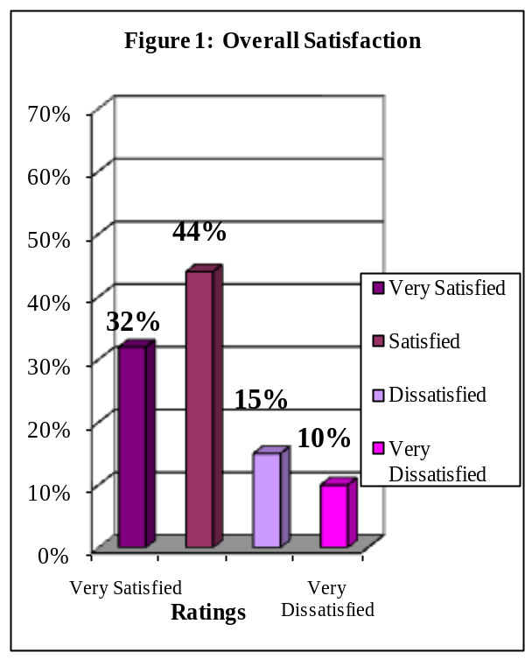

Overall Academic Experience
The findings in Figure 2 indicate that 68% of graduating respondents reported a positive overall academic experience at FIU: 38% rated their academic experience as excellent while 30% rated their academic experience as good. Thirty-two percent of respondents reported that their academic experience at FIU was negative: 20% rated their academic experience as fair and 12% rated their academic experience as poor.

Correlations: To the extent that graduating respondents rated their overall academic experience highly they also agreed their classes were too large (r = .69, p < .001), agreed they felt challenged (r = .66, p < .001), were satisfied with the opportunity of attaining a graduate student assistantship (r = .63, p < .001). Were satisfied with fairness of grading in program (r = .58 p < .001).

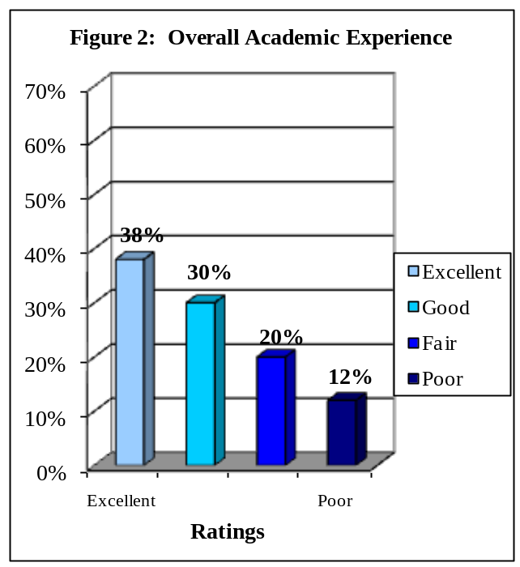

Challenged to Do Their Best
The findings depicted in Figure 3 indicate that 75% of graduating respondents reported that they were challenged to do their best at FIU: 55% reported that they were challenged to do their best most of the time and an additional 20% reported that they were challenged sometimes. Twenty-five percent of respondents reported that they were not challenged to do their best at FIU: 19% reported that they were seldom challenged and another 6% reported that they had never been challenged at FIU.

Correlations: To the extent that graduating respondents agreed they were challenged to do their best at FIU, rated highly their satisfaction with their program on meeting its goals and objectives (r= .68, p < .001), agreed they would recommend FIU, (r = .66, p < .001), agreed faculty were available to assist in research (r = .64, p < .001) and rated their academic experience highly (r = .61, p < .001).
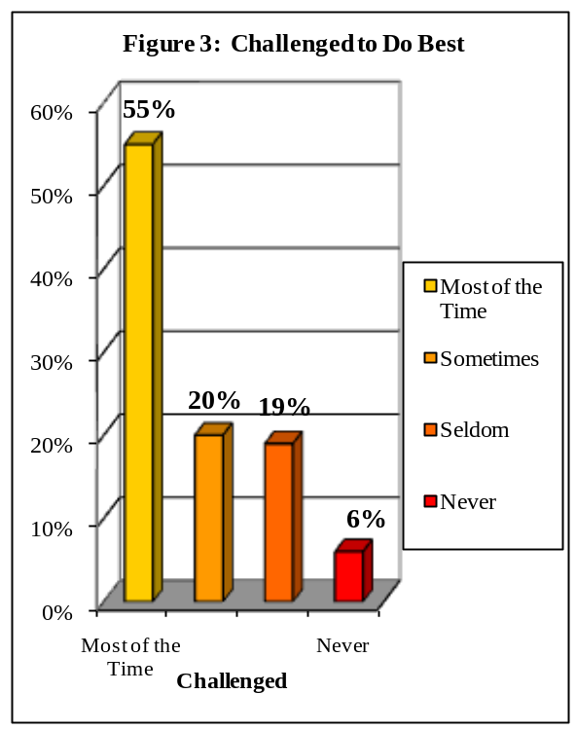

The findings depicted in Figure 4 indicate that 77% of respondents would recommend their graduate program to a friend or relative considering graduate school: 36% would recommend FIU without reservations and 41% would recommend FIU with reservations. Twenty-three percent of respondents reported that they would not recommend their graduate program. Approximately 16% of respondents reported that they probably would not recommend their graduate program and 7% reported that they would not recommend FIU under any circumstances.

Correlations: To the extent that graduating respondents agreed they would recommend their graduate program to others, they were also satisfied with how their department met its goals and objectives (r = .81, p < .001), they were satisfied overall with their graduate program (r = .74, p < .001), rated highly their academic experience (r = .73, p < .001), and agreed faculty were available to assist in research (r = .68, p < .001),.
Recommend Graduate Program to Others

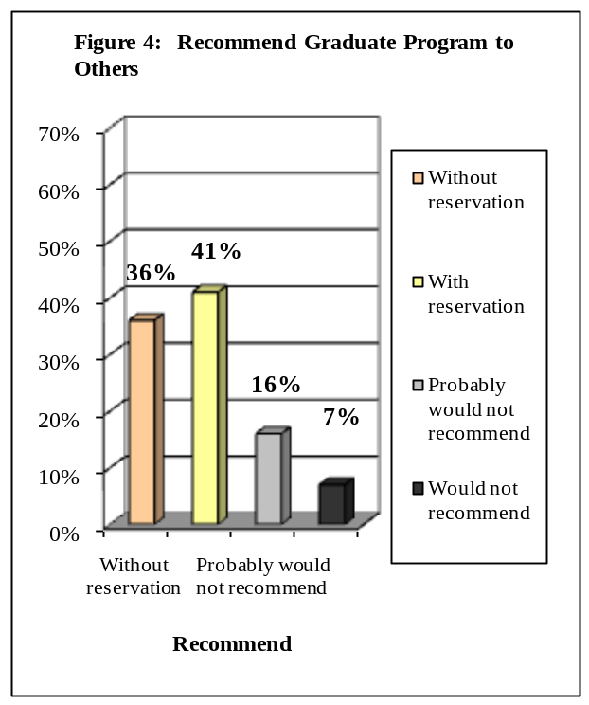

Satisfaction with Department of Major
The findings in Figure 5 indicate that 65% of graduating respondents were satisfied with the department of their major at FIU: 23% of respondents strongly agreed that they were satisfied and 42% agreed. Twenty-seven percent of respondents were not satisfied with the department of their major at FIU: 20% of respondents disagreed that they were satisfied and 7% strongly disagreed. Another 7% of respondents were not sure whether they agreed or disagreed.

Correlations: To the extent that graduating respondents rated highly their satisfaction with their major, they also rated highly their academic experience (r = .87, p < .001), agreed they would recommend FIU to a friend or relative (r = .81, p < .001), agreed they were overall satisfied with their graduate program (r = .78, p < .001) and rated the quality of courses highly (r=.77, p <.001).

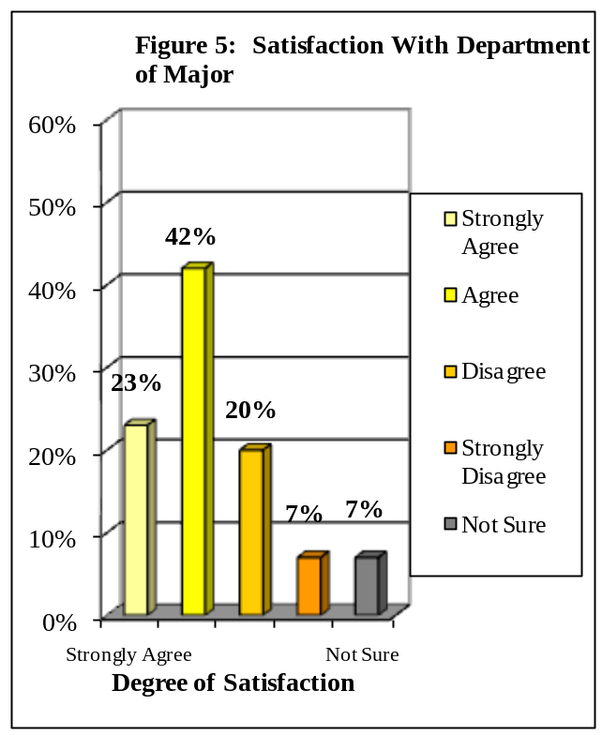

Professors Were Good Teachers
The findings in Figure 6 indicate that 68% of graduating respondents at FIU believed that the professors in their graduate program were good teachers: 32% strongly agreed and another 36% agreed. Sixteen percent of respondents at FIU believed that the professors in their major were not good teachers: 13% of respondents disagreed and 3% strongly disagreed. Sixteen percent of respondents were not sure whether they agreed or disagreed.

Correlations: To the extent that graduating respondents agreed professors were good teachers, they also rated highly the quality of instruction in their program (r = .77, p < .001), were satisfied with their academic experience (r = .76, p < .001), agreed they had the opportunity to interact with faculty in their program (r = .73, p < .001) and agreed faculty were available to assist with research (r=.69, p<.001)

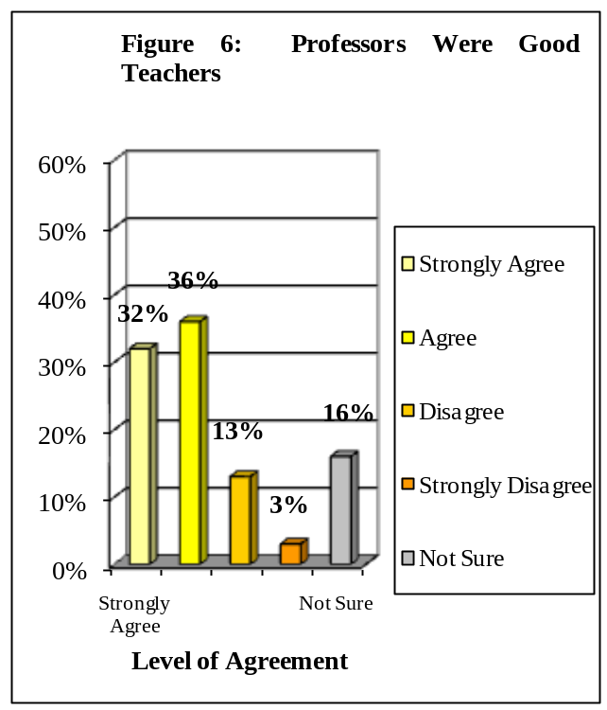

Availability of Research Facilities in Graduate Program
The findings in Figure 7 indicate that 62% of graduating respondents rated highly the availability of research facilities in their graduate program: 26% rated the availability as excellent and an additional 36% rated the availability as good. Thirty-eight percent of respondents assigned low ratings to the availability of research facilities in their graduate program: 23% rated the availability as fair and 15% rated the availability as poor.

Correlations: To the extent that graduating respondents were satisfied with the availability of research facilities in their program, they were also satisfied with the quality of research in their program (r = .82, p < .001), were satisfied with the coursework availability in my program (r = .67, p < .001), were satisfied with how their major department met its goals and objectives (r = .65, p < .001), and rated highly their academic experience (r = .64, p < .001).
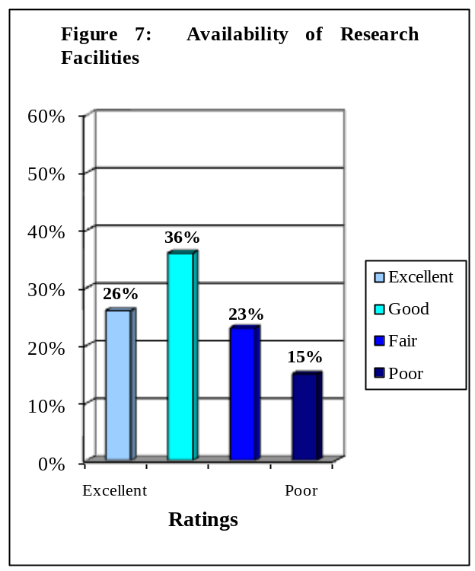

Professors Were Good Researchers
The findings in Figure 8 indicate that 71% of graduating respondents agreed that the professors in their graduate program were good researchers: 33% strongly agreed and another 38% agreed.
Seven percent of respondents disagreed that their professors were good researchers: 7% disagreed, while 0% strongly disagreed. Another 22% of respondents were not sure if the professors in their graduate program were good researchers.

Correlations: To the extent that the graduating respondents agreed the faculty were good researchers, were satisfied with the availability for faculty to assist with their research (r = .61, p < .001), were satisfied with the quality of research (r = .60, p < .001), agreed computer training prepared them for today’s technology (r = .57, p < .001), and were satisfied with their department met its goals and objectives (r = .56, p < .001).
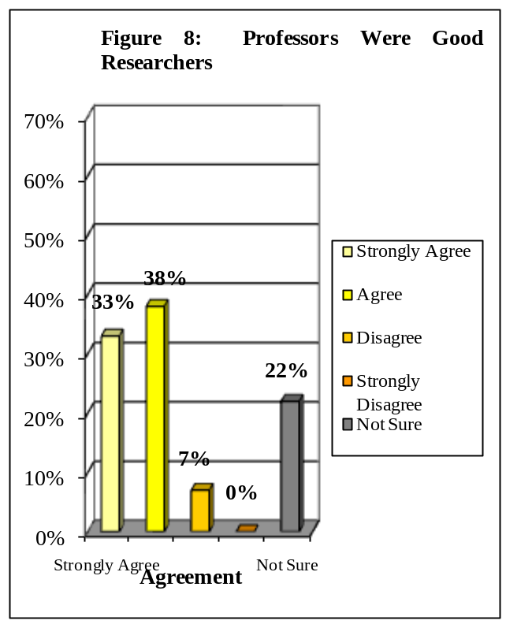

Research Quality in Graduate Program

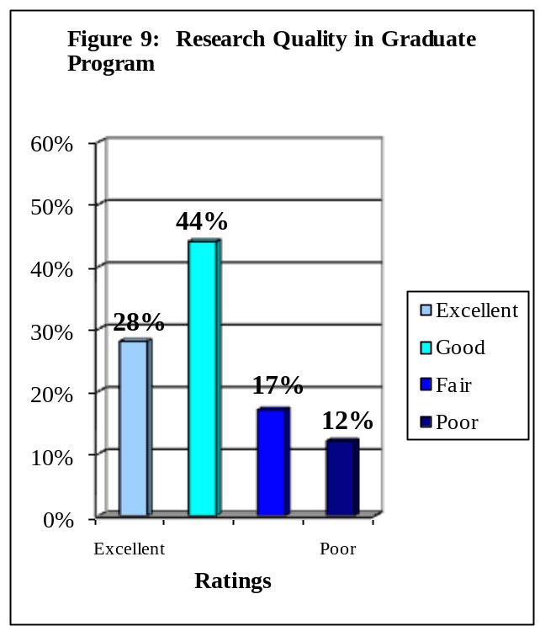
The findings in Figure 9 indicate that 71% of graduating respondents rated highly the research quality in their graduate program: 28% rated the quality as excellent, with another 44% giving the research quality a rating of good. Twenty-nine percent of respondents rated negatively the research quality in their graduate program: 17% rated the quality as fair and 12% rated the research quality as poor.

Correlations: To the extent that the graduating respondents rated highly the quality of research in their program, they were also satisfied with the availability of research facilities, (r = .82, p < .001), were satisfied with how well their major met its goals and objectives (r = .67, p < .001), were satisfied with their academic experience (r = .65, p < .001), and were satisfied with the availability of their coursework. (r = .61, p < .001).

Faculty Availability to Collaborate On Graduate Student Research

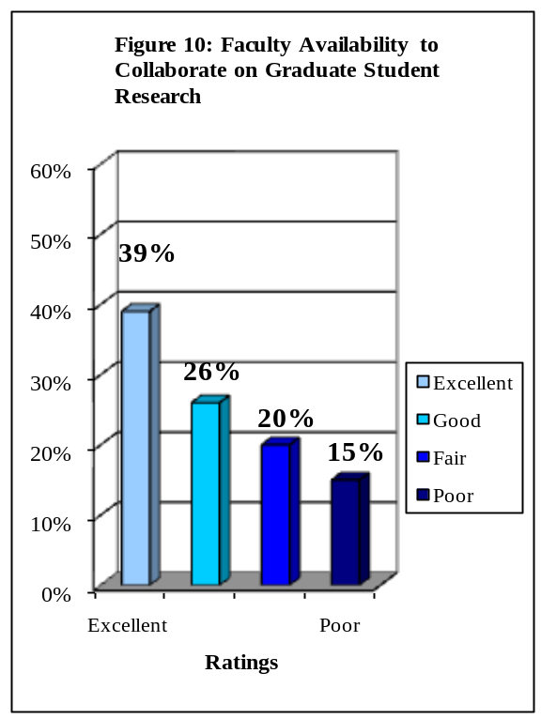
The findings in Figure 10 indicate that 65% of graduating respondents rated positively faculty availability to collaborate on graduate student research: 39% rated faculty availability as excellent and 26% rated faculty availability as good. Thirty-five percent of respondents rated negatively faculty availability to collaborate on graduate student research: 20% rated faculty availability as fair and 15% assigned a rating of poor.

Correlations: To the extent that the graduating respondents rated highly faculty availability to collaborate on research, they were also satisfied with the opportunity to interact with faculty in their program, (r = .85, p < .001), were satisfied with their academic experience (r = .84, p < .001), were satisfied with how their department met its goals and objectives (r = .76, p < .001), and were satisfied with the quality of instruction (r = .74, p < .001).

IV. SIX-YEAR COMPARISON OF TEN PRINCIPAL INDICATORS OF THE GRADUATING MASTERS AND DOCTORAL STUDENTS’ SATISFACTION WITH FIU

Florida International University began surveying its graduating students in the Spring of 2001. The survey for the Summer semester of 2008 through the Spring semester of 2009 is the eighth data collection of this graduating survey.

In this section of the report, the focus is on the survey items that have been established as the ten principal indicators of the graduating students’ satisfaction with the university. Responses to these items have been divided into the categories of positive and negative responses.

Please note that responses may not add up to 100%; some respondents did not answer every question.

Overall Satisfaction with Graduate Program at FIU

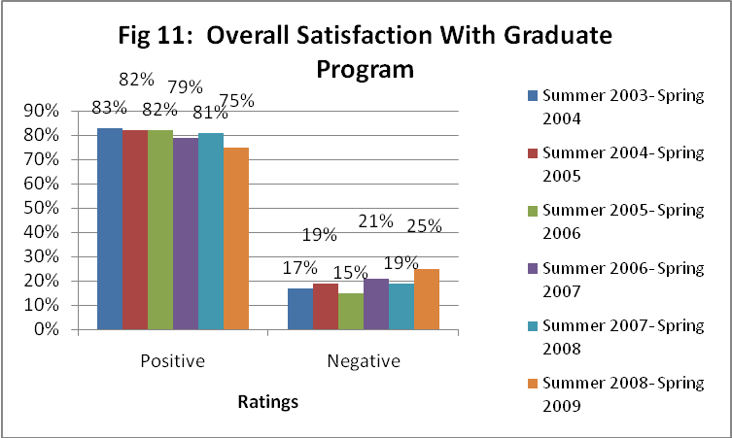

Graduating respondents at FIU reported increasing levels of overall satisfaction with their graduate program at FIU from 2003 to 2009 and a decline in overall satisfaction in 2003and 2006. Respondents who reported that they were ‘Very Satisfied’ (27%, 28%, 27%, 28% and 32% respectively) or ‘Satisfied’ (56%, 60%, 52%, 53% and 44 % respectively) ranged from 75-83% for the six-year period. Respondents who reported that they were ‘Dissatisfied’ (15%, 10%, 17%, 15% and 15% respectively) or ‘Very Dissatisfied’ (2%, 2%, 1%, 4%, 4% and 10% respectively) ranged from 15-25% for the six-year period.

Overall Academic Experience

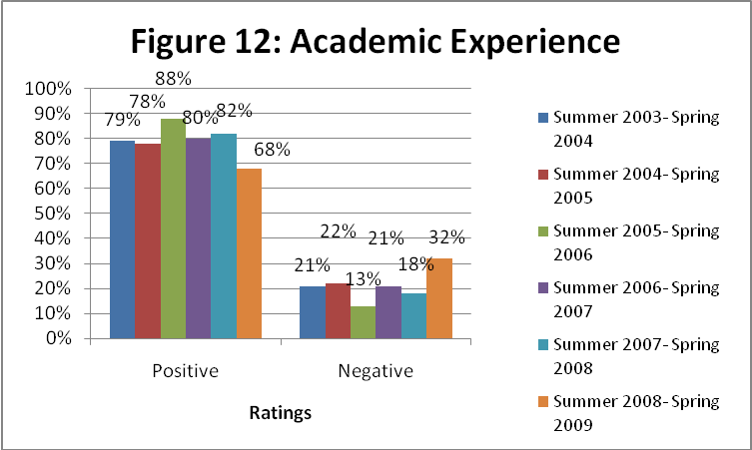

Graduating respondents at FIU reported varying levels of positive ratings toward their overall academic experience at FIU from 2003 to 2009. Respondents who reported ‘Excellent’ (31%, 29%, 44%, 35%, 35% and 38% respectively) or ‘Good’ (48%, 49%, 43%, 45%, 47% and 30% respectively) ratings ranged from 68-88% for the six-year period. Respondents who reported ‘Fair’ (16%, 14%, 9% 17%, 9% and 20% respectively) or ‘Poor’ (3%, 5%, 8% 4%, 9% and 12% respectively) ratings ranged from 13-32% for the six-year period.

Challenged to Do Their Best

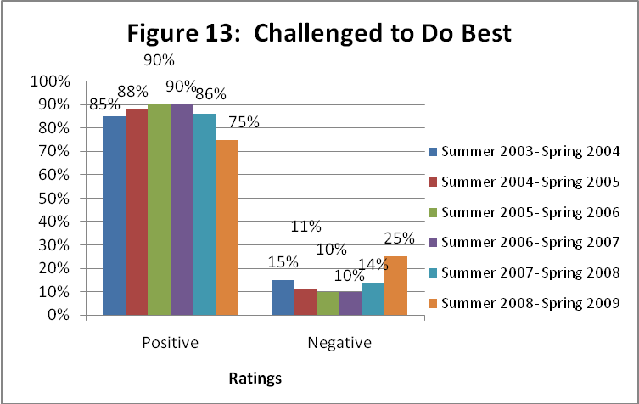

Graduating respondents at FIU reported that they were challenged to do their best at FIU at varying levels from 2003 to 2009. Respondents who reported that they are challenged ‘Most of the time’ (53%, 54%, 57%, 59%, 63% and 55 % respectively) or “Sometimes’ (32%, 34%, 33%, 35%, 23% and 20% respectively) ranged from 75-90% for the six-year period. Respondents who reported that they were challenged ‘Seldom’ (11%, 9%, 10%, 4%, 14% and 19% respectively) or ‘Never’ (4%, 2%, 10%, 2%, 0% and 6% respectively) ranged from 10-25% for the six-year period.

Recommend Graduate Program to a Friend or Relative

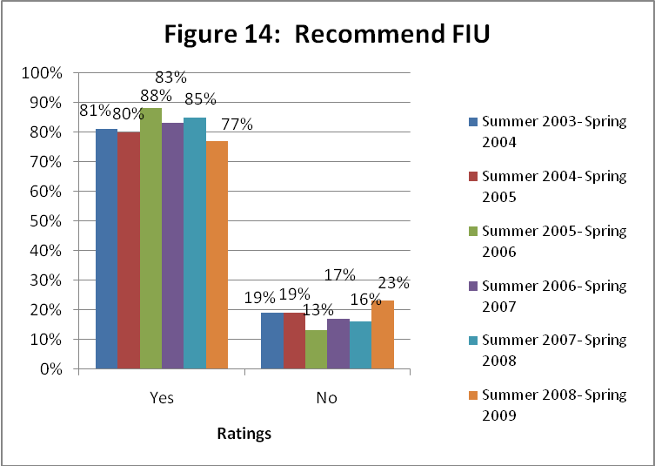

Graduating respondents at FIU have reported that they would recommend FIU to a friend or relative considering their graduate program at varying levels from 2003 to 2009. Respondents who reported that they would ‘recommend FIU without reservations’ (41%, 38%, 48%,36% 43% and 36% respectively) or would ‘recommend with reservations’ (40%, 42%, 40%, 47%, 42% and 41% respectively) ranged from 77-88% for the six-year period. Respondents who reported that they would ‘probably not recommend FIU’ (15%, 13%, 10%, 13%, 13% and 16% respectively) or ‘definitely would not recommend FIU’ (4%, 6%, 2%, 4%, 3% and 7%
respectively) ranged from 13-23% for the six-year period.

Satisfaction with Department of Major

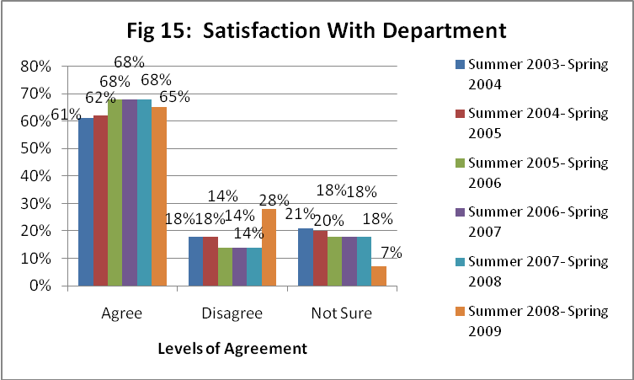

Graduating respondents at FIU reported varying levels of satisfaction with the department of their major at FIU from 2003 to 2009. Respondents who ‘Strongly Agreed’ (17% ,18%, 26%, 23%, 19% and 23% respectively) or ‘Agreed’ (44%, 44%, 42%,40% 40% and 42 % respectively) that they were satisfied with the department of their major ranged from 61-68% for the six-year period. Respondents who ‘Disagreed’ (14%, 9%, 11%, 11% 5% and 20% respectively) or ‘Strongly Disagreed’ (4%, 9%, 12%,6%, 12% and 7% respectively) ranged from 14-28% for the
six-year period. Respondents who made a response of ‘Not Sure’ ranged from 7-20% for the six-year period.

Professors Were Good Teachers

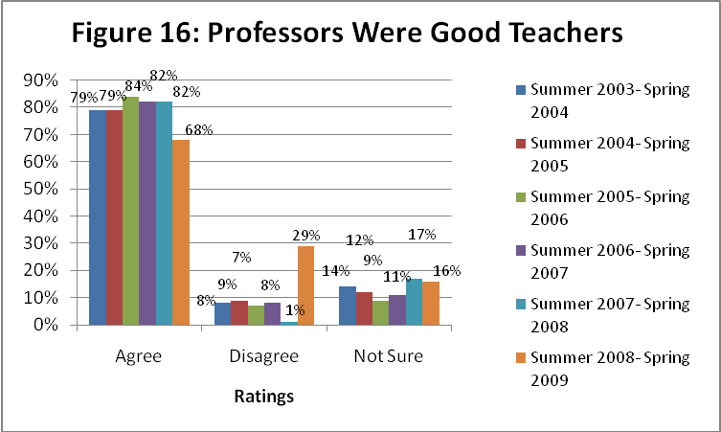

Graduating respondents at FIU reported varying levels of agreement with the statement “My professors were good teachers” from 2003 to 2009. Respondents who ‘Strongly Agreed’ (31%, 33%, 43%,42%, 36% and 32% respectively) or ‘Agreed’ (48%, 46%, 41%, 40%, 46% and 36% respectively) that their professors were good teachers and ranged from 68-84% for the six-year period. Respondents who ‘Disagreed’ (5%, 6%, 9%, 6%, 0% and 13% respectively) or ‘Strongly Disagreed’ (4%, 2%, 5%, 2%, 1% and 13% respectively) ranged from 1-29% for the six-year period. Respondents who made a response of ‘Not Sure’ ranged from 9-16% for the six-year period.

Availability of Research Facilities in Graduate Program

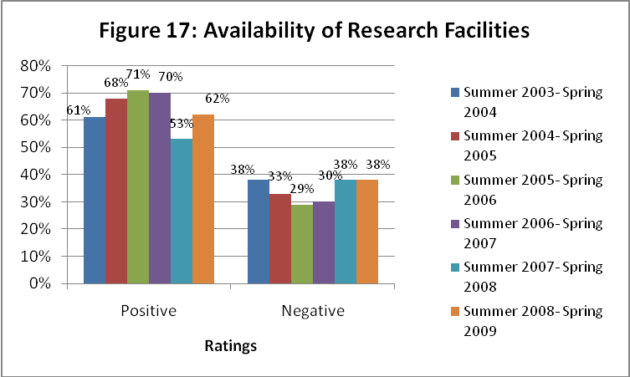

Graduating respondents at FIU reported varying levels of positive ratings toward the availability of research facilities in their graduate program from 2003 to 2009. Respondents who reported ‘Excellent’ (22%, 42%, 16%, 29%, 20% and 26% respectively) or ‘Good’ (46%, 33%, 55%, 41%, 43% and 36% respectively) ratings increased from 61-71% for the six-year period. Respondents who reported ‘Fair’ (22%, 18%, 22%, 18%, 32% and 23% respectively) or ‘Poor’
(11%, 7%, 7%, 12% 5% and 15% respectively) ratings ranged from 29-38% for the six-year period.

Professors in Graduate Program Were Good Researchers
*Please note that this question was added to the Graduating Master’s and Doctoral Student Survey in 2000.

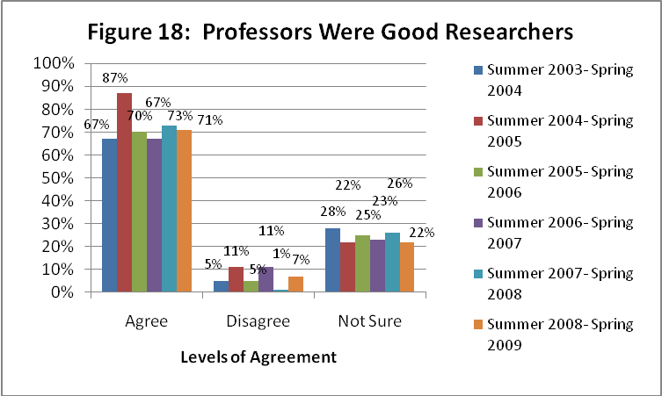

Graduating respondents at FIU reported fluctuating levels of agreement with the statement “My professors were good researchers” from 2003 to 2009. Respondents who ‘Strongly Agreed’ (23%, 32%, 33% 33% and 33 % respectively) or ‘Agreed’ (40%, 38%, 34% 40% and 38% respectively) that their professors were good teachers ranged from 67%-87% for the six-year period. Respondents who ‘Disagreed’ (3%, 3%, 2%, 6% 0% and 7%respectively) or ‘Strongly Disagreed’ (2%, 4%, 2%, 5% 1% and 0% respectively) ranged from 1-11% for the six-year period. Respondents who made a response of ‘Not Sure’ ranged from 22-28% for the six-year period.

Research Quality in Graduate Program
*Please note that this question was added to the Graduating Master’s and Doctoral Student Survey in 2000.

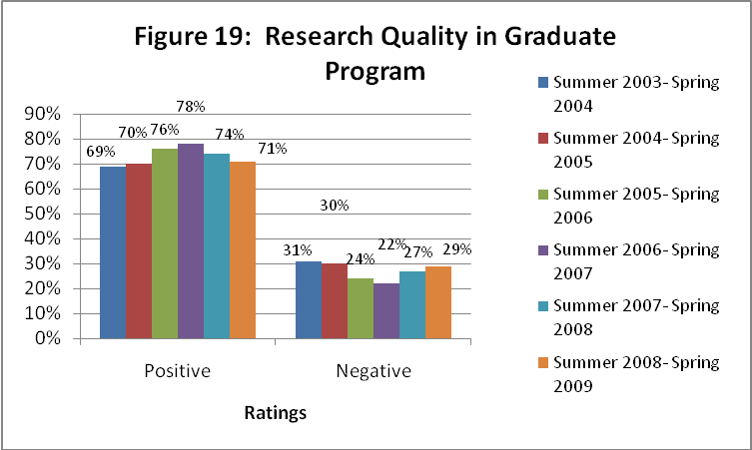

Graduating respondents at FIU reported stable levels of positive ratings toward the research quality in their graduate program from 2003 to 2009. Respondents who reported ‘Excellent’ (15%, 26%, 23%, 30%, 19% and 28% respectively) or ‘Good’ (54%, 44%, 53%, 48%, 55% and 44% respectively) ratings ranged from 69-78% for the six-year period. Respondents who reported ‘Fair’ (20%, 20%, 19%, 14% 24% and 17% respectively) or ‘Poor’ (11%, 10%, 4%, 8%, 3% and 12% respectively) ratings ranged from 22-31% for the six-year period.

Faculty Availability to Assist Graduate Student Research
*Please note that this question was added to the Graduating Master’s and Doctoral Student Survey in 2000.

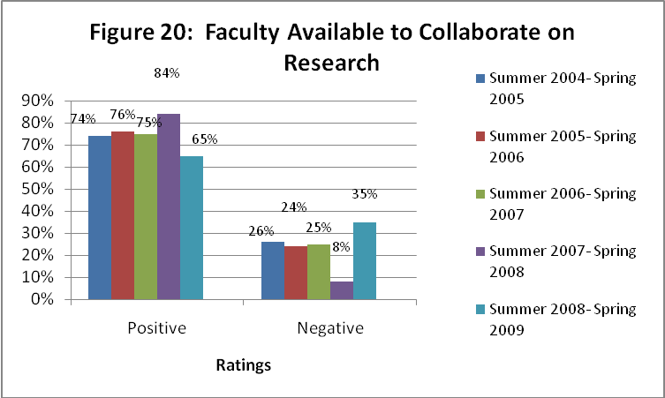

Graduating respondents at FIU reported increasing levels of positive ratings toward the availability of faculty in their graduate program to collaborate on graduate student research from 2003 to 2009. Respondents who reported ‘Excellent’ (38%, 33%, 42%, 38% and 39% respectively) or Good’ (35%, 41%, 33%, 46% and 26% respectively) ratings ranged from 65-84% for the five-year period. Respondents who reported ‘Fair’ (17%, 15%, 18%, 4% and 20% respectively) or ‘Poor’ (10%, 15%, 7%, 4% and 15% respectively) ratings ranged from 8-27% for the five-year period.

Conclusions

When looking at data over time, it is helpful to keep several issues in mind. When ratings are consistent over a time period, it is usually an indication that those ratings are a true measure of the item -- that is the measure is reliable. However, when ratings are not consistent over time it is possible to draw multiple conclusions. One conclusion would be that the ratings are inconsistent because of flaws in the representativeness of the sample over the time period. A second conclusion would be that there have been true fluctuations in the graduating respondents’ experiences over the time period. Typically, it is necessary to have data over a five to ten-year period in order to assess a trend. The data for the six-year period of this survey has been stable.

Positive ratings showed a mostly increasing trend for availability of research facilities.

Positive ratings were stable for professors being good researchers and satisfaction with department.

Positive ratings fluctuated over the six-year period for overall satisfaction with graduate program at FIU.

Positive ratings showed a mostly decreasing trend in reporting the satisfaction with faculty availability to collaborate with research, challenged to do best and professors were good teachers, availability of research facilities.

VII. CONCLUSIONS FROM THE 2008-2009 GRADUATING MASTERS AND DOCTORAL STUDENT SURVEY

Once again it is determined that the sample of graduating respondents is not representative of the graduating Master’s and Doctoral student population. Response rates remain low, maintaning a stable three percent to an overall response rate of three percent for this time period (Summer 2008 – Spring 2009). The College of Law had the highest response rate with 7% respectively, followed by the College of Arts and Sciences, Stempel School of Public Health and School of Journalism and Mass Communications with 5% respectively followed by School of Engineering and Computer Sciences, College of Architecture and the Arts. The College of Nursing and Health Sciences, College of Education, College of Business and Hospitality Management had the lowest response rates ranging from 1%-0%.

Positive responses to the ten principal indicators of student satisfaction varied somewhat compared to the responses from students who graduated in Summer 2007-Spring 2008. Positive ratings showed a mostly increasing trend for availability of research facilities. Positive ratings were stable for professors being good researchers and satisfaction with department. Positive ratings fluctuated over the six-year period for overall satisfaction with graduate program at FIU. Positive ratings showed a mostly decreasing trend in reporting the satisfaction with faculty availability to collaborate with research, challenged to do best and professors were good teachers, availability of research facilities.

Although response rates to the survey continue to be low, it is important to note that the overall number of responses from students has increased from a total of 56 respondents in 1999 to the current total of 70. Currently, the survey administrator is utilizing the FIU email address to notify the student that the survey is available. A greater effort needs to be made by the Administration, the Deans, and faculty members to get the students to activate and use the university email account (or at least forward mail in this account to another preferred account). Online surveys are very cost-effective and will continue to be utilized for the foreseeable future. A team effort by the Office of Planning and Institutional Research along with the Deans and Chairpersons will improve the response rates of the students.

APPENDIX A: GRADUATING MASTERS AND DOCTORAL STUDENT SURVEY

APPENDIX A
Graduating Master’s and Doctoral
Student Survey
Summer 2008– Summer 2009

A. Please indicate your graduate program college or school. |  | % |  |  |  | %
College of Architecture and the Arts |  | 2.9% |  | College of Nursing and Health Sciences |  | 4.3%
College of Arts & Sciences |  | 15.9% |  | School of Journalism & Mass Communication |  | 2.9%
College of Business Administration |  | 14.5% |  | College of Law |  | 13.0%
College of Education |  | 5.8%
College of Engineering and Computing |  | 17.4% |  | Stempel School of Public Health |  | 10.1%
B. What is the name of your program |  | # |  |  |  | #
Civil & Environmental Engineering |  | 1 |  | International Studies |  | 1
Biological Sciences |  | 1 |  | Juris Doctor |  | 3
Biomedical Engineering |  | 1 |  | Legal Psychology |  | 1
Comparative Sociology |  | 1 |  | Linguistics |  | 1
Computer engineering |  | 1 |  | Master in public health |  | 1
Construction Management |  | 2 |  | Masters in Accounting |  | 1
Criminal Justice / Public Administration Specialization |  | 4 |  | Master's in Chemistry |  | 1
Curriculum & Instruction |  | 1 |  | Master's in Physics |  | 1
Electrical Engineering |  | 2 |  | Masters in Public Health |  | 1
Environmental Studies |  | 1 |  | Master's in Social Work |  | 5
Epidemiology |  | 1 |  | Masters of Art in Teaching |  | 1
Evening MBA |  | 1 |  | Masters of Science in Telecommunications and Networking |  | 1
Exercise physiology |  | 2 |  | MSF & MBA |  | 1
Health Promotion and Disease Prevention |  | 3 |  | MSME |  | 1
IMBA |  | 2 |  | MSN. Adult track |  | 1
International MBA |  | 2 |  | Public Health Specializing in Biostatistics |  | 1
International Relations and Geography |  | 1 |  | Speech and Language Pathology |  | 2
C. Please indicate your graduate degree level. |  | % |  |  |  | %
M.A. |  | 14.3% |  | MPH |  | 5.7%
M.S. |  | 38.6% |  | MSW |  | 4.3%
M.B.A. |  | 10.0% |  | Other |  | 7.1%
Doctorate or Professional degree (Ph. D., Ed. D., J.D., etc.) |  | 20.0%
D. In general, how satisfied are you overall with your graduate program? |  | % |  | Quality of research in my program |  | %
Very Satisfied |  | 31.9% |  | Excellent |  | 27.5%
Satisfied |  | 43.5% |  | Good |  | 43.5%
Dissatisfied |  | 14.5% |  | Fair |  | 17.4%
Very Dissatisfied |  | 10.1% |  | Poor |  | 11.6%
Size of school |  | % |  | E. How did you rank your major program at the time you applied for graduate school admission at FIU? |  | %
Very Important |  | 15.9% |  | Top or one of the top available programs |  | 13.0%
Somewhat Important |  | 30.4% |  | An excellent program at FIU |  | 29.0%
Not Important |  | 53.6% |  | A good overall program at FIU |  | 40.6%
 |  |  |  | The FIU program appeared to be fairly good |  | 17.4%
Cost of education |  | % |  | Quality of instruction in my program |  | %
Very Important |  | 73.9% |  | Excellent |  | 31.9%
Somewhat Important |  | 20.3% |  | Good |  | 42.0%
Not Important |  | 5.8% |  | Fair |  | 14.5%
 |  |  |  | Poor |  | 11.6%
Type of program available |  | % |  | Coursework availability for my program |  | %
Very Important |  | 81.2% |  | Excellent |  | 24.6%
Somewhat Important |  | 15.9% |  | Good |  | 33.3%
Not Important |  | 2.9% |  | Fair |  | 27.5%
 |  |  |  | Poor |  | 14.5%
Reputation of program |  | % |  | Opportunity to interact with faculty in my program |  | %
Very Important |  | 53.6% |  | Excellent |  | 42.0%
Somewhat Important |  | 37.7% |  | Good |  | 30.4%
Not Important |  | 8.7% |  | Fair |  | 20.3%
 |  |  |  | Poor |  | 7.2%
Location of school |  | % |  | Availability of faculty to assist with my research |  | %
Very Important |  | 62.3% |  | Excellent |  | 39.1%
Somewhat Important |  | 24.6% |  | Good |  | 26.1%
Not Important |  | 13.0% |  | Fair |  | 20.3%
 |  |  |  | Poor |  | 14.5%
High admissions standards |  | % |  | Opportunity for graduate teaching assistantships |  | %
Very Important |  | 21.4% |  | Excellent |  | 17.6%
Somewhat Important |  | 54.3% |  | Good |  | 39.7%
Not Important |  | 24.3% |  | Fair |  | 17.6%
 |  |  |  | Poor |  | 25.0%
Academic reputation |  | % |  | Opportunity for graduate research assistantships |  | %
Very Important |  | 56.5% |  | Excellent |  | 5.9%
Somewhat Important |  | 37.7% |  | Good |  | 42.6%
Not Important |  | 5.8% |  | Fair |  | 23.5%
 |  |  |  | Poor |  | 27.9%
Scholarship availability |  | % |  | Preparation given to graduate students for teaching |  | %
Very Important |  | 47.8% |  | Excellent |  | 10.4%
Somewhat Important |  | 21.7% |  | Good |  | 28.4%
Not Important |  | 30.4% |  | Fair |  | 28.4%
 |  |  |  | Poor |  | 32.8%
Assistantship availability |  | % |  | Opportunities for applied experience |  | %
Very Important |  | 39.7% |  | Excellent |  | 27.5%
Somewhat Important |  | 22.1% |  | Good |  | 20.3%
Not Important |  | 38.2% |  | Fair |  | 30.4%
 |  |  |  | Poor |  | 21.7%
Research facilities available in my program |  | %
Excellent |  | 26.1%
Good |  | 36.2%
Fair |  | 23.2%
Poor |  | 14.5%
H. When you reflect upon your time during your current graduate program, have you been challenged to do the very best you could? |  | % |  | I. Would you recommend FIU to a friend or relative considering your graduate program? |  | %
Most of the time |  | 55.1% |  | Yes, without reservations |  | 36.2%
Sometimes |  | 20.3% |  | Yes, with reservations |  | 40.6%
Seldom |  | 18.8% |  | No, probably not |  | 15.9%
Never |  | 5.8% |  | No, under no circumstances |  | 7.2%
Your graduate academic experience |  | % |  | The courses I needed were available |  | %
Excellent |  | 37.7% |  | Strongly Agree |  | 18.8%
Good |  | 30.4% |  | Agree |  | 36.2%
Fair |  | 20.3% |  | Neutral |  | 18.8%
Poor |  | 11.6% |  | Disagree |  | 21.7%
 |  |  |  | Strongly Disagree |  | 4.3%
Safety measures on campus |  | % |  | There were a good range of courses |  | %
Excellent |  | 36.8% |  | Strongly Agree |  | 11.8%
Good |  | 35.3% |  | Agree |  | 26.5%
Fair |  | 20.6% |  | Neutral |  | 27.9%
Poor |  | 7.4% |  | Disagree |  | 25.0%
 |  |  |  | Strongly Disagree |  | 8.8%
Responsiveness of the administration to graduate student academic problems |  | % |  | I was provided opportunities to develop appropriate computer skills |  | %
Excellent |  | 27.5% |  | Strongly Agree |  | 15.9%
Good |  | 30.4% |  | Agree |  | 36.2%
Fair |  | 17.4% |  | Neutral |  | 23.2%
Poor |  | 24.6% |  | Disagree |  | 14.5%
 |  |  |  | Strongly Disagree |  | 10.1%
Responsiveness of the support services to graduate student needs |  | % |  | The quality of courses prepared me for employment |  | %
Excellent |  | 27.5% |  | Strongly Agree |  | 22.1%
Good |  | 29.0% |  | Agree |  | 27.9%
Fair |  | 18.8% |  | Neutral |  | 23.5%
Poor |  | 24.6% |  | Disagree |  | 13.2%
 |  |  |  | Strongly Disagree |  | 13.2%
Responsiveness of the financial aid office to graduate student needs |  | % |  | I was satisfied with the fairness of grading in my courses |  | %
Excellent |  | 21.9% |  | Strongly Agree |  | 26.1%
Good |  | 29.7% |  | Agree |  | 40.6%
Fair |  | 31.3% |  | Neutral |  | 20.3%
Poor |  | 17.2% |  | Disagree |  | 4.3%
 |  |  |  | Strongly Disagree |  | 8.7%
The faculty were good teachers |  | % |  | My computer training prepared me for today's technology |  | %
Strongly Agree |  | 31.9% |  | Strongly Agree |  | 18.8%
Agree |  | 36.2% |  | Agree |  | 23.2%
Neutral |  | 15.9% |  | Neutral |  | 34.8%
Disagree |  | 13.0% |  | Disagree |  | 13.0%
Strongly Disagree |  | 2.9% |  | Strongly Disagree |  | 10.1%
The faculty were good researchers |  | % |  | I am satisfied with how well my major department has met its goals and objectives |  | %
Strongly Agree |  | 33.3% |  | Strongly Agree |  | 23.2%
Agree |  | 37.7% |  | Agree |  | 42.0%
Neutral |  | 21.7% |  | Neutral |  | 7.2%
Disagree |  | 7.2% |  | Disagree |  | 20.3%
Strongly Disagree |  | 0.0% |  | Strongly Disagree |  | 7.2%
My classes were too large |  | % |  | Courses in other departments required by my program were available to me |  | %
Strongly Agree |  | 7.2% |  | Strongly Agree |  | 8.7%
Agree |  | 18.8% |  | Agree |  | 24.6%
Neutral |  | 21.7% |  | Neutral |  | 49.3%
Disagree |  | 33.3% |  | Disagree |  | 11.6%
Strongly Disagree |  | 18.8% |  | Strongly Disagree |  | 5.8%
L. If you engage in further formal study, what is the highest degree you eventually expect to earn? |  | % |  | M. Please indicate how many hours you were typically employed while attending graduate school. |  | %
Doctoral Degree |  | 37.8% |  | On-campus: 1-10 hours |  | 8.8%
J.D. |  | 3.7% |  | 11-20 hours |  | 25.0%
L.L.M. |  | 4.9% |  | 21-34 hours |  | 7.4%
MBA |  | 2.4% |  | 35 or more |  | 7.4%
MS |  | 1.2% |  | Not Applicable |  | 51.5%
None |  | 31.7%
Other |  | 17.1% |  | Off-campus: |  | %
Specialist |  | 1.2% |  | 1-10 hours |  | 7.8%
 |  |  |  | 11-20 hours |  | 10.9%
 |  |  |  | 21-34 hours |  | 3.1%
 |  |  |  | 35 or more |  | 34.4%
 |  |  |  | Not Applicable |  | 43.8%
N. Please indicate the name of the institution from which you received your most recent degree and the year it was received. |  | # |  |  |  | #
Anna University |  | 1 |  | Politechnical Superios Institute Jose Antonio Echevarria |  | 1
Arizona State University |  | 1 |  | Rajiv Gandhi IOT, Mumbai, India. |  | 1
University of Florida |  | 1 |  | SRTIST |  | 1
Colorado State University |  | 1 |  | St. Joseph's University |  | 1
CUNY Brooklyn College |  | 1 |  | Tribhuvan University, Nepal |  | 1
Florida Atlantic University |  | 2 |  | UF |  | 1
Florida International University |  | 23 |  | University of the Sacred Heart |  | 1
Florida State University |  | 5 |  | University of Costa Rica |  | 1
Gadjah Mada University, Indonesia |  | 1 |  | University of Florida |  | 1
Heichal Menachem |  | 1 |  | University of Guelph |  | 1
Oakland University |  | 1 |  | University of Miami |  | 4
Ohio State University |  | 1 |  | University of New Hampshire |  | 1
Osmania |  | 1 |  | University of Phoenix |  | 1
Other |  | 43
Letter of recommendation |  | % |  | Advice about personal decisions |  | %
Yes |  | 81.2% |  | Yes |  | 52.2%
No |  | 18.8% |  | No |  | 47.8%
Advice about professional decisions |  | %
Yes |  | 79.7%
No |  | 20.3%
In general my advisor was helpful |  | % |  | The advice I received was useful for my career goals |  | %
Strongly Agree |  | 40.3% |  | Strongly Agree |  | 38.7%
Agree |  | 27.4% |  | Agree |  | 21.0%
Neutral |  | 16.1% |  | Neutral |  | 14.5%
Disagree |  | 6.5% |  | Disagree |  | 12.9%
Strongly Disagree |  | 9.7% |  | Strongly Disagree |  | 12.9%
My advisor was available when needed |  | % |  | The advice I received was useful for my educational goals |  | %
Strongly Agree |  | 41.3% |  | Strongly Agree |  | 43.5%
Agree |  | 20.6% |  | Agree |  | 19.4%
Neutral |  | 20.6% |  | Neutral |  | 17.7%
Disagree |  | 9.5% |  | Disagree |  | 8.1%
Strongly Disagree |  | 7.9% |  | Strongly Disagree |  | 11.3%
Sufficient time was available during advising sessions |  | % |  | The advice I received was useful for my research goals |  | %
Strongly Agree |  | 39.7% |  | Strongly Agree |  | 39.3%
Agree |  | 23.8% |  | Agree |  | 18.0%
Neutral |  | 15.9% |  | Neutral |  | 21.3%
Disagree |  | 14.3% |  | Disagree |  | 8.2%
Strongly Disagree |  | 6.3% |  | Strongly Disagree |  | 13.1%
Q. What is your overall graduate grade point average? |  | % |  | R. Please indicate your age category. |  | %
3.00-3.29 |  | 6.3% |  | Less than 24 |  | 15.4%
3.30-3.49 |  | 12.5% |  | 24-29 |  | 46.2%
3.50-3.60 |  | 23.4% |  | 30-39 |  | 21.5%
over 3.60 |  | 57.8% |  | 40-49 |  | 13.8%
 |  |  |  | 50 or older |  | 3.1%
S. About how far do you live from FIU? |  | % |  | T. Please indicate your gender. |  | %
I live on campus (BB or UP) |  | 6.0% |  | Female |  | 50.8%
I live near the campus (one mile) |  | 13.4% |  | Male |  | 49.2%
I live 1-10 miles from the campus |  | 28.4%
I live 11-25 miles from the campus |  | 37.3%
I live more than 25 miles from the campus |  | 14.9%
U. Please indicate your racial/ethnic group (Check all that apply). |  | % |  | V. At which FIU Campus did you take most of your coursework? |  | %
Asian |  | 10.9% |  | Broward/Pines Center |  | 3.0%
Black/African American |  | 10.9% |  | University Park Campus |  | 95.5%
Hispanic |  | 35.9% |  | Other |  | 1.5%
White/Non-Hispanic |  | 29.7%
International Student/Non-Resident Alien |  | 15.6%
W. Please indicate how often you used each of the following and indicate the quality of the service
you received
 |  | Frequency of Use
Cultural Activities: speakers, concerts, etc. |  | % |  | World Wide Web Services |  | %
Frequently |  | 7.5% |  | Frequently |  | 52.2%
Occasionally |  | 14.9% |  | Occasionally |  | 31.3%
Seldom |  | 23.9% |  | Seldom |  | 4.5%
Never |  | 53.7% |  | Never |  | 11.9%
Registration |  | % |  | Recreational Services |  | %
Frequently |  | 34.3% |  | Frequently |  | 18.2%
Occasionally |  | 28.4% |  | Occasionally |  | 16.7%
Seldom |  | 28.4% |  | Seldom |  | 21.2%
Never |  | 9.0% |  | Never |  | 43.9%
Drop and Add Procedure |  | % |  | On-campus Student Employment |  | %
Frequently |  | 23.9% |  | Frequently |  | 11.9%
Occasionally |  | 34.3% |  | Occasionally |  | 6.0%
Seldom |  | 20.9% |  | Seldom |  | 3.0%
Never |  | 20.9% |  | Never |  | 79.1%
Financial Aid Services |  | % |  | Academic Advising in my major |  | %
Frequently |  | 28.4% |  | Frequently |  | 22.4%
Occasionally |  | 26.9% |  | Occasionally |  | 25.4%
Seldom |  | 14.9% |  | Seldom |  | 17.9%
Never |  | 29.9% |  | Never |  | 34.3%
Student Records Services |  | % |  | Intramural Activities |  | %
Frequently |  | 9.0% |  | Frequently |  | 7.5%
Occasionally |  | 26.9% |  | Occasionally |  | 6.0%
Seldom |  | 23.9% |  | Seldom |  | 11.9%
Never |  | 40.3% |  | Never |  | 74.6%
Graduate School Office |  | %
Frequently |  | 13.4%
Occasionally |  | 25.4%
Seldom |  | 35.8%
Never |  | 25.4%
 |  | Quality of Services
FIU Library at University Park Campus |  | % |  | Student Records Services |  | %
Excellent |  | 44.6% |  | Excellent |  | 6.3%
Good |  | 38.5% |  | Good |  | 22.2%
Fair |  | 10.8% |  | Fair |  | 12.7%
Don't Know |  | 4.6% |  | Poor |  | 7.9%
Other |  | 1.5% |  | Don't Know |  | 50.8%
FIU Library at Biscayne Bay Campus |  | % |  | Graduate School Office |  | %
Excellent |  | 10.8% |  | Excellent |  | 14.1%
Good |  | 13.8% |  | Good |  | 31.3%
Fair |  | 9.2% |  | Fair |  | 20.3%
Poor |  | 3.1% |  | Poor |  | 7.8%
Don't Know |  | 63.1% |  | Don't Know |  | 26.6%
Health Services |  | % |  | World Wide Web Services |  | %
Excellent |  | 16.9% |  | Excellent |  | 20.3%
Good |  | 24.6% |  | Good |  | 43.8%
Fair |  | 13.8% |  | Fair |  | 14.1%
Don't Know |  | 43.1% |  | Poor |  | 4.7%
Other |  | 1.5% |  | Don't Know |  | 17.2%
Computer Laboratories Services |  | % |  | Recreational Services |  | %
Excellent |  | 10.8% |  | Excellent |  | 18.8%
Good |  | 47.7% |  | Good |  | 25.0%
Fair |  | 18.5% |  | Fair |  | 4.7%
Poor |  | 3.1% |  | Don't Know |  | 50.0%
Don't Know |  | 20.0% |  | Other |  | 1.6%
Cultural Activities: speakers, concerts, etc. |  | % |  | On-campus Student Employment |  | %
Excellent |  | 6.2% |  | Excellent |  | 6.3%
Good |  | 16.9% |  | Good |  | 9.5%
Fair |  | 12.3% |  | Fair |  | 7.9%
Poor |  | 6.2% |  | Poor |  | 6.3%
Don't Know |  | 58.5% |  | Don't Know |  | 69.8%
Registration |  | % |  | Academic Advising in my major |  | %
Excellent |  | 10.8% |  | Excellent |  | 15.6%
Good |  | 36.9% |  | Good |  | 26.6%
Fair |  | 29.2% |  | Fair |  | 7.8%
Poor |  | 12.3% |  | Poor |  | 18.8%
Don't Know |  | 10.8% |  | Don't Know |  | 31.3%
Drop and Add Procedure |  | % |  | Intramural Activities |  | %
Excellent |  | 10.8% |  | Excellent |  | 7.8%
Good |  | 35.4% |  | Good |  | 9.4%
Fair |  | 21.5% |  | Fair |  | 6.3%
Poor |  | 7.7% |  | Poor |  | 4.7%
Don't Know |  | 24.6% |  | Don't Know |  | 71.9%
Financial Aid Services |  | %
Excellent |  | 12.3%
Good |  | 16.9%
Fair |  | 21.5%
Poor |  | 20.0%
Don't Know |  | 29.2%
X. How much did you graduate education at FIU contribute to your personal growth in each
area below?
Writing effectively |  | % |  | Ability to express thoughts |  | %
Very Much |  | 51.6% |  | Very Much |  | 42.9%
Somewhat |  | 34.4% |  | Somewhat |  | 39.7%
Very Little |  | 14.1% |  | Very Little |  | 17.5%
Speaking effectively |  | % |  | Critical thinking |  | %
Very Much |  | 53.1% |  | Very Much |  | 52.4%
Somewhat |  | 32.8% |  | Somewhat |  | 31.7%
Very Little |  | 14.1% |  | Very Little |  | 15.9%
Understanding written information |  | % |  | Ability to solve analytical problems |  | %
Very Much |  | 46.9% |  | Very Much |  | 45.2%
Somewhat |  | 39.1% |  | Somewhat |  | 32.3%
Very Little |  | 14.1% |  | Very Little |  | 22.6%
Working independently |  | % |  | Learning another language |  | %
Very Much |  | 53.1% |  | Very Much |  | 9.5%
Somewhat |  | 29.7% |  | Somewhat |  | 19.0%
Very Little |  | 17.2% |  | Very Little |  | 71.4%
Learning on my own |  | % |  | Learning to listen more closely to others |  | %
Very Much |  | 60.3% |  | Very Much |  | 36.5%
Somewhat |  | 22.2% |  | Somewhat |  | 36.5%
Very Little |  | 17.5% |  | Very Little |  | 27.0%
Leading a productive, satisfying life |  | % |  | Desiring intellectual challenges |  | %
Very Much |  | 37.5% |  | Very Much |  | 42.9%
Somewhat |  | 23.4% |  | Somewhat |  | 39.7%
Very Little |  | 39.1% |  | Very Little |  | 17.5%
Improving my computational skills |  | % |  | Prepared me to pursue life-long learning |  | %
Very Much |  | 34.4% |  | Very Much |  | 39.7%
Somewhat |  | 26.6% |  | Somewhat |  | 31.7%
Very Little |  | 39.1% |  | Very Little |  | 28.6%
Working cooperatively in a group |  | % |  | Understanding different philosophies and cultures |  | %
Very Much |  | 48.4% |  | Very Much |  | 42.9%
Somewhat |  | 32.8% |  | Somewhat |  | 31.7%
Very Little |  | 18.8% |  | Very Little |  | 25.4%
Organizing my time effectively |  | % |  | Ability to conceptualize and solve problems |  | %
Very Much |  | 39.7% |  | Very Much |  | 47.6%
Somewhat |  | 34.9% |  | Somewhat |  | 38.1%
Very Little |  | 25.4% |  | Very Little |  | 14.3%
Leading and guiding others |  | % |  | Understanding and applying scientific principles and methods |  | %
Very Much |  | 38.7% |  | Very Much |  | 39.7%
Somewhat |  | 37.1% |  | Somewhat |  | 31.7%
Very Little |  | 24.2% |  | Very Little |  | 28.6%
Becoming more aware of the importance of ethical practices |  | % |  | Gaining more respect for principles of moral living |  | %
Very Much |  | 45.2% |  | Very Much |  | 33.3%
Somewhat |  | 29.0% |  | Somewhat |  | 25.4%
Very Little |  | 25.8% |  | Very Little |  | 41.3%
Ability to develop the skills necessary to give effective presentations |  | %
Very Much |  | 57.1%
Somewhat |  | 28.6%
Very Little |  | 14.3%
Y. What was your overall enrollment status while a graduate student at FIU? |  | % |  | Z. Overall, where did you live while you were enrolled as a graduate student at FIU? |  | %
Full time |  | 83.9% |  | With parents |  | 17.7%
Part time |  | 16.1% |  | With other relative(s) |  | 3.2%
 |  |  |  | Other private dwelling |  | 71.0%
 |  |  |  | On-campus housing |  | 8.1%
Z1. Please indicate the sources from which you received beneficial advising at FIU (Check all that apply). |  | % |  | Z2. Please indicate which sources were most useful to you in learning about FIU (Check all that apply). |  | %
Advisors in my program |  | 61.7% |  | Advertisements |  | 6.6%
Professors not assigned as advisors |  | 56.7% |  | Friend, colleague or family member |  | 36.1%
Friends |  | 43.3% |  | I am a graduate of FIU |  | 34.4%
Printed materials including the catalog |  | 26.7% |  | Website |  | 44.3%
I did not seek help from advisors |  | 8.3% |  | Other |  | 6.6%
What other Universities did you apply to when you were considering FIU? |  | # |  |  |  | #
 | • American University |  | 1 |  | • U of M |  | 6
 | • Barry |  | 2 |  | • UCSBU in Washington |  | 1
 | • Boise State University |  | 1 |  | • UF |  | 2
 | • Carleton |  | 1 |  | • UF
 | • Cleveland State University |  | 1 |  | • University of Akron |  | 1
 | • Colorado State University |  | 1 |  | • University of Arizona |  | 1
 | • Cornell |  | 1 |  | • University of British Columbia |  | 1
 | • Empire College |  | 1 |  | • University of Florida |  | 1
 | • FAU |  | 4 |  | • University of Illinois, Chicago |  | 1
 | • Florida State University |  | 1 |  | • FAU |  | 1
 | • Fordham |  | 1 |  | • University of Minnesota |  | 1
 | • FSU |  | 2 |  | • University of North Carolina |  | 1
 | • John Jay College CUNY |  | 1 |  | • University of Ohio |  | 1
 | • N/A |  | 14 |  | • University of Texas Arlington |  | 1
 | • Nova Southeastern University |  | 4 |  | • University of Texas at El Paso |  | 1
 | • NYU |  | 1 |  | • University of Wyoming |  | 1
 | • Oregon State University |  | 1 |  | • UT |  | 1
 | • SIUC |  | 1 |  | • Virginia Commnwlth Univ |  | 1
 | • St. Thomas |  | 1 |  | • Virginia State University |  | 1
 | • Suffolk University |  | 1 |  | • Wake Forest University |  | 1
 | • SUNY |  | 1 |  | • Wayne St univ |  | 1
 | • Syracuse University |  | 1 |  | • West Virginia University |  | 2
 | • Tennessee Tech |  | 1 |  | • Yeshiva University |  | 1
 | • Texas Tech |  | 1 |  | • York University |  | 1
• American University |  | 1 |  | • U of M |  | 6

APPENDIX B: ANSWERS TO OPEN-ENDED QUESTIONS

In what single way did FIU best meet your expectations?
Academics
• I will now be able to receive credentials.
• Good Program
• It has given me a strong foundation to further pursue my educational goals.
• It allowed me to gain HR work experience while still being enrolled in a Master's program.
The other programs I looked at were full time, work and gain experience.
• The academic experience in the Public Health program provided an excellent foundation for me to enter the field as a professional
• Opportunity to work with a renowned scientist in specific area of interest.
• My specific program, Legal Psychology, was exactly what I expected it to be and provided exactly the kind of education and preparation for an occupation in both academia and applied
settings that I expected and hoped for.
• Challenged me to achieve my fullest output potential.
• I learnt a lot more than I expected to
• There were the research areas that I was interested in. to be invested in my career and future, and who have provided me with excellent professional and personal guidance.
• My advisor was an outstanding mentor and coach for my research interests.
• It gave me a degree
• Prepared me for full-time employment.
• The drive to be a great law school.
Convenience
• Flexibility and Affordability
• location, graduate assistantship
• location, research opportunities
• one year MBA program saved a precious year
• I was able to balance working full time and earning a Master's degree. FIU's schedule caters to
people like me.
• It was cheap, had evening classes, and was in South Florida.
• It offered the program I wanted at the location I wanted.
• Fast Track
• Allowed me to work and attend evening MBA at the same instance
• Convenience
• location was good, it was cheaper than U of M, great program
Cost Financial
• Low-Cost education.
• One-year program at a reasonable cost.
• Partial Assistantship
• Providing a local and affordable education.
Diversity
• excellent amount of diversity
Faculty
• Strong faculty with vast experience in the field
• I worked on a research project with 2 excellent professors who have been and continue
Misc
• infrastructure
• The efficacy of the library online system Monday-Friday programs that would not
give me the opportunity to.
• I was accepted here and not anywhere else
• It’s a pretty campus; the program itself was a disaster.
• Was already familiar from undergraduate studies
• None
Negative
• It did not meet my expectations.
• It did not because it cut the program I am enrolled in
• In no way....!
What one change would you suggest to improve the graduate experience at FIU for others?
Academics
• Stop removing funds from existing programs.
• Stricter admissions guidelines
• Emphasis on better quality of Education
• classes need to improve quality
• variety of classes
• Reduce the number of required courses.
• A way to propitiate weekly research group meetings with advisor and at least once per month with academic division.
• The graduate program should teach more quantitative theory.
• The Advisor's attitude in delivering the service of advising students and in answering their
questions....the orientation at the beginning of the term before you start classes was great and it was also a long time ago.... the school of social work can also offer more classes so that students would not HAVE TO SKIP AROUND IN ORDER TO STAY ENROLLED ...how are we SUPPOSED TO TAKE WHAT YOU WANT US TO TAKE WHEN IT IS NOT BEING
OFFERED????????????????????
• Academic advising sessions related to the specific program should be periodical, mandatory, and
should be guided by the advisor him/herself
Convenience
• Provide daytime and/or weekend classes for graduate students that allowed working individuals
enough time to get off of work, and be able to get to class on time.
• OFFER CLASSES AT THE OTHER CAMPUSES.
• More graduate classes offered
Cost Financial
• Create more scholarships and assistantship research programs.
Faculty
• motivation by the professors
• Though I appreciate the autonomy given to me by professors in the program, I would like to see
more hands on research collaboration between students and professors.
• Research professors would be required to teach and interact with their students instead of
erecting boundaries where the student feels hesitant to even ask them for career or academic advice. Further, there is no reason why an academic scheduling adviser is necessary if she does not
bother to answer the students' questions.
• The teaching professors are advised to evaluate a student from various prospects, not only from
The homework they do.
• Faculty who can properly speak English. Too many Indian Subcontinent professors spoke
an unrecognizable form of English.
• Many professors want to lecture in graduate classes - I really believe there should be more
emphasis on seminar-style learning at the graduate level.
• Improve faculty
Programs
• Improve the financial aid, registration, and admissions process! Chapman Grad. School of
Business was HORRIBLE from the very beginning in terms of these things.
I was notified very late that I had been accepted, then I had to rush to complete other paperwork
and take pre-req. courses.
• The online courses offered by the construction management department are horrible.
Students need some type of lecture, whether it is live, streamed, recorded, etc... Giving students
just a book and a syllabus does not promote an effective learning environment.
• I was disappointed in the (lack of) efficiency, friendliness, and willingness to help of the
administrative staff all around, including general administration (registrars, etc.) itself. as well as the Dean's office of Arts & Sciences and the Graduate Dean's office of Arts & Sciences and the Graduate School The strict and seemingly arbitrary requirements and deadlines of the Graduate School are often ridiculous, contradict one another, and simply waste graduate students' time and effort, which could be spent on more important endeavors such as research and teaching, rather than fixing the formatting on theses/dissertations.
• Offer more M.P.A. classes, and perhaps at the north campus.
• Availability of courses in criminal justice and public administration at the Biscayne Bay Campus
• Adjust the GPA curve higher. School needs a bigger budget for events, speakers, symposia, etc.
College of Law needs to add more classes at more convenient times. College of Law needs to
increase marketing efforts within local legal community.
Misc
• More networking opportunities for graduate students.
• None.
• Practical Experience to the International Students should be provided. Also, each course work has to be explained clearly before registering. Computer training facilities are less compared to
other universities.
• Up the standards for entry to the program. I experienced many people with sub-par writing,
critical thinking and/or analytical skills. I think some of these people are a disgrace to the master's
program. It is very easy for someone to have someone else write their entrance essay. I believe
people should be tested on site, or that the professors should notably raise their standards in class.
• None
• Provide funding opportunities to the students who seek financial aid not to those who don't really deserve it don't only stick to the academic GPA plz do check the GRE as well as TOEFL
scores and plz do remind the char person to be patient enough to listen to what the student is trying to say .........!
• Change the grading curve
• kosher food options on campus
Student Services/Response to Students
Throughout the entire year there were problems with registration and financial aid. Shouldn't these
problems have been fixed after the first semester?
They were not, and students had to deal with them on a regular basis throughout the year.
• Get the budget under control. Make registration procedures easier
• There is little communication between the school and students. Students have to seek
out information. Much of the information is confusing or students working in the offices do not have accurate information. It is easy for things to slip through the cracks. As a student, you have to be very aggressive about obtaining information or else you will have problems.
• We needed an advisor at the Pines campus. After ***departed, we were left without any
guidance except for the others in our cohort.
• Better career services for grad students only
• More organization on behalf of the staff. It is a common thing to hear that someone has misplaced an important document.
• Stop administrative nightmares for students (i.e. not receiving pay, getting spontaneously dropped from classes, loss of application material, and generally other unacceptable
unprofessional actions).
• there could be some course changes for my particular program
• The administrative aspect of being a graduate student (financial aid, registrar,
department secretaries) are a nightmare. Please improve that aspect of customer service.
• More financial assistance.
Other comments or suggestions?
• The school is not geared toward employment opportunities and hasn't done well in the
community to afford opportunities to student graduates.
• Career Services was an absolute joke. This was very disappointing, coming from a business school. Most of the IMBA students received very little help from career services.
• International students require certain amount of time with the advisors.
• My main concerns:
The program I was in was supposedly developed for working adults who needed to maintain
employment. However, due to the limited off-hours internship/practicum opportunities,
I personally lost 3 jobs as they were not able/willing to accommodate. We feel as though we were
left to fend for ourselves without guidance/assistance from the school. And, when the school did
inform us of something; it was often last minute or past due. My greatest concern is that I do not feel as though I was educated on the p[practical applications that I need to be competent in my new
career field. I do not feel that I received a quality education, despite my 3.9 GPA.
• Provide alternative financial support for graduate students other than loans to offset the cost of
paying for school. Have the food court open till a decent time for individuals who need food
between work and classes. As for the Social Work Department, OPEN UP THE STUDY ROOMS
FOR YOUR STUDENTS!!!!
• Please provide the dissertation document check list that the UGS uses to approval your
final masters or PhD document. The manual does not make clear hierarchical issues when writing
and formatting the document. For example, by removing orphan lines one also changes the margin
length at the base of the page. The writing manual suggest that the margins are most important but
the UGS checklist clearly says that orphans are not permitted and this is an exception to the
margin rule.
• None.
• None
• FIU School of Social Work is a mediocre program at best. It is very difficult for this program to
retain faculty who are not only researchers, but amazing teachers as well. There was only one
professor in this program who was worth the money I paid. I believe the program has amazing
research professors who conduct interesting and challenging research; however, they are so
rarefied from their students that there is no interaction whatsoever. As such, this would not be my
school of choice to pursue a doctoral degree. It's pretty sad too, because it would have been quite
convenient.
• Professors and Advisor need to also learn respect, courtesy, empathy, sympathy, and just plain
common sense....just like they expect from the students because Professors and Advisor were
students once too... how elsed did you get your degrees???? Every student asking for assistance is not trying to find the easy way out..most of us are actually trying to learn from you in order to be the best we can be in this field as well…so stop answering our questions with a question..more than likely we asked it a billions times before we finally came to you and asked form help.
• Change advisors
• Thank you for serving and exceeding my educational needs.
• There should be course available for the MACC which gives us some preparation for a CPA
• More projects. More case studies are true MBA programs have as the Professional MBA.
More difficult grading scale. More independent projects. Ability to jettison poorly performing team members. More Corporate Simulation classes as MAR6816-Best class by far at FIU
EMBA Program.
• The Counseling Center and Victim Advocacy Center helped me INCREDIBLY during a personal crisis in the midst of my graduate studies. Without their assistance, I certainly would
Have dropped out and abandoned my graduate education at FIU. I strongly encourage the
continuation of these support services to help maintain
they really made a huge
difference in my life.
• All in all, good experience and I ended up with a job as an attorney. Definitely can't complain.

