Office of
Planning and Institutional Effectiveness
Institutional Research



Hope, Knowledge, and Opportunity

Research Report 2008-2009
Survey of Graduating Seniors

University Park Campus
PC 543
Miami, FL 33199
Telephone: (305) 348-2731 Fax: (305) 348-1008
http://w3.fiu.edu/irdata/portal/effectiveness.htm

Office of Planning & Institutional Research

The Graduating Senior Survey is a survey in the series of Continuous Quality Improvement Surveys instituted by Florida International University’s Office of Planning and Institutional Research. The information in these Continuous Quality Improvement Survey Reports will be distributed to members of the university community and will be used by the appropriate departments to enhance continuous quality improvement efforts.

Every effort has been made to ensure that the data contained in this document is accurate. For further information about this and other Continuous Quality Improvement Survey Reports, visit our website at http://w3.fiu.edu/irdata/portal/effectiveness.htm, contact the Planning and Institutional Research at 305-348-2731, (FAX) 305-348-1008, or visit at Modesto Maidique Campus PC 543.

TABLE OF CONTENTS
Table of Contents |  |  |  |  |  |  |  |  |  |  |  |  |  |  |  |  |  |  |  |  |  |  |  |  |  |  |  |  |  |  |  |  |  |  |  |  |  |  |  | 1
Executive Summary of Graduating Senior Survey 2008-2009 |  |  |  |  |  |  |  |  |  |  |  |  |  |  |  |  |  |  |  |  |  |  |  |  |  |  |  |  |  |  |  |  |  |  |  |  |  |  |  | 4
I. Summary of the Responses to the Graduating Senior Survey 2008-2009
Introduction |  |  |  |  |  |  |  |  |  |  |  |  |  |  |  |  |  |  |  |  |  |  |  |  |  |  |  |  |  |  |  |  |  |  |  |  | 6
Methodology:
Sampling Design |  |  |  |  |  |  |  |  |  |  |  |  |  |  |  |  |  |  |  |  |  |  |  |  |  |  |  |  |  |  |  |  |  |  |  |  | 6
Table 1 Return Rates of 2008-2009 Seniors By College/School |  |  |  |  |  |  |  |  |  |  |  |  |  |  |  |  |  |  |  |  |  |  |  |  |  |  |  |  |  |  |  |  |  |  |  |  | 7
Statistics |  |  |  |  |  |  |  |  |  |  |  |  |  |  |  |  |  |  |  |  |  |  |  |  |  |  |  |  |  |  |  |  |  |  |  |  |  | 7
II. Primary Findings from the 2008-2009 Survey |  |  |  |  |  |  |  |  |  |  |  |  |  |  |  |  |  |  |  |  |  |  |  |  |  |  |  |  |  |  |  |  |  |  |  |  |  | 8
A. Principal Indicators of Satisfaction with FIU |  |  |  |  |  |  |  |  |  |  |  |  |  |  |  |  |  |  |  |  |  |  |  |  |  |  |  |  |  |  |  |  |  |  |  |  | 8
B. Items With the Highest Correlations |  |  |  |  |  |  |  |  |  |  |  |  |  |  |  |  |  |  |  |  |  |  |  |  |  |  |  |  |  |  |  |  |  |  |  |  | 9
C. Primary Reasons Students Did Not Finish FIU in Four Years |  |  |  |  |  |  |  |  |  |  |  |  |  |  |  |  |  |  |  |  |  |  |  |  |  |  |  |  |  |  |  |  |  |  |  |  | 9
D. Four Most Beneficial Sources of Academic Advisement |  |  |  |  |  |  |  |  |  |  |  |  |  |  |  |  |  |  |  |  |  |  |  |  |  |  |  |  |  |  |  |  |  |  |  |  | 9
E. Strongest Correlates of Overall Experience at FIU |  |  |  |  |  |  |  |  |  |  |  |  |  |  |  |  |  |  |  |  |  |  |  |  |  |  |  |  |  |  |  |  |  |  |  |  | 9
F. Strongest Correlates of Overall Academic Experience at FIU |  |  |  |  |  |  |  |  |  |  |  |  |  |  |  |  |  |  |  |  |  |  |  |  |  |  |  |  |  |  |  |  |  |  |  |  | 10
G. Strongest Correlates of Social Experience at FIU |  |  |  |  |  |  |  |  |  |  |  |  |  |  |  |  |  |  |  |  |  |  |  |  |  |  |  |  |  |  |  |  |  |  |  |  | 10
III. Twelve Principal Indicators of the Graduating Seniors’ Overall Satisfaction With FIU (A graphical analysis) |  |  |  |  |  |  |  |  |  |  |  |  |  |  |  |  |  |  |  |  |  |  |  |  |  |  |  |  |  |  |  |  |  |  |  |  |  |  |  |  | 11
Figure 1: Overall Experience at FIU |  |  |  |  |  |  |  |  |  |  |  |  |  |  |  |  |  |  |  |  |  |  |  |  |  |  |  |  |  |  |  |  |  |  |  |  |  | 11
Figure 2: Overall Academic Experience at FIU |  |  |  |  |  |  |  |  |  |  |  |  |  |  |  |  |  |  |  |  |  |  |  |  |  |  |  |  |  |  |  |  |  |  |  |  | 11
Figure 3: Challenged to Do Best |  |  |  |  |  |  |  |  |  |  |  |  |  |  |  |  |  |  |  |  |  |  |  |  |  |  |  |  |  |  |  |  |  |  |  |  | 12
Figure 4: Recommend FIU to Others |  |  |  |  |  |  |  |  |  |  |  |  |  |  |  |  |  |  |  |  |  |  |  |  |  |  |  |  |  |  |  |  |  |  |  |  | 12
Figure 5: Satisfaction With Department of Major |  |  |  |  |  |  |  |  |  |  |  |  |  |  |  |  |  |  |  |  |  |  |  |  |  |  |  |  |  |  |  |  |  |  |  |  | 13
Figure 6: Professors Were Good Teachers |  |  |  |  |  |  |  |  |  |  |  |  |  |  |  |  |  |  |  |  |  |  |  |  |  |  |  |  |  |  |  |  |  |  |  |  | 13
Figure 7: Professors Were Available Outside of Class |  |  |  |  |  |  |  |  |  |  |  |  |  |  |  |  |  |  |  |  |  |  |  |  |  |  |  |  |  |  |  |  |  |  |  |  | 14
Figure 8: Quality of Other Undergraduates |  |  |  |  |  |  |  |  |  |  |  |  |  |  |  |  |  |  |  |  |  |  |  |  |  |  |  |  |  |  |  |  |  |  |  |  | 14
Figure 9: Responsiveness of Administration |  |  |  |  |  |  |  |  |  |  |  |  |  |  |  |  |  |  |  |  |  |  |  |  |  |  |  |  |  |  |  |  |  |  |  |  | 15
Figure 10: Responsiveness of Support Services |  |  |  |  |  |  |  |  |  |  |  |  |  |  |  |  |  |  |  |  |  |  |  |  |  |  |  |  |  |  |  |  |  |  |  |  | 15
Figure 11: Courses Prepared Me For Employment |  |  |  |  |  |  |  |  |  |  |  |  |  |  |  |  |  |  |  |  |  |  |  |  |  |  |  |  |  |  |  |  |  |  |  |  | 16
Figure 12: Courses Prepared Me For Graduate School |  |  |  |  |  |  |  |  |  |  |  |  |  |  |  |  |  |  |  |  |  |  |  |  |  |  |  |  |  |  |  |  |  |  |  |  |  | 16
IV. Five-Year Comparison of Twelve Principal Indicators of the Graduating Seniors’ Overall Satisfaction With FIU |  |  |  |  |  |  |  |  |  |  |  |  |  |  |  |  |  |  |  |  |  |  |  |  |  |  |  |  |  |  |  |  |  |  |  |  | 17
Figure 13: Overall Experience At FIU |  |  |  |  |  |  |  |  |  |  |  |  |  |  |  |  |  |  |  |  |  |  |  |  |  |  |  |  |  |  |  |  |  |  |  | 17
Figure 14: Overall Academic Experience |  |  |  |  |  |  |  |  |  |  |  |  |  |  |  |  |  |  |  |  |  |  |  |  |  |  |  |  |  |  |  |  |  |  |  | 18
Figure 15: Challenged To Do Best |  |  |  |  |  |  |  |  |  |  |  |  |  |  |  |  |  |  |  |  |  |  |  |  |  |  |  |  |  |  |  |  |  |  |  | 18
Figure 16: Recommend FIU |  |  |  |  |  |  |  |  |  |  |  |  |  |  |  |  |  |  |  |  |  |  |  |  |  |  |  |  |  |  |  |  |  |  |  | 19
Figure 17: Satisfaction With Department of Major |  |  |  |  |  |  |  |  |  |  |  |  |  |  |  |  |  |  |  |  |  |  |  |  |  |  |  |  |  |  |  |  |  |  |  | 19
Figure 18: Professors Were Good Teachers |  |  |  |  |  |  |  |  |  |  |  |  |  |  |  |  |  |  |  |  |  |  |  |  |  |  |  |  |  |  |  |  |  |  |  |  |  |  | 20
Figure 19: Professors Available Outside of Class |  |  |  |  |  |  |  |  |  |  |  |  |  |  |  |  |  |  |  |  |  |  |  |  |  |  |  |  |  |  |  |  |  |  |  |  |  |  | 21
Figure 20: Quality of Other Undergraduates |  |  |  |  |  |  |  |  |  |  |  |  |  |  |  |  |  |  |  |  |  |  |  |  |  |  |  |  |  |  |  |  |  |  |  |  |  |  | 21
Figure 21: Responsiveness of Administration to Student Academic Problems |  |  |  |  |  |  |  |  |  |  |  |  |  |  |  |  |  |  |  |  |  |  |  |  |  |  |  |  |  |  |  |  |  |  |  |  |  |  | 22
Figure 22: Responsiveness of Support Services to Student Needs |  |  |  |  |  |  |  |  |  |  |  |  |  |  |  |  |  |  |  |  |  |  |  |  |  |  |  |  |  |  |  |  |  |  |  |  |  |  | 22
Figure 23: Quality of Courses Prepared Me For Employment |  |  |  |  |  |  |  |  |  |  |  |  |  |  |  |  |  |  |  |  |  |  |  |  |  |  |  |  |  |  |  |  |  |  |  | 23
Figure 24: Quality of Courses Prepared Me For Graduate School  Figure 24: Quality of Courses Prepared For Graduate School |  |  |  |  |  |  |  |  |  |  |  |  |  |  |  |  |  |  |  |  |  |  |  |  |  |  |  |  |  |  |  |  |  |  |  | 24
Conclusions |  |  |  |  |  |  |  |  |  |  |  |  |  |  |  |  |  |  |  |  |  |  |  |  |  |  |  |  |  |  |  |  |  |  |  | 25
Appendix A: Graduating Senior Survey |  |  |  |  |  |  |  |  |  |  |  |  |  |  |  |  |  |  |  |  |  |  |  |  |  |  |  |  |  |  |  |  |  |  |  | 26

EXECUTIVE SUMMARY OF GRADUATING SENIOR SURVEY
2008-2009

This report summarizes the major findings from the Florida International University Graduating Senior Survey, a Continuous Quality Improvement study conducted by the Office of Planning and Institutional Research. This survey was adapted from a prototype survey developed by the State University System (SUS) Accountability Committee on Survey Activity (Legg, Final Report, 1992). This survey was designed to measure graduating students’ satisfaction with and attitudes about Florida International University. The survey design assured each individual respondent of his or her anonymity in an attempt to facilitate candor.

The Graduating Senior Survey was distributed to 5,990 students who were intended members of the graduating classes of Summer 2008-Spring 2009. Five hundred-fifty nine seniors returned the survey for a response rate of ten percent. The comprehensive survey asked questions about the graduating seniors’ satisfaction with Florida International University in various domains such as the quality and availability of faculty in his or her major, the quality and availability of courses, the quality and availability of academic advising, and the quality of the libraries. The survey also questioned graduating seniors about the frequency of use and quality of services such as Counseling and Psychological Services, the Testing Center, Recreational Services, On-campus student employment, and Health Services.

Twelve principal indicators have been singled out as the most reliable measures of the graduating seniors’ satisfaction with FIU. They have been summarized below.

- Challenged: 90% of respondent seniors indicated that they had been challenged to do the best that they could at FIU (52% most of the time, 37% some of the time).

- Recommend FIU: 89% of respondent seniors reported that they would recommend FIU to a friend or relative considering college (46% without reservations, 43% with reservations).

- Academic experience: 86% of respondent seniors indicated that they had a positive academic experience (30% excellent, 56% good ratings).

- Faculty were good teachers: 81% of respondents agreed that their professor’s were good teachers (35% strongly agree, 45% agree).

- Professors, in my major, were available outside class: 77% of respondent seniors agreed that their professors were available outside class (32% strongly agreed, 46% agreed).

- Satisfaction with overall experience at FIU: 73% of respondent seniors indicated that they were satisfied with their overall experience (11% very satisfied, 62% satisfied).

- Satisfaction with department of major: 69% of respondent seniors agreed that they were satisfied with the department of their major (21% strongly agreed, 48% agreed).

- Quality of other undergraduates: 69% of respondent seniors gave the quality of their fellow
students’ favorable ratings (13% excellent, 57% good).

- Courses, in my major, prepared me for employment: 61% of respondent seniors agreed that their courses prepared them for employment (20% strongly agreed, 41% agreed).

- Responsiveness of FIU support services to student needs: 51% of respondent seniors rated the responsiveness of FIU support services favorably (12% gave excellent ratings, 39% good).

- Courses, in my major, prepared me for graduate or professional school: 51% of respondent seniors agreed that their courses prepared them for further study (12% strongly agreed, 39% agreed).

- Responsiveness of FIU administration to student academic problems: 52% of respondent seniors rated the administration as responsive to student problems (13% excellent, 39% good).

Items with the Highest Correlations:

- To the extent that graduating senior respondents believed the advice they received was useful for their career, they also believed the advice they received was useful for their education (r = .90, p < .001).
- To the extent that graduating respondents agreed that in general their advisors were helpful, they also agreed the advice they received was useful for their education (r = .86, p < .001).
- To the extent that respondent seniors agreed the advice they received was useful for his career, they also believed that advisors were helpful (r = .80, p < .001).
- To the extent that graduating respondents agreed that they developed appropriate computer skills,
they also agreed the training they received in computer skills prepared them for today’s technology (r = .79, p < 001).

Strongest Predictors of Academic Experience:

- Ratings of recommending FIU to a friend or family member
- Ratings of satisfaction with how well the department of their major has met its goals and objectives
- Ratings of overall satisfaction with Florida International University

The administration of the survey online may contribute to the problem of low response rates because online surveys generally have lower response rates than paper versions of surveys. However, when the survey was placed online, it was divided into three surveys instead of one, thereby giving each individual student fewer survey items to respond to. Currently, the survey administrator is utilizing the students’ preferred email address to notify the students that the survey is available. Finding ways to streamline the surveys may also increase the response rate. Online surveys are very cost-effective and will continue to be utilized for the foreseeable future.

I. SUMMARY OF THE RESPONSES TO THE GRADUATING SENIOR SURVEY

Summer 2008-Spring 2009

INTRODUCTION

As an institution of higher learning, it is vitally important that student feedback is elicited on a comprehensive range of topics involving the university community. One such avenue of feedback is to request graduating seniors to look back on their time at Florida International University and provide faculty and administrators feedback on their thoughts and attitudes about their experiences at FIU. Therefore, a Continuous Quality Improvement survey is distributed to graduating seniors to give each student an opportunity to have a voice in shaping the future at FIU as we move into the new millennium.

This report summarizes the main findings from the Florida International University Graduating Senior Survey, a Continuous Quality Improvement study conducted by the Office of Planning and Institutional Research. This survey was adapted from a prototype survey developed by the State University System (SUS) Accountability Committee on Survey Activity (Legg, Final Report, 1992). This survey was designed to measure graduating students’ satisfaction with and attitudes about Florida International University. The survey design assured each individual respondent of his or her anonymity in an attempt to facilitate candor.

METHODOLOGY

Sampling Design. The Registrar’s Office provided an exhaustive list of all students who had filed intent to graduate forms for the Summer 2008-Spring 2009 semester. These students were randomly assigned one of 3 versions of the survey (Academic, Quality, or Personal Growth and Advising) and were then e-mailed a letter from the survey coordinator inviting them to participate. Embedded in the letter was a link to the version of the online survey the student had been assigned. Four e-mail reminders followed up this initial letter before the end of the semester. Out of a graduating class of 5,990 students who were expected to graduate during the 2008-2009 semesters, 559 responded to the survey equaling a response rate of 10%. Table 1 shows the number of graduates by college, percentage of graduates by college, and response rate by college. Appendix A provides the Graduating Senior Survey, with tabulated responses for each question.

Table 1: Return Rates of 2008 - 2009 Seniors by College/School

 | Headcount Population  of Graduating Class |  | Surveys Returned by College |  | Return Rate of Surveys by College | (% of all returned) minus  (% of class)
FIU College/School | # | % of  graduating  class | # | % of all  returned | % | %
Architecture and the Arts | 193 | 3% | 15 | 3% | 8% | 0%
Arts & Sciences | 1985 | 33% | 223 | 40% | 11% | 16%
Business | 1703 | 28% | 121 | 22% | 7% | 1%
Education | 434 | 7% | 45 | 8% | 10% | 3%
Engineering | 469 | 8% | 44 | 8% | 9% | 2%
Hospitality Management | 476 | 8% | 39 | 7% | 8% | 1%
Journalism | 264 | 4% | 12 | 2% | 5% | -1%
Nursing and Health Sciences | 292 | 5% | 21 | 4% | 7% | 0%
Public Health | 174 | 3% | 39 | 7% | 22% | 5%
Totals | 5,990 | 100% | 559 | 100% | 10% | n/a

Based upon the response rate patterns, it is believed that these respondents were not representative of the 2008-2009 graduating classes. The response rates from each college varied from 2% in the School of Journalism to 40% for Arts and Sciences. Seniors from the Schools of Arts and Sciences were over represented in the survey responses. These seniors returned 40% of all surveys, and represented 24% of the graduating class. The School of Journalism seniors were under represented in the survey responses. These seniors constituted 3% of the graduating class, but they returned only two percent of all surveys.

Statistics. The data were analyzed using the Statistical Package for Social Sciences (SPSS) version 11.5. In general, a three to five point scale was used for the survey items, with higher scores indicating more positive attitudes. A variety of simple statistics are reported such as percentages and mean findings (arithmetic averages). Correlations (also called Bivariate relationships) are used to describe the relationships among two or more variables. The degree of correlation is denoted by “r” (Pearson Product Moment Correlation). A positive correlation indicates that as scores increase for one variable, they also increase for another variable (or both scores decrease).

II. PRIMARY FINDINGS FROM THE SUMMER 2008-SPRING 2009 SURVEY

A. Principal Indicators of Satisfaction with FIU

Introduction. Twelve principal indicators have been singled out as the most reliable measures of the graduating seniors’ satisfaction with FIU. These measures include overall satisfaction with FIU, whether or not the respondent would recommend FIU to a friend or relative considering college, and whether or not the respondent felt challenged at FIU. The principle indicators also included questions about the department of his or her major, his or her attitudes toward professors’ teaching skills and availability, and questions about the responsiveness of the administration and support services to student needs. In general, FIU students reported they were challenged to do the very best they could; however, positive responses to several important indicators decreased from the responses in the prior year. The following is a summary of graduating students’ responses to the twelve principal indicators. A more descriptive analysis can be found on page eleven. The percentage change from the prior year’s survey findings is listed in bold parentheses, rounded to the nearest percent.

- Challenged: 90% of respondent seniors indicated that they had been challenged to do the best that they could at FIU (52% most of the time, 37% some of the time). (+4)

- Recommend FIU: 89% of respondent seniors reported that they would recommend FIU to a friend or relative considering college (46% without reservations, 43% with reservations). (+1)

- Academic experience: 86% of respondent seniors indicated that they had a positive academic experience (30% excellent, 56% good ratings). (+12)

- Professors, in my major were good teachers: 81% of respondents agreed that their professor’s were good teachers (35% strongly agree, 45% agree). (-2)

- Professors, in my major, were available outside class: 77% of respondent seniors agreed that their professors were available outside class (32% strongly agreed, 46% agreed). (-1)

- Satisfaction with overall experience at FIU: 73% of respondent seniors indicated that they were satisfied with their overall experience (11% very satisfied, 62% satisfied). (-7)

- Satisfaction with department of major: 69% of respondent seniors agreed that they were satisfied with the department of their major (21% strongly agreed, 48% agreed). (-3)

- Quality of other undergraduates: 69% of respondent seniors gave the quality of their fellow
students’ favorable ratings (13% excellent, 57% good). (-2)

- Courses, in my major, prepared me for employment: 61% of respondent seniors agreed that their courses prepared them for employment (20% strongly agreed, 41% agreed). (+2)

- Responsiveness of FIU support services to student needs: 51% of respondent seniors rated the responsiveness of FIU support services favorably (12% gave excellent ratings, 39% good). (+9)

- Courses, in my major, prepared me for graduate or professional school: 51% of respondent seniors agreed that their courses prepared them for further study (12% strongly agreed, 39% agreed). (-15)

- Responsiveness of FIU administration to student academic problems: 52% of respondent seniors rated the administration as responsive to student problems (13% excellent, 39% good). (+10)

- Items with the Highest Correlations

- To the extent that graduating senior respondents believed the advice they received was useful for their career, they also believed the advice they received was useful for their education (r = .90, p < .001).
- To the extent that graduating respondents agreed that in general their advisors were helpful, they also agreed the advice they received was useful for their education (r = .86, p < .001).
- To the extent that respondent seniors agreed the advice they received was useful for his career, they also believed that advisors were helpful (r = .80, p < .001).
- To the extent that graduating respondents agreed that they developed appropriate computer skills,
they also agreed the training they received in computer skills prepared them for today’s technology (r = .79, p < 001).
- To the extent that senior respondents agreed the quality of courses prepared them for graduate school, they also agreed the quality of courses prepared them for employment (r = .77, p < .001),
- To the extent that senior respondents rated highly the quality of student scholarships as well as the quality of student grants (r = .74, p < .001),
- To the extent that graduating respondents believed they gained more respect for the principles of moral living, they also believed they were able to lead productive, satisfying lives (r = .73, p < .001).

- Primary Reasons Students Did Not Finish FIU in Four Years

- “Personal or family issues” (16%)
- “Courses were not available” (13%)
- “Seek advising help” (12%)
- “Reduced course load” (12%)
- “Took semester off” (12%)

- Four Most Beneficial Sources of Academic Advisement

- “Advisors in my major” (64%)
- “Friends” (49%)
- “SASS” (46%)
- “Printed Materials” (33%)

Strongest Correlates of Overall Experience at FIU

- Satisfaction with their academic experience
- Reported they would recommend FIU to a friend or a family member
- Satisfaction with the quality of their general education program

- Strongest Correlates of Overall Academic Experience at FIU

- Reporting they would recommend FIU to a friend or family member
- Reporting they were satisfied with how well the department of their major has met its goals and objectives
- Reporting they were overall satisfied with FIU

Strongest Correlates of Social Experience at FIU

- Ratings of the quality of other undergraduates
- Ratings of being satisfied with FIU
- Reporting of their academic experience
III. TWELVE PRINCIPAL INDICATORS OF THE GRADUATING SENIORS’

OVERALL SATISFACTION WITH FIU (A graphical analysis)

Overall Experience
The findings in Figure 1 indicate that 73% of graduating senior respondents were satisfied with their overall experience at FIU: 11% of graduating seniors reported that they were very satisfied and 62% were satisfied. Thirteen percent of respondents reported that they were dissatisfied with their overall experience at FIU: 10% reported being dissatisfied and 3% reported being very dissatisfied.

Correlations: To the extent that respondent seniors were satisfied with their overall experience at FIU: they rated highly their academic experience (r = .68, p < .001), agreed they would recommend FIU to a friend or a relative (r = .65, p < .001), and the quality their general education program (r = .50, p < .001).

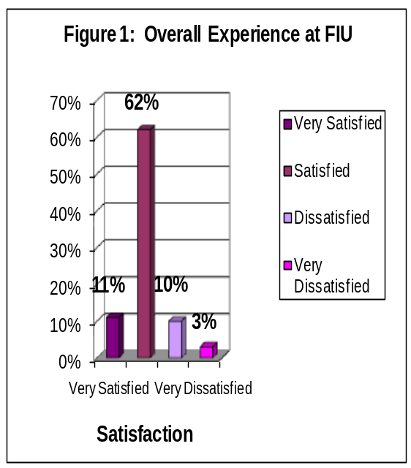

Overall Academic Experience

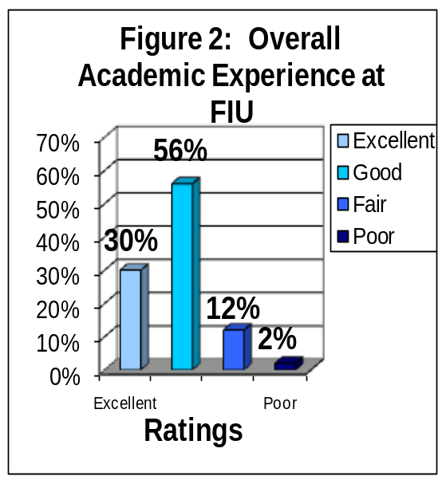
The findings in Figure 2 indicate that 86% of graduating respondents reported a positive overall academic experience: 30% rated their academic experience as excellent while 56% rated their academic experience as good. Fourteen percent of respondents reported that their academic experience at FIU was negative: 12% rated their academic experience as fair and 2% rated their academic experience as poor.

Correlations: To the extent that the graduating respondents rated highly their overall academic experience, they also reported they would recommend FIU to a friend or a relative (r = .69, p < .001), agreed they were satisfied with how well their department major has met its goals and objectives (r = .57, p < .001), and reported they were overall satisfied with FIU (r = .56, p < .001).

Challenged to Do Their Best
The findings depicted in Figure 3 indicate that 90% of graduating senior respondents reported that they were challenged to do their best at FIU: 52% reported that they were challenged to do their best most of the time; an additional 37% reported that they were challenged sometimes. Eleven percent of respondents reported that they were not challenged to do their best at FIU: 9% reported that they were seldom challenged and 1% reported that they had never been challenged.

Correlations: To the extent that graduating respondents were challenged, they agreed the courses they took prepared them for employment (r = .57, p < .001), also believed they were prepared to pursue life-long learning (r = .56 p < .001), and agreed they developed critical thinking (r = .56, p < .001).

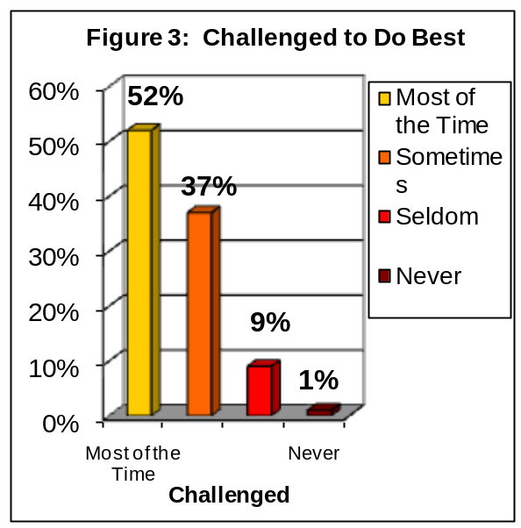

Recommend FIU to Others

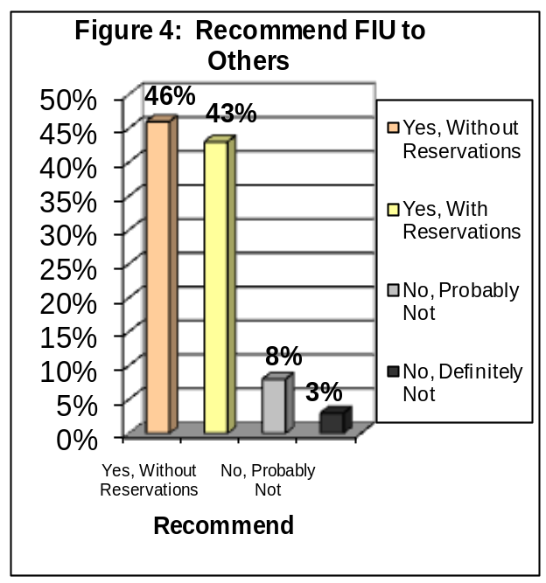
The findings depicted in Figure 4 indicate that 89% of graduating senior respondents would recommend FIU to a friend or relative considering college: 46% of respondents would recommend FIU, without reservations and 43% reported that they would recommend FIU, with reservations. Approximately 8% of respondents reported they probably would not recommend FIU and 3% reported that they would not recommend FIU under any circumstances.

Correlations: To the extent that senior respondents would recommend FIU to a friend or relative considering college, rated highly their academic experience (r = .70, p < .001), agreed they were overall satisfied with FIU (r = .69, p < .001), and agreed they were satisfied with how well their department met its goals and objectives (r = .69, p < .001).

Satisfaction With Department of Major

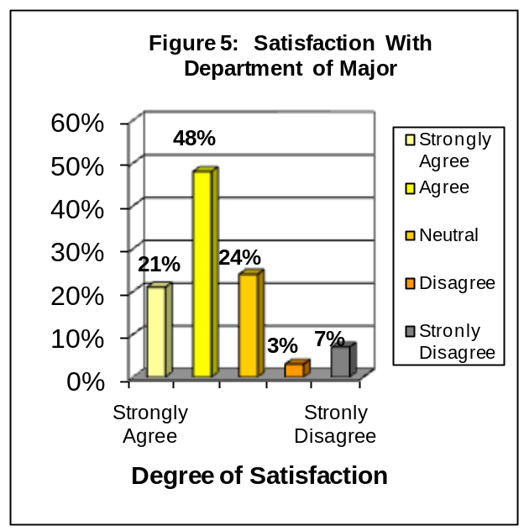
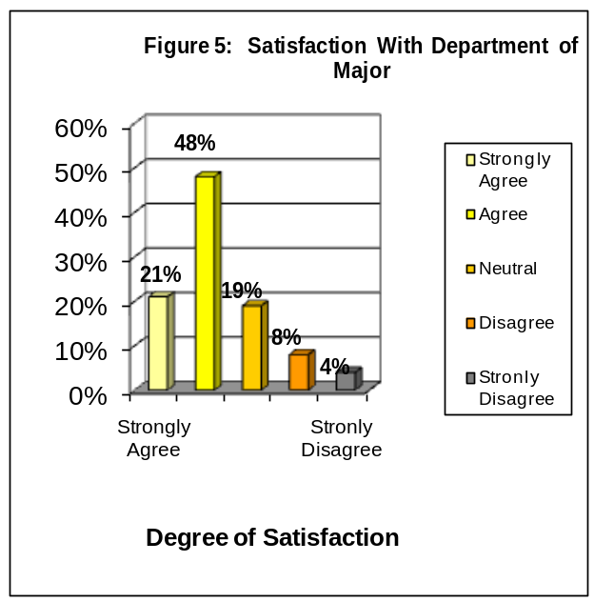
The findings in Figure 5 indicate that 69% of graduating senior respondents were satisfied with the department of their major at FIU: 21% of graduating respondents strongly agreed that they were satisfied and 48% agreed. Twelve percent of respondents were not satisfied with the department of their major at FIU: 8% disagreed and 4% strongly disagreed. Another 19% of graduating respondents did not know whether they agreed or disagreed.

Correlations: To the extent that graduating respondents agreed that they were satisfied with the department of their major, they agreed the courses they took prepared them for employment (r = .70, p < .001), as well as the courses they took prepared them for graduate school (r = .69, p < .001), and the faculty were good teachers (r = .69, p < .001).

Professors Were Good Teachers
The findings in Figure 6 indicate that 81% of graduating senior respondents at FIU reported that the professors in their major were good teachers: 35% of respondents strongly agreed, another 45% agreed. Seven percent of graduating respondents at FIU did not agree that the professors in their major were good teachers: 5% of graduating seniors disagreed and 2% strongly disagreed. Thirteen percent of graduating seniors did not know whether they agreed or disagreed.

Correlations: To the extent that graduating respondents believed that their professors were good teachers, agreed faculty were available outside of class (r = .72, p < .001), were satisfied with how well their department met its goals and objectives (r = .68, p < .001), and rated highly their academic experience (r = .61, p < .001).

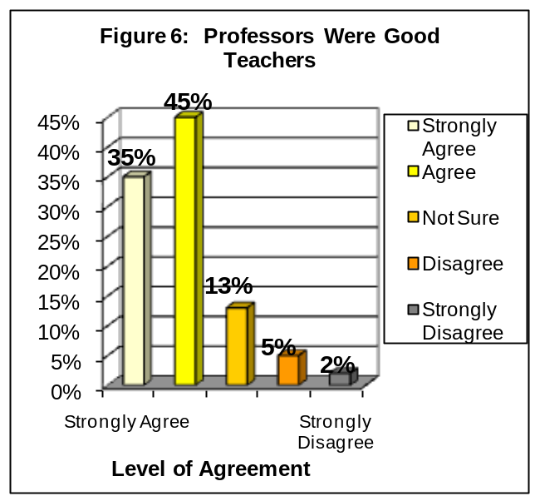

Professors Were Available Outside of Class

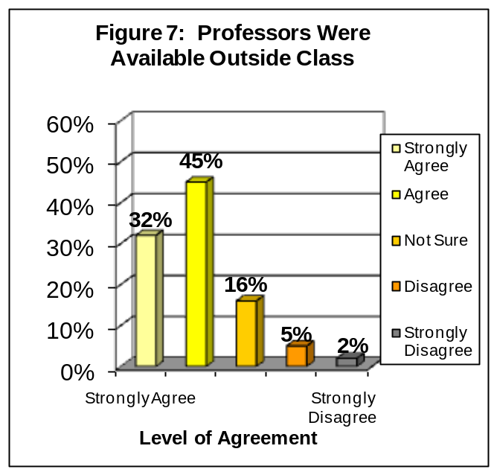
The findings in Figure 7 indicate that 77% of graduating respondents agreed that their professors were available outside of class to assist them: 32% of respondents strongly agreed, an additional 45% agreed. Seven percent of respondents did not agree that their professors were available outside of class: 5% of respondents disagreed that their professors were available and 2% strongly disagreed. Another 16% of respondents did not know whether they agreed or disagreed.

Correlations: To the extent that graduating respondents agreed that their professors were available outside of class, they also agreed faculty were good teachers (r = .72, p < .001), reported they were satisfied how well their department major met its goals and objectives (r = .60, p < .001), and agreed that the courses they took prepared them for graduate school (r = .58, p < .001).

Quality of Other Undergraduates
The findings in Figure 8 indicate that 69% of graduating respondents reported positive attitudes about the quality of their fellow undergraduate students: 13% believed that the quality of other undergraduate students at FIU was excellent; another 57% believed that the quality of other undergraduates was good. Thirty percent held negative attitudes about the quality of their fellow undergraduate students: 25% believed that the quality of other undergraduates was fair while 5% reported that they believed that the quality of other undergraduates was poor.

Correlations: To the extent that the graduating respondents rated the quality of other undergraduate students highly, they agreed the quality of courses prepared them for employment (r = .57, p < .001), rated highly their academic experience (r = .57, p < .001), agreed the responsiveness of FIU’s support services to undergraduate needs (r =.53, p < .001).

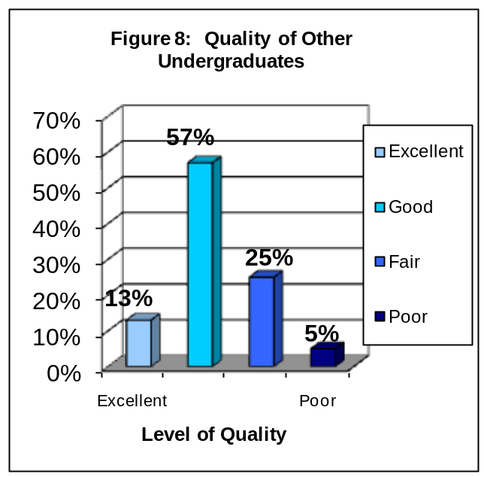

The Responsiveness of FIU Administration to Student Academic Problems
The findings in Figure 9 indicate that 51% of graduating respondents rated positively the responsiveness of the FIU administration to student academic problems: 12% rated the responsiveness to problems as excellent and 39% good. Forty-nine percent of respondents rated negatively the responsiveness of the FIU administration to problems: 29% rated the administration’s responsiveness as fair and 19% rated the administration’s responsiveness as poor.

Correlations: Graduating respondents who rated highly the administration’s responsiveness to student academic problems also agreed the responsiveness of support services to undergraduate students (r = .86, p < .001), agreed the advice they received was useful to their career (r = .56, p <.001), reported they would recommend FIU to a friend or relative (r = .54, p < .001).

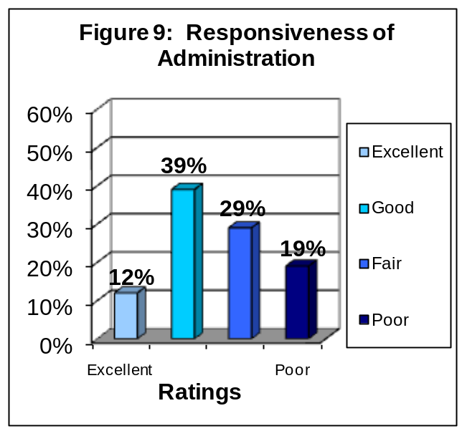

The Responsiveness of FIU Support Services to Student Needs

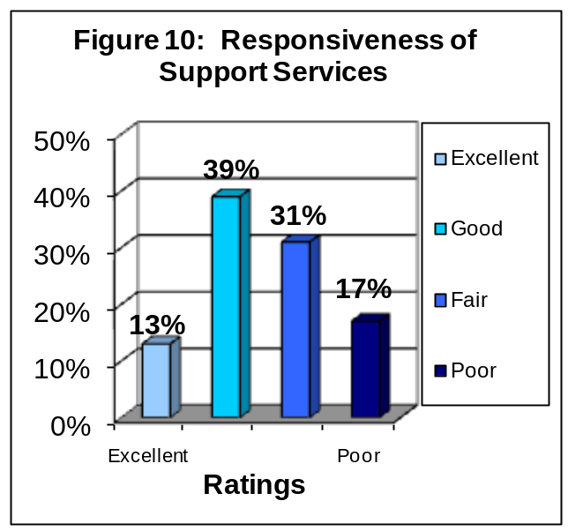
The findings in Figure 10 indicate that 52% of graduating respondents rated positively the responsiveness of FIU support services to student needs: 13% rated the responsiveness of FIU support services to student needs as excellent and 39% as good. Forty-seven percent of graduating respondents rated the responsiveness of FIU support services to student needs negatively: 31% rated the responsiveness of FIU support services to student needs as fair and 17% assigned a rating of poor.

Correlations: Graduating respondents who rated highly the responsiveness of FIU support services to student needs rated highly the responsiveness of FIU’s administration to undergraduate academic problems (r = . 86 p < .001), and reported they gained more respect for the principles of moral living (r = .56, p < .001), and were overall satisfied with FIU (r = .54, p < .001).

The Quality of Courses, in My Major, Prepared Me For Employment

The findings depicted in Figure 11 indicate that 61% of graduating respondents agreed that the quality of courses, in their major at FIU, prepared them for employment: 20% strongly agreed, another 41% agreed. Twelve percent of graduating respondents did not agree that their courses, in their major, prepared them for employment: 9% disagreed and 3% strongly disagreed. Another 27% of respondents did not know whether they agreed or disagreed.

Correlations: To the extent that graduating respondents agreed that courses in their major prepared them for employment, they also agreed the quality of courses prepared them for graduate school (r = .77, p < .001), they were satisfied with their major department (r = .70, p < .001), and rated highly their academic experience (r = .66, p < .001).

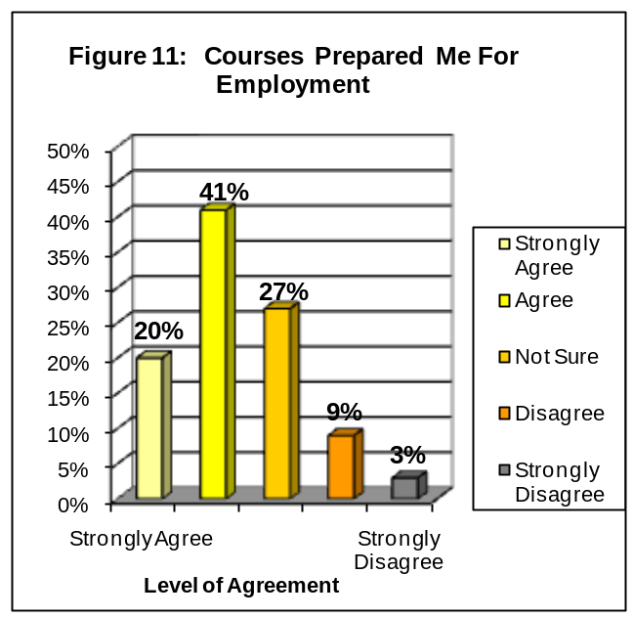

The Quality of Courses, in My Major, Prepared Me for Graduate or Professional School

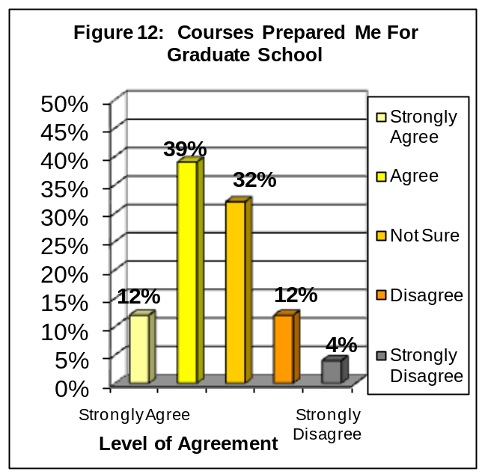
The findings depicted in Figure 12 indicate that 51% of graduating respondents agreed that the quality of courses, in their major, prepared them for graduate school: 12% strongly agreed, another 39% agreed. Sixteen percent of graduating respondents did not agree that the quality of courses, in their major, prepared them for graduate school: 12% disagreed and 4% strongly disagreed. Thirty-two percent of graduating respondents did not know whether they agreed or disagreed.

Correlations: To the extent that graduating respondents agreed that their courses prepared them for graduate school, they also agreed their courses prepared them for employment (r = .77, p < 001), were satisfied with the department of their major (r = .70, p < .001), and agreed faculty were good teachers (r = .58, p < .001).

IV. FIVE-YEAR COMPARISON OF TWELVE PRINCIPAL INDICATORS OF THE GRADUATING SENIORS’ OVERALL SATISFACTION WITH FIU

Florida International University began surveying its graduating students in the spring of 1999 and continues to survey graduating seniors every year. The surveys for the 2008-2009 mark the tenth year of data collection of this graduating senior survey.

In this section of the report, the focus is on the survey items that have been established as the twelve principal indicators of the graduating students’ satisfaction with the university. Responses to these items have been divided into the categories of positive and negative responses. Additionally, the average percentage of positive and negative responses is displayed.

Overall Experience at FIU

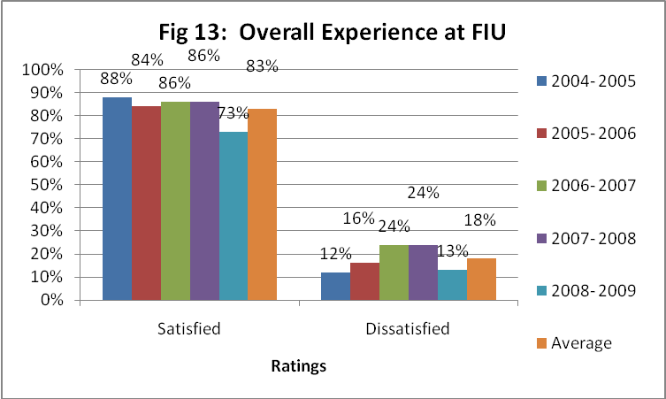

Graduating senior respondents at FIU have reported stable levels of satisfaction with their overall experience at FIU from 2004-2009. The levels of satisfaction decreased from 2007 to 2009. Respondents who reported that they are ‘Very Satisfied’ (29%, 26%, 21%, 26% and 11% respectively) or ‘Satisfied’ (63%, 65%, 67%, 60% and 62% respectively) ranged from 88-73% for the five-year period. Respondents who reported that they are ‘Dissatisfied’ (7%, 8%, 9%, 11% and 10% respectively) or ‘Very Dissatisfied’ (1%, 1%, 3%, 3% and 3% respectively) ranged from 12-24% for the five-year period.

Overall Academic Experience

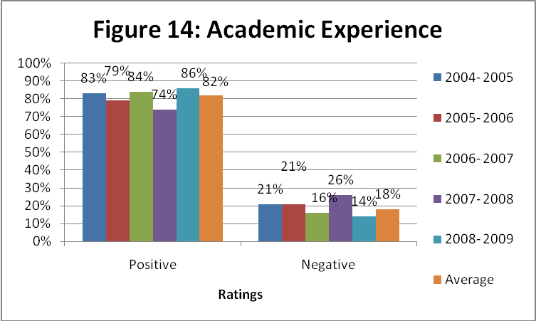

Graduating senior respondents at FIU reported varying levels of satisfaction with their overall academic experience at FIU from 2004-2009. Satisfaction levels decreased from 2006-2007, increased in 2008. Respondents who reported ‘Excellent’ (29%, 29%, 21%, 27% and 30% respectively) or ‘Good’ (57%, 60%, 62%, 47% and 56% respectively) ratings ranged from 86%-74% for the five-year period. Respondents who reported ‘Fair’ (13%, 11%, 14%, 11% and 12% respectively) or ‘Poor’ (1%, 1%, 3%, 15% and 2% respectively) ratings ranged from 14-26% for the five-year period.

Challenged to Do Best

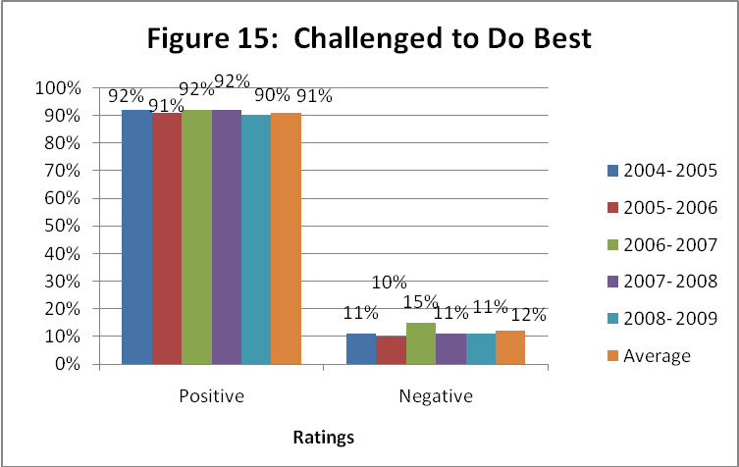

The percentage of graduating senior respondents who reported that they “are challenged to do their best” at FIU has been stable for the past five years with a slight decrease in 2006-2007. Respondents who reported that they are challenged ‘Most of the time’ (53%, 49%, 50% 50% and 52% respectively) or ‘Sometimes’ (39%, 43%, 41% 42% and 37% respectively) ranged from 90-85% for the five-year period. Respondents who have reported that they “are challenged to do their best” ‘Seldom’ (7%, 8%, 8% 6% and 9% respectively) or ‘Never’ (1%, 0%, 4%, 1% and 1% respectively) ranged from 10-15% for the five-year period.

Recommend FIU To Others

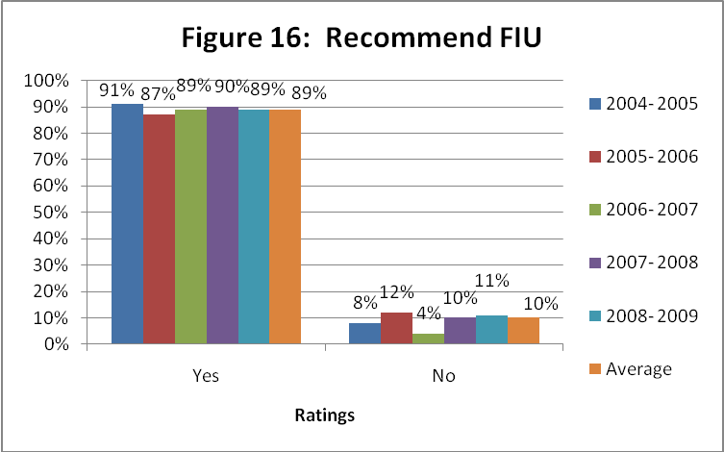

The percent of graduating senior respondents who reported that they would recommend FIU to a friend or relative considering college has remained relatively stable from 2004-2009. Respondents who reported that they would ‘recommend FIU without reservations’ (53%, 50%, 41%, 45% and 46% respectively) or would ‘recommend with reservations’ (40%, 41%, 50%, 45% and 43% respectively) ranged from 87-91% for the five-year period. Respondents who reported that they would ‘probably not recommend FIU’ (6%, 7%, 5%, 6% and 8% respectively) or ‘definitely would not recommend FIU’ (1%, 2%, 3%, 6%, 1% and 3% respectively) ranged from 4-12% for the five-year period.

Satisfaction With Department of Major
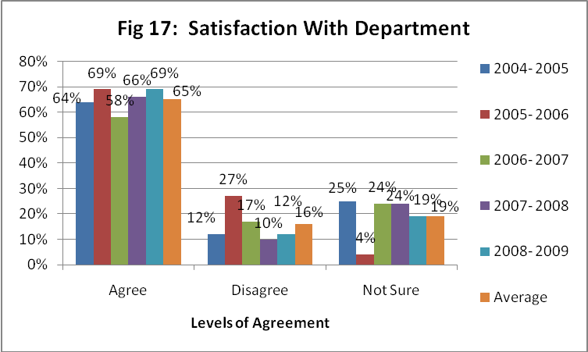

Graduating senior respondents at FIU reported varying levels of satisfaction with the department of their major at FIU from 2004-2009. Respondents who ‘Strongly Agreed’ (21%, 25%, 17%, 19% and 21% respectively) or ‘Agreed’ (49%, 48%, 47% 47% and 48% respectively) that they were satisfied with the department of their major ranged from 58-73% for the five-year period. Respondents who ‘Disagreed’ (21%, 8%, 9%, 7% and 8% respectively) or ‘Strongly Disagreed’ (7%, 3%, 3%, 3% and 4% respectively) ranged from 10-27% for the five-year period. Respondents who made a response of ‘Not Sure’ ranged from 4-25% for the five-year period.

Professors Were Good Teachers

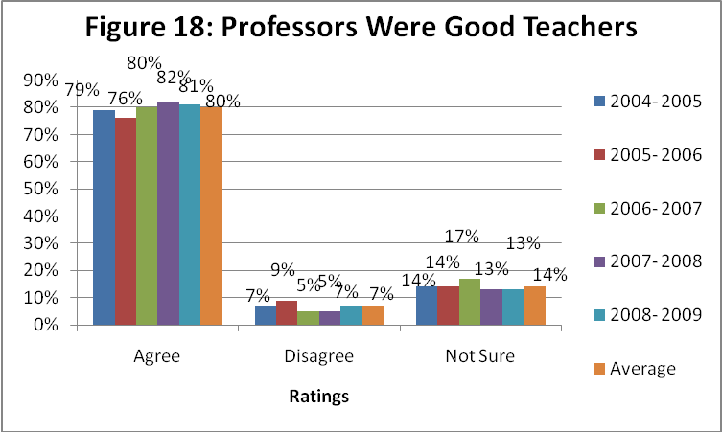

Graduating senior respondents at FIU reported relatively stable levels of agreement with the statement “My professors were good teachers” from 2004-2009. The number of respondents who ‘Strongly Agreed’ (32%, 31%, 37%, 38% and 35% respectively) or ‘Agreed’ (53%, 50%, 42%, 44% and 45% respectively) that their professors were good teachers ranged from 76-82% for the five-year period. Respondents who ‘Disagreed’ (11%, 4%, 4%, 3% and 5% respectively) or ‘Strongly Disagreed’ (3%, 1%, 3%, 2% and 2% respectively) ranged from 4-9% for the five-year period. Respondents who made a response of ‘Not Sure’ ranged from 13-17% for the five-year period.

Professors Were Available Outside of Class

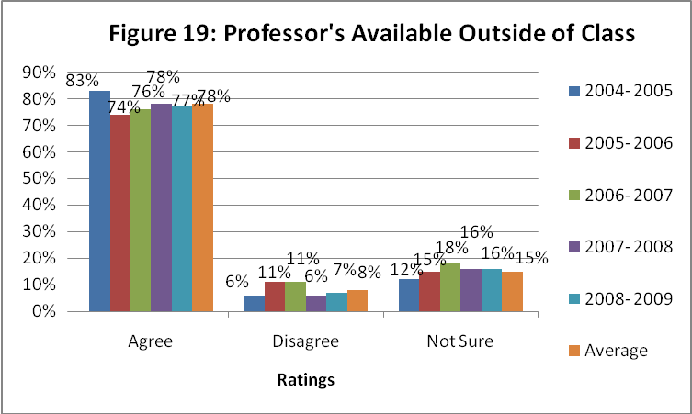

Graduating senior respondents at FIU reported varying levels of agreement with the statement “My professors were available outside of class”. Respondents who ‘Strongly Agreed’ (30%, 32%, 35%, 32% and 32% respectively) or ‘Agreed’ (52%, 48%, 48%, 46% and 45% respectively) that their professors were available ranged from 74-83% for the five-year period. Respondents who ‘Disagreed’ (13%, 4%, 5%, 4% and 5% respectively) or ‘Strongly Disagreed’ (4%, 1%, 1%, 2% and 2% respectively) ranged from 6-11% for the five-year period. Respondents who made a response of ‘Not Sure’ ranged from 12-18% for the five-year period.

Quality of Other Undergraduates

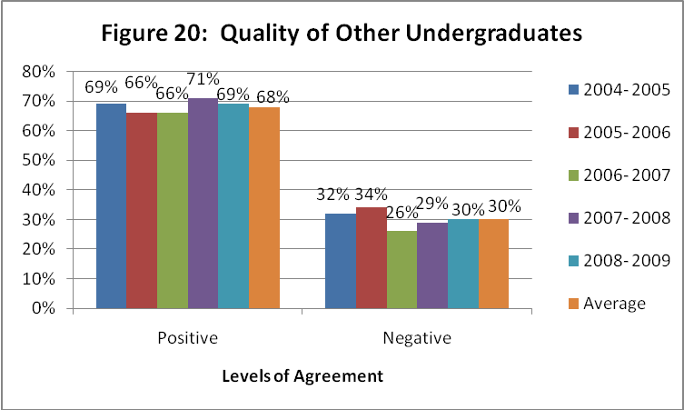

Graduating senior respondents at FIU reported varying levels of positive ratings of their fellow undergraduates from 2004-2009. Respondents who rated the quality of their fellow undergraduates as ‘Excellent’ (13%, 12%, 8%, 13% and 13% respectively) or ‘Good’ (63%, 62%, 61%, 58% and 56% respectively) ranged from 66-71% for the five-year period. Respondents who assigned ratings of ‘Fair’ (21%, 22%, 25%, 25% and 25% respectively) or ‘Poor’ (3%, 4%, 7%, 4% and 5% respectively) ranged from 26-34% for the five-year period.

Responsiveness of Administration to Student Academic Problems

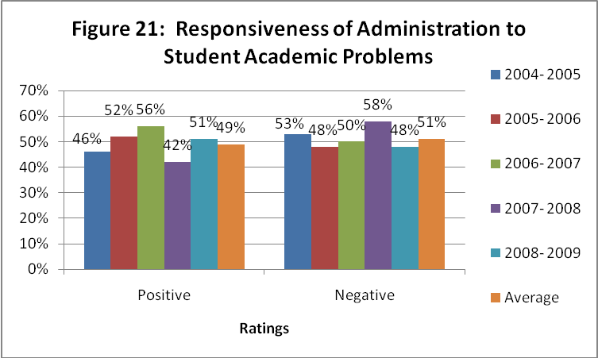

Graduating senior respondents at FIU reported relatively low positive ratings towards the responsiveness of the administration to student academic problems from 2004-2009. Respondents who reported that the response of the administration was ‘Excellent’ (10%, 10%, 12%, 11% and 12% respectively) or ‘Good’ (46%, 41%, 40%, 31% and 39% respectively) ranged from 42-56% for the five-year period. Respondents who reported ‘Fair’ (29%, 35%, 32%, 34% and 29% respectively) or ‘Poor’ (15%, 14%, 15%, 24% and 19% respectively) ratings ranged from 47-58% for the five-year period.

Responsiveness of Support Services to Student Needs

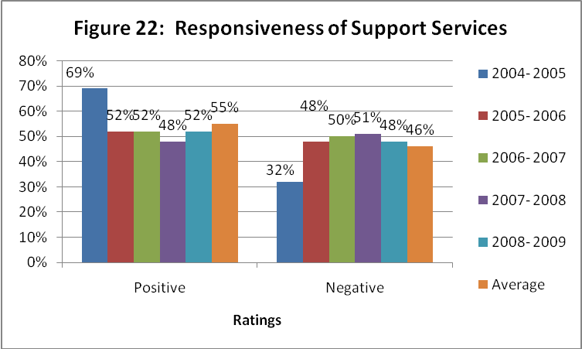
Graduating senior respondents at FIU also reported relatively low positive ratings towards the responsiveness of support services to student needs from 2004-2009. Respondents who reported that the response of the support services was ‘Excellent’ (12%, 11%, 13%, 11% and 13% respectively) or ‘Good’ (45%, 41%, 43%, 37% and 39% respectively) ranged from 52-69% for the five-year period. Respondents who reported ‘Fair’ (29%, 35%, 29%, 32% and 31% respectively) or ‘Poor’ (14%, 13%, 15%, 19% and 17% respectively) ratings ranged from 32-51% for the five-year period.

Quality of Courses Prepared for Employment

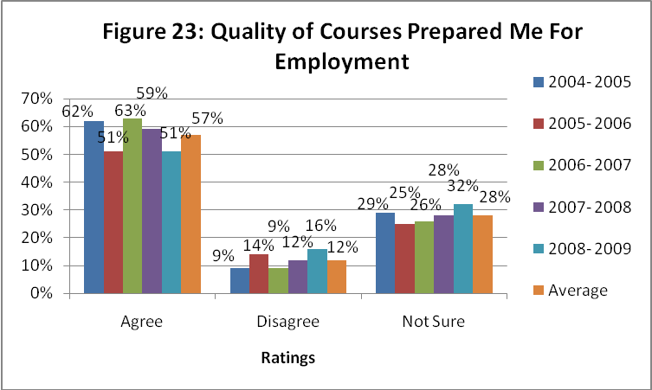

Graduating senior respondents at FIU reported varying levels of agreement from 2004-2009 that the quality of their courses prepared them for employment. Respondents who ‘Strongly Agreed’ (20%, 24%, 20%, 19% and 20% respectively) or ‘Agreed’ (44%, 41%, 44%, 40% and 41% respectively) with this item ranged from 51-63% for the five-year period. Respondents who ‘Disagreed’ (22%, 22%, 9%, 8% and 9% respectively) or ‘Strongly Disagreed’ (10%, 10%, 3%, 4% and 3% respectively) ranged from 9-16% for the five-year period. Respondents who made a response of ‘Not Sure’ ranged from 25-32% for the five-year period.

Quality of Courses Prepared Me for Graduate School

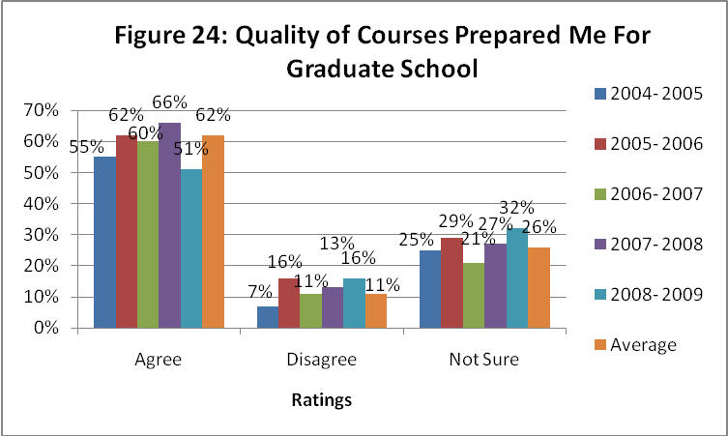

Graduating senior respondents at FIU reported varying levels of agreement from 2004-2009 that the quality of courses prepared them for graduate school. Respondents who ‘Strongly Agreed’ (20%, 20%, 23%, 21% and 12% respectively) or ‘Agreed’ (45%, 43%, 44%, 45% and 39% respectively) with this item ranged from 55-66% for the five-year period. Respondents who ‘Disagreed’ (27%, 29%, 5%, 7% and 12% respectively) or ‘Strongly Disagreed’ (7%, 6%, 2%, 2% and 4% respectively) ranged from 7-16% for the five-year period. Respondents who made a response of ‘Not Sure’ ranged from 21-29% for the five-year period.

Conclusions

When looking at data over time, it is helpful to keep several issues in mind. When ratings are consistent over a time period, it is usually an indication that those ratings are a true measure of the item that is the measure is a reliable one. However, when ratings are not consistent over time it is possible to draw multiple conclusions. One conclusion would be that the ratings are inconsistent because of flaws in the representativeness of the sample over the time period. A second conclusion would be that there have been true fluctuations in the graduating respondents’ experiences over the time period.

Positive ratings were relatively consistent over the five-year period for reports of whether the respondents felt challenged to do their best at FIU, the quality of other undergraduates, and whether the respondent would recommend FIU to a friend or relative considering college and if they were challenged to do best. Positive ratings mostly decreased over the five-year period for professors were available outside of class, responsiveness of support services, and whether courses prepared them for employment. Positive ratings fluctuated over the five-year period for perceptions of ratings of satisfaction with department of major, and responsiveness of administration to student academic problems.

APPENDIX A: GRADUATING SENIOR SURVEY

APPENDIX A
Graduating Senior Survey: Summer 2008-Spring 2009
Questions on all versions of survey: Principle indicators of student satisfaction
In general, how satisfied are you with your overall experience at FIU? | % | Please rate the quality of other undergraduates at FIU |  | %
Very Satisfied | 11.0% | Excellent |  | 12.6%
Satisfied | 62.4% | Good |  | 56.8%
Dissatisfied | 10.1% | Fair |  | 24.5%
Very Dissatisfied | 2.8% | Poor |  | 5.2%
What was your primary reason for attending FIU? | % | Please rate the responsiveness of FIU's administration to student academic problems |  | %
Academic Reputation | 9.2% | Excellent |  | 11.7%
Cost | 25.5% | Good |  | 39.4%
Location | 45.4% | Fair |  | 29.3%
Type of Program Available | 13.7% | Poor |  | 19.2%
Other | 6.2%
What was your status when you first entered FIU? | % | Please rate the responsiveness of FIU's support service to undergraduate students |  | %
Recent High School Graduate | 50.5% | Excellent |  | 13.4%
Transfer from Community College or University | 44.7% | Good |  | 38.7%
Other | 4.6% | Fair |  | 31.4%
 |  | Poor |  | 16.5%
When you reflect upon time at FIU, have you been challenged to do the very best you could? | % | In my major, the faculty were good teachers. |  | %
Most of the time | 52.3% | Strongly Agree |  | 35.2%
Sometimes | 37.2% | Agree |  | 45.4%
Seldom | 9.4% | Neutral |  | 12.5%
Never | 1.2% | Disagree |  | 4.8%
 |  | Strongly Disagree |  | 2.1%
Would you recommend FIU to a friend or relative considering college? | % | In my major, the faculty were available outside of the classroom |  | %
Yes, without reservation | 45.9% | Strongly Agree |  | 32.3%
Yes, with reservations | 42.9% | Agree |  | 44.6%
No, probably not | 8.2% | Neutral |  | 16.1%
No, under no circumstances | 2.9% | Disagree |  | 5.4%
 |  | Strongly Disagree |  | 1.6%
Please rate your academic experience at FIU. | % | In my major, lower division courses adequately prepared me for graduate/professional school |  | %
Excellent | 30.0% | Strongly Agree |  | 12.0%
Good | 55.8% | Agree |  | 39.4%
Fair | 11.9% | Neutral |  | 32.4%
Poor | 2.3% | Disagree |  | 12.0%
 |  | Strongly Disagree |  | 4.1%
I am satisfied with how well the department of my major has met its goals and objectives | % | In my major, the quality of courses I took prepared me for employment |  | %
Strongly Agree | 21.3% | Strongly Agree |  | 19.8%
Agree | 47.5% | Agree |  | 41.1%
Neutral | 19.0% | Neutral |  | 26.8%
Disagree | 8.1% | Disagree |  | 8.9%
Strongly Disagree | 4.1% | Strongly Disagree |  | 3.4%
Version A: Academic Issues
Did you develop a professional relationship (s) with faculty that is close enough to ask for a letter or recommendation? | % | In my major, the courses in need were available. |  | %
Yes | 72.0% | Strongly Agree |  | 15.7%
No | 28.0% | Agree |  | 41.3%
 |  | Neutral |  | 17.8%
 |  | Disagree |  | 16.5%
 |  | Strongly Disagree |  | 8.7%
Did you develop a professional relationship (s) with faculty that is close enough that you could ask for advice about career decisions? | % | In my major, there were a good range of courses available. |  | %
Yes | 72.5% | Strongly Agree |  | 11.9%
No | 27.5% | Agree |  | 34.4%
 |  | Neutral |  | 23.8%
 |  | Disagree |  | 22.1%
 |  | Strongly Disagree |  | 7.8%
Please rate your social experience at FIU. | % | In my major, I was provided the opportunity to develop computer skills |  | %
Excellent | 21.8% | Strongly Agree |  | 21.5%
Good | 39.9% | Agree |  | 33.1%
Fair | 27.2% | Neutral |  | 31.4%
Poor | 11.1% | Disagree |  | 11.6%
 |  | Strongly Disagree |  | 2.5%
Please rate the safety measures on campus. | % | Courses to meet general education requirements were available to me |  | %
Excellent | 29.3% | Strongly Agree |  | 23.2%
Good | 45.9% | Agree |  | 51.5%
Fair | 19.8% | Neutral |  | 18.7%
Poor | 5.0% | Disagree |  | 5.4%
 |  | Strongly Disagree |  | 1.2%
In my major, my classes were too large. | % | Courses in other departments, but required by my major were available to me |  | %
Strongly Agree | 7.8% | Strongly Agree |  | 15.4%
Agree | 16.5% | Agree |  | 58.8%
Neutral | 27.2% | Neutral |  | 18.3%
Disagree | 36.6% | Disagree |  | 6.7%
Strongly Disagree | 11.9% | Strongly Disagree |  | 0.8%
Version B: Quality Issues
How often have you used health services? | % | How often have you used the FIU library at Biscayne Bay Campus |  | %
Frequently | 7.9% | Frequently |  | 7.9%
Occasionally | 18.8% | Occasionally |  | 16.2%
Seldom | 24.8% | Seldom |  | 20.9%
Never | 48.5% | Never |  | 55.0%
How often have you used academic advising: lower division? | % | How often have you used counseling & psychological services? |  | %
Frequently | 10.2% | Frequently |  | 1.0%
Occasionally | 26.9% | Occasionally |  | 3.6%
Seldom | 42.1% | Seldom |  | 10.7%
Never | 20.8% | Never |  | 84.7%
Totals | 100.0% | Totals |  | 100.0%
How often have you used academic advising in your major? | % | How often have you used recreational services? |  | %
Frequently | 35.3% | Frequently |  | 20.9%
Occasionally | 36.8% | Occasionally |  | 28.9%
Seldom | 23.5% | Seldom |  | 24.4%
Never | 4.4% | Never |  | 25.9%
How often have you used the computer laboratories/services? | % | Please rate the quality of non-campus student employment? |  | %
Frequently | 46.0% | Excellent |  | 9.2%
Occasionally | 28.7% | Good |  | 26.7%
Seldom | 16.3% | Don't Know |  | 50.0%
Never | 8.9% | Fair |  | 7.5%
 |  | Poor |  | 6.7%
How often have you attended cultural activities such as speakers, concerts, movies, etc? | % | Please rate the quality of the university park library? |  | %
Frequently | 16.3% | Excellent |  | 57.9%
Occasionally | 27.7% | Good |  | 35.5%
Seldom | 31.7% | Don't Know |  | 1.5%
Never | 24.3% | Fair |  | 4.1%
 |  | Poor |  | 1.0%
How often have you been involved in intramural activities? | % | Please rate the quality of the Biscayne Bay Library |  | %
Frequently | 6.8% | Excellent |  | 10.5%
Occasionally | 11.0% | Good |  | 33.1%
Seldom | 13.6% | Don't Know |  | 37.9%
Never | 68.6% | Fair |  | 12.9%
 |  | Poor |  | 5.6%
How often have you used SASS (Student Academic Support System) | % | Please rate the quality of counseling & psychological services? |  | %
Frequently | 42.3% | Excellent |  | 8.6%
Occasionally | 27.4% | Good |  | 10.8%
Seldom | 17.9% | Don't Know |  | 71.0%
Never | 12.4% | Fair |  | 5.4%
 |  | Poor |  | 4.3%
How often have you used on-campus student employment? | % | Please rate the quality of the testing center. |  | %
Frequently | 6.0% | Excellent |  | 5.7%
Occasionally | 10.6% | Good |  | 35.0%
Seldom | 12.1% | Don't Know |  | 46.3%
Never | 71.4% | Fair |  | 11.4%
 |  | Poor |  | 1.6%
How often have you used health services? | % | Please rate the quality of recreational services. |  | %
Frequently | 7.9% | Excellent |  | 32.7%
Occasionally | 18.8% | Good |  | 44.2%
Seldom | 24.8% | Don't Know |  | 15.2%
Never | 48.5% | Fair |  | 6.1%
 |  | Poor |  | 1.8%
Please rate the quality of academic advising: lower division | % | Please rate the quality of intramural activities. |  | %
Excellent | 7.4% | Excellent |  | 12.2%
Good | 28.6% | Good |  | 32.2%
Don't Know | 13.1% | Don't Know |  | 49.6%
Fair | 26.3% | Fair |  | 2.6%
Poor | 24.6% | Poor |  | 3.5%
How often have you used academic advising: lower division | % | Please rate the quality of SASS (Student Academic Support Services) |  | %
Frequently | 10.2% | Excellent |  | 25.1%
Occasionally | 26.9% | Good |  | 50.8%
Seldom | 42.1% | Don't Know |  | 6.7%
Never | 20.8% | Fair |  | 13.4%
 |  | Poor |  | 3.9%
Please rate the quality of the computer laboratories | % | Please rate the quality of the FIU catalog. |  | %
Excellent | 31.9% | Excellent |  | 22.0%
Good | 58.2% | Good |  | 49.2%
Don't Know | 3.3% | Don't Know |  | 6.8%
Fair | 5.5% | Fair |  | 16.8%
Poor | 1.1% | Poor |  | 5.2%
Please rate the quality of cultural activities | % | Please rate the quality of the general education program. |  | %
Excellent | 20.3% | Excellent |  | 15.0%
Good | 45.1% | Good |  | 52.9%
Don't Know | 23.5% | Don't Know |  | 11.8%
Fair | 7.8% | Fair |  | 16.6%
Poor | 3.3% | Poor |  | 3.7%
Please rate the quality of the FIU class schedules | % | Please rate the quality of new student orientation |  | %
Excellent | 9.0% | Excellent |  | 20.4%
Good | 38.3% | Good |  | 44.0%
Don't Know | 0.0% | Don't Know |  | 11.5%
Fair | 28.9% | Fair |  | 16.8%
Poor | 23.9% | Poor |  | 7.3%
Please rate the quality of registration. | % | Please rate the quality of admissions. |  | %
Excellent | 15.1% | Excellent |  | 17.2%
Good | 41.2% | Good |  | 53.5%
Don't Know | 1.0% | Don't Know |  | 4.0%
Fair | 26.1% | Fair |  | 20.2%
Poor | 16.6% | Poor |  | 5.1%
Please rate the quality of student judicial services | % | Please rate the quality of student scholarships. |  | %
Excellent | 2.9% | Excellent |  | 25.9%
Good | 10.6% | Good |  | 34.3%
Don't Know | 77.9% | Don't Know |  | 19.3%
Fair | 4.8% | Fair |  | 11.4%
Poor | 3.8% | Poor |  | 9.0%
Please rate the quality of student grants. | % | Please rate the quality of student transcripts. |  | %
Excellent | 32.0% | Excellent |  | 23.7%
Good | 28.0% | Good |  | 46.3%
Don't Know | 22.7% | Don't Know |  | 15.3%
Fair | 9.3% | Fair |  | 9.5%
Poor | 8.0% | Poor |  | 5.3%
Please rate the quality of student loans. | % | Please rate the quality of student records. |  | %
Excellent | 17.7% | Excellent |  | 17.7%
Good | 38.3% | Good |  | 45.2%
Don't Know | 31.2% | Don't Know |  | 17.2%
Fair | 5.7% | Fair |  | 14.5%
Poor | 7.1% | Poor |  | 5.4%
How often have you used the FIU library at University Park | % | Please rate the quality of the drop and add procedure. |  | %
Frequently | 53.2% | Excellent |  | 20.2%
Occasionally | 28.3% | Good |  | 47.7%
Seldom | 13.7% | Don't Know |  | 6.2%
Never | 4.9% | Fair |  | 19.7%
 |  | Poor |  | 6.2%
Version C: Personal Growth and Advising Issues
How much did FIU contribute to your personal growth in each area below?
Writing effectively | % | Learning another language |  | %
Very Much | 56.9% | Very Much |  | 25.0%
Somewhat | 33.6% | Somewhat |  | 21.6%
Very Little | 9.5% | Very Little |  | 53.4%
Speaking effectively | % | Understanding different philosophies and cultures |  | %
Very Much | 50.0% | Very Much |  | 55.7%
Somewhat | 36.8% | Somewhat |  | 27.0%
Very Little | 13.2% | Very Little |  | 17.4%
Understanding written information | % | Gaining a broad education about different fields of knowledge |  | %
Very Much | 61.2% | Very Much |  | 53.0%
Somewhat | 30.2% | Somewhat |  | 33.0%
Very Little | 8.6% | Very Little |  | 13.9%
Working independently | % | Becoming more aware of the importance of ethical practices |  | %
Very Much | 68.7% | Very Much |  | 59.5%
Somewhat | 21.7% | Somewhat |  | 24.1%
Very Little | 9.6% | Very Little |  | 16.4%
Learning on your own | % | Understanding and appreciating the arts |  | %
Very Much | 72.4% | Very Much |  | 46.6%
Somewhat | 19.0% | Somewhat |  | 35.3%
Very Little | 8.6% | Very Little |  | 18.1%
Working cooperatively in a group | % | Ability to express your thoughts |  | %
Very Much | 60.0% | Very Much |  | 58.4%
Somewhat | 30.4% | Somewhat |  | 28.3%
Very Little | 9.6% | Very Little |  | 13.3%
Organizing your time effectively | % | Learning to listen more closely to others |  | %
Very Much | 53.4% | Very Much |  | 65.2%
Somewhat | 32.8% | Somewhat |  | 22.6%
Very Little | 13.8% | Very Little |  | 12.2%
Leading and guiding others | % | Critical thinking |  | %
Very Much | 53.9% | Very Much |  | 69.8%
Somewhat | 29.6% | Somewhat |  | 23.3%
Very Little | 16.5% | Very Little |  | 6.9%
Leading a productive, satisfying life | % | Ability to conceptualize and solve problems |  | %
Very Much | 54.8% | Very Much |  | 59.1%
Somewhat | 29.6% | Somewhat |  | 31.3%
Very Little | 15.7% | Very Little |  | 9.6%
Improving your computational skills | % | Gaining more respect for the principles of moral living |  | %
Very Much | 53.4% | Very Much |  | 53.0%
Somewhat | 29.3% | Somewhat |  | 35.7%
Very Little | 17.2% | Very Little |  | 11.3%
Ability to solve analytical problems | % | Ability to develop the skills necessary to give effective, professional presentations |  | %
Very Much | 53.9% | Very Much |  | 56.1%
Somewhat | 34.8% | Somewhat |  | 36.0%
Very Little | 11.3% | Very Little |  | 7.9%
Desiring intellectual challenges | % | Understanding and applying scientific principles and methods |  | %
Very Much | 58.3% | Very Much |  | 51.3%
Somewhat | 29.6% | Somewhat |  | 33.0%
Very Little | 12.2% | Very Little |  | 15.7%
Prepared me to pursue life-long learning | % | From which sources did you receive beneficial academic advising during your last two years at FIU? (Check all that apply). |  | %
Very Much | 60.0% | Advisors in my major |  | 64.3%
Somewhat | 28.7% | Central advisors in my college/school |  | 26.1%
Very Little | 11.3% | Friends |  | 48.7%
 |  | I did not seek help from advisors |  | 3.5%
 |  | Printed material including the catalog |  | 27.0%
 |  | Professors not assigned as advisors |  | 24.3%
 |  | SASS |  | 46.1%
 |  | Student Advisors |  | 4.3%
 |  | Other |  | 5.2%
If you received advising from University, College or Departmental sources, please answer the
following questions.
In general, the advisors were helpful. | % | The advice I received was useful for my career goals. |  | %
Strongly Agree | 33.6% | Strongly Agree |  | 27.0%
Agree | 31.0% | Agree |  | 30.6%
Neutral | 16.8% | Neutral |  | 19.8%
Disagree | 12.4% | Disagree |  | 10.8%
Strongly Disagree | 6.2% | Strongly Disagree |  | 11.7%
Advisors were available when needed. | % | The advice I received was useful for my educational goals. |  | %
Strongly Agree | 25.9% | Strongly Agree |  | 29.2%
Agree | 28.6% | Agree |  | 36.3%
Neutral | 21.4% | Neutral |  | 18.6%
Disagree | 19.6% | Disagree |  | 5.3%
Strongly Disagree | 4.5% | Strongly Disagree |  | 10.6%
Sufficient time was available during advising sessions. | %
Strongly Agree | 34.5%
Agree | 30.1%
Neutral | 14.2%
Disagree | 14.2%
Strongly Disagree | 7.1%
DEMOGRAPHIC INFORMATION: All Respondents
While school was in session, about how many hours did you work per week for pay? | % | Overall, what was your enrollment status in college? |  | %
I was not employed | 16.4% | Full-time |  | 86.1%
1 - 10 hours | 7.0% | Part-time |  | 13.9%
11 - 20 hours | 21.1%
21 - 34 hours | 26.7%
35 hours or more | 28.7%
I participated in the following activities while working on my degree (checking all that apply) | % | For your first two years of college, where did you live? |  | %
Student Government | 6.1% | With parents |  | 63.4%
Intercollegiate Athletics | 2.8% | With other relative(s) |  | 5.0%
Student Publications | 0.8% | On-campus housing |  | 13.1%
The Greek System | 6.4% | Other private dwelling |  | 18.5%
Political Activities | 4.2%
Community Service | 18.6%
Church Activities | 9.1%
Performing Arts | 3.9%
Intramural Sports | 5.7%
Honor Societies | 20.9%
Organizations related to my major | 18.6%
Other | 7.4%
 | % | For your last two years of college, where did you live?
What is the highest degree you expect to attain? | % |  |  | %
No further study intended | 6.5% | With parents |  | 55.8%
Master's degree | 51.3% | With other relative(s) |  | 2.9%
Specialist degree | 3.0% | On-campus housing |  | 7.9%
Doctorate or Professional degree (Ph. D., Ed. D., J.D., etc.) | 37.1% | Other private dwelling |  | 33.4%
Other | 2.2%
What is your overall grade point average? | % | About how far do you live from the campus of FIU that you primarily attend? |  | %
3.5 - 4.0 | 35.8% | I live on campus |  | 5.9%
3.0 - 3.4 | 45.7% | I live within 1 mile of campus |  | 3.6%
2.5 - 2.9 | 16.0% | I live 1 - 10 miles from campus |  | 36.8%
2.0 - 2.4 | 2.1% | I live 11 - 25 miles from campus |  | 35.9%
Don't know | 0.0% | I live over 25 miles from campus |  | 17.9%
What is your age? | % | Please indicate your college/school. |  | %
Less than 24 | 56.1% | Architecture |  | 2.7%
24 - 29 | 29.9% | Arts & Sciences |  | 39.9%
30 - 39 | 15.2% | Business |  | 21.6%
40 - 49 | 2.3% | Education |  | 8.1%
50 or older | 1.8% | Engineering |  | 7.9%
 |  | Health & Urban Affairs |  | 14.0%
 |  | Hospitality Management |  | 3.8%
 |  | Journalism and Mass Communication |  | 2.1%
What is your major? | # |  |  | #
Accounting | 21 | Hospitality Management |  | 5
Advertising | 4 | Information Technology |  | 2
Architecture | 3 | International Business |  | 15
Biological Sciences | 21 | International Relations |  | 20
Biomedical Engineering | 7 | Liberal Studies |  | 7
Business Management | 2 | Management Information Systems |  | 2
Chemistry | 7 | Marketing |  | 9
Civil Engineering | 4 | Nursing |  | 4
Computer Engineering | 3 | Occupational Therapy |  | 4
Criminal Justice | 15 | Other |  | 218
Early Childhood Education | 3 | Philosophy |  | 3
Economics | 4 | Physics |  | 2
Electrical Engineering | 6 | Political Science |  | 13
Elementary Education | 13 | Psychology |  | 40
English | 13 | Public Administration |  | 2
Exercise Physiology | 2 | Religious Studies |  | 4
Finance | 24 | Social Work |  | 4
Health Sciences | 10 | Sociology/Anthropology |  | 5
Health Service Administration | 3 | Travel and Tourism Management |  | 2
Please indicate your racial/ethnic group | % | At which FIU campus did you take most of your courses |  | %
Asian | 7.2% | Biscayne Bay Campus |  | 11.6%
Black/African American | 9.4% | Broward/Pines Center |  | 1.1%
Hispanic | 59.1% | University Park Campus |  | 87.3%
American Indian/Alaskan Native | 1.1%
White | 22.9% | What is your gender? |  | %
International Student/Non-Resident Alien | 3.1% | Female |  | 69.1%
 |  | Male |  | 30.4%
If you are not finishing your degree in 4 years, please indicate all of the reasons why not | % | Have you ever visited the career services office? |  | %
5 year degree program | 2.8% | Yes |  | 39.8%
I had to withdraw during a semester | 10.6% | No |  | 60.2%
I took a semester off from school | 12.1%
My job caused me to take reduced course loads | 16.0% | If you have visited the career services office, please rate its usefulness |  | %
I voluntarily took reduced course loads | 8.6% | Very useful |  | 9.6%
I changed majors | 15.0% | Somewhat useful |  | 21.2%
I had some financial problems | 11.6% | Not sure |  | 13.6%
I had personal or family issues | 11.8% | Not very useful |  | 7.1%
I was misadvised by advisor(s) | 10.2% | Not at all useful |  | 4.5%
I failed to seek advising help | 7.6% | Not applicable |  | 43.9%
My required courses were not available | 12.9%
What is most likely to be your principal activity upon graduation? | % | Have you ever visited the career services office? |  | %
Employment, full-time paid | 40.6% | Yes |  | 39.8%
Employment, part-time paid | 7.0% | No |  | 60.2%
Graduate or professional school, full-time | 26.8%
Graduate or professional school, part-time | 13.1% | If you have visited career services webpage, please rate its usefulness: |  | %
Additional undergraduate coursework | 2.4% | Very useful |  | 12.8%
Military service | 0.8% | Somewhat useful |  | 30.1%
Volunteer activities (e.g., Peace Corps) | 2.5% | Not sure |  | 10.9%
Starting or raising a family | 4.4% | Not very useful |  | 7.9%
Other | 2.3% | Not at all useful |  | 5.6%
 |  | Not applicable |  | 34.5%
Are you currently working or have an offer in your field? | %
Yes | 38.0%
No | 62.0%
Have you ever visited the career services web page? | %
Yes | 52.5%
No | 47.5%

