Office of
Planning and Institutional Effectiveness
Institutional Research



Hope, Knowledge, and Opportunity

Research Report
Survey of Graduating Seniors
Summer 2004 – Spring 2005

University Park Campus
PC 543
Miami, FL 33199
Telephone: (305) 348-2731 Fax: (305) 348-1908
http://www.fiu.edu/~opie/effectiveness.htm

Office of Planning & Institutional Effectiveness

The Graduating Senior Survey is a survey in the series of Continuous Quality Improvement Surveys instituted by Florida International University’s Office of Planning and Institutional Effectiveness. The information in these Continuous Quality Improvement Survey Reports will be distributed to members of the university community and will be used by the appropriate departments to enhance continuous quality improvement efforts.

Every effort has been made to ensure that the data contained in this document is accurate. For further information about this and other Continuous Quality Improvement Survey Reports, visit our website at http://www.fiu.edu/~opie/effectiveness.htm, contact the Office of Planning and Institutional Effectiveness at 305-348-2731.

TABLE OF CONTENTS
Table of Contents |  |  |  |  |  |  |  |  |  |  |  |  |  |  |  |  |  |  |  |  |  |  |  |  |  |  |  |  |  |  |  |  |  |  |  |  |  |  |  | 1
Executive Summary of Graduating Senior Survey Summer 2004 – Spring 2005 |  |  |  |  |  |  |  |  |  |  |  |  |  |  |  |  |  |  |  |  |  |  |  |  |  |  |  |  |  |  |  |  |  |  |  |  |  |  |  | 3
I. Summary of the Responses to the Graduating Senior Survey Summer 2004 – Spring 2005
Introduction |  |  |  |  |  |  |  |  |  |  |  |  |  |  |  |  |  |  |  |  |  |  |  |  |  |  |  |  |  |  |  |  |  |  |  |  | 5
Methodology:
Sampling Design |  |  |  |  |  |  |  |  |  |  |  |  |  |  |  |  |  |  |  |  |  |  |  |  |  |  |  |  |  |  |  |  |  |  |  |  | 5
Table 1 Return Rates of Summer 2004 – Spring 2005 Seniors By College/School |  |  |  |  |  |  |  |  |  |  |  |  |  |  |  |  |  |  |  |  |  |  |  |  |  |  |  |  |  |  |  |  |  |  |  |  | 6
Table 2 Comparison of Response Rates By College/School 2002-2004 |  |  |  |  |  |  |  |  |  |  |  |  |  |  |  |  |  |  |  |  |  |  |  |  |  |  |  |  |  |  |  |  |  |  |  |  |  | 6
Statistics |  |  |  |  |  |  |  |  |  |  |  |  |  |  |  |  |  |  |  |  |  |  |  |  |  |  |  |  |  |  |  |  |  |  |  |  |  | 7
II. Primary Findings from the Summer 2004 – Spring 2005 Survey
A. Principal Indicators of Satisfaction with FIU |  |  |  |  |  |  |  |  |  |  |  |  |  |  |  |  |  |  |  |  |  |  |  |  |  |  |  |  |  |  |  |  |  |  |  |  | 8
B. Items With the Highest Correlations |  |  |  |  |  |  |  |  |  |  |  |  |  |  |  |  |  |  |  |  |  |  |  |  |  |  |  |  |  |  |  |  |  |  |  |  | 9
C. Primary Reasons Students Did Not Finish FIU in Four Years |  |  |  |  |  |  |  |  |  |  |  |  |  |  |  |  |  |  |  |  |  |  |  |  |  |  |  |  |  |  |  |  |  |  |  |  | 9
D. Four Most Beneficial Sources of Academic Advisement |  |  |  |  |  |  |  |  |  |  |  |  |  |  |  |  |  |  |  |  |  |  |  |  |  |  |  |  |  |  |  |  |  |  |  |  | 9
E. Strongest Correlates of Overall Experience at FIU |  |  |  |  |  |  |  |  |  |  |  |  |  |  |  |  |  |  |  |  |  |  |  |  |  |  |  |  |  |  |  |  |  |  |  |  | 9
F. Strongest Correlates of Overall Academic Experience at FIU |  |  |  |  |  |  |  |  |  |  |  |  |  |  |  |  |  |  |  |  |  |  |  |  |  |  |  |  |  |  |  |  |  |  |  |  | 10
G. Strongest Correlates of Social Experience at FIU |  |  |  |  |  |  |  |  |  |  |  |  |  |  |  |  |  |  |  |  |  |  |  |  |  |  |  |  |  |  |  |  |  |  |  |  | 10
III. Twelve Principal Indicators of the Graduating Seniors’ Overall Satisfaction With FIU (A graphical analysis) |  |  |  |  |  |  |  |  |  |  |  |  |  |  |  |  |  |  |  |  |  |  |  |  |  |  |  |  |  |  |  |  |  |  |  |  |  |  |  |  | 11
Figure 1: Overall Experience at FIU |  |  |  |  |  |  |  |  |  |  |  |  |  |  |  |  |  |  |  |  |  |  |  |  |  |  |  |  |  |  |  |  |  |  |  |  |  | 11
Figure 2: Overall Academic Experience at FIU |  |  |  |  |  |  |  |  |  |  |  |  |  |  |  |  |  |  |  |  |  |  |  |  |  |  |  |  |  |  |  |  |  |  |  |  | 11
Figure 3: Challenged to Do Best |  |  |  |  |  |  |  |  |  |  |  |  |  |  |  |  |  |  |  |  |  |  |  |  |  |  |  |  |  |  |  |  |  |  |  |  | 12
Figure 4: Recommend FIU to Others |  |  |  |  |  |  |  |  |  |  |  |  |  |  |  |  |  |  |  |  |  |  |  |  |  |  |  |  |  |  |  |  |  |  |  |  | 12
Figure 5: Satisfaction With Department of Major |  |  |  |  |  |  |  |  |  |  |  |  |  |  |  |  |  |  |  |  |  |  |  |  |  |  |  |  |  |  |  |  |  |  |  |  | 13
Figure 6: Professors Were Good Teachers |  |  |  |  |  |  |  |  |  |  |  |  |  |  |  |  |  |  |  |  |  |  |  |  |  |  |  |  |  |  |  |  |  |  |  |  | 13
Figure 7: Professors Were Available Outside of Class |  |  |  |  |  |  |  |  |  |  |  |  |  |  |  |  |  |  |  |  |  |  |  |  |  |  |  |  |  |  |  |  |  |  |  |  | 14
Figure 8: Quality of Other Undergraduates |  |  |  |  |  |  |  |  |  |  |  |  |  |  |  |  |  |  |  |  |  |  |  |  |  |  |  |  |  |  |  |  |  |  |  |  | 14
Figure 9: Responsiveness of Administration |  |  |  |  |  |  |  |  |  |  |  |  |  |  |  |  |  |  |  |  |  |  |  |  |  |  |  |  |  |  |  |  |  |  |  |  | 15
Figure 10: Responsiveness of Support Services |  |  |  |  |  |  |  |  |  |  |  |  |  |  |  |  |  |  |  |  |  |  |  |  |  |  |  |  |  |  |  |  |  |  |  |  | 15
Figure 11: Courses Prepared Me For Employment |  |  |  |  |  |  |  |  |  |  |  |  |  |  |  |  |  |  |  |  |  |  |  |  |  |  |  |  |  |  |  |  |  |  |  |  | 16
Figure 12: Courses Prepared Me For Graduate School |  |  |  |  |  |  |  |  |  |  |  |  |  |  |  |  |  |  |  |  |  |  |  |  |  |  |  |  |  |  |  |  |  |  |  |  |  | 16
IV. Seven-Year Comparison of Twelve Principal Indicators of the Graduating Seniors’ Overall Satisfaction With FIU |  |  |  |  |  |  |  |  |  |  |  |  |  |  |  |  |  |  |  |  |  |  |  |  |  |  |  |  |  |  |  |  |  |  |  |  | 17
Figure 13: Overall Experience At FIU |  |  |  |  |  |  |  |  |  |  |  |  |  |  |  |  |  |  |  |  |  |  |  |  |  |  |  |  |  |  |  |  |  |  |  | 17
Figure 14: Overall Academic Experience |  |  |  |  |  |  |  |  |  |  |  |  |  |  |  |  |  |  |  |  |  |  |  |  |  |  |  |  |  |  |  |  |  |  |  | 18
Figure 15: Challenged To Do Best |  |  |  |  |  |  |  |  |  |  |  |  |  |  |  |  |  |  |  |  |  |  |  |  |  |  |  |  |  |  |  |  |  |  |  | 18
Figure 16: Recommend FIU |  |  |  |  |  |  |  |  |  |  |  |  |  |  |  |  |  |  |  |  |  |  |  |  |  |  |  |  |  |  |  |  |  |  |  | 19
Figure 17: Satisfaction With Department of Major |  |  |  |  |  |  |  |  |  |  |  |  |  |  |  |  |  |  |  |  |  |  |  |  |  |  |  |  |  |  |  |  |  |  |  | 19
Figure 18: Professors Were Good Teachers |  |  |  |  |  |  |  |  |  |  |  |  |  |  |  |  |  |  |  |  |  |  |  |  |  |  |  |  |  |  |  |  |  |  |  |  |  |  | 20
Figure 19: Professors Available Outside of Class |  |  |  |  |  |  |  |  |  |  |  |  |  |  |  |  |  |  |  |  |  |  |  |  |  |  |  |  |  |  |  |  |  |  |  |  |  |  | 20
Figure 20: Quality of Other Undergraduates |  |  |  |  |  |  |  |  |  |  |  |  |  |  |  |  |  |  |  |  |  |  |  |  |  |  |  |  |  |  |  |  |  |  |  |  |  |  | 21
Figure 21: Responsiveness of Administration to Student Academic Problems |  |  |  |  |  |  |  |  |  |  |  |  |  |  |  |  |  |  |  |  |  |  |  |  |  |  |  |  |  |  |  |  |  |  |  |  |  |  | 21
Figure 22: Responsiveness of Support Services to Student Needs |  |  |  |  |  |  |  |  |  |  |  |  |  |  |  |  |  |  |  |  |  |  |  |  |  |  |  |  |  |  |  |  |  |  |  |  |  |  | 22
Figure 23: Quality of Courses Prepared For Employment |  |  |  |  |  |  |  |  |  |  |  |  |  |  |  |  |  |  |  |  |  |  |  |  |  |  |  |  |  |  |  |  |  |  |  | 22
Figure 24: Quality of Courses Prepared For Graduate School |  |  |  |  |  |  |  |  |  |  |  |  |  |  |  |  |  |  |  |  |  |  |  |  |  |  |  |  |  |  |  |  |  |  |  | 23
Conclusions |  |  |  |  |  |  |  |  |  |  |  |  |  |  |  |  |  |  |  |  |  |  |  |  |  |  |  |  |  |  |  |  |  |  |  | 23
Appendix A: Graduating Senior Survey |  |  |  |  |  |  |  |  |  |  |  |  |  |  |  |  |  |  |  |  |  |  |  |  |  |  |  |  |  |  |  |  |  |  |  | 24

EXECUTIVE SUMMARY OF GRADUATING SENIOR SURVEY
SUMMER 2004 – SPRING 2005

This report summarizes the major findings from the Florida International University Graduating Senior Survey, a Continuous Quality Improvement study conducted by the Office of Planning and Institutional Effectiveness. This survey was adapted from a prototype survey developed by the State University System (SUS) Accountability Committee on Survey Activity (Legg, Final Report, 1992). This survey was designed to measure graduating students’ satisfaction with and attitudes about Florida International University. The survey design assured each individual respondent of his or her anonymity in an attempt to facilitate candor.

The Graduating Senior Survey was distributed to 5,150 students who were members of the graduating classes of Summer 2004, Fall 2004 and Spring 2005. Six hundred eighty-four seniors returned the survey for a response rate of thirteen percent. The comprehensive survey asked questions about the graduating seniors’ satisfaction with Florida International University in various domains such as the quality and availability of faculty in his or her major, the quality and availability of courses, the quality and availability of academic advising, and the quality of the libraries. The survey also questioned graduating seniors about the frequency of use and quality of services such as Counseling and Psychological Services, the Testing Center, Recreational Services, On-campus student employment, and Health Services.

Twelve principal indicators have been singled out as the most reliable measures of the graduating seniors’ satisfaction with FIU. They have been summarized below.

- Satisfaction with overall experience at FIU: 86% of respondent seniors indicated that they were satisfied with their overall experience (22% very satisfied, 64% satisfied).

- Academic experience: 83% of respondent seniors indicated that they had a positive academic experience (26% excellent, 57% good ratings).

- Challenged: 88% of respondent seniors indicated that they had been challenged to do the best that they could at FIU (47% most of the time, 41% some of the time).

- Recommend FIU: 87% of respondent seniors reported that they would recommend FIU to a friend or relative considering college (45% without reservations, 42% with reservations).

- Satisfaction with department of major: 63% of respondent seniors agreed that they were satisfied with the department of their major (18% strongly agreed, 45% agreed).

- Professors, in my major, were good teachers: 79% of respondent seniors agreed that their professors were good teachers (33% strongly agreed, 46% agreed).

- Professors, in my major, were available outside class: 78% of respondent seniors agreed that their professors were available outside class (29% strongly agreed, 49% agreed).

- Quality of other undergraduates: 68% of respondent seniors gave the quality of their fellow
students’ favorable ratings (10% excellent, 58% good).

- Responsiveness of FIU administration to student academic problems: 41% of respondent seniors rated the administration as responsive to student problems (9% excellent, 32% good).

- Responsiveness of FIU support services to student needs: 43% of respondent seniors rated the responsiveness of FIU support services favorably (8% gave excellent ratings, 35% good).

- Courses, in my major, prepared me for employment: 56% of respondent seniors agreed that their courses prepared them for employment (18% strongly agreed, 38% agreed).

- Courses, in my major, prepared me for graduate or professional school: 59% of respondent seniors agreed that their courses prepared them for further study (18% strongly agreed, 41% agreed).

Items with the Highest Correlations:

- To the extent that graduating respondents believed that the FIU administration was responsive to student academic problem, they also believed that FIU support services were responsive to student needs (r = .72, p < .001).
- To the extent that graduating respondents believed that their professors were good teachers, they were also satisfied with the department of their major (r = .63, p < .001).
- To the extent that graduating respondents believed that their professors were good teachers, they were also satisfied with their academic experience at FIU (r = .63, p < .001).

Strongest Predictors of Academic Experience:

- Ratings of overall experience
- Reporting that the faculty were good teachers
- Whether respondent would recommend FIU to a friend or relative considering college

Online surveys generally have lower response rates than paper versions of surveys. However, when the survey was placed online, it was divided into three surveys instead of one, thereby giving each individual student fewer survey items to respond to. Currently, the survey administrator and the college/school deans are utilizing the email address assigned to each student at FIU to notify the student that the survey is available. A greater effort needs to be made by the Administration, the Deans, and faculty members to get the students to activate and use this email account (or at least forward mail in this account to another preferred account). Finding ways to streamline the surveys may also increase the response rate. Online surveys are very cost-effective and will continue to be utilized for the foreseeable future.

I. SUMMARY OF THE RESPONSES TO THE GRADUATING SENIOR SURVEY

SUMMER 2004 – SPRING 2005

INTRODUCTION

As an institution of higher learning, it is vitally important that student feedback is elicited on a comprehensive range of topics involving the university community. One such avenue of feedback is to request graduating seniors to look back on their time at Florida International University and provide faculty and administrators feedback on their thoughts and attitudes about their experiences at FIU. Therefore, a Continuous Quality Improvement survey is distributed to graduating seniors to give each student an opportunity to have a voice in shaping the future at FIU as we move into the new millennium.

This report summarizes the main findings from the Florida International University Graduating Senior Survey, a Continuous Quality Improvement study conducted by the Office of Planning and Institutional Effectiveness. This survey was adapted from a prototype survey developed by the State University System (SUS) Accountability Committee on Survey Activity (Legg, Final Report, 1992). This survey was designed to measure graduating students’ satisfaction with and attitudes about Florida International University. The survey design assured each individual respondent of his or her anonymity in an attempt to facilitate candor.

METHODOLOGY

Sampling Design. The Registrar’s Office provided an exhaustive list of all students who had filed intent to graduate forms for the Summer 2004, Fall 2004, and Spring 2005 semesters. These students were randomly assigned one of 3 versions of the survey (Academic, Quality, or Personal Growth and Advising) and were then e-mailed a letter from the survey coordinator and the Vice-Provost of Planning and Institutional Effectiveness inviting them to participate. Embedded in the letter was a link to the version of the online survey the student had been assigned. Two e-mail reminders followed up this initial letter before the end of the semester. Out of a graduating class of 5,150 students who were expected to graduate at the end of the Summer 2004, Fall 2004 or Spring 2005 semesters, 684 responded to the survey equaling a response rate of 13%. Table 1 shows the number of graduates by college, percentage of graduates by college, and response rate by college. Table 2 shows the response rates for the Summer 2004 – Spring 2005 data collection compared to the Fall 2003-Spring 2004 data collection. Appendix A provides the Graduating Senior Survey, with tabulated responses for each question.

Table 1: Return Rates of Summer 2003, Fall 2003 & Spring 2004 Seniors By College/School
 | Graduating Class |  | Surveys Returned by College |  | Return Rate of Surveys by College | (% of all returned) minus  (% of class)
FIU College/School | # | % of  graduating  class | # | % of all  returned | % | %
Architecture | 160 | 3% | 8 | 1% | 5.00% | -2%
Arts & Sciences | 1293 | 25% | 251 | 37% | 19.41% | 12%
Business | 1720 | 33% | 181 | 26% | 10.52% | -7%
Education | 341 | 7% | 31 | 5% | 9.09% | -2%
Engineering | 391 | 8% | 31 | 5% | 7.93% | -3%
Health & Urban Affairs | 761 | 15% | 103 | 15% | 13.53% | 0%
Hospitality Management | 192 | 4% | 30 | 4% | 15.63% | 0%
Journalism | 292 | 6% | 57 | 8% | 19.52% | 2%
Totals | 5150 | 100% | 684 | 100% | 13.28% | 0%

Based upon the response rate patterns, it is believed that these respondents were not representative of the Summer 2004, Fall 2004 & Spring 2005 graduating classes. The response rates from each college varied from 5.00% percent in the School of Architecture to 19.52% for Journalism. Seniors from the School of Journalism were over represented in the survey responses. These seniors returned 8% of all surveys, but they represented 6% of the graduating class. College of Business seniors were under represented in the survey responses. These seniors constituted 33% of the graduating class, but they returned only 11% percent of all surveys.

Table 2: Comparison of Response Rates By College/School 2003-2004
College/School | Return Rate of Surveys Summer 2004- Spring 2005 | Return Rate of Surveys Summer 2003- Spring 2004 | Average Return Rate by College/School 2003-2005
 | % | % | %
Architecture | 5.00 | 5.97 | 5.49
Arts & Sciences | 19.41 | 14.01 | 16.71
Business | 10.52 | 4.50 | 7.51
Education | 9.09 | 6.33 | 7.71
Engineering | 7.93 | 4.44 | 6.19
Health & Urban Affairs | 13.53 | 4.35 | 8.94
Hospitality Management | 15.63 | 5.78 | 10.71
Journalism | 19.52 | 10.36 | 14.94
Totals | 13.28 | 7.61 | 10.45

When comparing the return rates of surveys for Summer 2004- Spring 2005 versus Summer 2003- Spring 2004, there was an overall increase in response rates. While Architecture had a small decrease, all other colleges/schools showed a considerable increase in response rates.

Statistics. The data were analyzed using the Statistical Package for Social Sciences (SPSS) version 11.0. In general, a three to five point scale was used for the survey items, with higher scores indicating more positive attitudes. A variety of simple statistics are reported such as percentages and mean findings (arithmetic averages). Correlations (also called Bivariate relationships) are used to describe the relationships among two or more variables. The degree of correlation is denoted by “r” (Pearson Product Moment Correlation). A positive correlation indicates that as scores increase for one variable, they also increase for another variable (or both scores decrease).

II. PRIMARY FINDINGS FROM THE SUMMER 2004 – SPRING 2005 SURVEY

A. Principal Indicators of Satisfaction with FIU

Introduction. Twelve principal indicators have been singled out as the most reliable measures of the graduating seniors’ satisfaction with FIU. These measures include overall satisfaction with FIU, whether or not the respondent would recommend FIU to a friend or relative considering college, and whether or not the respondent felt challenged at FIU. The principle indicators also included questions about the department of his or her major, his or her attitudes toward professors’ teaching skills and availability, and questions about the responsiveness of the administration and support services to student needs. In general, FIU students reported very positive attitudes toward FIU. The following is a summary of graduating students’ responses to the twelve principal indicators. A more descriptive analysis can be found on page eleven. The percentage change from the Summer 2003 – Spring 2004 survey findings is listed in bold parentheses, rounded to the nearest percent.

- Satisfaction with overall experience at FIU: 86% of respondent seniors indicated that they were satisfied with their overall experience (22% very satisfied, 64% satisfied). (-2%)

- Academic experience: 83% of respondent seniors indicated that they had a positive academic experience (26% excellent, 57% good ratings). (=)

- Challenged: 88% of respondent seniors indicated that they had been challenged to do the best that they could at FIU (47% most of the time, 41% some of the time). (-3)

- Recommend FIU: 87% of respondent seniors reported that they would recommend FIU to a friend or relative considering college (41% without reservations, 50% with reservations). (-4)

- Satisfaction with department of major: 63% of respondent seniors agreed that they were satisfied with the department of their major (17% strongly agreed, 47% agreed). (-1%)

- Professors, in my major, were good teachers: 79% of respondent seniors agreed that their professors were good teachers (33% strongly agreed, 46% agreed). (=)

- Professors, in my major, were available outside class: 78% of respondent seniors agreed that their professors were available outside class (29% strongly agreed, 49% agreed). (-2%)

- Quality of other undergraduates: 68% of respondent seniors gave the quality of their fellow
students’ favorable ratings (10% excellent, 58% good). (-1%)

- Responsiveness of FIU administration to student academic problems: 41% of respondent seniors rated the administration as responsive to student problems (9% excellent, 32% good). (-5%)

- Responsiveness of FIU support services to student needs: 43% of respondent seniors rated the responsiveness of FIU support services favorably (6% gave excellent ratings, 42% good). (-5%)

- Courses, in my major, prepared me for employment: 56% of respondent seniors agreed that their courses prepared them for employment (18% strongly agreed, 38% agreed). (-6%)

- Courses, in my major, prepared me for graduate or professional school: 59% of respondent seniors agreed that their courses prepared them for further study (18% strongly agreed, 41% agreed). (-4%)

- Items with the Highest Correlations

- To the extent that graduating respondents believed that the FIU administration was responsive to student academic problem, they also believed that FIU support services were responsive to student needs (r = .72, p < .001).
- To the extent that graduating respondents believed that their professors were good teachers, they were also satisfied with the department of their major (r = .63, p < .001).
- To the extent that graduating respondents believed that their professors were good teachers, they were also satisfied with their academic experience at FIU (r = .63, p < .001).
- To the extent that graduating respondents were satisfied with FIU, they would recommend FIU to a friend or relative considering college (r = .62, p < .001).
- To the extent that graduating respondents were satisfied with FIU, they were also satisfied with the academic experience at FIU (r = .61, p < .001).
- To the extent that graduating respondents were satisfied with the department of their major, they also reported that the quality of courses they took in their major prepared them for employment (r = .61, p < .001).

- Primary Reasons Students Did Not Finish FIU in Four Years

- “Job caused reduced course load” (17%)
- “My required courses were not available” (13%)
- “I changed majors” (13%)
- “I had personal or family issues” (13%)
- “Took a semester off from school” (12%)
- “I had some financial problems” (9%)
- “I was misadvised by advisors” (8%)

- Four Most Beneficial Sources of Academic Advisement

- “Advisors in my major” (64%)
- “Friends” (47%)
- “Printed Materials” (34%)
- “Central Advisors” (11%)

Strongest Correlates of Overall Experience at FIU

- Whether respondent would recommend FIU to a friend or relative considering college
- Ratings of their overall academic experience at FIU
- Ratings of how well their major department met its goals and objectives

- Strongest Correlates of Overall Academic Experience at FIU

- Ratings of overall experience
- Reporting that the faculty were good teachers
- Whether respondent would recommend FIU to a friend or relative considering college

Strongest Correlates of Social Experience at FIU

- Ratings of the quality of other undergraduates
- Satisfaction with academic experience at FIU
- Satisfaction with overall experience at FIU
III. TWELVE PRINCIPAL INDICATORS OF THE GRADUATING SENIORS’

OVERALL SATISFACTION WITH FIU (A graphical analysis)

Overall Experience

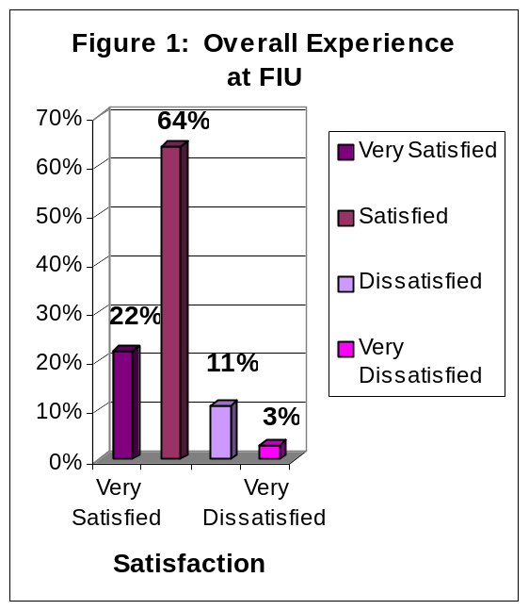
The findings in Figure 1 indicate that 86% of graduating senior respondents were satisfied with their overall experience at FIU: 22% of graduating seniors reported that they were very satisfied and 64% were satisfied. Fourteen percent of respondents reported that they were dissatisfied with their overall experience at FIU: 11% reported being dissatisfied and 3% reported being very dissatisfied.

Correlations: To the extent that respondent seniors were satisfied with FIU, they would recommend FIU to a friend or relative considering college (r = .62, p < .001), they also rated highly their overall academic experience (r = .61, p < .001), were satisfied with the department of their major (r = .56, p < .001).

Overall Academic Experience

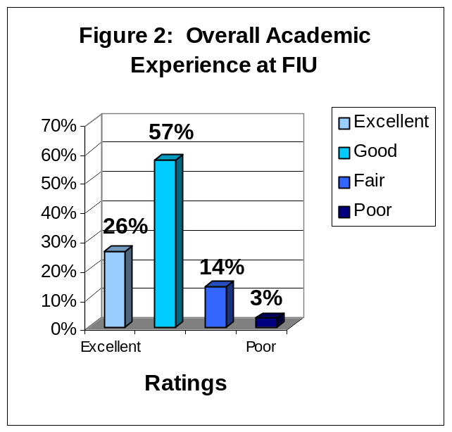
The findings in Figure 2 indicate that 83% of graduating respondents reported a positive overall academic experience: 26% rated their academic experience as excellent while 57% rated their academic experience as good. Seventeen percent of respondents reported that their academic experience at FIU was negative: 14% rated their academic experience as fair and 3% rated their academic experience as poor.

Correlations: To the extent that the graduating respondents rated highly their overall academic experience, they were satisfied with their overall experience at FIU (r=.61, p <.001), reported that the faculty were good teachers (r=.59, p <.001), and would recommend FIU to a friend or relative considering college (r = .57, p < .001).

Challenged to Do Their Best
The findings depicted in Figure 3 indicate that 88% of graduating senior respondents reported that they were challenged to do their best at FIU: 47% reported that they were challenged to do their best most of the time, an additional 41% reported that they were challenged sometimes. Eleven percent of respondents reported that they were not challenged to do their best at FIU: 10% reported that they were seldom challenged and 1%, reported that they had never been challenged.

Correlations: To the extent that graduating respondents were challenged, they were satisfied with their overall experience at FIU (r=.48, p <.001), reported that the faculty were good teachers (r=.47, p <.001), and would recommend FIU to a friend or relative considering college (r = .46, p < .001).

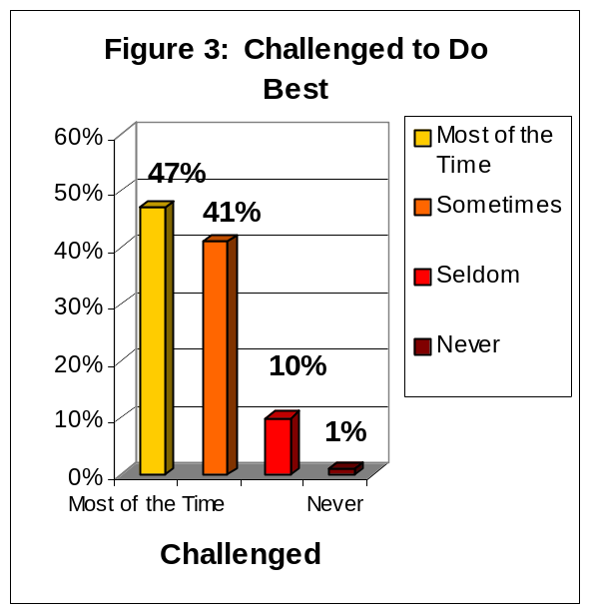

Recommend FIU to Others
The findings depicted in Figure 4 indicate that 87% of graduating senior respondents would recommend FIU to a friend or relative considering college: 45% of respondents would recommend FIU, without reservations and 42% reported that they would recommend FIU, with reservations. Approximately 10% of respondents reported they probably would not recommend FIU and 3% reported that they would not recommend FIU under any circumstances.

Correlations: To the extent that senior respondents would recommend FIU to a friend or relative considering college, they also were satisfied with their overall experience at FIU (r = .62, p < .001), rated their overall academic experience highly (r = .57, p < .001) and rated the quality of other undergraduates at FIU highly (r = .48, p < .001).
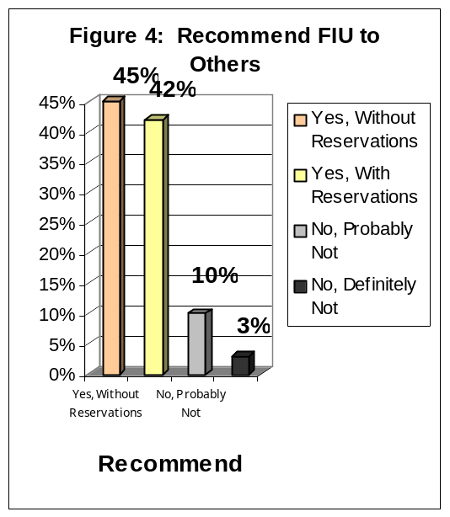

Satisfaction With Department of Major
The findings in Figure 5 indicate that 63% of graduating senior respondents were satisfied with the department of their major at FIU: 18% of graduating respondents strongly agreed that they were satisfied and 45% agreed. Fourteen percent of respondents were not satisfied with the department of their major at FIU: 9% disagreed and 5% strongly disagreed. Another 22% of graduating respondents did not know whether they agreed or disagreed.

Correlations: To the extent that graduating respondents agreed that they were satisfied with the department of their major, they also reported that the faculty in their major were good teachers (r = .63, p < .001) that the quality of courses they took prepared them for employment (r = .61, p < .001), and were satisfied with their overall experience at FIU (r = .56, p < .001).

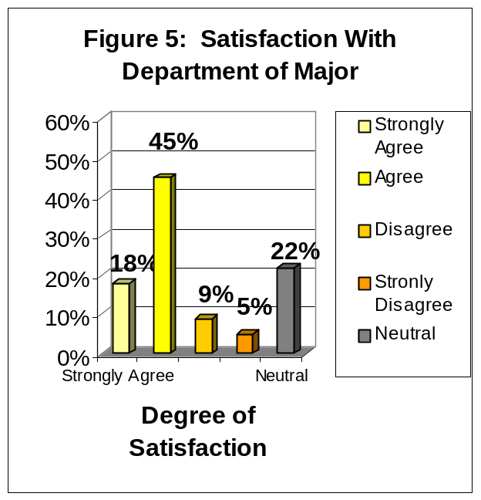

Professors Were Good Teachers
The findings in Figure 6 indicate that 79% of graduating senior respondents at FIU reported that the professors in their major were good teachers: 33% of respondents strongly agreed, another 46% agreed. Seven percent of graduating respondents at FIU did not agree that the professors in their major were good teachers: 5% of graduating seniors disagreed and 2% strongly disagreed. Fourteen percent of graduating seniors did not know whether they agreed or disagreed.

Correlations: To the extent that graduating respondents believed that their professors were good teachers, they also rated highly the department of their major (r = .63, p < .001),
their academic experience at FIU (r = .63, p < .001), and reported that the quality of

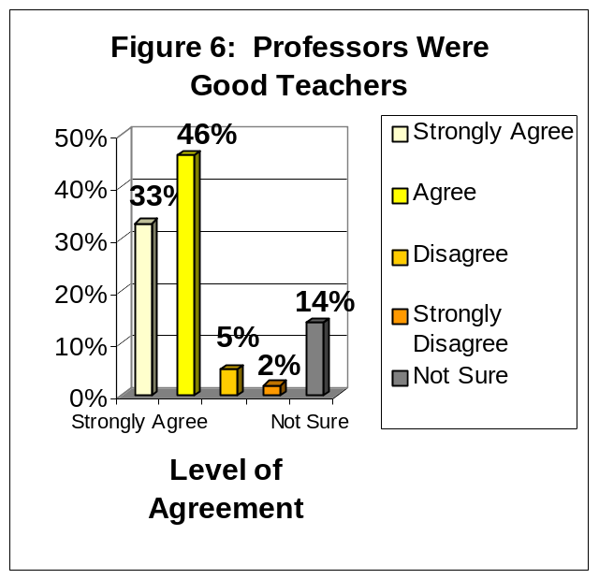

courses they took prepared them for graduate or professional school (r = .58, p < .001).

Professors Were Available Outside of Class
The findings in Figure 7 indicate that 78% of graduating respondents agreed that their professors were available outside of class to assist them: 29% of respondents strongly agreed, an additional 49% agreed. Six percent of respondents did not agree that their professors were available outside of class: 5% of respondents disagreed that their professors were available and 1% strongly disagreed. Another 14% of respondents did not know whether they agreed or disagreed.

Correlations: To the extent that graduating respondents agreed that their professors were available outside of class, they also reported that their professors were good teachers (r = .50, p < .001), were satisfied with their
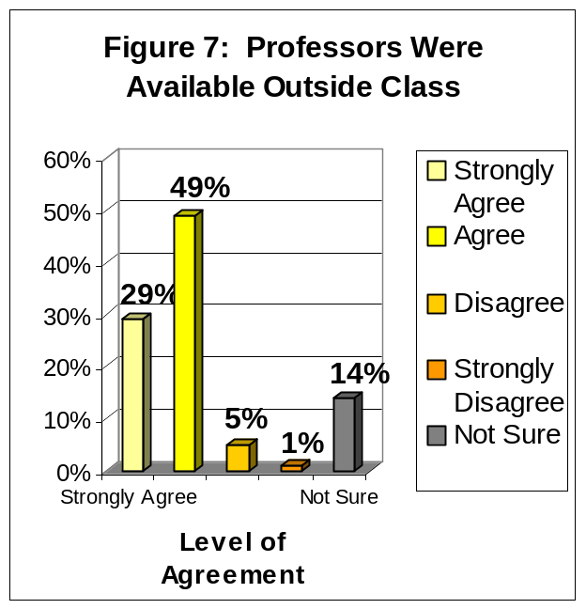
overall experience at FIU (r = .45, p < .001), and were satisfied with the department of their major (r = .44, p < .001).

Quality of Other Undergraduates
The findings in Figure 8 indicate that 68% of graduating respondents reported positive attitudes about the quality of their fellow undergraduate students: 10% believed that the quality of other undergraduate students at FIU was excellent, another 58% believed that the quality of other undergraduates was good. Thirty-two percent held negative attitudes about the quality of their fellow undergraduate students: 26% believed that the quality of other undergraduates was fair while 6% reported that they believed that the quality of other undergraduates was poor.

Correlations: To the extent that the graduating respondents rated the quality of other undergraduate students highly, they also would recommend FIU to a friend or relative considering college (r = .48, p < .001), rated highly their
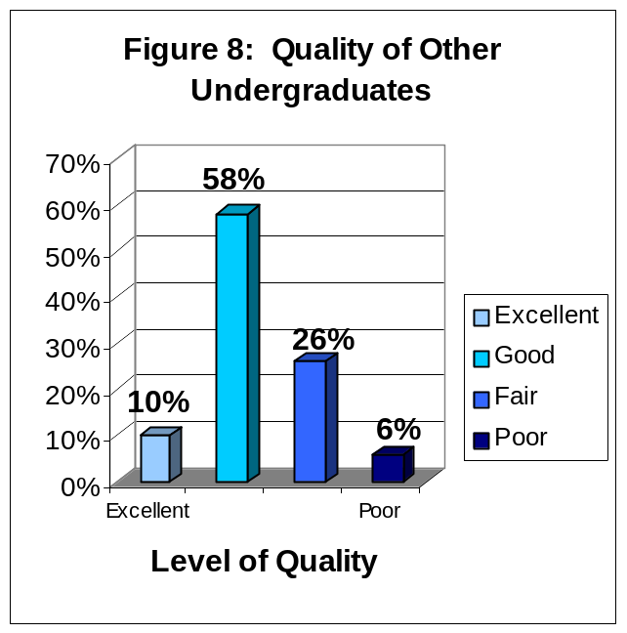
social experience at FIU (r = .48, p < .001), and their academic experience at FIU (r = .45, p < .001).

The Responsiveness of FIU Administration to Student Academic Problems
The findings in Figure 9 indicate that 41% of graduating respondents rated positively the responsiveness of the FIU administration to student academic problems: 9% rated the responsiveness to problems as excellent and 32% good. Fifty-eight percent of respondents rated negatively the responsiveness of the FIU administration to problems: 32% rated the administration’s responsiveness as fair and 26% rated the administration’s responsiveness as poor.

Correlations: Graduating respondents who rated highly the administration’s responsiveness to student academic problems also rated highly the responsiveness of FIU support services to student needs (r = .72, p < .001), were satisfied with their overall experience at FIU (r = .44, p < .001),

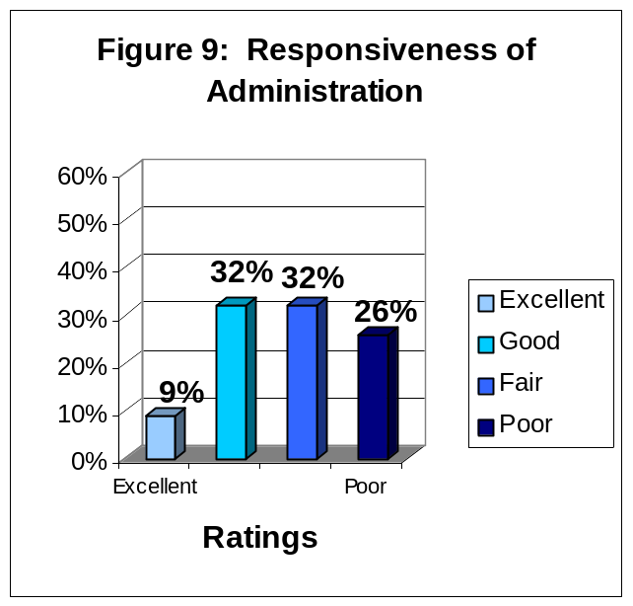
and would recommend FIU to a friend or relative considering college (r = .42, p < .001).

The Responsiveness of FIU Support Services to Student Needs
The findings in Figure 10 indicate that 43% of graduating respondents rated positively the responsiveness of FIU support services to student needs: 8% rated the responsiveness of FIU support services to student needs as excellent and 35% as good. Fifty-four percent of graduating respondents rated the responsiveness of FIU support services to student needs negatively: 32% rated the responsiveness of FIU support services to student needs as fair and 22% assigned a rating of poor.

Correlations: Graduating respondents who rated highly the responsiveness of FIU support services to student needs also rated highly the administration’s responsiveness to student academic problems (r = .72, p < .001),

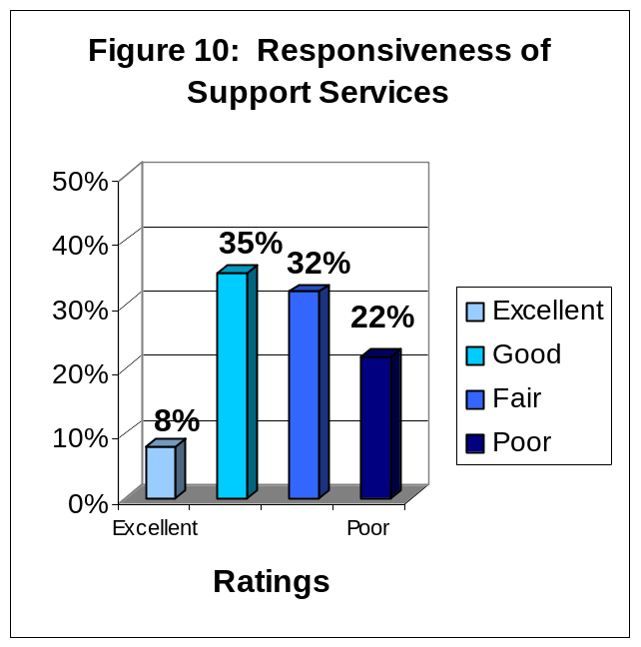
their overall satisfaction with FIU (r = .45, p < .001), and the safety measures on campus (r = .41, p < .001).

The Quality of Courses, in My Major, Prepared Me For Employment

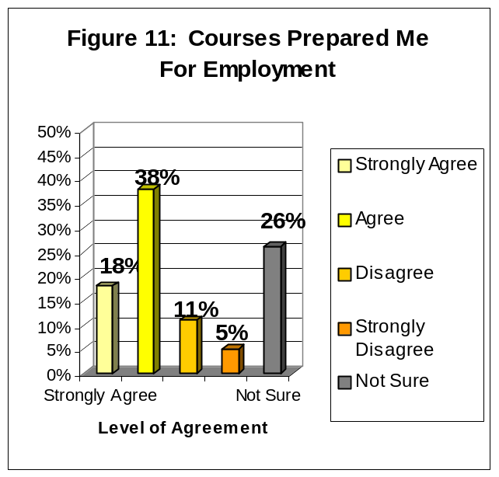
The findings depicted in Figure 11 indicate that 56% of graduating respondents agreed that the quality of courses, in their major at FIU, prepared them for employment: 18% strongly agreed, another 38% agreed. Sixteen percent of graduating respondents did not agree that their courses, in their major, prepared them for employment: 11% disagreed and 5% strongly disagreed. Another 26% of respondents did not know whether they agreed or disagreed.

Correlations: To the extent that graduating respondents agreed that courses in their major prepared them for employment, they reported that the quality of courses they took prepared them for graduate or professional school (r = .59, p < .001), they were satisfied with their overall experience at FIU (r=.53, p <.001),

FIU (r = .53, p < .001), and rated their academic experience at FIU positively (r = .50, p < .001).

The Quality of Courses, in My Major, Prepared Me for Graduate or Professional School

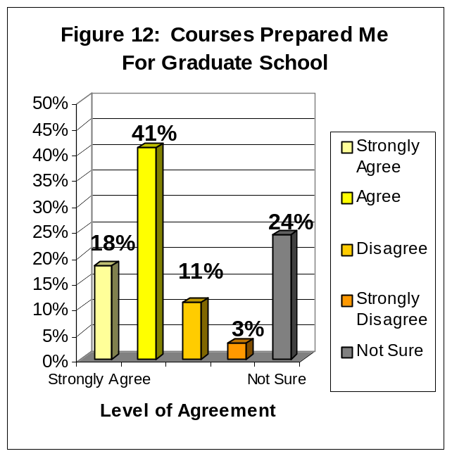
The findings depicted in Figure 12 indicate that 59% of graduating respondents agreed that the quality of courses, in their major, prepared them for graduate school: 18% strongly agreed, another 41% agreed. Fourteen percent of graduating respondents did not agree that the quality of courses, in their major, prepared them for graduate school: 11% disagreed and 3% strongly disagreed. Twenty-four percent of graduating respondents did not know whether they agreed or disagreed.

Correlations: To the extent that graduating respondents agreed that their courses prepared them for graduate school, they also were satisfied with the department of their major (r = .61, p < .001), reported that the quality of courses they
took prepared them for employment (r = .59 p < .001), and the faculty were good teachers (r = .58, p < .001).

IV. SEVEN-YEAR COMPARISON OF TWELVE PRINCIPAL INDICATORS OF THE GRADUATING SENIORS’ OVERALL SATISFACTION WITH FIU

Florida International University began surveying its graduating students in the spring of 1999 and continues to survey gradating seniors every year during the Summer, Fall and Spring semesters. The surveys for the Summer 2004 through Spring 2005 mark the seventh year of data collection of this graduating senior survey. With this sixth data collection we begin to see some trends in students’ responses.

In this section of the report, the focus is on the survey items that have been established as the twelve principal indicators of the graduating students’ satisfaction with the university. Responses to these items have been divided into the categories of positive and negative responses. Additionally, the average percentage of positive and negative responses is displayed.

Overall Experience At FIU

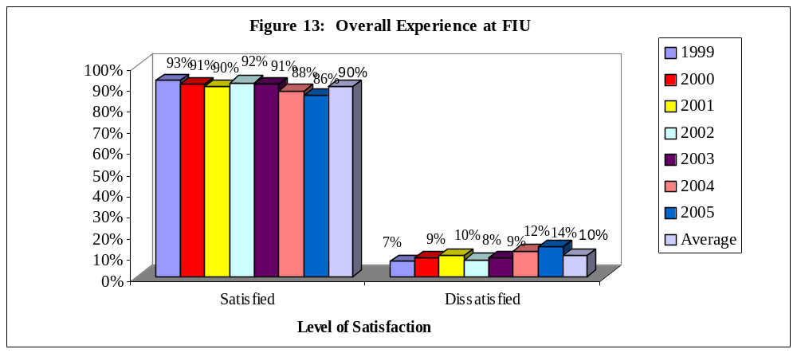

Graduating senior respondents at FIU have reported slightly decreasing levels of satisfaction with their overall experience at FIU from 1999-2001. Then, the levels of satisfaction increased from 2001 to 2002 and decreased from 2002-2005. Respondents who reported that they are ‘Very Satisfied’ (32%, 28%, 29%, 29%, 26%, 21%, and 22% respectively) or ‘Satisfied’ (61%, 63%, 61%, 63%, 65%, 67%, and 64% respectively) ranged from 86-93% for the seven-year period. Respondents who reported that they are ‘Dissatisfied’ (3%, 8%, 8%, 7%, 8%, 9%, and 11% respectively) or ‘Very Dissatisfied’ (4%, 1%, 2%, 1%, 1%, 3%, and 3% respectively) ranged from 7-14% for the seven-year period.

Overall Academic Experience

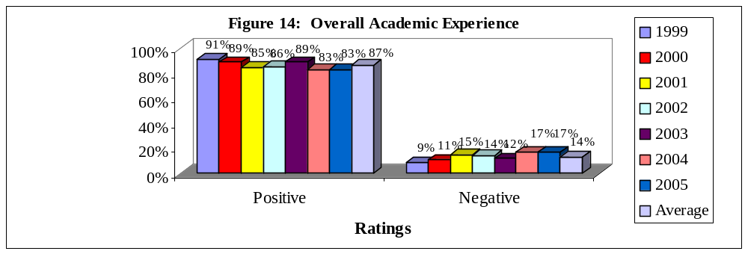

Graduating senior respondents at FIU reported decreasing levels of satisfaction with their overall academic experience at FIU from 1999-2001. However, satisfaction levels increased from 2001-2003 and decreased to its lowest levels in 2004 and 2005. Respondents who reported ‘Excellent’ (36%, 29%, 26%, 29%, 29%, 21%, and 26% respectively) or ‘Good’ (55%, 60%, 59%, 57%, 60%, 62%, and 57% respectively) ratings ranged from 83-91% for the seven-year period. Respondents who reported ‘Fair’ (9%, 8%, 14%, 13%, 11%, 14%, and 14% respectively) or ‘Poor’ (0%, 3%, 1%, 1%, 1%, 3%, and 3% respectively) ratings ranged from 9-17% for the seven-year period.

Challenged to Do Best

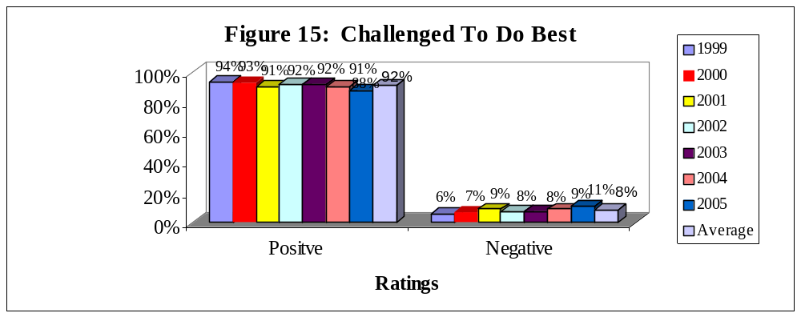

The number of graduating senior respondents that reported that they “are challenged to do their best” at FIU decreased slightly from 1999-2001, remained stable from 2001-2004, and decreased again in 2005. Respondents who reported that they are challenged ‘Most of the time’ (57%, 50%, 50%, 53%, 49%, 50%, 47% respectively) or ‘Sometimes’ (37%, 43%, 41%, 39%, 43%, 41%, and 41% respectively) ranged from 88-94% for the seven-year period. Respondents who have reported that they “are challenged to do their best” ‘Seldom’ (6%, 5%, 8%, 7%, 8%, 8%, and 10% respectively) or ‘Never’ (0%, 2%, 1%, 1%, 0%, 1%, and 1% respectively) ranged from 6-11% for the seven-year period.

Recommend FIU To Others

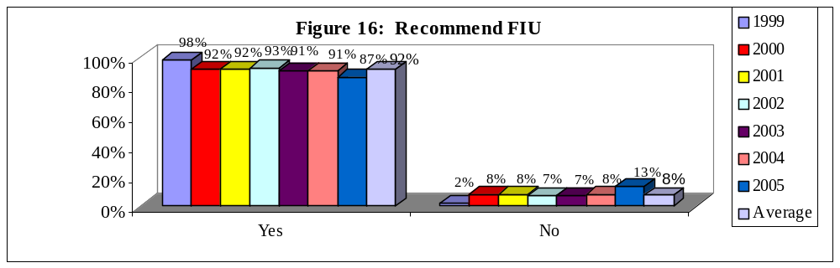
The percent of graduating senior respondents who reported that they would recommend FIU to a friend or relative considering college decreased form 1999 to 2000, remained stable from 2000-2004 and decreased again in 2005. Respondents who reported that they would ‘recommend FIU without reservations’ (60%, 55%, 52%, 53%, 50%, 41%, and 455 respectively) or would ‘recommend with reservations’ (38%, 37%, 40%, 40%, 41%, 50%, and 42% respectively) ranged from 87-98% for the seven-year period. Respondents who reported that they would ‘probably not recommend FIU’ (2%, 7%, 7%, 6%, 7%, 5%, and 10% respectively) or ‘definitely would not recommend FIU’ (0%, 1%, 1%, 1%, 2%, 3%, and 3% respectively) ranged from 2-13% for the seven-year period.

Satisfaction With Department of Major

Please note that the wording of this item was slightly different in 1999, than for 2000-2005.
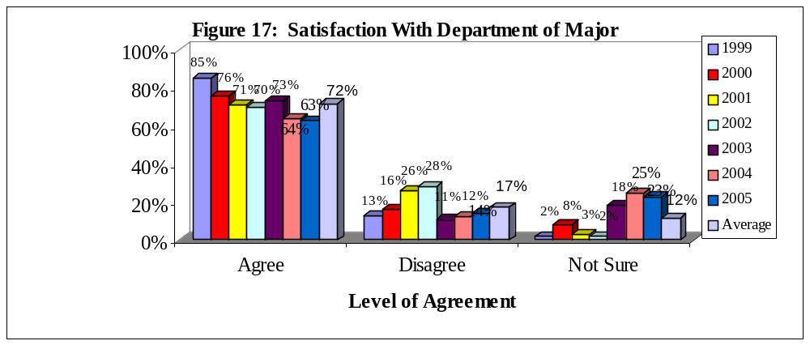
Graduating senior respondents at FIU reported an overall decreasing trend of satisfaction with the department of their major at FIU from 1999-2005. Respondents who ‘Strongly Agreed’ (31%, 22%, 20%, 21%, 25%, 17%, and 18% respectively) or ‘Agreed’ (54%, 54%, 51%, 49%, 48%, 47%, and 45% respectively) that they were satisfied with the department of their major ranged from 63-85% for the seven-year period. Respondents who ‘Disagreed’ (11%, 12%, 17%, 21%, 8%, 9%, and 9% respectively) or ‘Strongly Disagreed’ (2%, 4%, 9%, 7%, 3%, 3%, and 5% respectively) ranged from 11-14% for the seven-year period. Respondents who made a response of ‘Not Sure’ ranged from 2-25% for the five-year period.

Professors Were Good Teachers

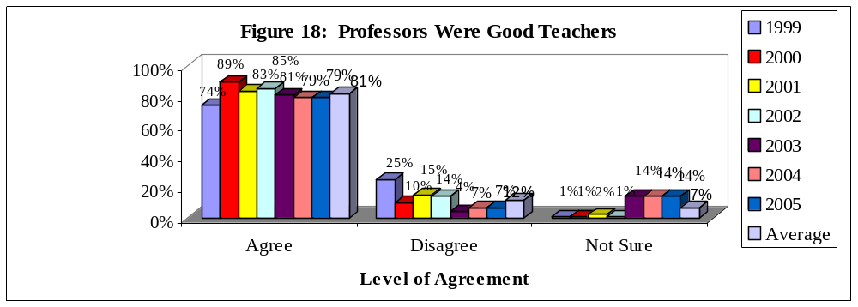

Graduating senior respondents at FIU reported fluctuating levels of agreement with the statement “My professors were good teachers” from 1999-2002 and a decline from 2003-2005. The number of respondents who ‘Strongly Agreed’ (19%, 27%, 32%, 32%, 31%, 37%, and 33% respectively) or ‘Agreed’ (55%, 62%, 51%, 53%, 50%, 42%, and 46% respectively) that their professors were good teachers ranged from 74-89% for the seven-year period. Respondents who ‘Disagreed’ (20%, 8%, 11%, 11%, 4%, 4%, and 5% respectively) or ‘Strongly Disagreed’ (5%, 2%, 4%, 3%, 1%, 3%, and 2% respectively) ranged from 4-25% for the seven-year period. Respondents who made a response of ‘Not Sure’ ranged from 1-14% for the seven-year period.

Professors Were Available Outside of Class

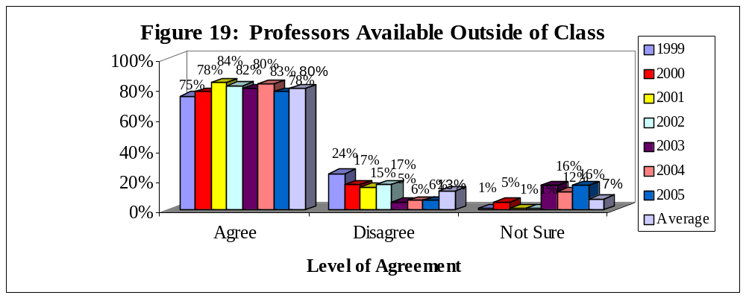

Graduating senior respondents at FIU reported overall increasing levels of agreement with the statement “My professors were available outside of class”. Respondents who ‘Strongly Agreed’ (21%, 21%, 35%, 30%, 32%, 35%, and 29% respectively) or ‘Agreed’ (54%, 57%, 49%, 52%, 48%, 48%, and 49% respectively) that their professors were available ranged from 75-84% for the seven-

year period. Respondents who ‘Disagreed’ (16%, 14%, 12%, 13%, 4%, 5%, and 5% respectively) or ‘Strongly Disagreed’ (8%, 3%, 3%, 4%, 1%, 1%, and 1% respectively) ranged from 5-24% for the seven-year period. Respondents who made a response of ‘Not Sure’ ranged from 1-16% for the seven-year period.

Quality of Other Undergraduates

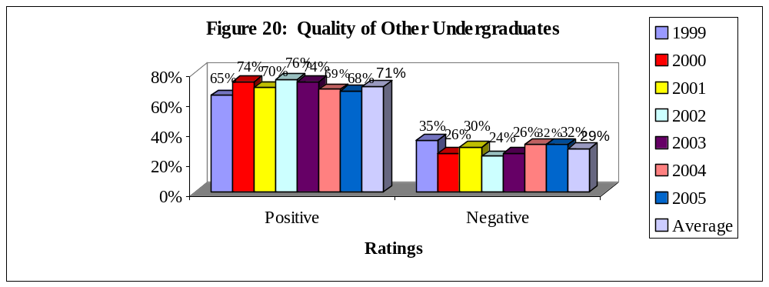
Graduating senior respondents at FIU reported varying levels of positive ratings of their fellow undergraduates from 1999-2005. Respondents who rated the quality of their fellow undergraduates as ‘Excellent’ (11%, 11%, 11%, 13%, 12%, 8%, and 10% respectively) or ‘Good’ (54%, 63%, 59%, 63%, 62%, 61%, and 58% respectively) ranged from 65-76% for the seven-year period. Respondents who assigned ratings of ‘Fair’ (31%, 23%, 26%, 21%, 22%, 25%, and 26% respectively) or ‘Poor’ (4%, 3%, 4%, 3%, 4%, 7%, and 6% respectively) ranged from 24-35% for the seven-year period.

Responsiveness of Administration to Student Academic Problems

Please note that this question was added to the Graduating Senior Survey in 2000.
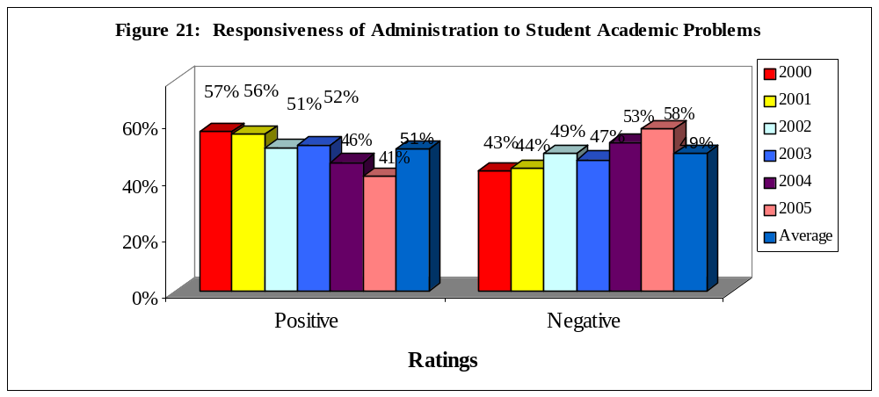
Graduating senior respondents at FIU reported relatively low positive ratings towards the responsiveness of the administration to student academic problems from 2000-2005. Respondents
who reported that the response of the administration was ‘Excellent’ (15%, 10%, 10%, 12%, 7%, and 9% respectively) or ‘Good’ (42%, 46%, 41%, 40%, 39%, and 32% respectively) ranged from 41-57% for the six-year period. Respondents who reported ‘Fair’ (30%, 29%, 35%, 32%, 29%, and 32% respectively) or ‘Poor’ (13%, 15%, 14%, 15%, 24%, and 26% respectively) ratings ranged from 43-58% for the six-year period.

Responsiveness of Support Services to Student Needs

Please note that this question was added to the Graduating Senior Survey in 2000.
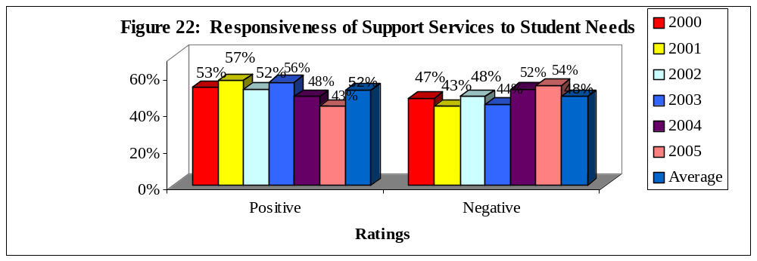

Graduating senior respondents at FIU also reported relatively low positive ratings towards the responsiveness of support services to student needs from 2000-2005. Respondents who reported that the response of the support services was ‘Excellent’ (12%, 12%, and 11%, 13%, 6%, and 8% respectively) or ‘Good’ (41%, 45%, 41%, 43%, 42%, and 35% respectively) ranged from 43-57% for the six-year period. Respondents who reported ‘Fair’ (34%, 29%, 35%, 29%, 33%, and 32% respectively) or ‘Poor’ (13%, 14%,13%, 15%, 19%, and 22% respectively) ratings ranged from 43-54% for the six-year period.

Quality of Courses Prepared for Employment

Please note that the wording of this item was slightly different in 1999.
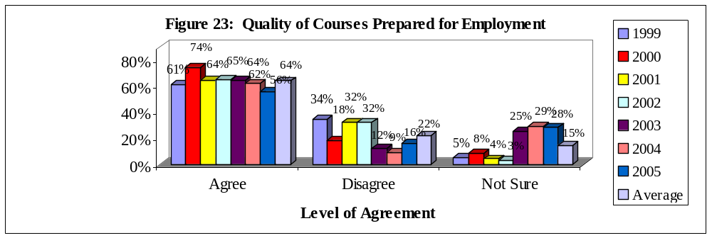
Graduating senior respondents at FIU reported varying levels of agreement from 1999-2005 that the quality of their courses prepared them for employment. Respondents who ‘Strongly Agreed’ (24%, 20%, 20%, 24%, 20%, 18%, and 18% respectively) or ‘Agreed’ (37%, 54%, 44%, 41%, 44%, 44%,
and 38% respectively) with this item ranged from 56-74% for the seven-year period. Respondents who ‘Disagreed’ (23%, 14%, 22%, 22%, 9%, 8%, and 11% respectively) or ‘Strongly Disagreed’ (11%, 4%, 10%, 10%, 3% 1%, and 5% respectively) ranged from 9-34% for the seven-year period. Respondents who made a response of ‘Not Sure’ ranged from 3-29% for the seven-year period.

Quality of Courses Prepared Me for Graduate School

Please note that the wording of the item was slightly different in 1999, than for 2000-2005. 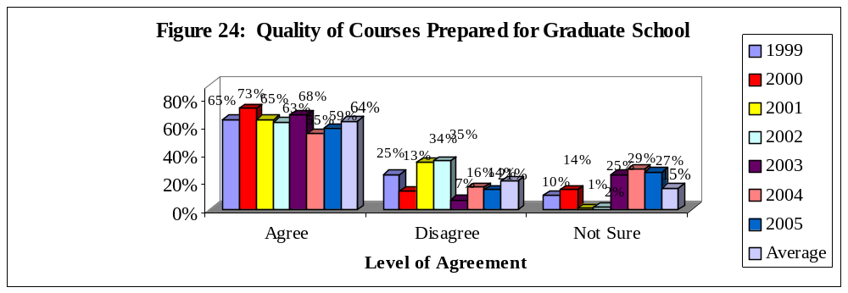

Graduating senior respondents at FIU reported varying levels of agreement from 1999-2005 that the quality of courses prepared them for graduate school. Respondents who ‘Strongly Agreed’ (22%, 19%, 20%, 20%, 23%, 15%, and 18% respectively) or ‘Agreed’ (43%, 54%, 45%, 43%, 44%, 40%, 41% respectively) with this item ranged from 55-73% for the seven-year period. Respondents who ‘Disagreed’ (21%, 11%, 27%, 29%, 5%, 11%, and 11% respectively) or ‘Strongly Disagreed’ (4%, 2%, 7%, 6%, 2%, 5%, and 3% respectively) ranged from 7-35% for the seven-year period. Respondents who made a response of ‘Not Sure’ ranged from 1-29% for the seven-year period.

Conclusions

When looking at data over time, it is helpful to keep several issues in mind. When ratings are consistent over a time period, it is usually an indication that those ratings are a true measure of the item -- that is the measure is a reliable one. However, when ratings are not consistent over time it is possible to draw multiple conclusions. One conclusion would be that the ratings are inconsistent because of flaws in the representativeness of the sample over the time period. A second conclusion would be that there have been true fluctuations in the graduating respondents’ experiences over the time period.

For the most part, positive ratings were relatively consistent over the seven-year period. Positive ratings showed a decrease of 2-3% for 10 of the 12 indicators from 2003-04 to 2004-05. The other two indicators showed no change from the previous year; respondents’ ratings of professors as good teachers and satisfaction with academic experience at FIU.

APPENDIX A: GRADUATING SENIOR SURVEY

APPENDIX A
Graduating Senior Survey: Summer 2004-Spring 2005
Questions on all versions of survey: Principle indicators of student satisfaction
In general, how satisfied are you with |  |  | I am satisfied with how well the department of
your overall experience at FIU? | % |  | my major has met its goals and objectives | %
Very Satisfied | 22 |  | Strongly Agree | 18
Satisfied | 64 |  | Agree | 46
Dissatisfied | 11 |  | Disagree | 9
Very Dissatisfied | 3 |  | Strongly Disagree | 5
 |  |  | Not Sure | 23
What was your primary reason for
attending FIU? | % |  | Please rate the quality of other
Academic reputation | 7 |  | undergraduates at FIU. | %
Cost | 30 |  | Excellent | 10
Location | 37 |  | Good | 59
Type of Program Available | 18 |  | Fair | 24
Other | 8 |  | Poor | 7
What was your status when you first entered |  |  | Please rate the responsiveness of FIU’s
FIU? | % |  | administration to student academic problems. | %
Recent high school graduate | 39 |  | Excellent | 10
Transfer from Community College or | 57 |  | Good | 36
University |  |  | Fair | 32
Other | 4 |  | Poor | 22
When you reflect upon your time at FIU, have |  |  | Please rate the responsiveness of FIU’s
you been challenged to do the very best you |  |  | support services to undergraduate
could? | % |  | student needs | %
Most of the time | 47 |  | Excellent | 9
Sometimes | 41 |  | Good | 38
Seldom | 10 |  | Fair | 32
Never | 1 |  | Poor | 22
Would you recommend FIU to a friend or |  |  | In my major, my professors were good
relative considering college? | % |  | teachers | %
Yes, without reservations | 45 |  | Strongly Agree | 36
Yes, with reservations | 42 |  | Agree | 41
No, probably not | 10 |  | Disagree | 5
No, under no circumstances | 3 |  | Strongly Disagree | 3
 |  |  | Not Sure | 14
Please rate your academic experience |  |  | In my major my professors were
at FIU. | % |  | available outside of class to help me | %
Excellent | 27 |  | Strongly Agree | 32
Good | 56 |  | Agree | 49
Fair | 14 |  | Disagree | 5
Poor | 3 |  | Strongly Disagree | 2
 |  |  | Not Sure | 13
In my major, the quality of courses I took
prepared me for graduate or professional |  |  | In my major, the quality of courses I
school | % |  | took prepared me for employment | %
Strongly Agree | 22 |  | Strongly Agree | 17
Agree | 40 |  | Agree | 39
Disagree | 8 |  | Disagree | 10
Strongly Disagree | 4 |  | Strongly Disagree | 6
Not Sure | 27 |  | Not Sure | 28
Version A: Academic Issues
Did you develop a professional relationship(s) |  |  | In my major, my classes were too large | %
with faculty that is close enough to ask for a |  |  | Strongly Agree | 7
letter of recommendation? | % |  | Agree | 15
Yes | 73 |  | Disagree | 45
No | 27 |  | Strongly Disagree | 9
 |  |  | Not Sure | 25
Did you develop a professional relationship(s) |  |  | In my major, the classes I needed
with faculty that is close enough to ask for |  |  | were available | %
advice about career decisions? | % |  | Strongly Agree | 17
Yes | 75 |  | Agree | 34
No | 25 |  | Disagree | 21
 |  |  | Strongly Disagree | 5
 |  |  | Not Sure | 24
Please rate your social experience at FIU | % |  | In my major, there were a good range
Excellent | 16 |  | of courses available | %
Good | 42 |  | Strongly Agree | 10
Fair | 30 |  | Agree | 33
Poor | 12 |  | Disagree | 28
 |  |  | Strongly Disagree | 8
 |  |  | Not Sure | 22
 |  |  | Courses to meet general education
Please rate the safety measures on campus | % |  | requirements were available to me | %
Excellent | 24 |  | Strongly Agree | 22
Good | 53 |  | Agree | 54
Fair | 18 |  | Disagree | 5
Poor | 5 |  | Strongly Disagree | 2
 |  |  | Not Sure | 18
 |  |  | In my major, I was provided the opportunity
 |  |  | to develop appropriate computer skills | %
In my major, my training in computer skills |  |  | Agree |  |  | 39
prepared me for today’s technology | % |  | Disagree | 13
Strongly Agree | 14 |  | Strongly Disagree | 7
Agree | 28 |  | Not Sure | 23
Disagree | 18
Strongly Disagree | 10 |  | Courses in other departments, but required
Not Sure | 30 |  | by my major were available to me | %
 |  |  | Strongly Agree | 13
In my major, lower division courses |  |  | Agree | 57
adequately prepared me for upper division |  |  | Disagree | 6
courses | % |  | Strongly Disagree | 2
Strongly Agree | 12 |  | Not Sure | 22
Agree | 44
Disagree | 14
Strongly Disagree | 4 |  | Version B: Quality Issues
Not Sure | 26
 |  |  | Please rate the quality of Student
In my major, I was satisfied with my practicum |  |  | Grants | %
or internship experiences | % |  | Excellent | 23
Strongly Agree | 16 |  | Good | 25
Agree | 22 |  | Don’t Know | 28
Disagree | 10 |  | Fair | 15
Strongly Disagree | 9 |  | Poor | 9
Not Sure | 44
 |  |  | Please rate the quality of Student
In my major, I was satisfied with the fairness |  |  | loans | %
of grading in my courses | % |  | Excellent | 11
Strongly Agree | 21 |  | Good | 34
Agree | 55 |  | Don’t Know | 32
Disagree | 10 |  | Fair | 17
Strongly Disagree | 3 |  | Poor | 7
Not Sure | 12
How often have you used Health Services? | % |  | How often have you used the FIU
Frequently | 7 |  | Library at University Park? | %
Occasionally | 18 |  | Frequently | 59
Seldom | 31 |  | Occasionally | 24
Never | 44 |  | Seldom | 14
 |  |  | Never | 4
How often have you used Academic Advising:
Lower Division? | % |  | How often have you used the FIU
Frequently | 16 |  | Library at Biscayne Bay Campus? | %
Occasionally | 23 |  | Frequently | 8
Seldom | 33 |  | Occasionally | 14
Never | 28 |  | Seldom | 23
 |  |  | Never | 55
How often have you used Academic Advising
in your major? | %
Frequently | 29
Occasionally | 39 |  | How often have you used the Counseling
Seldom | 29 |  | and Psychological Services Center? | %
Never | 4 |  | Frequently | 1
 |  |  | Occasionally | 5
How often have you used the Computer |  |  | Seldom | 9
Laboratories/Services? | % |  | Never | 85
Frequently | 44
Occasionally | 30
Seldom | 20 |  | How often have you used Recreational
Never | 6 |  | Services? | %
 |  |  | Frequently | 11
How often have you attended Cultural |  |  | Occasionally | 29
Activities such as speakers, concerts, |  |  | Seldom | 26
movies, etc.? | % |  | Never | 34
Frequently | 11
Occasionally | 21 |  | How often have you used on-campus
Seldom | 40 |  | student employment? | %
Never | 28 |  | Frequently | 10
 |  |  | Occasionally | 10
 |  |  | Seldom | 9
 |  |  | Never | 72
 |  |  | Please rate the quality of the University
 |  |  | Park library | %
 |  |  | Excellent | 46
 |  |  | Good | 44
 |  |  | Don’t Know | 4
 |  |  | Fair | 5
How often have you been involved in |  |  | Please rate the quality of the Biscayne
intramural activities? | % |  | Bay library | %
Frequently | 6 |  | Excellent | 11
Occasionally | 7 |  | Good | 34
Seldom | 12 |  | Don’t Know | 39
Never | 75 |  | Fair | 13
 |  |  | Poor | 3
How often have you used SASS? | %
Frequently | 60 |  | Please rate the quality of Counseling
Occasionally | 21 |  | and Psychological Services | %
Seldom | 10 |  | Excellent | 7
Never | 9 |  | Good | 11
 |  |  | Don’t Know | 77
Please rate the quality of on-campus Student |  |  | Fair | 3
employment | % |  | Poor | 3
Excellent | 10
Good | 22
Don’t Know | 52 |  | Please rate the quality of the Testing Center | %
Fair | 11 |  | Excellent | 4
Poor | 5 |  | Good | 25
 |  |  | Don’t Know | 58
Please rate the quality of Health Services | % |  | Fair | 12
Excellent | 19 |  | Poor | 2
Good | 38
Don’t Know | 28 |  | Please rate the quality of Recreational | %
Fair | 13 |  | Services
Poor | 3 |  | Excellent | 7
 |  |  | Good | 45
Please rate the quality of Academic Advising: |  |  | Don’t Know | 29
Lower Division | % |  | Fair | 17
Excellent | 7 |  | Poor | 2
Good | 29
Don’t Know | 20 |  | Please rate the quality of Intramural
Fair | 28 |  | Activities | %
Poor | 16 |  | Excellent | 4
 |  |  | Good | 21
 |  |  | Don’t Know | 60
Please rate the quality of Academic Advising |  |  | Fair | 12
in your major | % |  | Poor | 2
Excellent | 21
Good | 39
Don’t Know | 1
Fair | 17
Poor | 22
Please rate the quality of the Computer |  |  | Please rate the quality of SASS | %
Laboratories | % |  | Excellent | 32
Excellent | 20 |  | Good | 50
Good | 56 |  | Don’t Know | 6
Don’t Know | 4 |  | Fair | 10
Fair | 16 |  | Poor | 2
Poor | 4
Please rate the quality of Cultural |  |  | Please rate the quality of the FIU catalog | %
Activities | % |  | Excellent | 16
Excellent | 15 |  | Good | 54
Good | 39 |  | Don’t Know | 6
Don’t Know | 33 |  | Fair | 18
Fair | 10 |  | Poor | 5
Poor | 2
 |  |  | P Please rate the quality of the General
Please rate the quality of FIU Class Schedules | % |  | Education program | %
Excellent | 13 |  | Excellent | 14
Good | 32 |  | Good | 52
Don’t Know | 1 |  | Don’t Know | 10
Fair | 30 |  | Fair | 19
Poor | 24 |  | Poor | 5
Please rate the quality of Registration | % |  | Please rate the quality of New Student
Excellent | 11 |  | orientation | %
Good | 42 |  | Excellent | 20
Don’t Know | 0 |  | Good | 40
Fair | 27 |  | Don’t Know | 17
Poor | 21 |  | Fair | 15
 |  |  | Poor | 9
Please rate the quality of Student Judicial
Services | % |  | Please rate the quality of Admissions | %
Excellent | 1 |  | Excellent | 10
Good | 5 |  | Good | 56
Don’t Know | 87 |  | Don’t Know | 5
Fair | 5 |  | Fair | 18
Poor | 3 |  | Poor | 11
Please rate the quality of the Drop and Add |  |  | Please rate the quality of Student
procedure | % |  | Scholarships | %
Excellent | 20 |  | Excellent | 18
Good | 45 |  | Good | 29
Don’t Know | 5 |  | Don’t Know | 30
Fair | 20 |  | Fair | 11
Poor | 11 |  | Poor | 11
Please rate the quality of Student
Records | % |  | Please rate the quality of Student
Excellent | 16 |  | Transcripts | %
Good | 48 |  | Excellent | 15
Don’t Know | 9 |  | Good | 45
Fair | 19 |  | Fair | 16
Poor | 8
Version C: Personal Growth and Advising Issues
How much did FIU contribute to your personal growth in each area below? |  |  | Learning another language? | %
 |  |  | Very Much | 14
Writing effectively? | % |  | Somewhat | 24
Very Much | 36 |  | Very Little | 62
Somewhat | 48
Very Little | 16 |  | Understanding different philosophies
 |  |  | and cultures? | %
Speaking effectively? | % |  | Very Much | 46
Very Much | 45 |  | Somewhat | 39
Somewhat | 40 |  | Very Little | 15
Very Little | 14
 |  |  | Gaining a broad education about
Understanding written information? | % |  | different fields of knowledge? | %
Very Much | 43 |  | Very Much | 40
Somewhat | 43 |  | Somewhat | 41
Very Little | 14 |  | Very Little | 19
Working independently? | % |  | Becoming more aware about the
Very Much | 58 |  | importance of ethical practices? | %
Somewhat | 29 |  | Very Much | 48
Very Little | 13 |  | Somewhat | 36
 |  |  | Very Little | 16
Learning on your own? | %
Very Much | 63 |  | Understanding and appreciating the arts? | %
Somewhat | 27 |  | Very Much | 26
Very Little | 10 |  | Somewhat | 34
 |  |  | Very Little | 40
Working in a group? | %
Very Much | 56 |  | Ability to express your thoughts? | %
Somewhat | 33 |  | Very Much | 38
Very Little | 10 |  | Somewhat | 43
 |  |  | Very Little | 19
Organizing your time effectively? | % |  | Learning to listen more closely to
Very Much | 45 |  | others? | %
Somewhat | 38 |  | Very Much | 42
Very Little | 17 |  | Somewhat | 45
 |  |  | Very Little | 14
Leading and guiding others? | %
Very Much | 46 |  | Critical thinking? | %
Somewhat | 39 |  | Very Much | 50
Very Little | 15 |  | Somewhat | 35
 |  |  | Very Little | 15
Leading a productive life? | %
Very Much | 34 |  | Ability to conceptualize and solve
Somewhat | 44 |  | problems? | %
Very Little | 22 |  | Very Much | 40
 |  |  | Somewhat | 46
Improving your computational skills? | % |  | Very Little | 15
Very Much | 43
Somewhat | 35 |  | Gaining more respect for the principles of
Very Little | 22 |  | moral living? | %
 |  |  | Very Much | 35
Ability to solve analytical problems? | % |  | Somewhat | 42
Very Much | 40 |  | Very Little | 23
Somewhat | 43
Very Little | 17 |  | Ability to develop the skills necessary to
 |  |  | give effective, professional presentations? | %
Desiring intellectual challenges? | % |  | Very Much | 53
Very Much | 44 |  | Somewhat | 35
Somewhat | 41 |  | Very Little | 11
Very Little | 15
Prepared me to pursue life-long learning? | %
Very Much | 45
Somewhat | 39
Very Little
Understanding and applying scientific
principles and methods? | %
Very Much | 30
Somewhat | 45
Very Little | 25
Sources from which I received beneficial academic advising during my last two years at FIU? | % |  | The advice I received was very useful for my educational goals | %
Advisors in my major | 64 |  | Strongly Agree | 25
Central advisors in my college | 11 |  | Agree | 29
Friends | 47 |  | Neutral | 26
I did not seek help from advisors | 6 |  | Disagree | 8
Printed material including the catalog | 34 |  | Strongly Disagree | 12
SASS | 47
Student advisors | 4 |  | The advice I received was very useful
Other | 8 |  | for my career goals | %
 |  |  | Strongly Agree | 22
 |  |  | Agree | 27
If you received advising from University, College |  |  | Neutral | 24
or Departmental sources, please answer |  |  | Disagree | 13
the following questions: |  |  | Strongly Disagree | 14
 | %
In general the advisors were helpful | 27
Strongly Agree | 38
Agree | 16
Neutral | 9
Disagree | 10
Strongly Disagree
Sufficient time was available during |  |  |  |  | %
the advising session | %
Strongly Agree | 22
Agree | 39
Neutral | 16
Disagree | 10
Strongly Disagree | 13
DEMOGRAPHIC INFORMATION: All Respondents
 |  |  | What is your age? | %
While school was in session, about how |  |  | Less than 24 | 49
many hours did you work per week |  |  | 24-29 | 31
for pay? | % |  | 30-39 | 13
I was not employed | 17 |  | 40-49 | 5
1-10 hours | 5 |  | 50 or older | 2
11-20 hours | 18
21-34 hours | 29 |  | Overall, what was your enrollment
35 hours or more | 31 |  | status in college? | %
 |  |  | Full time | 85
I participated in the following activities |  |  | Part time | 15
while working on my degree
(Check all that apply) | % |  | For your first two years of college,
Student Government | 3 |  | where did you live? | %
Intercollegiate Athletics | 2 |  | With parents or relatives | 60
Student Publications | 1 |  | On campus housing | 11
Greek System | 5 |  | Other private dwelling | 29
Political Activities | 5
Community Service | 24 |  | For your last two years of college
Church Activities | 14 |  | where did you live? | %
Performing Arts | 4 |  | With parents or relatives | 56
Intramural Sports | 6 |  | On campus housing | 6
Honor Societies | 17 |  | Other private dwelling | 38
Organizations related to my major | 20
 |  |  | About how far do you live from the campus
What is the highest degree you expect to |  |  | of FIU that you primarily attend? | %
attain? | % |  | I live on campus | 5
No further study intended | 7 |  | I live within one mile of campus | 5
Masters degree | 54 |  | I live 1-10 miles from campus | 36
Specialist degree | 2 |  | I live 11-25 miles from campus | 34
Doctorate | 34 |  | I live over 25 miles from campus | 21
Other | 3
 |  |  | Please indicate your college/school | %
What is your overall Grade Point |  |  | Architecture | 1
Average? | % |  | Arts & Sciences | 36
3.5-4.0 | 31 |  | Business | 26
3.0-3.4 | 47 |  | CHUA | 15
2.5-2.9 | 18 |  | Education | 4
2.0-2.4 | 2 |  | Engineering | 4
Don’t know | 1 |  | Hospitality Management | 4
 |  |  | Journalism & Mass Communication | 8
Please indicate your major
 | N |  | If you are not finishing your degree in 4 years,
Accounting | 24 |  | please indicate all of the reasons why not | %
Advertising | 19 |  | 5 year degree program | 1
Biology | 14 |  | I had to withdraw during a semester | 5
Business Management | 4 |  | I took a semester off from school | 12
Chemistry | 3 |  | Job caused me to reduce course load | 17
Computer Science | 14 |  | I voluntarily took reduced course loads | 8
Criminal Justice | 27 |  | I changed majors | 13
Economics | 5 |  | I had some financial problems | 9
Elementary Education | 6 |  | I had personal or family issues | 13
English | 14 |  | I was misadvised by advisors | 8
Environmental Studies | 4 |  | My required courses were not available | 13
Finance | 25
International Business | 8 |  | What is your gender? | %
International Relation | 9 |  | Female | 67
Liberal Arts | 6 |  | Male | 33
Management Information Systems | 13
Management | 20
Marketing | 14
Mathematical Sciences | 0
Nursing | 6
Political Science | 17
Psychology | 61
Please indicate your racial/ethnic group | %
American Indian/Alaskan Native | 1
Asian | 5
Black/African American | 15
Hispanic | 79
Native Hawaiian/Other Pacific Islander | 0
White | 33
International Student/Non-Resident Alien | 8
Biracial/Multiracial | 0
At which campus did you take most of your
coursework? | %
Biscayne Bay | 21
Broward | 0
University Park | 79

