Office of
Planning and Institutional Effectiveness
Institutional Research



Hope, Knowledge, and Opportunity

Research Report 2007-2008
Survey of Graduating Seniors

University Park Campus
PC 543
Miami, FL 33199
Telephone: (305) 348-2731 Fax: (305) 348-1008
http://w3.fiu.edu/irdata/portal/effectiveness.htm

Office of Planning & Institutional Effectiveness

The Graduating Senior Survey is a survey in the series of Continuous Quality Improvement Surveys instituted by Florida International University’s Office of Planning and Institutional Effectiveness. The information in these Continuous Quality Improvement Survey Reports will be distributed to members of the university community and will be used by the appropriate departments to enhance continuous quality improvement efforts.

Every effort has been made to ensure that the data contained in this document is accurate. For further information about this and other Continuous Quality Improvement Survey Reports, visit our website at http://w3.fiu.edu/irdata/portal/effectiveness.htm, contact the Planning and Institutional Effectiveness at 305-348-2731, (FAX) 305-348-1008, or visit at University Park PC 543.

TABLE OF CONTENTS
Table of Contents |  |  |  |  |  |  |  |  |  |  |  |  |  |  |  |  |  |  |  |  |  |  |  |  |  |  |  |  |  |  |  |  |  |  |  |  |  |  |  | 1
Executive Summary of Graduating Senior Survey 2007-2008 |  |  |  |  |  |  |  |  |  |  |  |  |  |  |  |  |  |  |  |  |  |  |  |  |  |  |  |  |  |  |  |  |  |  |  |  |  |  |  | 4
I. Summary of the Responses to the Graduating Senior Survey 2007-2008
Introduction |  |  |  |  |  |  |  |  |  |  |  |  |  |  |  |  |  |  |  |  |  |  |  |  |  |  |  |  |  |  |  |  |  |  |  |  | 6
Methodology:
Sampling Design |  |  |  |  |  |  |  |  |  |  |  |  |  |  |  |  |  |  |  |  |  |  |  |  |  |  |  |  |  |  |  |  |  |  |  |  | 6
Table 1 Return Rates of 2007-2008 Seniors By College/School |  |  |  |  |  |  |  |  |  |  |  |  |  |  |  |  |  |  |  |  |  |  |  |  |  |  |  |  |  |  |  |  |  |  |  |  | 7
Statistics |  |  |  |  |  |  |  |  |  |  |  |  |  |  |  |  |  |  |  |  |  |  |  |  |  |  |  |  |  |  |  |  |  |  |  |  |  | 7
II. Primary Findings from the 2007-2008 Survey |  |  |  |  |  |  |  |  |  |  |  |  |  |  |  |  |  |  |  |  |  |  |  |  |  |  |  |  |  |  |  |  |  |  |  |  |  | 8
A. Principal Indicators of Satisfaction with FIU |  |  |  |  |  |  |  |  |  |  |  |  |  |  |  |  |  |  |  |  |  |  |  |  |  |  |  |  |  |  |  |  |  |  |  |  | 9
B. Items With the Highest Correlations |  |  |  |  |  |  |  |  |  |  |  |  |  |  |  |  |  |  |  |  |  |  |  |  |  |  |  |  |  |  |  |  |  |  |  |  | 9
C. Primary Reasons Students Did Not Finish FIU in Four Years |  |  |  |  |  |  |  |  |  |  |  |  |  |  |  |  |  |  |  |  |  |  |  |  |  |  |  |  |  |  |  |  |  |  |  |  | 9
D. Four Most Beneficial Sources of Academic Advisement |  |  |  |  |  |  |  |  |  |  |  |  |  |  |  |  |  |  |  |  |  |  |  |  |  |  |  |  |  |  |  |  |  |  |  |  | 9
E. Strongest Correlates of Overall Experience at FIU |  |  |  |  |  |  |  |  |  |  |  |  |  |  |  |  |  |  |  |  |  |  |  |  |  |  |  |  |  |  |  |  |  |  |  |  | 9
F. Strongest Correlates of Overall Academic Experience at FIU |  |  |  |  |  |  |  |  |  |  |  |  |  |  |  |  |  |  |  |  |  |  |  |  |  |  |  |  |  |  |  |  |  |  |  |  | 10
G. Strongest Correlates of Social Experience at FIU |  |  |  |  |  |  |  |  |  |  |  |  |  |  |  |  |  |  |  |  |  |  |  |  |  |  |  |  |  |  |  |  |  |  |  |  | 10
III. Twelve Principal Indicators of the Graduating Seniors’ Overall Satisfaction With FIU (A graphical analysis) |  |  |  |  |  |  |  |  |  |  |  |  |  |  |  |  |  |  |  |  |  |  |  |  |  |  |  |  |  |  |  |  |  |  |  |  |  |  |  |  | 11
Figure 1: Overall Experience at FIU |  |  |  |  |  |  |  |  |  |  |  |  |  |  |  |  |  |  |  |  |  |  |  |  |  |  |  |  |  |  |  |  |  |  |  |  |  | 11
Figure 2: Overall Academic Experience at FIU |  |  |  |  |  |  |  |  |  |  |  |  |  |  |  |  |  |  |  |  |  |  |  |  |  |  |  |  |  |  |  |  |  |  |  |  | 11
Figure 3: Challenged to Do Best |  |  |  |  |  |  |  |  |  |  |  |  |  |  |  |  |  |  |  |  |  |  |  |  |  |  |  |  |  |  |  |  |  |  |  |  | 12
Figure 4: Recommend FIU to Others |  |  |  |  |  |  |  |  |  |  |  |  |  |  |  |  |  |  |  |  |  |  |  |  |  |  |  |  |  |  |  |  |  |  |  |  | 12
Figure 5: Satisfaction With Department of Major |  |  |  |  |  |  |  |  |  |  |  |  |  |  |  |  |  |  |  |  |  |  |  |  |  |  |  |  |  |  |  |  |  |  |  |  | 13
Figure 6: Professors Were Good Teachers |  |  |  |  |  |  |  |  |  |  |  |  |  |  |  |  |  |  |  |  |  |  |  |  |  |  |  |  |  |  |  |  |  |  |  |  | 13
Figure 7: Professors Were Available Outside of Class |  |  |  |  |  |  |  |  |  |  |  |  |  |  |  |  |  |  |  |  |  |  |  |  |  |  |  |  |  |  |  |  |  |  |  |  | 14
Figure 8: Quality of Other Undergraduates |  |  |  |  |  |  |  |  |  |  |  |  |  |  |  |  |  |  |  |  |  |  |  |  |  |  |  |  |  |  |  |  |  |  |  |  | 14
Figure 9: Responsiveness of Administration |  |  |  |  |  |  |  |  |  |  |  |  |  |  |  |  |  |  |  |  |  |  |  |  |  |  |  |  |  |  |  |  |  |  |  |  | 15
Figure 10: Responsiveness of Support Services |  |  |  |  |  |  |  |  |  |  |  |  |  |  |  |  |  |  |  |  |  |  |  |  |  |  |  |  |  |  |  |  |  |  |  |  | 15
Figure 11: Courses Prepared Me For Employment |  |  |  |  |  |  |  |  |  |  |  |  |  |  |  |  |  |  |  |  |  |  |  |  |  |  |  |  |  |  |  |  |  |  |  |  | 16
Figure 12: Courses Prepared Me For Graduate School |  |  |  |  |  |  |  |  |  |  |  |  |  |  |  |  |  |  |  |  |  |  |  |  |  |  |  |  |  |  |  |  |  |  |  |  |  | 16
IV. Five-Year Comparison of Twelve Principal Indicators of the Graduating Seniors’ Overall Satisfaction With FIU |  |  |  |  |  |  |  |  |  |  |  |  |  |  |  |  |  |  |  |  |  |  |  |  |  |  |  |  |  |  |  |  |  |  |  |  | 17
Figure 13: Overall Experience At FIU |  |  |  |  |  |  |  |  |  |  |  |  |  |  |  |  |  |  |  |  |  |  |  |  |  |  |  |  |  |  |  |  |  |  |  | 17
Figure 14: Overall Academic Experience |  |  |  |  |  |  |  |  |  |  |  |  |  |  |  |  |  |  |  |  |  |  |  |  |  |  |  |  |  |  |  |  |  |  |  | 18
Figure 15: Challenged To Do Best |  |  |  |  |  |  |  |  |  |  |  |  |  |  |  |  |  |  |  |  |  |  |  |  |  |  |  |  |  |  |  |  |  |  |  | 18
Figure 16: Recommend FIU |  |  |  |  |  |  |  |  |  |  |  |  |  |  |  |  |  |  |  |  |  |  |  |  |  |  |  |  |  |  |  |  |  |  |  | 19
Figure 17: Satisfaction With Department of Major |  |  |  |  |  |  |  |  |  |  |  |  |  |  |  |  |  |  |  |  |  |  |  |  |  |  |  |  |  |  |  |  |  |  |  | 19
Figure 18: Professors Were Good Teachers |  |  |  |  |  |  |  |  |  |  |  |  |  |  |  |  |  |  |  |  |  |  |  |  |  |  |  |  |  |  |  |  |  |  |  |  |  |  | 20
Figure 19: Professors Available Outside of Class |  |  |  |  |  |  |  |  |  |  |  |  |  |  |  |  |  |  |  |  |  |  |  |  |  |  |  |  |  |  |  |  |  |  |  |  |  |  | 20
Figure 20: Quality of Other Undergraduates |  |  |  |  |  |  |  |  |  |  |  |  |  |  |  |  |  |  |  |  |  |  |  |  |  |  |  |  |  |  |  |  |  |  |  |  |  |  | 21
Figure 21: Responsiveness of Administration to Student Academic Problems |  |  |  |  |  |  |  |  |  |  |  |  |  |  |  |  |  |  |  |  |  |  |  |  |  |  |  |  |  |  |  |  |  |  |  |  |  |  | 21
Figure 22: Responsiveness of Support Services to Student Needs |  |  |  |  |  |  |  |  |  |  |  |  |  |  |  |  |  |  |  |  |  |  |  |  |  |  |  |  |  |  |  |  |  |  |  |  |  |  | 22
Figure 23: Quality of Courses Prepared For Employment |  |  |  |  |  |  |  |  |  |  |  |  |  |  |  |  |  |  |  |  |  |  |  |  |  |  |  |  |  |  |  |  |  |  |  | 22
Figure 24: Quality of Courses Prepared For Graduate School |  |  |  |  |  |  |  |  |  |  |  |  |  |  |  |  |  |  |  |  |  |  |  |  |  |  |  |  |  |  |  |  |  |  |  | 23
Conclusions |  |  |  |  |  |  |  |  |  |  |  |  |  |  |  |  |  |  |  |  |  |  |  |  |  |  |  |  |  |  |  |  |  |  |  | 23
Appendix A: Graduating Senior Survey |  |  |  |  |  |  |  |  |  |  |  |  |  |  |  |  |  |  |  |  |  |  |  |  |  |  |  |  |  |  |  |  |  |  |  | 24

EXECUTIVE SUMMARY OF GRADUATING SENIOR SURVEY
2007-2008

This report summarizes the major findings from the Florida International University Graduating Senior Survey, a Continuous Quality Improvement study conducted by the Office of Planning and Institutional Effectiveness. This survey was adapted from a prototype survey developed by the State University System (SUS) Accountability Committee on Survey Activity (Legg, Final Report, 1992). This survey was designed to measure graduating students’ satisfaction with and attitudes about Florida International University. The survey design assured each individual respondent of his or her anonymity in an attempt to facilitate candor.

The Graduating Senior Survey was distributed to 5,811 students who were intended members of the graduating classes of Summer 2007-Spring 2008. Five hundred-twenty three seniors returned the survey for a response rate of nine percent. The comprehensive survey asked questions about the graduating seniors’ satisfaction with Florida International University in various domains such as the quality and availability of faculty in his or her major, the quality and availability of courses, the quality and availability of academic advising, and the quality of the libraries. The survey also questioned graduating seniors about the frequency of use and quality of services such as Counseling and Psychological Services, the Testing Center, Recreational Services, On-campus student employment, and Health Services.

Twelve principal indicators have been singled out as the most reliable measures of the graduating seniors’ satisfaction with FIU. They have been summarized below.

- Satisfaction with overall experience at FIU: 86% of respondent seniors indicated that they were satisfied with their overall experience (26% very satisfied, 60% satisfied).

- Academic experience: 74% of respondent seniors indicated that they had a positive academic experience (27% excellent, 47% good ratings).

- Challenged: 92% of respondent seniors indicated that they had been challenged to do the best that they could at FIU (50% most of the time, 42% some of the time).

- Recommend FIU: 90% of respondent seniors reported that they would recommend FIU to a friend or relative considering college (45% without reservations, 45% with reservations).

- Satisfaction with department of major: 66% of respondent seniors agreed that they were satisfied with the department of their major (19% strongly agreed, 47% agreed).

- Professors, in my major, were good teachers: 82% of respondent seniors agreed that their professors were good teachers (38% strongly agreed, 44% agreed).

- Professors, in my major, were available outside class: 78% of respondent seniors agreed that their professors were available outside class (32% strongly agreed, 46% agreed).

- Quality of other undergraduates: 71% of respondent seniors gave the quality of their fellow
students’ favorable ratings (13% excellent, 58% good).

- Responsiveness of FIU administration to student academic problems: 42% of respondent seniors rated the administration as responsive to student problems (11% excellent, 31% good).

- Responsiveness of FIU support services to student needs: 42% of respondent seniors rated the responsiveness of FIU support services favorably (11% gave excellent ratings, 31% good).

- Courses, in my major, prepared me for employment: 59% of respondent seniors agreed that their courses prepared them for employment (19% strongly agreed, 40% agreed).

- Courses, in my major, prepared me for graduate or professional school: 66% of respondent seniors agreed that their courses prepared them for further study (21% strongly agreed, 45% agreed).

Items with the Highest Correlations:

- To the extent that graduating senior respondents believed that the FIU support services were responsive to student needs, they also believed that faculty were good teachers (r = .77, p < .001).
- To the extent that graduating respondents agreed that they were able to develop a professional relationship with a faculty member, they also agreed that their department offered a good range of courses (r = .70, p < .001).
- To the extent that respondent seniors were satisfied with their academic experience, they also reported that they developed a professional relationship with a faculty member (r = .68, p < .001).

Strongest Predictors of Academic Experience:

- Ratings of developing professional relationships with faculty members
- Ratings of responsiveness of FIU’s support services towards undergraduates
- Ratings of the quality of other undergraduates

The administration of the survey online may contribute to the problem of low response rates because online surveys generally have lower response rates than paper versions of surveys. However, when the survey was placed online, it was divided into three surveys instead of one, thereby giving each individual student fewer survey items to respond to. Currently, the survey administrator is utilizing the students’ preferred email address to notify the students that the survey is available. Finding ways to streamline the surveys may also increase the response rate. Online surveys are very cost-effective and will continue to be utilized for the foreseeable future.

I. SUMMARY OF THE RESPONSES TO THE GRADUATING SENIOR SURVEY

Summer 2007-Spring 2008

INTRODUCTION

As an institution of higher learning, it is vitally important that student feedback is elicited on a comprehensive range of topics involving the university community. One such avenue of feedback is to request graduating seniors to look back on their time at Florida International University and provide faculty and administrators feedback on their thoughts and attitudes about their experiences at FIU. Therefore, a Continuous Quality Improvement survey is distributed to graduating seniors to give each student an opportunity to have a voice in shaping the future at FIU as we move into the new millennium.

This report summarizes the main findings from the Florida International University Graduating Senior Survey, a Continuous Quality Improvement study conducted by the Office of Planning and Institutional Effectiveness. This survey was adapted from a prototype survey developed by the State University System (SUS) Accountability Committee on Survey Activity (Legg, Final Report, 1992). This survey was designed to measure graduating students’ satisfaction with and attitudes about Florida International University. The survey design assured each individual respondent of his or her anonymity in an attempt to facilitate candor.

METHODOLOGY

Sampling Design. The Registrar’s Office provided an exhaustive list of all students who had filed intent to graduate forms for the Summer 2007-Spring 2008 semester. These students were randomly assigned one of 3 versions of the survey (Academic, Quality, or Personal Growth and Advising) and were then e-mailed a letter from the survey coordinator inviting them to participate. Embedded in the letter was a link to the version of the online survey the student had been assigned. Two e-mail reminders followed up this initial letter before the end of the semester. Out of a graduating class of 5,811 students who were expected to graduate during the 2007-2008 semester, 523 responded to the survey equaling a response rate of 9%. Table 1 shows the number of graduates by college, percentage of graduates by college, and response rate by college. Appendix A provides the Graduating Senior Survey, with tabulated responses for each question.

Table 1: Return Rates of 2007- 2008 Seniors By College/School
 | Headcount Population  of Graduating Class |  | Surveys Returned by College |  | Return Rate of Surveys by College | (% of all returned) minus  (% of class)
FIU College/School | # | % of  graduating  class | # | % of all  returned | % | %
Architecture and the Arts | 189 | 3% | 5 | 1% | 3% | -2%
Arts & Sciences | 1895 | 33% | 272 | 52% | 14% | 19%
Business | 1670 | 29% | 43 | 8% | 3% | -21%
Education | 414 | 7% | 21 | 4% | 5% | -3%
Engineering | 501 | 9% | 36 | 7% | 7% | -2%
Hospitality Management | 227 | 4% | 15 | 3% | 7% | -1%
Journalism | 286 | 5% | 46 | 9% | 16% | 4%
Nursing and Health Sciences | 442 | 8% | 42 | 8% | 10% | 0%
Public Health | 187 | 3% | 43 | 8% | 23% | 5%
Totals | 5,811 | 100% | 523 | 100% | 9% | n/a

Based upon the response rate patterns, it is believed that these respondents were not representative of the 2007-2008 graduating classes. The response rates from each college varied from 1% in the School of Architecture and the Arts to 52% for Arts and Sciences. Seniors from the Schools of Arts and Sciences were over represented in the survey responses. These seniors returned 52% of all surveys, and represented 33% of the graduating class. The School of Architecture and the Arts seniors were under represented in the survey responses. These seniors constituted 3% of the graduating class, but they returned only one percent of all surveys.

Statistics. The data were analyzed using the Statistical Package for Social Sciences (SPSS) version 11.5. In general, a three to five point scale was used for the survey items, with higher scores indicating more positive attitudes. A variety of simple statistics are reported such as percentages and mean findings (arithmetic averages). Correlations (also called Bivariate relationships) are used to describe the relationships among two or more variables. The degree of correlation is denoted by “r” (Pearson Product Moment Correlation). A positive correlation indicates that as scores increase for one variable, they also increase for another variable (or both scores decrease).

II. PRIMARY FINDINGS FROM THE SUMMER 2007-SPRING 2008 SURVEY

A. Principal Indicators of Satisfaction with FIU

Introduction. Twelve principal indicators have been singled out as the most reliable measures of the graduating seniors’ satisfaction with FIU. These measures include overall satisfaction with FIU, whether or not the respondent would recommend FIU to a friend or relative considering college, and whether or not the respondent felt challenged at FIU. The principle indicators also included questions about the department of his or her major, his or her attitudes toward professors’ teaching skills and availability, and questions about the responsiveness of the administration and support services to student needs. In general, FIU students reported very positive attitudes toward FIU; however, positive responses to several important indicators decreased from the responses in the prior year. The following is a summary of graduating students’ responses to the twelve principal indicators. A more descriptive analysis can be found on page eleven. The percentage change from the prior year’s survey findings is listed in bold parentheses, rounded to the nearest percent.

- Satisfaction with overall experience at FIU: 86% of respondent seniors indicated that they were satisfied with their overall experience (26% very satisfied, 60% satisfied). (=)

- Academic experience: 74% of respondent seniors indicated that they had a positive academic experience (27% excellent, 47% good ratings). (-10%)

- Challenged: 92% of respondent seniors indicated that they had been challenged to do the best that they could at FIU (50% most of the time, 42% some of the time). (=)

- Recommend FIU: 90% of respondent seniors reported that they would recommend FIU to a friend or relative considering college (45% without reservations, 45% with reservations. (+1)

- Satisfaction with department of major: 66% of respondent seniors agreed that they were satisfied with the department of their major (19% strongly agreed, 47% agreed). (+8%)

- Professors, in my major, were good teachers: 82% of respondent seniors agreed that their professors were good teachers (38% strongly agreed, 44% agreed). (+2%)

- Professors, in my major, were available outside class: 78% of respondent seniors agreed that their professors were available outside class (32% strongly agreed, 46% agreed). (+2%)

- Quality of other undergraduates: 71% of respondent seniors gave the quality of their fellow
students’ favorable ratings (13% excellent, 58% good). (+6%)

- Responsiveness of FIU administration to student academic problems: 42% of respondent seniors rated the administration as responsive to student problems (11% excellent, 31% good). (-14%)

- Responsiveness of FIU support services to student needs: 42% of respondent seniors rated the responsiveness of FIU support services favorably (11% gave excellent ratings, 31% good). (-10%)

- Courses, in my major, prepared me for employment: 59% of respondent seniors agreed that their courses prepared them for employment (19% strongly agreed, 40% agreed). (-4%)

- Courses, in my major, prepared me for graduate or professional school: 66% of respondent seniors agreed that their courses prepared them for further study (21% strongly agreed, 45% agreed). (+6)

- Items with the Highest Correlations

- To the extent that graduating senior respondents believed that the FIU support services were responsive to student needs, they also believed that faculty were good teachers (r = .77, p < .001).
- To the extent that graduating respondents agreed that they were able to develop a professional relationship with a faculty member, they also agreed that their department offered a good range of courses (r = .70, p < .001).
- To the extent that respondent seniors were satisfied with their academic experience, they also reported that they developed a professional relationship with a faculty member (r = .68, p < .001).
- To the extent that graduating respondents agreed that their courses prepared them for graduate school, they also agreed that their courses were too large (r = .64, p < 001).
- To the extent that senior respondents rated highly the quality of other undergraduates, they reported that faculty were available outside of class (r = .62, p < .001),
- To the extent that the graduating respondents rated highly their overall social experience, they also reported that they were able to develop a professional relationship with a faculty member (r = .61, p < .001).
- To the extent that graduating respondents believed that their courses prepared them for employment, they also believed the faculty were good teachers (r = .60, p < .001).

- Primary Reasons Students Did Not Finish FIU in Four Years

- “Changed majors” (32%)
- “Personal or family issues (30%)
- “Financial problems” (22%)
- “Took a semester off from school” (15%)
- “Job caused reduced course load” (12%)

- Four Most Beneficial Sources of Academic Advisement

- “Advisors in my major” (71%)
- “SASS” (47%)
- “Friends” (44%)
- “Printed Materials” (33%)

Strongest Correlates of Overall Experience at FIU

- Whether respondent would recommend FIU to a friend or relative considering college
- Satisfaction with the availability of faculty outside of the classroom
- Satisfaction with the quality of other undergraduate students

- Strongest Correlates of Overall Academic Experience at FIU

- Reporting that they were a able to develop a professional relationship with a faculty member
- Reporting that they were satisfied with the responsiveness of support services to students
- Reporting that they were satisfied with the quality of other undergraduate students

Strongest Correlates of Social Experience at FIU

- Ratings of developing a professional relationship with a faculty member
- Ratings of fairness in grading
- Reporting that the quality of courses they took in their major adequately prepared them for employment
III. TWELVE PRINCIPAL INDICATORS OF THE GRADUATING SENIORS’

OVERALL SATISFACTION WITH FIU (A graphical analysis)

Overall Experience

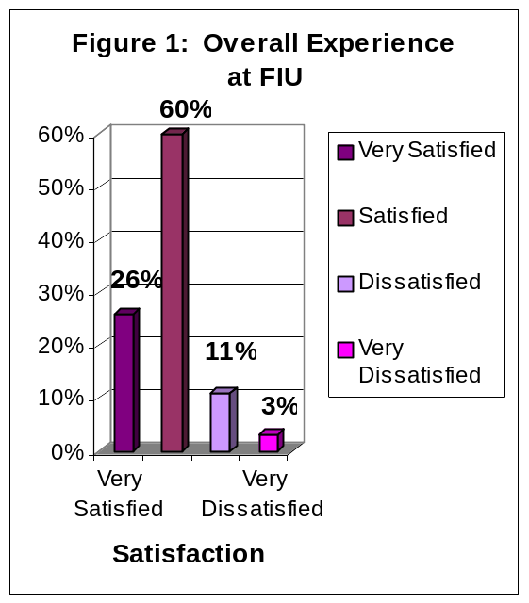
The findings in Figure 1 indicate that 86% of graduating senior respondents were satisfied with their overall experience at FIU: 26% of graduating seniors reported that they were very satisfied and 60% were satisfied. Fourteen percent of respondents reported that they were dissatisfied with their overall experience at FIU: 11% reported being dissatisfied and 3% reported being very dissatisfied.

Correlations: To the extent that respondent seniors were satisfied with FIU, they would recommend FIU to a friend or relative considering college (r = . 42, p < .001), agreed that faculty were available outside of class (r = .41, p < .001), and they also rated highly the quality of other undergraduate (r = .31, p < .001).

Overall Academic Experience

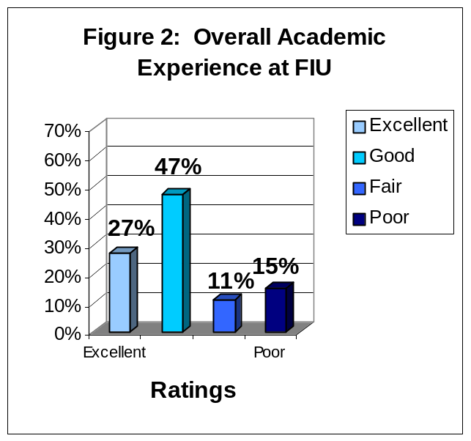
The findings in Figure 2 indicate that 74% of graduating respondents reported a positive overall academic experience: 27% rated their academic experience as excellent while 47% rated their academic experience as good. Twenty-one percent of respondents reported that their academic experience at FIU was negative: 11% rated their academic experience as fair and 15% rated their academic experience as poor.

Correlations: To the extent that the graduating respondents rated highly their overall academic experience, they also reported that they developed a professional relationship with a faculty member (r = .68, p < .001), rated highly the responsiveness of support services to undergraduates (r = .62, p < .001), and rated highly the quality of other

undergraduates (r = .58, p < .001).

Challenged to Do Their Best

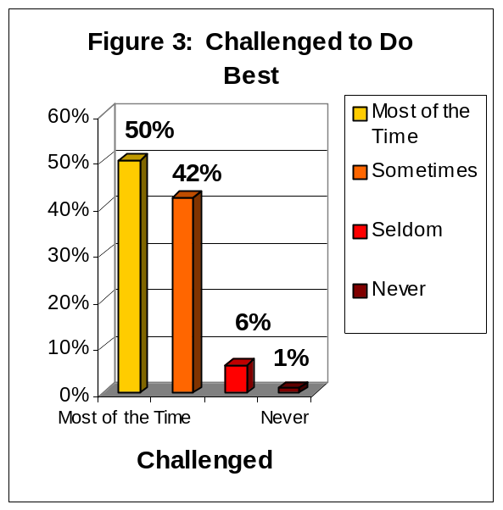
The findings depicted in Figure 3 indicate that 92% of graduating senior respondents reported that they were challenged to do their best at FIU: 50% reported that they were challenged to do their best most of the time, an additional 42% reported that they were challenged sometimes. Seven percent of respondents reported that they were not challenged to do their best at FIU: 6% reported that they were seldom challenged and 1% reported that they had never been challenged.

Correlations: To the extent that graduating respondents were challenged, they would also rated highly their academic experience (r = .42, p < .001), agreed that the faculty were good teachers (r = .43, p < .001), and agreed they were able to develop a professional relationship with a faculty

member (r = .30, p < .001).

Recommend FIU to Others

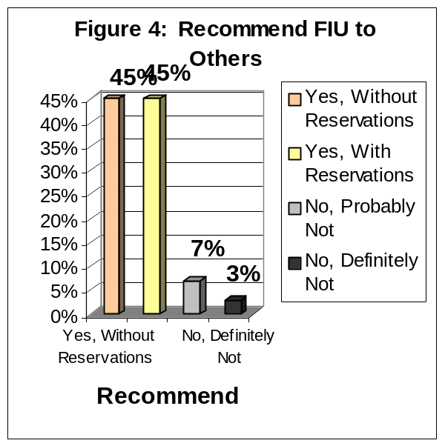
The findings depicted in Figure 4 indicate that 90% of graduating senior respondents would recommend FIU to a friend or relative considering college: 45% of respondents would recommend FIU, without reservations and 45% reported that they would recommend FIU, with reservations. Approximately 7% of respondents reported they probably would not recommend FIU and 3% reported that they would not recommend FIU under any circumstances.

Correlations: To the extent that senior respondents would recommend FIU to a friend or relative considering college, rated highly their academic experience (r = .56, p < .001), were satisfied with the quality of other undergraduates

(r = .55, p < .001), and with the responsiveness of FIU’s administration to students (r = .54, p < .001).

Satisfaction With Department of Major

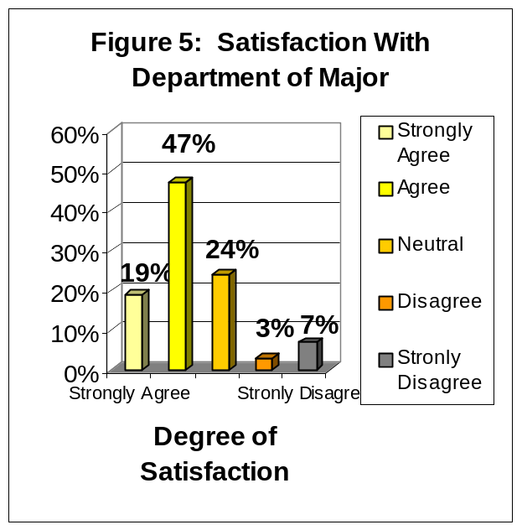
The findings in Figure 5 indicate that 66% of graduating senior respondents were satisfied with the department of their major at FIU: 19% of graduating respondents strongly agreed that they were satisfied and 47% agreed. Ten percent of respondents were not satisfied with the department of their major at FIU: 3% disagreed and 7% strongly disagreed. Another 24% of graduating respondents did not know whether they agreed or disagreed.

Correlations: To the extent that graduating respondents agreed that they were satisfied with the department of their major, they also believed that the courses they took prepared them for employment (r = .76, p < .001), that the courses they took prepared them for graduate school

(r =
(r = .60, p < .001), they also rated highly the quality of students (r = .57, p < .001).

Professors Were Good Teachers
The findings in Figure 6 indicate that 82% of graduating senior respondents at FIU reported that the professors in their major were good teachers: 38% of respondents strongly agreed, another 44% agreed. Five percent of graduating respondents at FIU did not agree that the professors in their major were good teachers: 3% of graduating seniors disagreed and 2% strongly disagreed. Thirteen percent of graduating seniors did not know whether they agreed or disagreed.

Correlations: To the extent that graduating respondents believed that their professors were good teachers, they also rated highly the the responsiveness of FIU’s administration to student’s needs (r = .77, p < .001),
Rated highly their academic experience
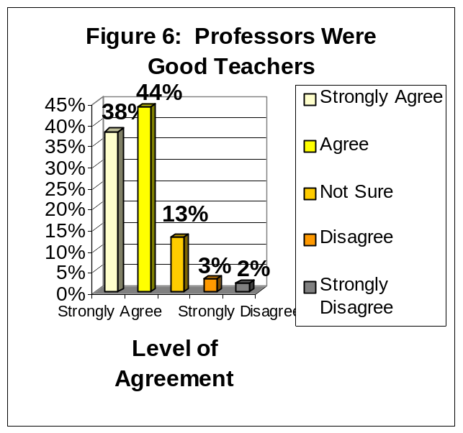

(r = .45, p < .001.), and agreed that they were able to develop a professional relationship with a faculty memeber (r = .45, p < .001).

Professors Were Available Outside of Class
The findings in Figure 7 indicate that 78% of graduating respondents agreed that their professors were available outside of class to assist them: 32% of respondents strongly agreed, an additional 46% agreed. Six percent of respondents did not agree that their professors were available outside of class: 4% of respondents disagreed that their professors were available and 2% strongly disagreed. Another 16% of respondents did not know whether they agreed or disagreed.

Correlations: To the extent that graduating respondents agreed that their professors were available outside of class, they also rated highly the quality of other undergraduates (r = .62,p < .001), reported that in the courses they took

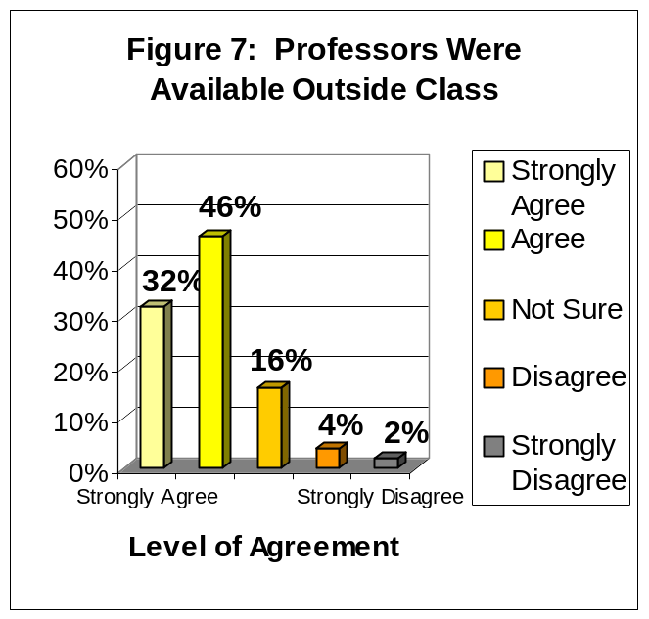
prepared them for employment (r = .60, p < .001), and agreed that the courses they took prepared them for graduate school (r = .57, p < .001).

Quality of Other Undergraduates
The findings in Figure 8 indicate that 71% of graduating respondents reported positive attitudes about the quality of their fellow undergraduate students: 13% believed that the quality of other undergraduate students at FIU was excellent, another 58% believed that the quality of other undergraduates was good. Twenty-nine percent held negative attitudes about the quality of their fellow undergraduate students: 25% believed that the quality of other undergraduates was fair while 4% reported that they believed that the quality of other undergraduates was poor.

Correlations: To the extent that the graduating respondents rated the quality of other undergraduate students highly, they also agreed that the faculty were available outside of the classroom (r = .62, p < .001), were overall

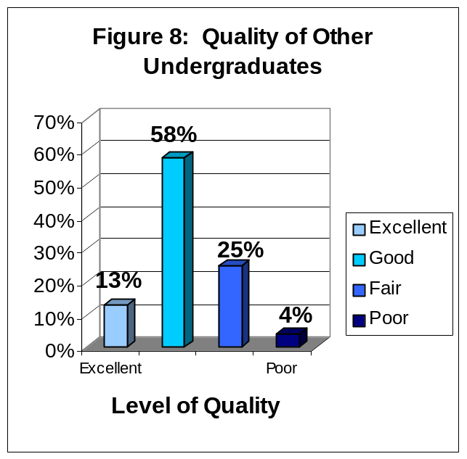

satisfied with department (r = .57, p < .001), would recommend FIU to a friend or relative considering college (r =.55, p < .001).

The Responsiveness of FIU Administration to Student Academic Problems
The findings in Figure 9 indicate that 42% of graduating respondents rated positively the responsiveness of the FIU administration to student academic problems: 11% rated the responsiveness to problems as excellent and 31% good. Fifty-eight percent of respondents rated negatively the responsiveness of the FIU administration to problems: 34% rated the administration’s responsiveness as fair and 24% rated the administration’s responsiveness as poor.

Correlations: Graduating respondents who rated highly the administration’s responsiveness to student academic problems also agreed that faculty were good teachers (r = .77, p < .001), rated their academic experience highly (r = .62, p <.001),

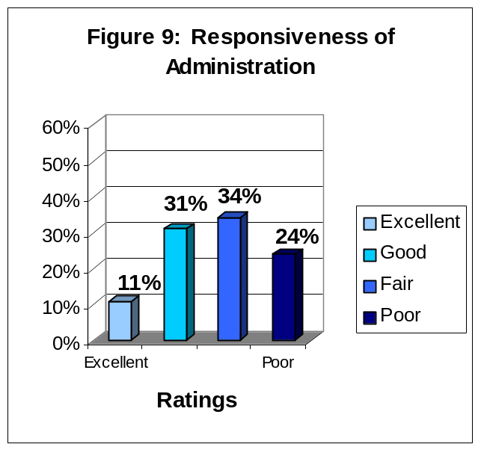
rated highly the responsiveness of FIU support services to student needs (r = .74, p < .001).

The Responsiveness of FIU Support Services to Student Needs
The findings in Figure 10 indicate that 48% of graduating respondents rated positively the responsiveness of FIU support services to student needs: 11% rated the responsiveness of FIU support services to student needs as excellent and 37% as good. Fifty-one percent of graduating respondents rated the responsiveness of FIU support services to student needs negatively: 32% rated the responsiveness of FIU support services to student needs as fair and 19% assigned a rating of poor.

Correlations: Graduating respondents who rated highly the responsiveness of FIU support services to student needs rated highly their academic experience (r = .59, p < .001), and the responsiveness of the administration to student

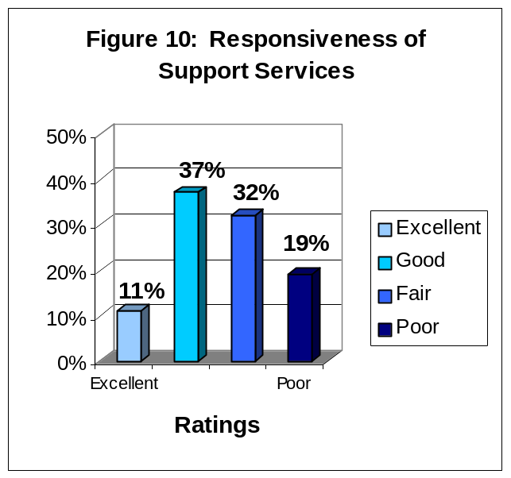
academic problems (r = .54, p < .001), and agreed that they would recommend FIU to family and friends (r = .54, p < .001).

The Quality of Courses, in My Major, Prepared Me For Employment
The findings depicted in Figure 11 indicate that 59% of graduating respondents agreed that the quality of courses, in their major at FIU, prepared them for employment: 19% strongly agreed, another 40% agreed. Twelve percent of graduating respondents did not agree that their courses, in their major, prepared them for employment: 8% disagreed and 4% strongly disagreed. Another 28% of respondents did not know whether they agreed or disagreed.

Correlations: To the extent that graduating respondents agreed that courses in their major prepared them for employment, they also agreed that they were satisfied with major department (r = .71, p < .001), agreed that faculty were available outside of classroom (r = .53, p < .001), and

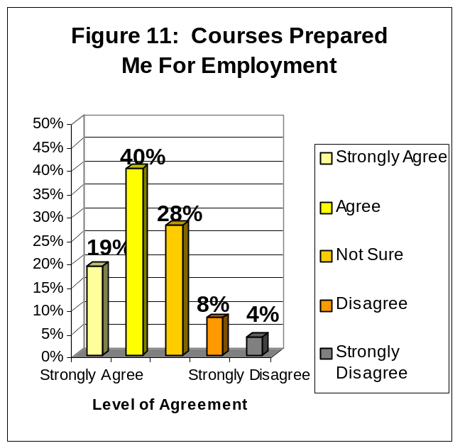
were satisfied with academic experience (r = .51, p < .001).

The Quality of Courses, in My Major, Prepared Me for Graduate or Professional School

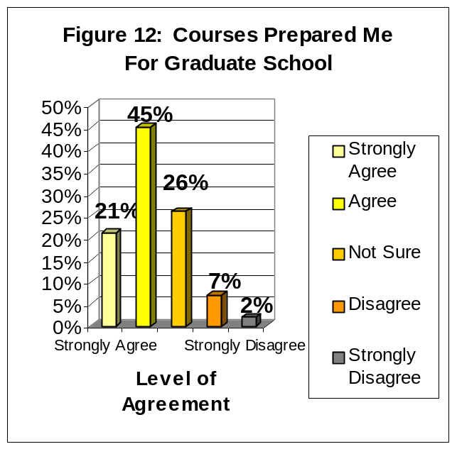
The findings depicted in Figure 12 indicate that 66% of graduating respondents agreed that the quality of courses, in their major, prepared them for graduate school: 21% strongly agreed, another 45% agreed. Nine percent of graduating respondents did not agree that the quality of courses, in their major, prepared them for graduate school: 7% disagreed and 2% strongly disagreed. Twenty-six percent of graduating respondents did not know whether they agreed or disagreed.

Correlations: To the extent that graduating respondents agreed that their courses prepared them for graduate school, they also agreed that the faculty were available outside of class to assist them (r = .60, p < 001), were satisfied with the department of their major (r = .52, p < .001), and

agreed that the courses they took prepared them for employment (r = .51, p < .001).

IV. FIVE-YEAR COMPARISON OF TWELVE PRINCIPAL INDICATORS OF THE GRADUATING SENIORS’ OVERALL SATISFACTION WITH FIU

Florida International University began surveying its graduating students in the spring of 1999 and continues to survey graduating seniors every year. The surveys for the 2007-2008 mark the eighth year of data collection of this graduating senior survey.

In this section of the report, the focus is on the survey items that have been established as the twelve principal indicators of the graduating students’ satisfaction with the university. Responses to these items have been divided into the categories of positive and negative responses. Additionally, the average percentage of positive and negative responses is displayed.

Overall Experience At FIU

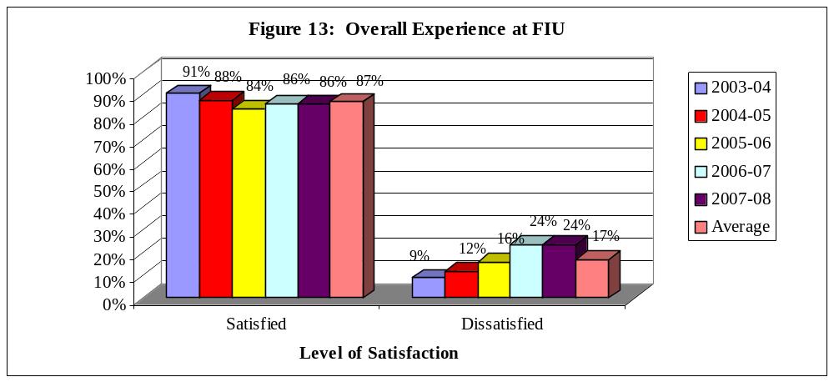

Graduating senior respondents at FIU have reported stable levels of satisfaction with their overall experience at FIU from 2003-2008. The levels of satisfaction decreased slightly from 2003 to 2005 and increased slightly for 2006-2007. Respondents who reported that they are ‘Very Satisfied’ (29%, 29%, 26%, 21% and 26% respectively) or ‘Satisfied’ (61%, 63%, 65%, 67% and 60% respectively) ranged from 91-86% for the five-year period. Respondents who reported that they are ‘Dissatisfied’ (8%, 7%, 8%, 9% and 11% respectively) or ‘Very Dissatisfied’ (2%, 1%, 1%, 3% and 3% respectively) ranged from 9-24% for the five-year period.

Overall Academic Experience

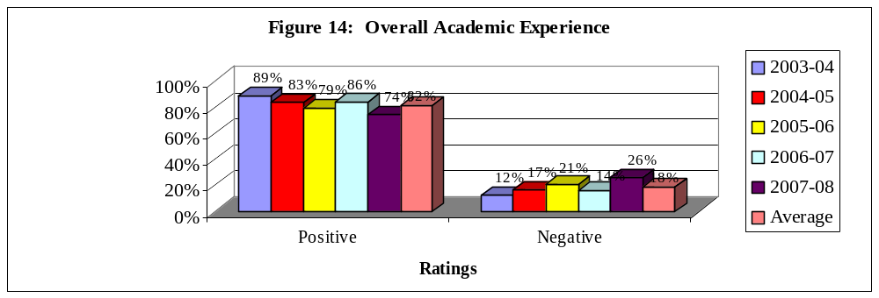

Graduating senior respondents at FIU reported varying levels of satisfaction with their overall academic experience at FIU from 2003-2008. Satisfaction levels decreased from 2003-2005, increased in 2006 and decrease again in 2007. Respondents who reported ‘Excellent’ (26%, 29%, 29%, 21%, and 27% respectively) or ‘Good’ (59%, 57%, 60%, 62%, and 47% respectively) ratings ranged from 89%-74% for the five-year period. Respondents who reported ‘Fair’ (14%, 13%, 11%, 14%, and 11% respectively) or ‘Poor’ (1%, 1%, 1%, 3%, and 15% respectively) ratings ranged from 12-26% for the five-year period.

Challenged to Do Best

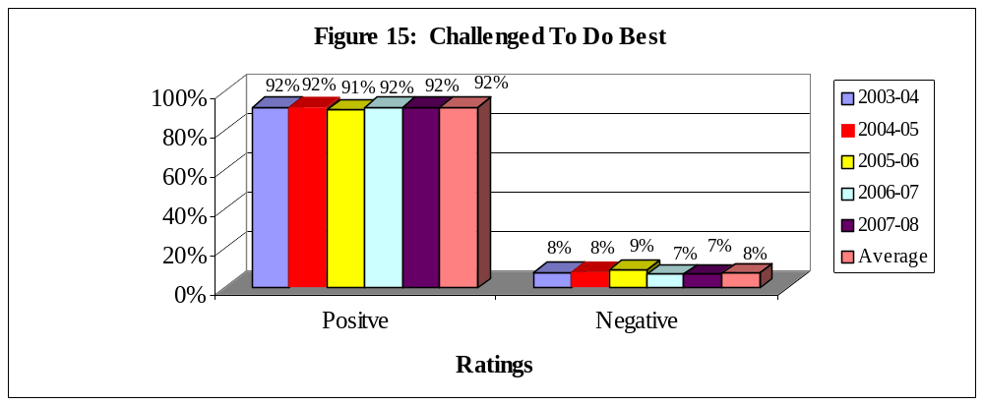

The percentage of graduating senior respondents who reported that they “are challenged to do their best” at FIU has been stable for the past five years. Respondents who reported that they are challenged ‘Most of the time’ (50%, 53%, 49%, 50% and 50% respectively) or ‘Sometimes’ (41%, 39%, 43%, 41% and 42% respectively) ranged from 91-92% for the five-year period. Respondents who have reported that they “are challenged to do their best” ‘Seldom’ (8%, 7%, 8%, 8% and 6% respectively) or ‘Never’ (1%, 1%, 0%, 4% and 1% respectively) ranged from 7-8% for the five-year period.

Recommend FIU To Others

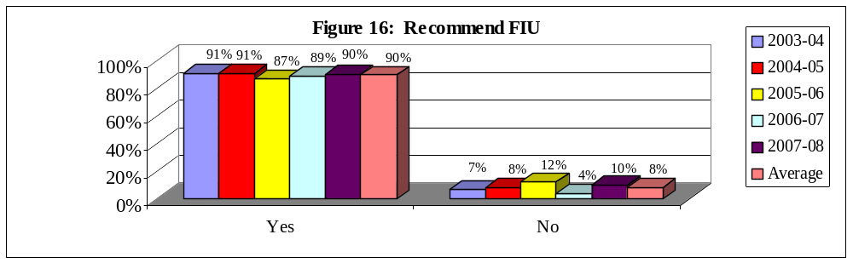
The percent of graduating senior respondents who reported that they would recommend FIU to a friend or relative considering college has remained relatively stable from 2003-2007. Respondents who reported that they would ‘recommend FIU without reservations’ (52%, 53%, 50%, 41% and 45% respectively) or would ‘recommend with reservations’ (40%, 40%, 41%, 50% and 45% respectively) ranged from 87-91% for the five-year period. Respondents who reported that they would ‘probably not recommend FIU’ (7%, 6%, 7%, 5% and 6% respectively) or ‘definitely would not recommend FIU’ (1%, 1%, 2%, 3%, 6% and 1% respectively) ranged from 4-12% for the five-year period.

Satisfaction With Department of Major

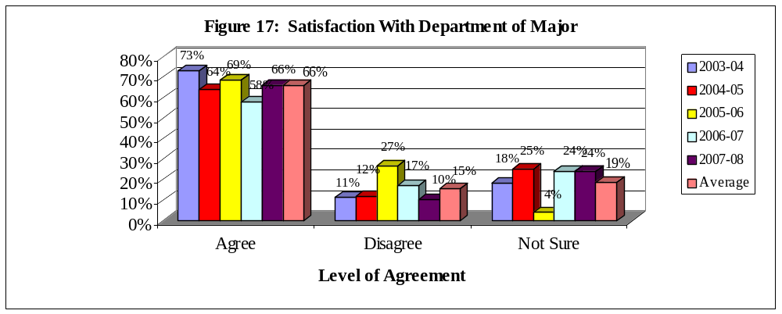
Graduating senior respondents at FIU reported varying levels of satisfaction with the department of their major at FIU from 2003-2007. Respondents who ‘Strongly Agreed’ (20%, 21%, 25%, 17% and 19% respectively) or ‘Agreed’ (51%, 49%, 48%, 47% and 47% respectively) that they were satisfied with the department of their major ranged from 58-73% for the five-year period. Respondents who ‘Disagreed’ (17%, 21%, 8%, 9% and 7% respectively) or ‘Strongly Disagreed’ (9%, 7%, 3%, 3% and 3% respectively) ranged from 10-27% for the five-year period. Respondents who made a response of ‘Not Sure’ ranged from 4-25% for the five-year period.

Professors Were Good Teachers

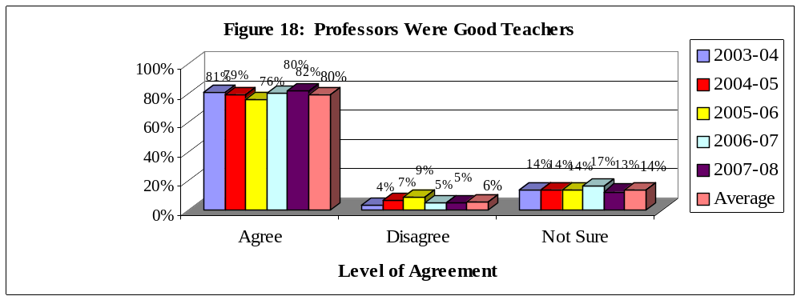

Graduating senior respondents at FIU reported relatively stable levels of agreement with the statement “My professors were good teachers” from 2003-2007. The number of respondents who ‘Strongly Agreed’ (32%, 32%, 31%, 37% and 38% respectively) or ‘Agreed’ (51%, 53%, 50%, 42% and 44% respectively) that their professors were good teachers ranged from 76-82% for the five-year period. Respondents who ‘Disagreed’ (11%, 11%, 4%,4% and 3% respectively) or ‘Strongly Disagreed’ (4%, 3%, 1%, 3% and 2% respectively) ranged from 4-9% for the five-year period. Respondents who made a response of ‘Not Sure’ ranged from 13-17% for the five-year period.

Professors Were Available Outside of Class

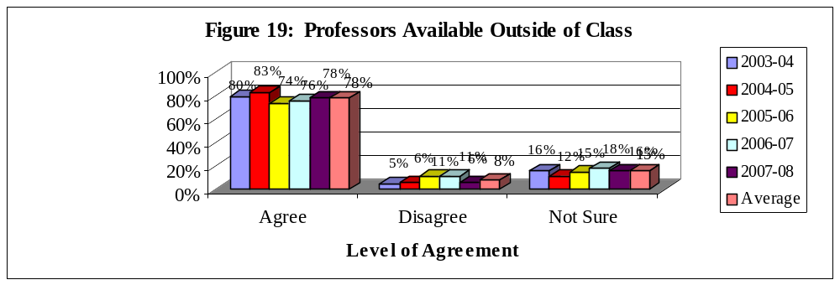

Graduating senior respondents at FIU reported varying levels of agreement with the statement “My professors were available outside of class”. Respondents who ‘Strongly Agreed’ (35%, 30%, 32%, 35%, and 32% respectively) or ‘Agreed’ (49%, 52%, 48%, 48% and 46% respectively) that their professors were available ranged from 74-83% for the five-year period. Respondents who ‘Disagreed’ (12%, 13%, 4%, 5% and 4% respectively) or ‘Strongly Disagreed’ (3%, 4%, 1%, 1% and 2% respectively) ranged from 5-11% for the five-year period. Respondents who made a response of ‘Not Sure’ ranged from 12-18% for the five-year period.

Quality of Other Undergraduates

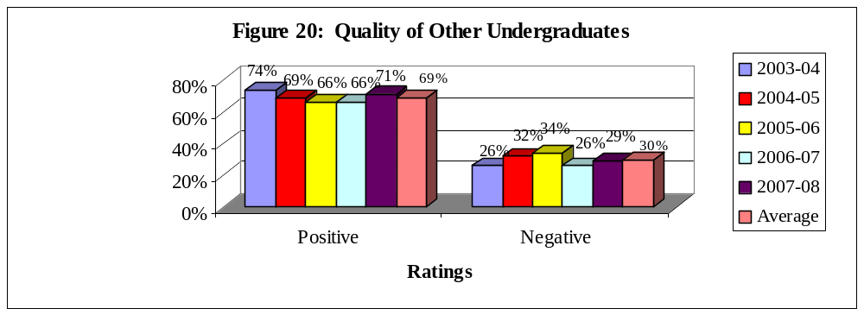
Graduating senior respondents at FIU reported varying levels of positive ratings of their fellow undergraduates from 2003-2007. Respondents who rated the quality of their fellow undergraduates as ‘Excellent’ (11%, 13%, 12%, 8% and 13% respectively) or ‘Good’ (59%, 63%, 62%, 61% and 58% respectively) ranged from 66-74% for the five-year period. Respondents who assigned ratings of ‘Fair’ (26%, 21%, 22%, 25% and 25% respectively) or ‘Poor’ (4%, 3%, 4%, 7% and 4% respectively) ranged from 26-34% for the five-year period.

Responsiveness of Administration to Student Academic Problems

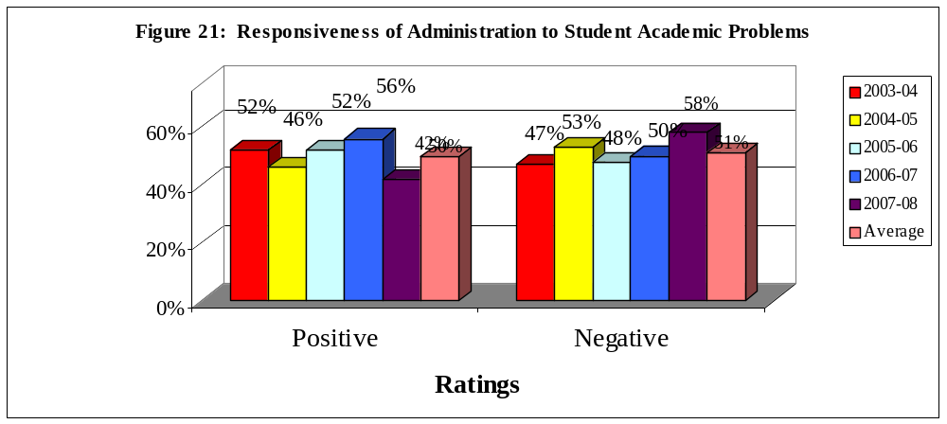

Graduating senior respondents at FIU reported relatively low positive ratings towards the responsiveness of the administration to student academic problems from 2003-2007. Respondents who reported that the response of the administration was ‘Excellent’ (15%, 10%, 10%, 12% and 11% respectively) or ‘Good’ (42%, 46%, 41%, 40% and 31% respectively) ranged from 42-56% for the five-year period. Respondents who reported ‘Fair’ (30%, 29%, 35%, 32% and 34% respectively) or ‘Poor’ (13%, 15%, 14%, 15% and 24% respectively) ratings ranged from 47-58% for the five-year period.

Responsiveness of Support Services to Student Needs

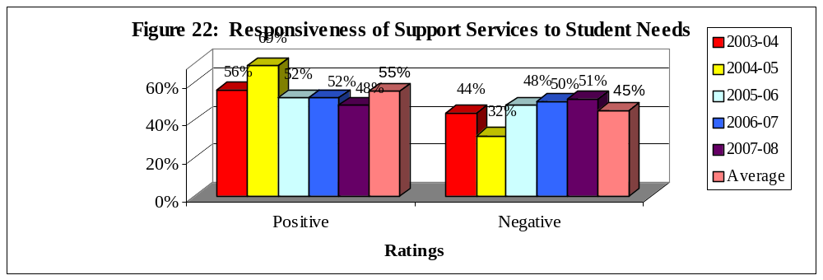

Graduating senior respondents at FIU also reported relatively low positive ratings towards the responsiveness of support services to student needs from 2003-2007. Respondents who reported that the response of the support services was ‘Excellent’ (12%, 12%, 11%, 13% and 11% respectively) or ‘Good’ (41%, 45%, 41%, 43% and 37% respectively) ranged from 52-69% for the five-year period. Respondents who reported ‘Fair’ (34%, 29%, 35%, 29% and 32% respectively) or ‘Poor’ (13%, 14%, 13%, 15% and 19% respectively) ratings ranged from 32-51% for the five-year period.

Quality of Courses Prepared for Employment

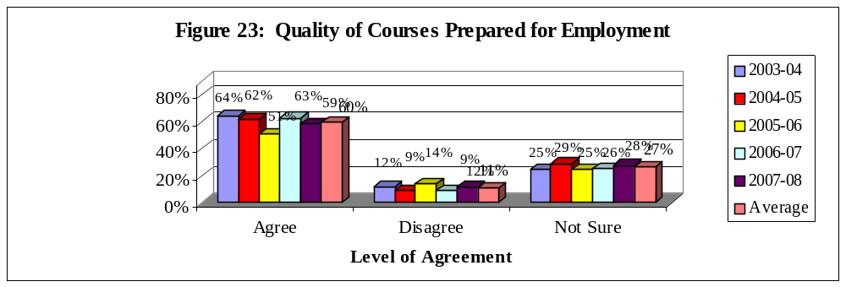

Graduating senior respondents at FIU reported varying levels of agreement from 2003-2007 that the quality of their courses prepared them for employment. Respondents who ‘Strongly Agreed’ (20%, 20%, 24%, 20% and 19% respectively) or ‘Agreed’ (54%, 44%, 41%, 44% and 40% respectively) with this item ranged from 51-64% for the five-year period. Respondents who ‘Disagreed’ (14%, 22%, 22%, 9% and 8% respectively) or ‘Strongly Disagreed’ (4%, 10%, 10%, 3% and 4% respectively) ranged from 9-12% for the five-year period. Respondents who made a response of ‘Not Sure’ ranged from 25-29% for the five-year period.

Quality of Courses Prepared Me for Graduate School

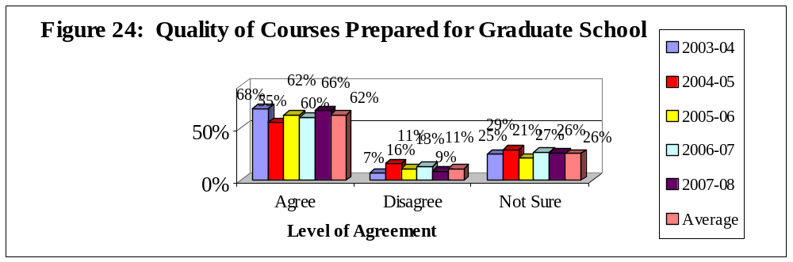

Graduating senior respondents at FIU reported varying levels of agreement from 2003-2007 that the quality of courses prepared them for graduate school. Respondents who ‘Strongly Agreed’ (19%, 20%, 20%, 23% and 21% respectively) or ‘Agreed’ (54%, 45%, 43%, 44% and 45% respectively) with this item ranged from 55-68% for the five-year period. Respondents who ‘Disagreed’ (11%, 27%, 29%, 5% and 7% respectively) or ‘Strongly Disagreed’ (2%, 7%, 6%, 2% and 2% respectively) ranged from 7-13% for the five-year period. Respondents who made a response of ‘Not Sure’ ranged from 21-29% for the five-year period.

Conclusions

When looking at data over time, it is helpful to keep several issues in mind. When ratings are consistent over a time period, it is usually an indication that those ratings are a true measure of the item -- that is the measure is a reliable one. However, when ratings are not consistent over time it is possible to draw multiple conclusions. One conclusion would be that the ratings are inconsistent because of flaws in the representativeness of the sample over the time period. A second conclusion would be that there have been true fluctuations in the graduating respondents’ experiences over the time period.

Positive ratings were relatively consistent over the five-year period for reports of whether the respondents felt challenged to do their best at FIU, the quality of other undergraduates, and whether the respondent would recommend FIU to a friend or relative considering college. Positive ratings mostly decreased over the five-year period for satisfaction with major, whether courses prepared them for graduate school, and whether courses prepared them for employment. Positive ratings fluctuated over the five-year period for perceptions of ratings of satisfaction with department of major, professors availability outside of class, whether the quality of courses prepared them for employment, and responsiveness of support services to student needs.

APPENDIX A: GRADUATING SENIOR SURVEY

APPENDIX A
Graduating Senior Survey: Summer 2007-Spring 2008
Questions on all versions of survey: Principle indicators of student satisfaction
In general, how satisfied are you with |  |  |  |  |  | I am satisfied with how well the department of
your overall experience at FIU? |  |  |  | % |  | my major has met its goals and objectives | %
Very Satisfied |  |  |  | 26 |  | Strongly Agree | 19
Satisfied |  |  |  | 60 |  | Agree | 47
Dissatisfied |  |  |  | 11 |  | Disagree | 7
Very Dissatisfied |  |  |  | 3 |  | Strongly Disagree | 3
 |  |  |  |  |  | Not Sure | 24
What was your primary reason for
attending FIU? |  |  |  | % |  | Please rate the quality of other
Academic reputation |  |  |  | 4 |  | undergraduates at FIU. | %
Cost |  |  |  | 30 |  | Excellent | 11
Location |  |  |  | 46 |  | Good | 55
Type of Program Available |  |  |  | 13 |  | Fair | 28
Other |  |  |  | 7 |  | Poor | 7
What was your status when you first entered |  |  |  |  |  | Please rate the responsiveness of FIU’s
FIU? |  |  |  | % |  | administration to student academic problems. | %
Recent high school graduate |  |  |  | 38 |  | Excellent | 13
Transfer from Community College or |  |  |  | 55 |  | Good | 58
University |  |  |  |  |  | Fair | 25
Other |  |  |  | 6 |  | Poor | 4
When you reflect upon your time at FIU, have |  |  |  |  |  | Please rate the responsiveness of FIU’s
you been challenged to do the very best you |  |  |  |  |  | support services to undergraduate
could? |  |  |  | % |  | student needs | %
Most of the time |  |  |  | 50 |  | Excellent | 11
Sometimes |  |  |  | 42 |  | Good | 37
Seldom |  |  |  | 6 |  | Fair | 32
Never |  |  |  | 1 |  | Poor | 19
Would you recommend FIU to a friend or |  |  |  |  |  | In my major, my professors were good
relative considering college? |  |  |  | % |  | teachers | %
Yes, without reservations |  |  |  | 45 |  | Strongly Agree | 38
Yes, with reservations |  |  |  | 45 |  | Agree | 44
No, probably not |  |  |  | 7 |  | Disagree | 3
No, under no circumstances |  |  |  | 3 |  | Strongly Disagree | 2
 |  |  |  |  |  | Not Sure | 13
Please rate your academic experience |  |  |  |  |  | In my major my professors were
at FIU. |  |  |  | % |  | available outside of class to help me | %
Excellent |  |  |  | 27 |  | Strongly Agree | 32
Good |  |  |  | 47 |  | Agree | 46
Fair |  |  |  | 11 |  | Disagree | 4
Poor |  |  |  | 15 |  | Strongly Disagree | 2
 |  |  |  |  |  | Not Sure | 16
In my major, the quality of courses I took
prepared me for graduate or professional |  |  |  |  |  | In my major, the quality of courses I
school |  |  |  | % |  | took prepared me for employment | %
Strongly Agree |  |  |  | 21 |  | Strongly Agree | 19
Agree |  |  |  | 45 |  | Agree | 40
Disagree |  |  |  | 7 |  | Disagree | 8
Strongly Disagree |  |  |  | 2 |  | Strongly Disagree | 4
Not Sure |  |  |  | 26 |  | Not Sure | 28
Version A: Academic Issues
Did you develop a professional relationship(s) |  |  | In my major, my classes were too large |  |  |  | %
with faculty that is close enough to ask for a |  |  | Strongly Agree |  |  |  | 8
letter of recommendation? | % |  | Agree |  |  |  | 14
Yes | 79.4 |  | Disagree |  |  |  | 55
No | 20.6 |  | Strongly Disagree |  |  |  | 6
 |  |  | Not Sure |  |  |  | 18
Did you develop a professional relationship(s)
with faculty that is close enough to ask for |  |  | In my major, the classes I needed
advice about career decisions? | % |  | were available |  |  |  | %
Yes | 79.4 |  | Strongly Agree |  |  |  | 15
No | 20.6 |  | Agree |  |  |  | 48
 |  |  | Disagree |  |  |  | 15
 |  |  | Strongly Disagree |  |  |  | 8
 |  |  | Not Sure |  |  |  | 48
Please rate your social experience at FIU | %
Excellent | 23 |  | In my major, there were a good range
Good | 31 |  | of courses available |  |  |  | %
Fair | 35 |  | Strongly Agree |  |  |  | 13
Poor | 11 |  | Agree |  |  |  | 33
 |  |  | Disagree |  |  |  | 30
 |  |  | Strongly Disagree |  |  |  | 8
 |  |  | Not Sure |  |  |  | 17
Please rate the safety measures on campus | %
Excellent | 17 |  | In my major, I was provided the opportunity
Good | 57 |  | to develop appropriate computer skills |  |  |  | %
Fair | 22 |  | Strongly Agree |  |  |  | 21
Poor | 5 |  | Agree |  |  |  | 38
 |  |  | Disagree |  |  |  | 10
 |  |  | Strongly Disagree |  |  |  | 4
 |  |  | Not Sure |  |  |  | 28
Courses to meet general education |  |  | Courses in other departments, but required
requirements were available to me | % |  | by my major were available to me |  |  |  | %
Strongly Agree | 14 |  | Strongly Agree |  |  |  | 11
Agree | 65 |  | Agree |  |  |  | 58
Disagree | 3 |  | Disagree |  |  |  | 6
Strongly Disagree | 1 |  | Strongly Disagree |  |  |  | 1
Not Sure | 18 |  | Not Sure |  |  |  | 23
Version B: Quality Issues
How often have you used Health Services? | % |  | Please rate the quality of Student
Frequently | 10 |  | Grants |  |  |  | %
Occasionally | 15 |  | Excellent |  |  |  | 15
Seldom | 24 |  | Good |  |  |  | 26
Never | 51 |  | Don’t Know |  |  |  | 39
 |  |  | Fair |  |  |  | 9
How often have you used Academic Advising: |  |  | Poor |  |  |  | 11
Lower Division? | %
Frequently | 14 |  | Please rate the quality of Student
Occasionally | 26 |  | Loans |  |  |  | %
Seldom | 35 |  | Excellent |  |  |  | 14
Never | 26 |  | Good |  |  |  | 41
 |  |  | Don’t Know |  |  |  | 33
How often have you used Academic Advising |  |  | Fair |  |  |  | 10
in your major? | % |  | Poor |  |  |  | 2
Frequently | 35
Occasionally | 38 |  | How often have you used the FIU
Seldom | 24 |  | Library at University Park? |  |  |  | %
Never | 3 |  | Frequently |  |  |  | 40
 |  |  | Occasionally |  |  |  | 39
How often have you used the Computer |  |  | Seldom |  |  |  | 18
Laboratories/Services? | % |  | Never |  |  |  | 3
Frequently | 44
Occasionally | 27 |  | How often have you used the FIU
Seldom | 20 |  | Library at Biscayne Bay Campus? |  |  |  | %
Never | 9 |  | Frequently |  |  |  | 9
 |  |  | Occasionally |  |  |  | 25
How often have you attended Cultural |  |  | Seldom |  |  |  | 22
Activities such as speakers, concerts, |  |  | Never |  |  |  | 45
movies, etc.? | %
Frequently | 5 |  | How often have you used the Counseling
Occasionally | 20 |  | and Psychological Services Center? |  |  |  | %
Seldom | 37 |  | Frequently |  |  |  | 3
Never | 39 |  | Occasionally |  |  |  | 5
 |  |  | Seldom |  |  |  | 18
How often have you been involved in |  |  | Never |  |  |  | 75
intramural activities? | %
Frequently | 5
Occasionally | 6 |  | How often have you used Recreational
Seldom | 3 |  | Services? |  |  |  | %
Never | 86 |  | Frequently |  |  |  | 12
 |  |  | Occasionally |  |  |  | 13
How often have you used SASS? | % |  | Seldom |  |  |  | 28
Frequently | 54 |  | Never |  |  |  | 46
Occasionally | 32
Seldom | 9 |  | How often have you used on-campus
Never | 5 |  | student employment? |  |  |  | %
 |  |  | Frequently |  |  |  | 8
Please rate the quality of on-campus Student |  |  | Occasionally |  |  |  | 6
employment | % |  | Seldom |  |  |  | 9
Excellent | 3 |  | Never |  |  |  | 77
Good | 27
Don’t Know | 51 |  | Please rate the quality of the University Park library |  |  |  | %
Fair | 11 |  | Excellent |  |  |  | 43
Poor | 8 |  | Good |  |  |  | 48
 |  |  | Don’t Know |  |  |  | 6
Please rate the quality of Health Services | % |  | Fair |  |  |  | 3
Excellent | 21 |  | Poor |  |  |  | 0
Good | 43
Don’t Know | 29 |  | Please rate the quality of the Biscayne
Fair | 7 |  | Bay library |  |  |  | %
Poor | 0 |  | Excellent |  |  |  | 7
 |  |  | Good |  |  |  | 50
Please rate the quality of Academic Advising: |  |  | Don’t Know |  |  |  | 29
Lower Division | % |  | Fair |  |  |  | 12
Excellent | 4 |  | Poor |  |  |  | 2
Good | 35
Don’t Know | 12 |  | Please rate the quality of Counseling
Fair | 33 |  | and Psychological Services |  |  |  | %
Poor | 16 |  | Excellent |  |  |  | 6
 |  |  | Good |  |  |  | 24
 |  |  | Don’t Know |  |  |  | 55
Please rate the quality of Academic Advising |  |  | Fair |  |  |  | 12
in your major | % |  | Poor |  |  |  | 3
Excellent | 24
Good | 40 |  | Please rate the quality of the Testing Center |  |  |  | %
Don’t Know | 2 |  | Excellent |  |  |  | 3
Fair | 21 |  | Good |  |  |  | 27
Poor | 13 |  | Don’t Know |  |  |  | 51
 |  |  | Fair |  |  |  | 19
Please rate the quality of the Computer |  |  | Poor |  |  |  | 0
Laboratories | %
Excellent | 24 |  | Please rate the quality of Recreational |  |  |  | %
Good | 51 |  | Services
Don’t Know | 6 |  | Excellent |  |  |  | 15
Fair | 14 |  | Good |  |  |  | 42
Poor | 5 |  | Don’t Know |  |  |  | 33
 |  |  | Fair |  |  |  | 8
Please rate the quality of Cultural |  |  | Poor |  |  |  | 2
Activities | %
Excellent | 9 |  | Please rate the quality of Intramural
Good | 43 |  | Activities |  |  |  | %
Don’t Know | 36 |  | Excellent |  |  |  | 4.2
Fair | 9 |  | Good |  |  |  | 9.3
Poor | 2 |  | Don’t Know |  |  |  | 77.9
 |  |  | Fair |  |  |  | 5.1
 |  |  | Poor |  |  |  | 3.5
Please rate the quality of FIU Class Schedules | %
Excellent | 13.2 |  | Please rate the quality of SASS |  |  |  | %
Good | 43.9 |  | Excellent |  |  |  | 41
Don’t Know | 27.1 |  | Good |  |  |  | 44.5
Fair | 15.8 |  | Don’t Know |  |  |  | 9.5
Poor | 13.2 |  | Fair |  |  |  | 4.4
 |  |  | Poor |  |  |  | 0.6
Please rate the quality of Registration | %
Excellent | 13.1
Good | 48.6 |  | Please rate the quality of the FIU catalog |  |  |  | %
Don’t Know | 26.8 |  | Excellent |  |  |  | 27.1
Fair | 11.5 |  | Good |  |  |  | 57
Poor | 13.1 |  | Don’t Know |  |  |  | 7
 |  |  | Fair |  |  |  | 6.7
Please rate the quality of Student Judicial |  |  | Poor |  |  |  | 2.2
Services | %
Excellent | 2.6 |  | Please rate the quality of the General
Good | 4.5 |  | Education program |  |  |  | %
Don’t Know | 85.2 |  | Excellent |  |  |  | 16
Fair | 2.3 |  | Good |  |  |  | 49.8
Poor | 5.5 |  | Don’t Know |  |  |  | 20.4
 |  |  | Fair |  |  |  | 12.1
 |  |  | Poor |  |  |  | 1.6
Please rate the quality of Academic Advising |  |  | Please rate the quality of New Student orientation |  |  |  | %
in your major | % |  | Excellent |  |  |  | 15.1
Excellent | 24 |  | Good |  |  |  | 34.6
Good | 40 |  | Don’t Know |  |  |  | 34.3
Don’t Know | 2 |  | Fair |  |  |  | 11.9
Fair | 21 |  | Poor |  |  |  | 4.2
Poor | 13
Please rate the quality of the Computer |  |  | Please rate the quality of Admissions |  |  |  | %
Laboratories | % |  | Excellent |  |  |  | 14.1
Excellent | 24 |  | Good |  |  |  | 54.3
Good | 51 |  | Don’t Know |  |  |  | 5.1
Don’t Know | 6 |  | Fair |  |  |  | 21.7
Fair | 14 |  | Poor |  |  |  | 4.8
Poor | 5
Please rate the quality of Cultural Activities | % |  | Please rate the quality of Student Scholarships |  |  |  | %
Excellent | 9 |  | Excellent |  |  |  | 13.7
Good | 43 |  | Good |  |  |  | 19.7
Don’t Know | 36 |  | Don’t Know |  |  |  | 45.2
Fair | 9 |  | Fair |  |  |  | 11.5
Poor | 2 |  | Poor |  |  |  | 9.9
Please rate the quality of FIU Class Schedules | % |  | Please rate the quality of Student Transcripts |  |  |  | %
Excellent | 13.2 |  | Excellent |  |  |  | 17.3
Good | 43.9 |  | Good |  |  |  | 43.3
Don’t Know | 27.1 |  | Don’t Know |  |  |  | 18.3
Fair | 15.8 |  | Fair |  |  |  | 17
Poor | 13.2 |  | Poor |  |  |  | 4.2
Please rate the quality of Registration | % |  | Please rate the quality of Student Records |  |  |  | %
Excellent | 13.1 |  | Excellent |  |  |  | 21.4
Good | 48.6 |  | Good |  |  |  | 50.8
Don’t Know | 26.8 |  | Don’t Know |  |  |  | 6.4
Fair | 11.5 |  | Fair |  |  |  | 17.9
Poor | 13.1 |  | Poor |  |  |  | 3.5
Please rate the quality of Student Judicial Services | % |  | Please rate the quality of the Drop and Add procedure |  |  |  | %
Excellent | 2.6 |  | Excellent |  |  |  | 18.5
Good | 4.5 |  | Good |  |  |  | 48.1
Don’t Know | 85.2 |  | Don’t Know |  |  |  | 4.5
Fair | 2.3 |  | Fair |  |  |  | 20.7
Poor | 5.5 |  | Poor |  |  |  | 8.3

Version C: Personal Growth and Advising Issues
How much did FIU contribute to your personal growth in each area below?
Writing effectively? | % |  |  |  | Learning another language? | %
Very Much | 43.5 |  |  |  | Very Much | 14.7
Somewhat | 40.4 |  |  |  | Somewhat | 21.1
Very Little | 16.1 |  |  |  | Very Little | 64.2
Speaking effectively? | % |  |  |  | Understanding different philosophies and cultures? | %
Very Much | 41.9 |  |  |  | Very Much | 46.6
Somewhat | 41.9 |  |  |  | Somewhat | 38.1
Very Little | 16.1 |  |  |  | Very Little | 15.2
Understanding written information? | % |  |  |  | Gaining a broad education about different fields of knowledge? | %
Very Much | 44.2 |  |  |  | Very Much | 45
Somewhat | 43.9 |  |  |  | Somewhat | 42.2
Very Little | 11.9 |  |  |  | Very Little | 12.8
Working independently? | % |  |  |  | Becoming more aware about the importance of ethical practices | %
Very Much | 55.8 |  |  |  | Very Much | 45.1
Somewhat | 33.2 |  |  |  | Somewhat | 39.9
Very Little | 11 |  |  |  | Very Little | 14.9
Learning on your own? | % |  |  |  | Understanding and appreciating the arts? | %
Very Much | 63 |  |  |  | Very Much | 27.2
Somewhat | 26.9 |  |  |  | Somewhat | 39.2
Very Little | 10.1 |  |  |  | Very Little | 33.6
Working in a group? | % |  |  |  | Ability to express your thoughts? | %
Very Much | 52.1 |  |  |  | Very Much | 39.1
Somewhat | 38.4 |  |  |  | Somewhat | 45.9
Very Little | 9.5 |  |  |  | Very Little | 15
Organizing your time effectively? | % |  |  |  | Learning to listen more closely to others? | %
Very Much | 42.1 |  |  |  | Very Much | 41
Somewhat | 40.5 |  |  |  | Somewhat | 43.7
Very Little | 17.4 |  |  |  | Very Little | 15.3
Leading and guiding others? | % |  |  |  | Critical thinking? | %
Very Much | 43 |  |  |  | Very Much | 53.8
Somewhat | 37.8 |  |  |  | Somewhat | 37.8
Very Little | 19.2 |  |  |  | Very Little | 8.3
Leading a productive life? | % |  |  |  | Ability to conceptualize and solve problems? | %
Very Much | 35 |  |  |  | Very Much | 46.7
Somewhat | 42.3 |  |  |  | Somewhat | 45.2
Very Little | 22.7 |  |  |  | Very Little | 8
Improving your computational skills? | % |  |  |  | Gaining more respect for the principles of moral living? | %
Very Much | 48.2 |  |  |  | Very Much | 33.8
Somewhat | 38.7 |  |  |  | Somewhat | 40.5
Very Little | 13.2 |  |  |  | Very Little | 25.6
Ability to solve analytical problems? | % |  |  |  | Ability to develop the skills necessary to give effective, professional presentations? | %
Very Much | 43.6 |  |  |  | Very Much | 53.1
Somewhat | 44.8 |  |  |  | Somewhat | 39.3
Very Little | 11.7 |  |  |  | Very Little | 7.7
Desiring intellectual challenges? | % |  |  |  | Understanding and applying scientific principles and methods? | %
Very Much | 49.2 |  |  |  | Very Much | 36.9
Somewhat | 40.2 |  |  |  | Somewhat | 47.3
Very Little | 10.5 |  |  |  | Very Little | 15.9
Prepared me to pursue life-long learning? | %
Very Much | 51.2
Somewhat | 38
Very Little | 10.7
Sources from which I received beneficial academic advising during my last two years at FIU?
(Please check all that apply)
 | % |  |  |  |  | %
Advisors in my major | 19.4 |  |  |  | Professors not assigned as advisors | 11.7
Central advisors in my college | 12.2 |  |  |  | SASS | 10.8
Friends | 18 |  |  |  | Student advisors | 3.6
I did not seek help from advisors | 4.1 |  |  |  | Other | 5
Printed material including the catalog | 15.3
If you received advising from University, College or Departmental sources, please answer the following questions:
In general the advisors were helpful | % |  |  |  | The advice I received was very useful
Strongly Agree | 27.1 |  |  |  | for my educational goals | %
Agree | 39.2 |  |  |  | Strongly Agree | 29.6
Neutral | 15.6 |  |  |  | Agree | 32.8
Disagree | 8.9 |  |  |  | Neutral | 22.6
Strongly Disagree | 9.2 |  |  |  | Disagree | 6.7
 |  |  |  |  | Strongly Disagree | 8.3
Sufficient time was available during
the advising session | % |  |  |  | The advice I received was very useful
Strongly Agree | 24.9 |  |  |  | for my career goals | %
Agree | 39.3 |  |  |  | Strongly Agree | 21.1
Neutral | 18.8 |  |  |  | Agree | 27.8
Disagree | 8.6 |  |  |  | Neutral | 28.4
Strongly Disagree | 8.3 |  |  |  | Disagree | 14.1
 |  |  |  |  | Strongly Disagree | 8.6
DEMOGRAPHIC INFORMATION: All Respondents
While school was in session, about how many |  |  |  | What is your age? |  | %
hours did you work per week for pay? | % |  |  | Less than 24 |  | 47.2
I was not employed | 17.9 |  |  | 24-29 |  | 36.1
1-10 hours | 4.2 |  |  | 30-39 |  | 12.8
11-20 hours | 17.8 |  |  | 40-49 |  | 3.2
21-34 hours | 32.3 |  |  | 50 or older |  | 0.7
35 hours or more | 27.7
 |  |  |  | Overall, what was your enrollment
 |  |  |  | status in college? |  | %
I participated in the following activities |  |  |  | Full time |  | 87.3
while working on my degree |  |  |  | Part time |  | 12.7
(Check all that apply) | %
Student Government | 2.7 |  |  | For your first two years of college,
Intercollegiate Athletics | 4.3 |  |  | where did you live? |  | %
Student Publications | 1.2 |  |  | With parents or relatives |  | 58.4
Greek System | 3.7 |  |  | On campus housing |  | 8.6
Political Activities | 0.3 |  |  | Other private dwelling |  | 26.6
Community Service | 26
Church Activities | 14 |  |  | For your last two years of college
Performing Arts | 4.3 |  |  | where did you live? |  | %
Intramural Sports | 9.8 |  |  | With parents or relatives |  | 57.3
Honor Societies | 16 |  |  | On campus housing |  | 5
Organizations related to my major | 12 |  |  | Other private dwelling |  | 37.7
What is the highest degree you expect to |  |  |  | About how far do you live from the campus
attain? | % |  |  | of FIU that you primarily attend? |  | %
No further study intended | 7.2 |  |  | I live on campus |  | 4.2
Masters degree | 56 |  |  | I live within one mile of campus |  | 4.9
Specialist degree | 3.1 |  |  | I live 1-10 miles from campus |  | 34.9
Doctorate | 8.6 |  |  | I live 11-25 miles from campus |  | 37.9
Other | 1.3 |  |  | I live over 25 miles from campus |  | 18
What is your overall Grade Point |  |  |  | Please indicate your college/school |  | %
Average? | % |  |  | Architecture |  | 1.1
3.5-4.0 | 28.4 |  |  | Arts & Sciences |  | 27.5
3.0-3.4 | 43.6 |  |  | Business |  | 31.6
2.5-2.9 | 21.7 |  |  | CHUA |  | 9.9
2.0-2.4 | 5.7 |  |  | Education |  | 10.9
Don’t know | 0.7 |  |  | Engineering |  | 6.9
 |  |  |  | Hospitality Management |  | 6.1
 |  |  |  | Journalism & Mass Communication |  | 5.8
Please indicate your major | N |  |  | Please indicate your major |  | N
Accounting | 5 |  |  | Human Resources Management |  | 7
Advertising | 1 |  |  | Industrial Engineering |  | 6
Architecture | 4 |  |  | International Business |  | 25
Art Education | 0 |  |  | International Relation |  | 4
Art History | 1 |  |  | Journalism |  | 4
Athletic Training | 1 |  |  | Liberal Arts |  | 4
Biology | 7 |  |  | Linguistics |  | 1
Broadcast | 3 |  |  | Management Information Systems |  | 9
Business Management | 3 |  |  | Management |  | 1
Business Administration | 3 |  |  | Marketing |  | 16
Chemical Engineering | 1 |  |  | Mathematical Sciences |  | 4
Chemistry | 1 |  |  | Mechanical Engineering |  | 5
Civil Engineering | 2 |  |  | Modern Language |  | 0
Communication | 1 |  |  | Music |  | 2
Computer Engineering | 2 |  |  | Nursing |  | 3
Computer Science | 3 |  |  | Occupational Therapy |  | 3
Construction Management | 2 |  |  | Parks & Recreation Management |  | 2
Criminal Justice | 5 |  |  | Philosophy |  | 2
Dance | 0 |  |  | Physical Education |  | 3
Dietetics & Nutrition | 4 |  |  | Physical Therapy |  | 2
Early Childhood Education | 3 |  |  | Physics |  | 1
Economics | 2 |  |  | Political Science |  | 2
Education | 0 |  |  | Psychology |  | 4
Electrical Engineering | 4 |  |  | Public Administration |  | 7
Elementary Education | 8 |  |  | Public Relations |  | 2
English | 7 |  |  | Religious Studies |  | 1
Environmental Studies | 1 |  |  | Social Work |  | 0
Exercise & Sport Science | 4 |  |  | Sociology & Anthropology |  | 2
Family & Consumer Sciences | 0 |  |  | Spanish |  | 9
Finance | 10 |  |  | Special Education |  | 4
French | 0 |  |  | Sport Management |  | 3
Geology | 2 |  |  | Television Production |  | 2
Health Information Management | 2 |  |  | Theater |  | 2
Health Services Administration | 3 |  |  | Travel & Tourism Management |  | 2
History | 2 |  |  | TV Production |  | 2
Hospitality Management | 11 |  |  | Visual Arts |  | 2
Please indicate your racial/ethnic group | % |  |  | If you are not finishing your degree in 4 years,
American Indian/Alaskan Native | 9.8 |  |  | please indicate all of the reasons why not |  | %
Asian | 13.7 |  |  | 5 year degree program |  | 1.7
Black/African American | 15.7 |  |  | I had to withdraw during a semester |  | 7.4
Hispanic | 13.7 |  |  | I took a semester off from school |  | 9.6
Native Hawaiian/Other Pacific | 2 |  |  | Job caused me to take reduced course loads |  | 8.3
Islander | 2 |  |  | I voluntarily took reduced course loads |  | 0
White | 17.6 |  |  | I changed majors |  | 27.5
International Student/Non-Resident | 13.7 |  |  | I had some financial problems |  | 11.8
Alien | 11.8 |  |  | I had personal or family issues |  | 26.7
Biracial/Multiracial | 0 |  |  | I was misadvised by advisors |  | 5.8
 |  |  |  | My required courses were not available |  | 1.1
At which campus did you take most of your |  |  |  | What is your gender? |  | %
coursework? | % |  |  | Female |  | 62.4
Biscayne Bay | 20.2 |  |  | Male |  | 37.6
Broward | 0.3
University Park | 79.4

