Office of
Planning and Institutional Effectiveness
Institutional Research



Hope, Knowledge, and Opportunity

Research Report 2003-01
Survey of Graduating Seniors
Summer 2001 – Spring 2002

University Park Campus
PC 543
Miami, FL 33199
Telephone: (305) 348-2731 Fax: (305) 348-1908
www.fiu.edu/~opie/cqis/index.htm

Office of Planning & Institutional Effectiveness

The Graduating Senior Survey is a survey in the series of Continuous Quality Improvement Surveys instituted by Florida International University’s Office of Planning and Institutional Effectiveness. This is the fourth survey report from the Graduating Senior Survey, and the eleventh Continuous Quality Improvement Survey report. The information in these Continuous Quality Improvement Survey Reports will be distributed to members of the university community and will be used by the appropriate departments to enhance continuous quality improvement efforts.

Every effort has been made to ensure that the data contained in this document is accurate. For further information about this and other Continuous Quality Improvement Survey Reports, visit our website at www.fiu.edu/~opie/cqis/index.htm, contact the Vice Provost for Academic Affairs at 305-348-2731, (FAX) 305-348-1908, or visit at University Park PC 543.

TABLE OF CONTENTS
Table of Contents |  |  |  |  |  |  |  |  |  |  |  |  |  |  |  |  |  |  |  |  |  |  |  |  |  |  |  |  |  |  |  |  |  |  |  |  |  |  |  | 1
Executive Summary of Graduating Senior Survey Summer 2001 – Spring 2002 |  |  |  |  |  |  |  |  |  |  |  |  |  |  |  |  |  |  |  |  |  |  |  |  |  |  |  |  |  |  |  |  |  |  |  |  |  |  |  | 3
I. Summary of the Responses to the Graduating Senior Survey Summer 2001 – Spring 2002
Introduction |  |  |  |  |  |  |  |  |  |  |  |  |  |  |  |  |  |  |  |  |  |  |  |  |  |  |  |  |  |  |  |  |  |  |  |  | 5
Methodology:
Sampling Design |  |  |  |  |  |  |  |  |  |  |  |  |  |  |  |  |  |  |  |  |  |  |  |  |  |  |  |  |  |  |  |  |  |  |  |  | 5
Table 1 Return Rates of Summer 2001 – Spring 2002Seniors By College/School |  |  |  |  |  |  |  |  |  |  |  |  |  |  |  |  |  |  |  |  |  |  |  |  |  |  |  |  |  |  |  |  |  |  |  |  | 6
Table 2 Comparison of Response Rates By College/School 2000-2002 |  |  |  |  |  |  |  |  |  |  |  |  |  |  |  |  |  |  |  |  |  |  |  |  |  |  |  |  |  |  |  |  |  |  |  |  |  | 6
Statistics |  |  |  |  |  |  |  |  |  |  |  |  |  |  |  |  |  |  |  |  |  |  |  |  |  |  |  |  |  |  |  |  |  |  |  |  |  | 7
II. Primary Findings from the Summer 2001 – Spring 2002 Survey
A. Principal Indicators of Satisfaction with FIU |  |  |  |  |  |  |  |  |  |  |  |  |  |  |  |  |  |  |  |  |  |  |  |  |  |  |  |  |  |  |  |  |  |  |  |  | 8
B. Items With the Highest Correlations |  |  |  |  |  |  |  |  |  |  |  |  |  |  |  |  |  |  |  |  |  |  |  |  |  |  |  |  |  |  |  |  |  |  |  |  | 9
C. Primary Reasons Students Did Not Finish FIU in Four Years |  |  |  |  |  |  |  |  |  |  |  |  |  |  |  |  |  |  |  |  |  |  |  |  |  |  |  |  |  |  |  |  |  |  |  |  | 9
D. Four Most Beneficial Sources of Academic Advisement |  |  |  |  |  |  |  |  |  |  |  |  |  |  |  |  |  |  |  |  |  |  |  |  |  |  |  |  |  |  |  |  |  |  |  |  | 9
E. Strongest Correlates of Overall Experience at FIU |  |  |  |  |  |  |  |  |  |  |  |  |  |  |  |  |  |  |  |  |  |  |  |  |  |  |  |  |  |  |  |  |  |  |  |  | 10
F. Strongest Correlates of Overall Academic Experience at FIU |  |  |  |  |  |  |  |  |  |  |  |  |  |  |  |  |  |  |  |  |  |  |  |  |  |  |  |  |  |  |  |  |  |  |  |  | 10
G. Strongest Correlates of Social Experience at FIU |  |  |  |  |  |  |  |  |  |  |  |  |  |  |  |  |  |  |  |  |  |  |  |  |  |  |  |  |  |  |  |  |  |  |  |  | 10
III. Twelve Principal Indicators of the Graduating Seniors’ Overall Satisfaction With FIU (A graphical analysis) |  |  |  |  |  |  |  |  |  |  |  |  |  |  |  |  |  |  |  |  |  |  |  |  |  |  |  |  |  |  |  |  |  |  |  |  |  |  |  |  | 11
Figure 1: Overall Experience at FIU |  |  |  |  |  |  |  |  |  |  |  |  |  |  |  |  |  |  |  |  |  |  |  |  |  |  |  |  |  |  |  |  |  |  |  |  |  | 11
Figure 2: Overall Academic Experience at FIU |  |  |  |  |  |  |  |  |  |  |  |  |  |  |  |  |  |  |  |  |  |  |  |  |  |  |  |  |  |  |  |  |  |  |  |  | 11
Figure 3: Challenged to Do Best |  |  |  |  |  |  |  |  |  |  |  |  |  |  |  |  |  |  |  |  |  |  |  |  |  |  |  |  |  |  |  |  |  |  |  |  | 12
Figure 4: Recommend FIU to Others |  |  |  |  |  |  |  |  |  |  |  |  |  |  |  |  |  |  |  |  |  |  |  |  |  |  |  |  |  |  |  |  |  |  |  |  | 12
Figure 5: Satisfaction With Department of Major |  |  |  |  |  |  |  |  |  |  |  |  |  |  |  |  |  |  |  |  |  |  |  |  |  |  |  |  |  |  |  |  |  |  |  |  | 13
Figure 6: Professors Were Good Teachers |  |  |  |  |  |  |  |  |  |  |  |  |  |  |  |  |  |  |  |  |  |  |  |  |  |  |  |  |  |  |  |  |  |  |  |  | 13
Figure 7: Professors Were Available Outside of Class |  |  |  |  |  |  |  |  |  |  |  |  |  |  |  |  |  |  |  |  |  |  |  |  |  |  |  |  |  |  |  |  |  |  |  |  | 14
Figure 8: Quality of Other Undergraduates |  |  |  |  |  |  |  |  |  |  |  |  |  |  |  |  |  |  |  |  |  |  |  |  |  |  |  |  |  |  |  |  |  |  |  |  | 14
Figure 9: Responsiveness of Administration |  |  |  |  |  |  |  |  |  |  |  |  |  |  |  |  |  |  |  |  |  |  |  |  |  |  |  |  |  |  |  |  |  |  |  |  | 15
Figure 10: Responsiveness of Support Services |  |  |  |  |  |  |  |  |  |  |  |  |  |  |  |  |  |  |  |  |  |  |  |  |  |  |  |  |  |  |  |  |  |  |  |  | 15
Figure 11: Courses Prepared Me For Employment |  |  |  |  |  |  |  |  |  |  |  |  |  |  |  |  |  |  |  |  |  |  |  |  |  |  |  |  |  |  |  |  |  |  |  |  | 16
Figure 12: Courses Prepared Me For Graduate School |  |  |  |  |  |  |  |  |  |  |  |  |  |  |  |  |  |  |  |  |  |  |  |  |  |  |  |  |  |  |  |  |  |  |  |  |  | 16
IV. Four-Year Comparison of Twelve Principal Indicators of the Graduating Seniors’ Overall Satisfaction With FIU |  |  |  |  |  |  |  |  |  |  |  |  |  |  |  |  |  |  |  |  |  |  |  |  |  |  |  |  |  |  |  |  |  |  |  |  | 17
Figure 13: Overall Experience At FIU |  |  |  |  |  |  |  |  |  |  |  |  |  |  |  |  |  |  |  |  |  |  |  |  |  |  |  |  |  |  |  |  |  |  |  | 17
Figure 14: Overall Academic Experience |  |  |  |  |  |  |  |  |  |  |  |  |  |  |  |  |  |  |  |  |  |  |  |  |  |  |  |  |  |  |  |  |  |  |  | 18
Figure 15: Challenged To Do Best |  |  |  |  |  |  |  |  |  |  |  |  |  |  |  |  |  |  |  |  |  |  |  |  |  |  |  |  |  |  |  |  |  |  |  | 18
Figure 16: Recommend FIU |  |  |  |  |  |  |  |  |  |  |  |  |  |  |  |  |  |  |  |  |  |  |  |  |  |  |  |  |  |  |  |  |  |  |  | 19
Figure 17: Satisfaction With Department of Major |  |  |  |  |  |  |  |  |  |  |  |  |  |  |  |  |  |  |  |  |  |  |  |  |  |  |  |  |  |  |  |  |  |  |  | 19
Figure 18: Professors Were Good Teachers |  |  |  |  |  |  |  |  |  |  |  |  |  |  |  |  |  |  |  |  |  |  |  |  |  |  |  |  |  |  |  |  |  |  |  |  |  |  | 20
Figure 19: Professors Available Outside of Class |  |  |  |  |  |  |  |  |  |  |  |  |  |  |  |  |  |  |  |  |  |  |  |  |  |  |  |  |  |  |  |  |  |  |  |  |  |  | 20
Figure 20: Quality of Other Undergraduates |  |  |  |  |  |  |  |  |  |  |  |  |  |  |  |  |  |  |  |  |  |  |  |  |  |  |  |  |  |  |  |  |  |  |  |  |  |  | 21
Figure 21: Responsiveness of Administration to Student Academic Problems |  |  |  |  |  |  |  |  |  |  |  |  |  |  |  |  |  |  |  |  |  |  |  |  |  |  |  |  |  |  |  |  |  |  |  |  |  |  | 21
Figure 22: Responsiveness of Support Services to Student Needs |  |  |  |  |  |  |  |  |  |  |  |  |  |  |  |  |  |  |  |  |  |  |  |  |  |  |  |  |  |  |  |  |  |  |  |  |  |  | 22
Figure 23: Quality of Courses Prepared For Employment |  |  |  |  |  |  |  |  |  |  |  |  |  |  |  |  |  |  |  |  |  |  |  |  |  |  |  |  |  |  |  |  |  |  |  | 22
Figure 24: Quality of Courses Prepared For Graduate School |  |  |  |  |  |  |  |  |  |  |  |  |  |  |  |  |  |  |  |  |  |  |  |  |  |  |  |  |  |  |  |  |  |  |  | 23
Conclusions |  |  |  |  |  |  |  |  |  |  |  |  |  |  |  |  |  |  |  |  |  |  |  |  |  |  |  |  |  |  |  |  |  |  |  | 23
VII. Conclusions from the 2000-2001 Graduating Senior Survey |  |  |  |  |  |  |  |  |  |  |  |  |  |  |  |  |  |  |  |  |  |  |  |  |  |  |  |  |  |  |  |  |  |  |  | 23
Appendix A: Graduating Senior Survey |  |  |  |  |  |  |  |  |  |  |  |  |  |  |  |  |  |  |  |  |  |  |  |  |  |  |  |  |  |  |  |  |  |  |  | 24

EXECUTIVE SUMMARY OF GRADUATING SENIOR SURVEY
SUMMER 2001 – SPRING 2002

This report summarizes the major findings from the Florida International University Graduating Senior Survey, a Continuous Quality Improvement study conducted by the Office of Planning and Institutional Effectiveness. This survey was adapted from a prototype survey developed by the State University System (SUS) Accountability Committee on Survey Activity (Legg, Final Report, 1992). This survey was designed to measure graduating students’ satisfaction with and attitudes about Florida International University. The survey design assured each individual respondent of his or her anonymity in an attempt to facilitate candor.

The Graduating Senior Survey was distributed to 5810 students who were intended members of the graduating classes of Summer 2001, Fall 2001 and Spring 2002. Nine hundred eighty-eight seniors returned the survey for a response rate of sixteen percent. The comprehensive survey asked questions about the graduating seniors’ satisfaction with Florida International University in various domains such as the quality and availability of faculty in his or her major, the quality and availability of courses, the quality and availability of academic advising, and the quality of the libraries. The survey also questioned graduating seniors about the frequency of use and quality of services such as Counseling and Psychological Services, the Testing Center, Recreational Services, On-campus student employment, and Health Services.

Twelve principal indicators have been singled out as the most reliable measures of the graduating seniors’ satisfaction with FIU. They have been summarized below.

- Satisfaction with overall experience at FIU: 92% of respondent seniors indicated that they were satisfied with their overall experience (29% very satisfied, 63% satisfied).

- Academic experience: 86% of respondent seniors indicated that they had a positive academic experience (29% excellent, 57% good ratings).

- Challenged: 92% of respondent seniors indicated that they had been challenged to do the best that they could at FIU (53% most of the time, 39% some of the time).

- Recommend FIU: 93% of respondent seniors reported that they would recommend FIU to a friend or relative considering college (53% without reservations, 40% with reservations).

- Satisfaction with department of major: 70% of respondent seniors agreed that they were satisfied with the department of their major (21% strongly agreed, 49% agreed).

- Professors, in my major, were good teachers: 85% of respondent seniors agreed that their professors were good teachers (32% strongly agreed, 53% agreed).

- Professors, in my major, were available outside class: 82% of respondent seniors agreed that their professors were available outside class (30% strongly agreed, 52% agreed).

- Quality of other undergraduates: 76% of respondent seniors gave the quality of their fellow
students’ favorable ratings (13% excellent, 63% good).

- Responsiveness of FIU administration to student academic problems: 51% of respondent seniors rated the administration as responsive to student problems (10% excellent, 41% good).

- Responsiveness of FIU support services to student needs: 52% of respondent seniors rated the responsiveness of FIU support services favorably (11% gave excellent ratings, 41% good).

- Courses, in my major, prepared me for employment: 65% of respondent seniors agreed that their courses prepared them for employment (24% strongly agreed, 41% agreed).

- Courses, in my major, prepared me for graduate or professional school: 63% of respondent seniors agreed that their courses prepared them for further study (20% strongly agreed, 43% agreed).

Items with the Highest Correlations:

- To the extent that graduating senior respondents believed that the advice they received was useful for their educational goals, they also believed that the advice was very useful for their career goals (r = .89, p < .001).
- To the extent that graduating senior respondents believed that their advisors were helpful, they also believed that the advice they received was useful for their educational goals (r = .80, p < .001).
- To the extent that graduating senior respondents believed that they were given the opportunity at FIU to develop appropriate computer skills, they also believed that in their major, their training in computer skills had prepared them for today’s technology (r = .78, p < .001).

Strongest Predictors of Academic Experience:

- Ratings of overall experience at FIU
- Ratings of how much FIU contributed to the pursuit of life long learning
- Ratings of how well the major department met its goal and objectives

Although response rates to the survey continue to be a problem, the overall number of student responses has improved dramatically from a total of 586 respondents for 2000-2001 to the current total of. 987. The administration of the survey online may contribute to this problem because online surveys generally have lower response rates than paper versions of surveys. However, when the survey was placed online, it was divided into three surveys instead of one, thereby giving each individual student fewer survey items to respond to. Currently, the survey administrator and the college/school deans are utilizing the email address assigned to each student at FIU to notify the student that the survey is available. A greater effort needs to be made by the Administration, the Deans, and faculty members to get the students to activate and use this email account (or at least forward mail in this account to another preferred account). Finding ways to streamline the surveys may also increase the response rate. Online surveys are very cost-effective and will continue to be utilized for the foreseeable future.

I. SUMMARY OF THE RESPONSES TO THE GRADUATING SENIOR SURVEY

SUMMER 2001 – SPRING 2002

INTRODUCTION

As an institution of higher learning, it is vitally important that student feedback is elicited on a comprehensive range of topics involving the university community. One such avenue of feedback is to request graduating seniors to look back on their time at Florida International University and provide faculty and administrators feedback on their thoughts and attitudes about their experiences at FIU. Therefore, a Continuous Quality Improvement survey is distributed to graduating seniors to give each student an opportunity to have a voice in shaping the future at FIU as we move into the new millennium.

This report summarizes the main findings from the Florida International University Graduating Senior Survey, a Continuous Quality Improvement study conducted by the Office of Planning and Institutional Effectiveness. This survey was adapted from a prototype survey developed by the State University System (SUS) Accountability Committee on Survey Activity (Legg, Final Report, 1992). This survey was designed to measure graduating students’ satisfaction with and attitudes about Florida International University. The survey design assured each individual respondent of his or her anonymity in an attempt to facilitate candor.

METHODOLOGY

Sampling Design. The Registrar’s Office provided an exhaustive list of all students who had filed intent to graduate forms for the Summer 2001, Fall 2001, and Spring 2002 semesters. These students were randomly assigned one of 3 versions of the survey (Academic, Quality, or Personal Growth and Advising) and were then e-mailed a letter from the survey coordinator and the Vice-Provost of Planning and Institutional Effectiveness inviting them to participate. Embedded in the letter was a link to the version of the online survey the student had been assigned. Two e-mail reminders followed up this initial letter before the end of the semester. In addition, beginning in Fall 2001, the Deans of each College/School were provided files with the names of all of their graduating students. The Dean’s Offices were requested to also contact their students and ask them to participate in the graduating survey. Out of a graduating class of 5,810 students who were expected to graduate at the end of the Summer 2001, Fall 2001 or Spring 2002 semesters, 987 responded to the survey equaling a response rate of 17%. Table 1 shows the number of graduates by college, percentage of graduates by college, and response rate by college. Table 2 shows the response rates for the Summer 2001 – Spring 2002 data collection compared to the Fall 2000-Spring 2001 data collection. Appendix A provides the Graduating Senior Survey, with tabulated responses for each question.

Table 1: Return Rates of Fall 2001 & Spring 2002 Seniors By College/School
 | Headcount Population  of Graduating Class |  | Surveys Returned by College |  | Return Rate of Surveys by College | (% of all returned) minus  (% of class)
FIU College/School | # | % of  graduating  class | # | % of all  returned | % | %
Architecture | 83 | 1.4 | 7 | 0.7 | 8.4 | -0.7
Arts & Sciences | 1420 | 24.4 | 265 | 26.8 | 18.7 | 2.4
Business | 1946 | 33.5 | 203 | 20.6 | 10.4 | -12.9
Education | 490 | 8.4 | 59 | 6.0 | 12.0 | -2.4
Engineering | 340 | 5.9 | 192 | 19.5 | 56.5 | 13.6
Health & Urban Affairs | 776 | 13.4 | 50 | 5.1 | 6.4 | -8.3
Hospitality Management | 369 | 6.4 | 94 | 9.5 | 25.5 | 3.1
Journalism | 310 | 5.3 | 87 | 8.8 | 28.1 | 3.5
Not indicated | 76 | 1.3 | 30 | 3.0 | 39.5 | 1.7
Totals | 5810 | 100.0 | 987 | 100 | 17.0 | 0.0

Based upon the response rate patterns, it is believed that these respondents were not representative of the Fall 2001and Spring 2002 graduating classes. The response rates from each college varied widely from 6.4 percent in the College of Health & Urban Affairs to 56.5% for the Engineering. Seniors from the College of Engineering were over represented in the survey responses. These seniors returned 19.5% of all surveys, but they represented 5.9% of the graduating class. College of Business seniors were under represented in the survey responses. These seniors constituted 34% of the graduating class, but they returned only twenty-one percent of all surveys.

It should be noted that it is unclear whether every student filing an "intent to graduate" form in Fall 2001 received a graduating survey from the Registrar’s Office, or whether every college/school returned the completed surveys to the Office of Planning and Institutional Effectiveness. Therefore, the response rates that are indicated may be artificially low. The response rates were calculated by dividing the total number of responses to the survey by the number of graduating seniors for the two semesters.

Table 2: Comparison of Response Rates By College/School 2000-2002
College/School | Return Rate of Surveys Summer 2001- Spring 2002 | Return Rate of Surveys Fall 2000- Spring 2001 | Average Return Rate by College/School 2000-2002
 | % | % | %
Architecture | 8.4 | 15.7 | 12.1
Arts & Sciences | 18.7 | 23.7 | 21.2
Business | 10.4 | 9.1 | 9.8
Education | 12.0 | 6.4 | 9.2
Engineering | 56.5 | 35.3 | 45.9
Health & Urban Affairs | 6.4 | 13.8 | 10.1
Hospitality Management | 25.5 | 24.3 | 24.9
Journalism | 28.1 | 53.3 | 40.7
Totals | 17.0 | 17.4 | 17.2

When comparing the return rates of surveys for Summer 2001- Spring 2002 versus Fall 2000- Spring 2001 several interesting changes can be observed. First, there were a numbers of colleges whose response rate decreased significantly over the 2-year period. For example, for the 2001-2002 period, the response rates for Architecture, Health and Urban affairs, and Journalism were approximately half of what they were in 2000-2001. There were also some positive changes in responding. The School of Engineering is an excellent example of positive response rates for the Summer 2001 through Spring 2002 time period. While the average response rates for graduating seniors for that same period was 17%, the response rates for Engineering was more than triple the average response rate and almost doubled their previous year’s response rate.

Statistics. The data were analyzed using the Statistical Package for Social Sciences (SPSS) version 11.0. In general, a three to five point scale was used for the survey items, with higher scores indicating more positive attitudes. A variety of simple statistics are reported such as percentages and mean findings (arithmetic averages). Correlations (also called Bivariate relationships) are used to describe the relationships among two or more variables. The degree of correlation is denoted by “r” (Pearson Product Moment Correlation). A positive correlation indicates that as scores increase for one variable, they also increase for another variable (or both scores decrease).

II. PRIMARY FINDINGS FROM THE SUMMER 2001 – SPRING 2002 SURVEY

A. Principal Indicators of Satisfaction with FIU

Introduction. Twelve principal indicators have been singled out as the most reliable measures of the graduating seniors’ satisfaction with FIU. These measures include overall satisfaction with FIU, whether or not the respondent would recommend FIU to a friend or relative considering college, and whether or not the respondent felt challenged at FIU. The principle indicators also included questions about the department of his or her major, his or her attitudes toward professors’ teaching skills and availability, and questions about the responsiveness of the administration and support services to student needs. In general, FIU students reported very positive attitudes toward FIU; however, positive responses to several important indicators decreased from the responses in Fall 2000 – Spring 2001. The following is a summary of graduating students’ responses to the twelve principal indicators. A more descriptive analysis can be found on page eleven. The percentage change from the Fall 2000 – Spring 2001 survey findings is listed in bold parentheses, rounded to the nearest percent.

- Satisfaction with overall experience at FIU: 92% of respondent seniors indicated that they were satisfied with their overall experience (29% very satisfied, 63% satisfied). (+2%)

- Academic experience: 86% of respondent seniors indicated that they had a positive academic experience (29% excellent, 57% good ratings). (+1%)

- Challenged: 92% of respondent seniors indicated that they had been challenged to do the best that they could at FIU (53% most of the time, 39% some of the time). (+1%)

- Recommend FIU: 93% of respondent seniors reported that they would recommend FIU to a friend or relative considering college (53% without reservations, 40% with reservations). (+1)

- Satisfaction with department of major: 70% of respondent seniors agreed that they were satisfied with the department of their major (21% strongly agreed, 49% agreed). (-1%)

- Professors, in my major, were good teachers: 85% of respondent seniors agreed that their professors were good teachers (32% strongly agreed, 53% agreed). (+2%)

- Professors, in my major, were available outside class: 82% of respondent seniors agreed that their professors were available outside class (30% strongly agreed, 52% agreed). (-2%)

- Quality of other undergraduates: 76% of respondent seniors gave the quality of their fellow
students’ favorable ratings (13% excellent, 63% good). (+6%)

- Responsiveness of FIU administration to student academic problems: 51% of respondent seniors rated the administration as responsive to student problems (10% excellent, 41% good). (-5%)
- Responsiveness of FIU support services to student needs: 52% of respondent seniors rated the responsiveness of FIU support services favorably (11% gave excellent ratings, 41% good). (-5%)

- Courses, in my major, prepared me for employment: 65% of respondent seniors agreed that their courses prepared them for employment (24% strongly agreed, 41% agreed). (+1%)

- Courses, in my major, prepared me for graduate or professional school: 63% of respondent seniors agreed that their courses prepared them for further study (20% strongly agreed, 43% agreed). (-2%)

- Items with the Highest Correlations

- To the extent that graduating senior respondents believed that the advice they received was useful for their educational goals, they also believed that it was useful for their career goals (r = .89, p < .001).
- To the extent that graduating senior respondents believed that their advisors were helpful, they also believed that the advice they received was useful for their educational goals (r = .80, p < .001).
- To the extent that graduating senior respondents believed that they were given the opportunity to develop appropriate computer skills, they also believed that their training in computer skills had prepared them for today’s technology (r = .78, p < .001).
- To the extent that graduating senior respondents believed that advisors were helpful, they also believed that the advice they received was useful for their career goals (r = .76, p < .001).
- To the extent that students were satisfied with the quality of student records, they were also satisfied with the quality of student transcripts (r = .75, p < .001).
- To the extent that graduating senior respondents believed that FIU contributed to their logical thinking skills, they also believed that FIU contributed to their critical thinking skills (r = .75, p < .001).
- To the extent that graduating senior respondents believed that FIU contributed to improving their computational skills, they also believed that FIU contributed to their ability solve analytical problems (r = .74, p < .001).
- To the extent that students were satisfied with the responsiveness of FIU's administration to student academic problems, they were also satisfied with the responsiveness of FIU's support services to undergraduate student needs (r = .72, p < .001).

- Primary Reasons Students Did Not Finish FIU in Four Years

- “Job caused me to take reduced course loads” (15%)
- “Voluntarily took reduced course loads” (15%)
- “Took a semester off” (13%)
- “Had personal or family issues” (11%)
- Changed majors” (10%)

- Four Most Beneficial Sources of Academic Advisement

- “Advisors in my major” (26%)
- “Friends” (22%)
- “Central Advisors” (17%)
- “Student Advisors” (13%)
- “Printed Materials” (12%)

Strongest Correlates of Overall Experience at FIU

- Ratings of academic experience
- Whether respondent would recommend FIU to a friend or relative considering college
- Ratings of how well their major department met its goals and objectives
- Ratings of how much FIU contributed to the pursuit of life long learning
- Ratings of the responsiveness of FIU's administration to student academic problems

- Strongest Correlates of Overall Academic Experience at FIU

- Ratings of overall experience
- Ratings of how much FIU contributed to the pursuit of life long learning
- Ratings of how well their major department met its goals and objectives
- Whether respondent would recommend FIU to a friend or relative considering college
- Ratings of how much FIU contributed to the ability to listen to others

Strongest Correlates of Social Experience at FIU

- Ratings of quality of other undergraduate students
- Whether respondent would recommend FIU to a friend or relative considering college
- Ratings of academic experience
- Ratings of the responsiveness of FIU's support services to undergraduate student needs
- Ratings of overall experience
III. TWELVE PRINCIPAL INDICATORS OF THE GRADUATING SENIORS’

OVERALL SATISFACTION WITH FIU (A graphical analysis)

Overall Experience

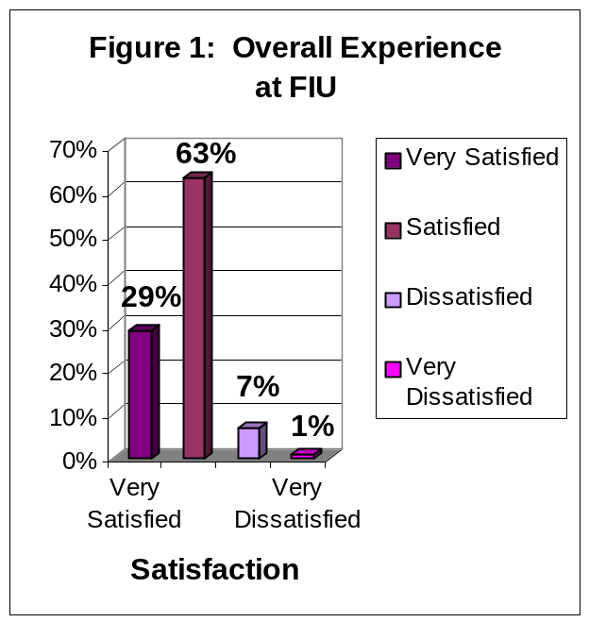
The findings in Figure 1 indicate that 92% of graduating senior respondents were satisfied with their overall experience at FIU: 29% of graduating seniors reported that they were very satisfied and 63% were satisfied. Eight percent of respondents reported that they were dissatisfied with their overall experience at FIU: 7% reported being dissatisfied and 1% reported being very dissatisfied.

Correlations: To the extent that respondent seniors were satisfied with FIU, they also rated highly their overall academic experience (r = .56, p < .001), would recommend FIU to a friend or relative considering college (r = .54, p < .001), rated highly how well their major department met its goals and objectives (r = .45, p < .001.), and rated highly how much FIU contributed to the pursuit of life long learning (r = .42, p < .001).

Overall Academic Experience

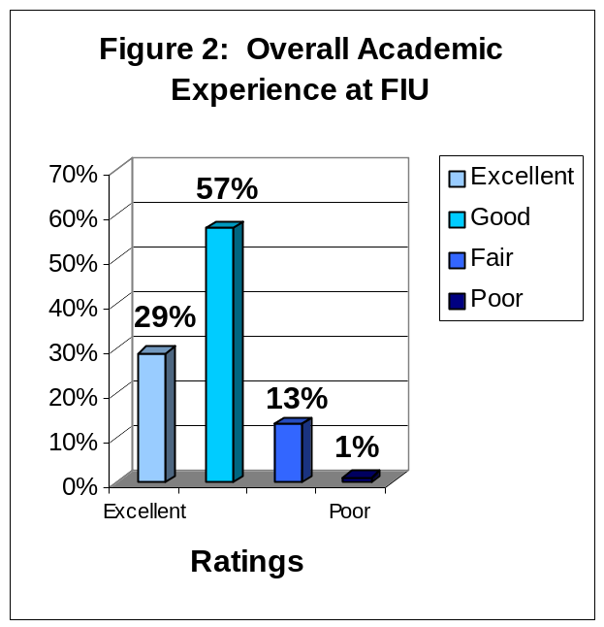
The findings in Figure 2 indicate that 86% of graduating respondents reported a positive overall academic experience: 29% rated their academic experience as excellent while 57% rated their academic experience as good. Fourteen percent of respondents reported that their academic experience at FIU was negative: 13% rated their academic experience as fair and 1% rated their academic experience as poor.

Correlations: To the extent that the graduating respondents rated highly their overall academic experience, they also were satisfied with their overall experience at FIU (r = .56, p < .001), rated highly how much FIU contributed to the pursuit of life long learning (r = .52, p < .001), rated highly how well their major department met its goals and

objectives (r = .45, p < .001.), and would recommend FIU to a friend or relative considering college (r = .49, p < .001).

Challenged to Do Their Best

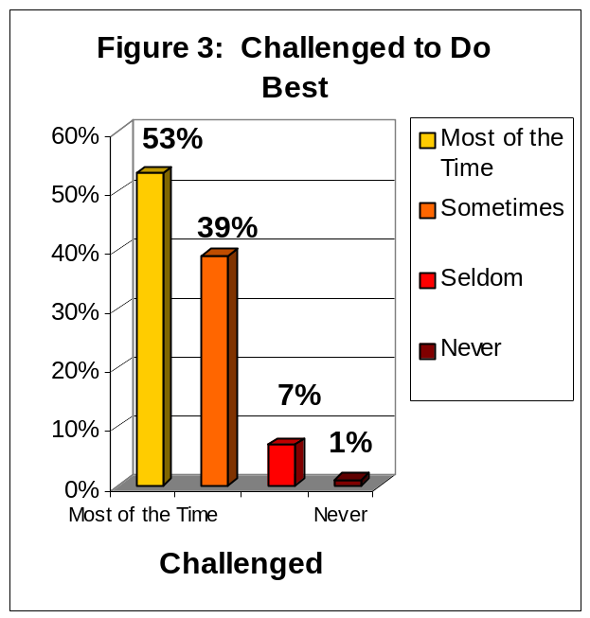
The findings depicted in Figure 3 indicate that 92% of graduating senior respondents reported that they were challenged to do their best at FIU: 53% reported that they were challenged to do their best most of the time, an additional 39% reported that they were challenged sometimes. Eight percent of respondents reported that they were not challenged to do their best at FIU: 7% reported that they were seldom challenged and another 1% reported that they had never been challenged.

Correlations: To the extent that graduating respondents were challenged, they also rated highly their overall academic experiences (r = .47,
p < .001), rated highly much FIU contributed to the pursuit of life long learning (r = .42, p < .001), would recommend FIU to a friend or relative

considering college (r = .42, p < .001), and were satisfied with how well their major department met its goals and objectives (r = .41, p < .001).

Recommend FIU to Others
The findings depicted in Figure 4 indicate that 93% of graduating senior respondents would recommend FIU to a friend or relative considering college: 53% of respondents would recommend FIU, without reservations and 40% reported that they would recommend FIU, with reservations. Approximately 6% of respondents reported they probably would not recommend FIU and 1% reported that they would not recommend FIU under any circumstances.

Correlations: To the extent that senior respondents would recommend FIU to a friend or relative considering college, they also rated highly their overall experience at FIU (r = .54,
p < .001), rated highly their overall academic experience at FIU (r = .49, p < .001), rated
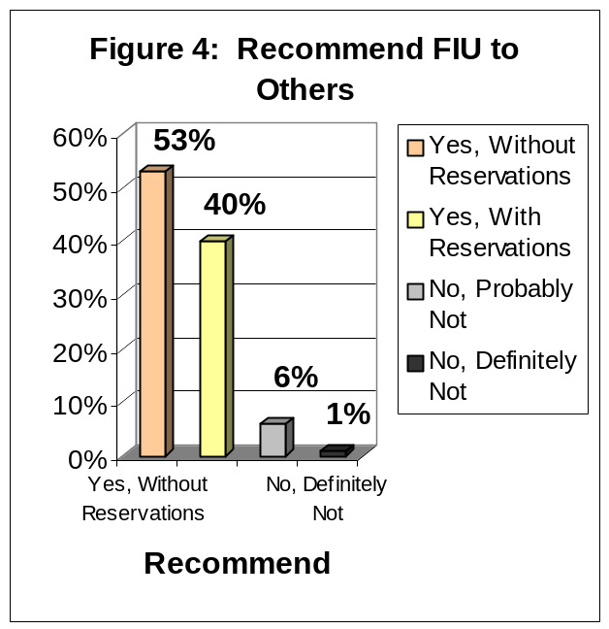
highly the quality of the General Education Program (r = .48, p < .001), and rated highly the responsiveness of FIU's administration to student academic problems (r = .45, p < .001).

Satisfaction With Department of Major
The findings in Figure 5 indicate that 70% of graduating senior respondents were satisfied with the department of their major at FIU: 21% of graduating respondents strongly agreed that they were satisfied and 49% agreed. Twenty-eight percent of respondents were not satisfied with the department of their major at FIU: 21% disagreed and 7% strongly disagreed. Another 2% of graduating respondents did not know whether they agreed or disagreed.

Correlations: To the extent that graduating respondents agreed that they were satisfied with the department of their major, they also believed that the quality of courses in their major prepared them for employment (r = .60, p < .001) and for graduate school (r = .58, p < .001), believed that
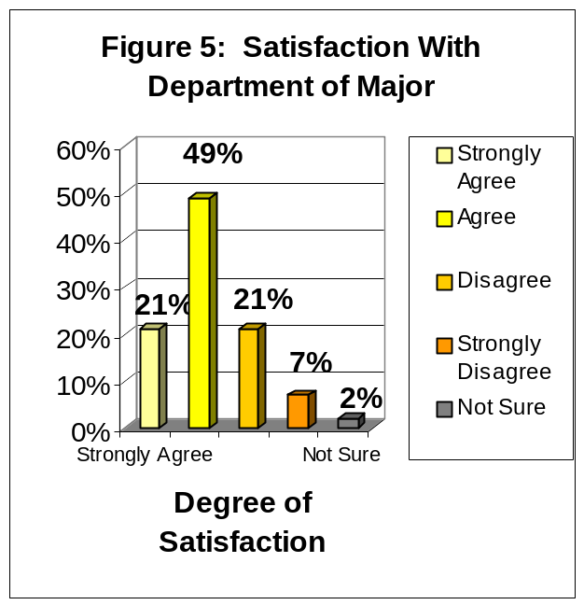
the professors in their major were good teachers (r = .57, p < .001), and were satisfied with the fairness of grading in their courses (r = .53, p < .001).

Professors Were Good Teachers
The findings in Figure 6 indicate that 85% of graduating senior respondents at FIU reported that the professors in their major were good teachers: 32% of respondents strongly agreed, another 53% agreed. Fourteen percent of graduating respondents at FIU did not agree that the professors in their major were good teachers: 11% of graduating seniors disagreed and 3% strongly disagreed. One percent of graduating seniors did not know whether they agreed or disagreed.

Correlations: To the extent that graduating respondents believed that their professors were good teachers, they also rated highly the department of their major (r = .57, p < .001), believed that the professors in their major were
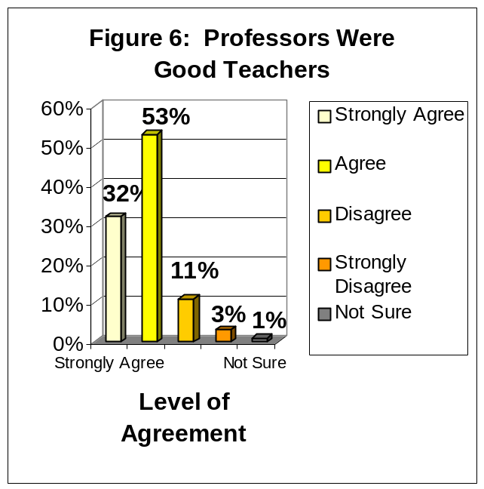
available to assist them outside of class (r = .52, p < .001.), and believed that the courses they took prepared them for employment (r = .46, p < .001) and for graduate or professional school (r = .44, p < .001).

Professors Were Available Outside of Class
The findings in Figure 7 indicate that 82% of graduating respondents agreed that their professors were available outside of class to assist them: 30% of respondents strongly agreed, an additional 52% agreed. Seventeen percent of respondents did not agree that their professors were available outside of class: 13% of respondents disagreed that their professors were available and 4% strongly disagreed. Another 1% of respondents did not know whether they agreed or disagreed.

Correlations: To the extent that graduating respondents agreed that their professors were available outside of class, they also believed that their professors were good teachers (r = .52,
p < .001), rated highly the department of their
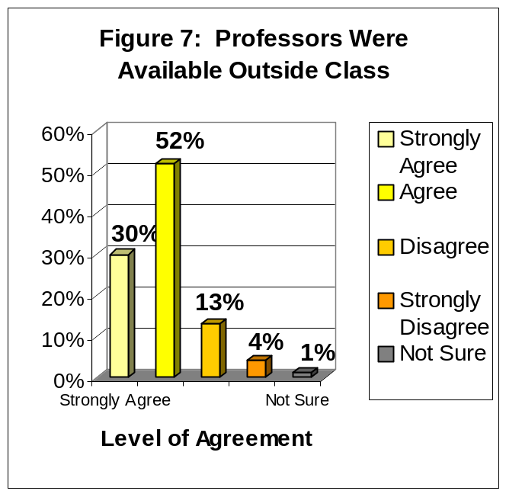
major (r = .44, p< .001), believed that the advice they received was useful for their educational goals. (r = .39, p < .001), and believed that the quality of their courses prepared them for graduate or professional school (r = .36, p < .001).

Quality of Other Undergraduates
The findings in Figure 8 indicate that 76% of graduating respondents reported positive attitudes about the quality of their fellow undergraduate students: 13% believed that the quality of other undergraduate students at FIU was excellent, another 63% believed that the quality of other undergraduates was good. Twenty-four percent held negative attitudes about the quality of their fellow undergraduate students: 21% believed that the quality of other undergraduates was fair while 3% reported that they believed that the quality of other undergraduates was poor.

Correlations: To the extent that the graduating respondents rated the quality of other undergraduate students highly, they also rated highly their social experience at FIU (r = .45, p < .001), rated highly their academic experience at
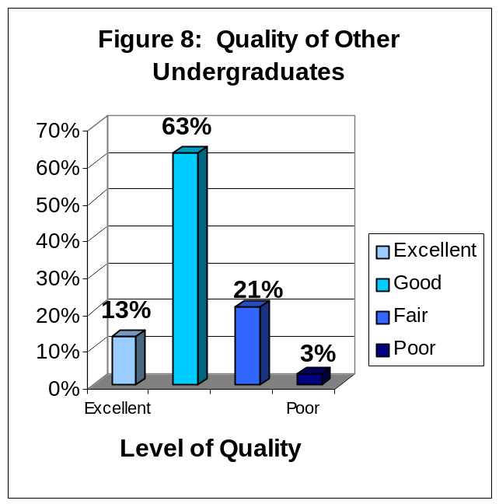
FIU (r = .43, p < .001), would recommend FIU to a friend or relative considering college (r = .40,
p < .001) and believed FIU contributed to leading a productive life (r =.47, p < .001).

The Responsiveness of FIU Administration to Student Academic Problems
The findings in Figure 9 indicate that 51% of graduating respondents rated positively the responsiveness of the FIU administration to student academic problems: 10% rated the responsiveness to problems as excellent and 41% good. Forty-nine percent of respondents rated negatively the responsiveness of the FIU administration to problems: 35% rated the administration’s responsiveness as fair and 14% rated the administration’s responsiveness as poor.

Correlations: Graduating respondents who rated highly the administration’s responsiveness to student academic problems also rated highly the responsiveness of FIU support services to student needs (r = .72, p < .001), rated highly the quality of FIU Class Schedules (r = .45, p < .001),
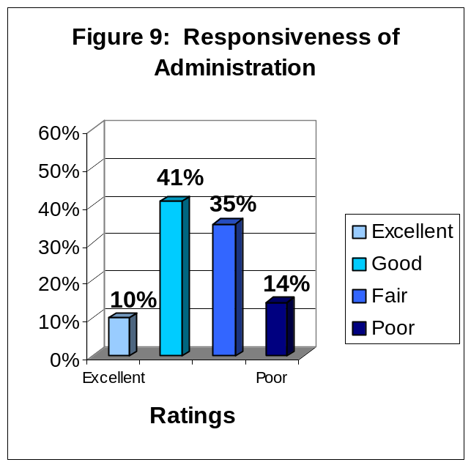
reported that they would recommend FIU to a friend or relative considering college (r = .45, p < .001), and rated highly their overall academic experience at FIU (r = .42, p < .001).
and rated highly their overall experience at FIU (r = .47, p < .001).

The Responsiveness of FIU Support Services to Student Needs
The findings in Figure 10 indicate that 52% of graduating respondents rated positively the responsiveness of FIU support services to student needs: 11% rated the responsiveness of FIU support services to student needs as excellent and 41% as good. Forty-eight percent of graduating respondents rated the responsiveness of FIU support services to student needs negatively: 35% rated the responsiveness of FIU support services to student needs as fair and 13% assigned a rating of poor.

Correlations: Graduating respondents who highly rated the responsiveness of FIU support services to student needs also rated highly the responsiveness of the administration to student academic problems (r = .72, p < .001), believed
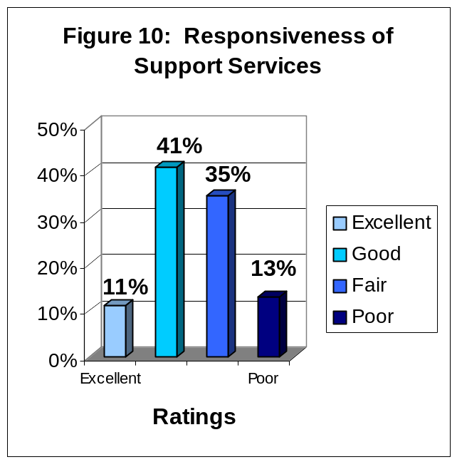
that their advisors were helpful (r = .44, p < .001), reported that they would recommend FIU to a friend or relative considering college (r = .41, p < .001) and rated highly their overall satisfaction with FIU (r = .41, p < .001).
(r = .47, p < .001), and

The Quality of Courses, in My Major, Prepared Me For Employment
The findings depicted in Figure 11 indicate that 65% of graduating respondents agreed that the quality of courses, in their major at FIU, prepared them for employment: 24% strongly agreed, another 41% agreed. Thirty-two percent of graduating respondents did not agree that their courses, in their major, prepared them for employment: 22% disagreed and 10% strongly disagreed. Another 3% of respondents did not know whether they agreed or disagreed.

Correlations: To the extent that graduating respondents agreed that courses in their major prepared them for employment, they also rated highly the department of their major (r = .60,
p < .001), agreed that the quality of courses in their major prepared them for graduate or
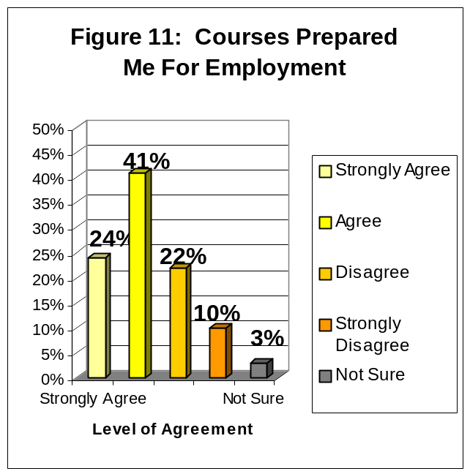
professional school (r = .56, p < .001), reported that their training in computer skills prepared them for today’s technology (r = .48, p < .001), and reported FIU contributed to pursue life long learning (r = .47, p < .001).

The Quality of Courses, in My Major, Prepared Me for Graduate or Professional School

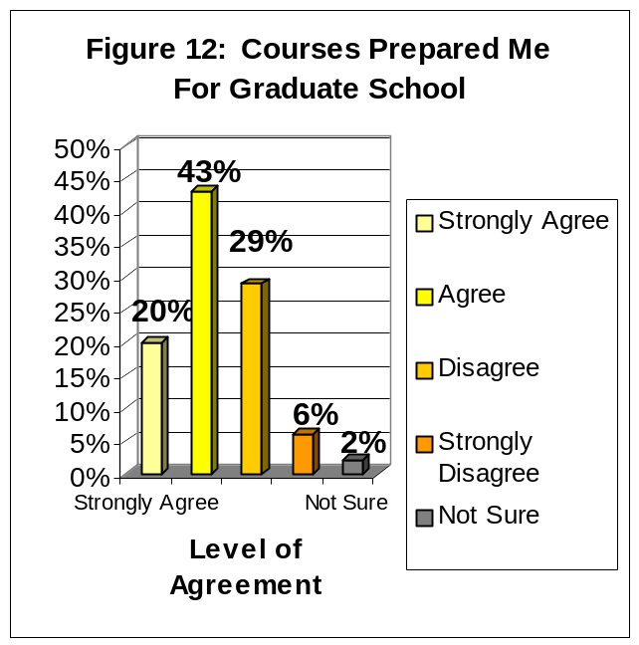
The findings depicted in Figure 12 indicate that 63% of graduating respondents agreed that the quality of courses, in their major, prepared them for graduate school: 20% strongly agreed, another 43% agreed. Thirty-five percent of graduating respondents did not agree that the quality of courses, in their major, prepared them for graduate school: 29% disagreed and 6% strongly disagreed. Two percent of graduating respondents did not know whether they agreed or disagreed.

Correlations: To the extent that graduating respondents agreed that their courses prepared them for graduate school, they also reported that they were satisfied that the department of their major had met its goals and objectives (r = .58,
p < .001), agreed that the quality of their courses
prepared them for employment (r = .56, p < 001), believed that FIU contributed to understanding and applying scientific methods and principals (r = .46, p < .001), and believed that their professors were good teachers (r = .43, p < .001).

IV. FOUR-YEAR COMPARISON OF TWELVE PRINCIPAL INDICATORS OF THE GRADUATING SENIORS’ OVERALL SATISFACTION WITH FIU

Florida International University began surveying its graduating students in the spring of 1999 and continues to survey gradating seniors every year during the Summer, Fall and Spring semesters. The surveys for the Summer 2001 through Spring 2002 mark the fourth year of data collection of this graduating senior survey. With this forth data collection we may soon begin to see some trends in students’ responses.

In this section of the report, the focus is on the survey items that have been established as the twelve principal indicators of the graduating students’ satisfaction with the university. Responses to these items have been divided into the categories of positive and negative responses. Additionally, the average percentage of positive and negative responses is displayed.

Overall Experience At FIU

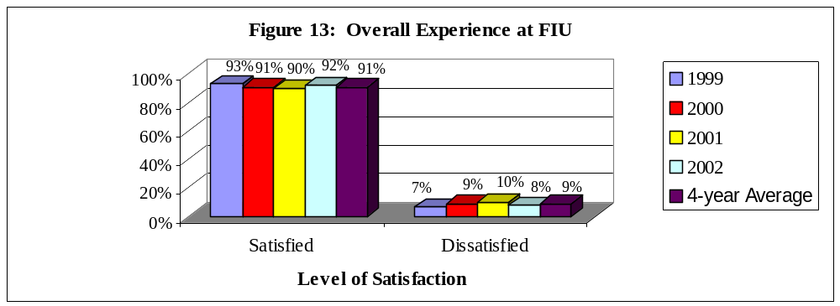
Graduating senior respondents at FIU have reported slightly decreasing levels of satisfaction with their overall experience at FIU from 1999-2001. Then, the levels of satisfaction increased from 2001 to 2002. Respondents who reported that they are ‘Very Satisfied’ (32%, 28%, 29%, 29%, respectively) or ‘Satisfied’ (61%, 63%, 61%, 63%, respectively) ranged from 90-93% for the four-year period. Respondents who reported that they are ‘Dissatisfied’ (3%, 8%, 8%, 7%, respectively) or ‘Very Dissatisfied’ (4%, 1%, 2%, 1%, respectively) ranged from 7-10% for the four-year period.

Overall Academic Experience

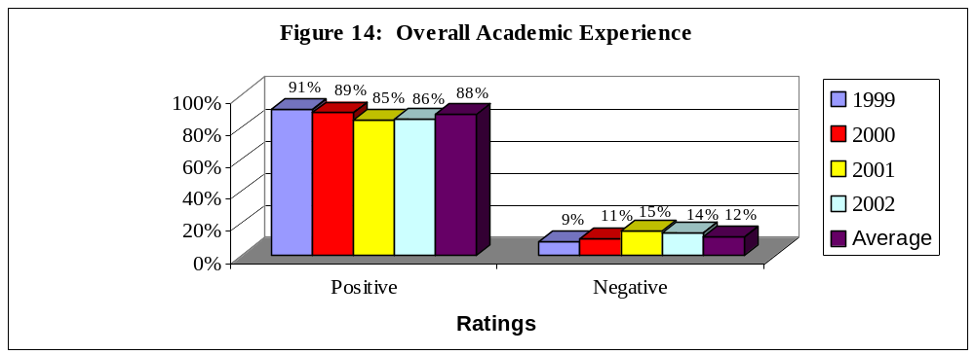

Graduating senior respondents at FIU reported decreasing levels of satisfaction with their overall academic experience at FIU from 1999-2001. However, satisfaction levels increased slightly from 2001-2002. Respondents who reported ‘Excellent’ (36%, 29%, 26%, 29%, respectively) or ‘Good’ (55%, 60%, 59%, 57%, respectively) ratings ranged from 85-91% for the four-year period. Respondents who reported ‘Fair’ (9%, 8%, 14%, 13%, respectively) or ‘Poor’ (0%, 3%, 1%, 1%, respectively) ratings ranged from 9-15% for the four-year period.

Challenged to Do Best

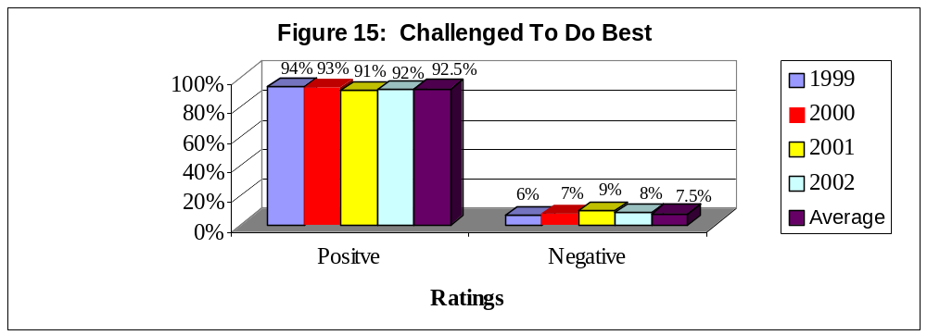

The number of graduating senior respondents that reported that they “are challenged to do their best” at FIU decreased slightly from 1999-2001 and then increased slightly from 2001-2002. Respondents who reported that they are challenged ‘Most of the time’ (57%, 50%, 50%, 53%, respectively) or ‘Sometimes’ (37%, 43%, 41%, 39%, respectively) ranged from 91-94% for the four-year period. Respondents who have reported that they “are challenged to do their best” ‘Seldom’ (6%, 5%, 8%, 7%, respectively) or ‘Never’ (0%, 2%, 1%, 1%, respectively) ranged from 6-9% for the four-year period.

Recommend FIU To Others

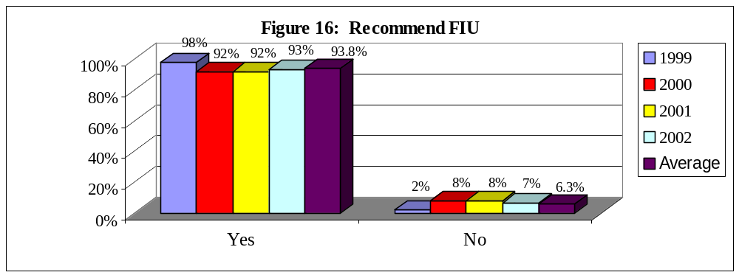

The percent of graduating senior respondents who reported that they would recommend FIU to a friend or relative considering college decreased form 1999 to 2000 yet has not changed from 2000-2002. Respondents who reported that they would ‘recommend FIU without reservations’ (60%, 55%, 52%, 53%, respectively) or would ‘recommend with reservations’ (38%, 37%, 40%, 40%, respectively) ranged from 98-92% for the four-year period. Respondents who reported that they would ‘probably not recommend FIU’ (2%, 7%, 7%, 6%, respectively) or ‘definitely would not recommend FIU’ (0%, 1%, 1%, 1%, respectively) ranged from 2-8% for the four-year period.

Satisfaction With Department of Major

Please note that the wording of this item was slightly different in 1999, than for 2000-2002.
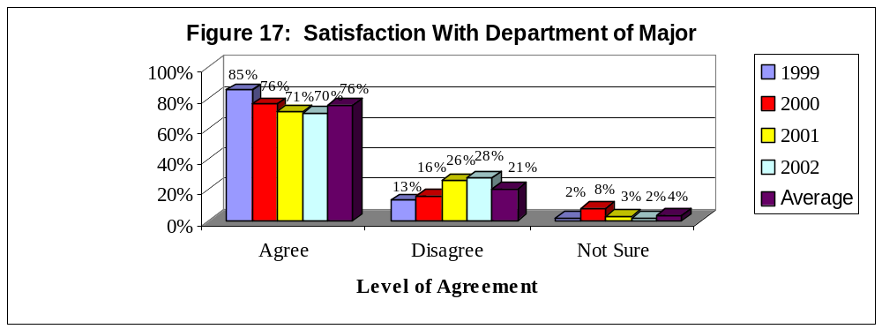

Graduating senior respondents at FIU reported decreasing levels of satisfaction with the department of their major at FIU from 1999-2002. Respondents who ‘Strongly Agreed’ (31%, 22%, 20%, 21%, respectively) or ‘Agreed’ (54%, 54%, 51%, 49%, respectively) that they were satisfied with the department of their major ranged from 69-85% for the four-year period. Respondents who ‘Disagreed’ (11%, 12%, 17%, 21%, respectively) or ‘Strongly Disagreed’ (2%, 4%, 9%, 7%, respectively) ranged from 13-28% for the four-year period. Respondents who made a response of ‘Not Sure’ ranged from 2-8% for the four-year period.

Professors Were Good Teachers

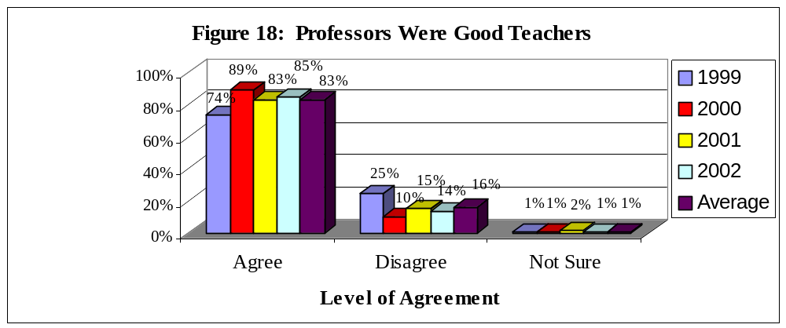

Graduating senior respondents at FIU reported fluctuating levels of agreement with the statement “My professors were good teachers” from 1999-2002. The number of respondents who ‘Strongly Agreed’ (19%, 27%, 32%, 32%, respectively) or ‘Agreed’ (55%, 62%, 51%, 53%, respectively) that their professors were good teachers ranged from 74-89% for the four-year period. Respondents who ‘Disagreed’ (20%, 8%, 11%, 11%, respectively) or ‘Strongly Disagreed’ (5%, 2%, 4%, 3%, respectively) ranged from 10-25% for the four-year period. Respondents who made a response of ‘Not Sure’ ranged from 1-2% for the four-year period.

Professors Were Available Outside of Class

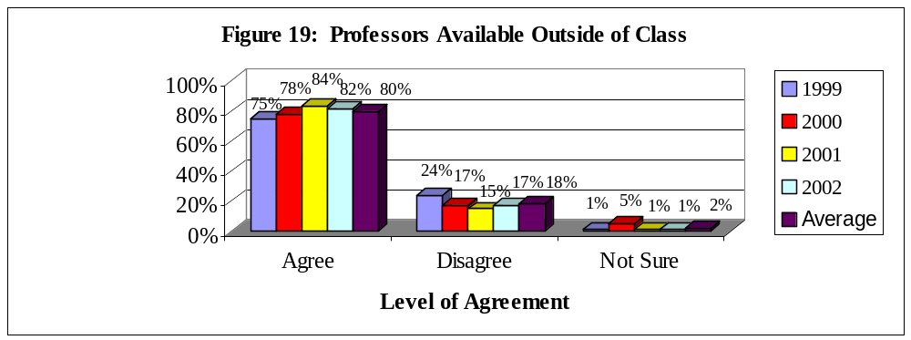

Graduating senior respondents at FIU reported increasing levels of agreement with the statement “My professors were available outside of class” from 1999-2001, unfortunately there was a decrease 2001 to 2002. Respondents who ‘Strongly Agreed’ (21%, 21%, 35%, 30%, respectively) or ‘Agreed’ (54%, 57%, 49%, 52%, respectively) that their professors were available ranged from 75-84% for the four-year period. Respondents who ‘Disagreed’ (16%, 14%, 12%, 13%, respectively) or ‘Strongly Disagreed’ (8%, 3%, 3%, 4%, respectively) ranged from 15-24% for the four-year period. Respondents who made a response of ‘Not Sure’ ranged from 1-5% for the four-year period.

Quality of Other Undergraduates

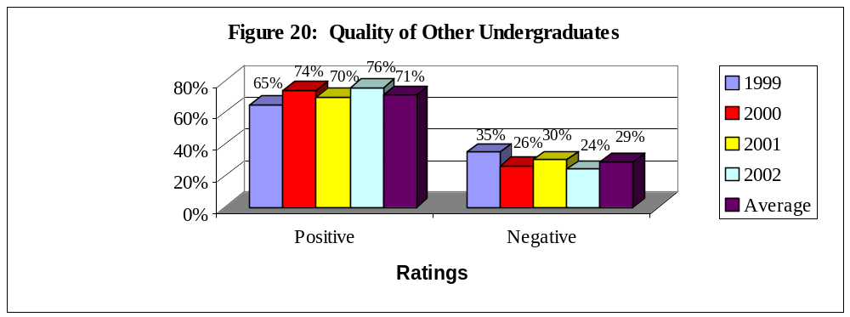
Graduating senior respondents at FIU reported varying levels of positive ratings of their fellow undergraduates from 1999-2002. Respondents who rated the quality of their fellow undergraduates as ‘Excellent’ (11%, 11%, 11%, 13%, respectively) or ‘Good’ (54%, 63%, 59%, 63%, respectively) ranged from 65-76% for the four-year period. Respondents who assigned ratings of ‘Fair’ (31%, 23%, 26%, 21%, respectively) or ‘Poor’ (4%, 3%, 4%, 3%, respectively) ranged from 24-35% for the four-year period.

Responsiveness of Administration to Student Academic Problems

Please note that this question was added to the Graduating Senior Survey in 2000.
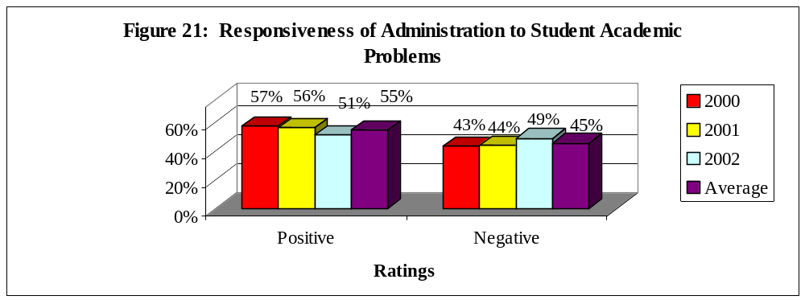

Graduating senior respondents at FIU reported relatively low positive ratings towards the responsiveness of the administration to student academic problems from 2000-2002. Respondents
who reported that the response of the administration was ‘Excellent’ (15%, 10%, and 10%, respectively) or ‘Good’ (42%, 46%, and 41%, respectively) ranged from 51-57% for the three-year period. Respondents who reported ‘Fair’ (30%, 29%, and 35%, respectively) or ‘Poor’ (13%, 15%, and 14%, respectively) ratings ranged from 43-49% for the three-year period.

Responsiveness of Support Services to Student Needs

Please note that this question was added to the Graduating Senior Survey in 2000.
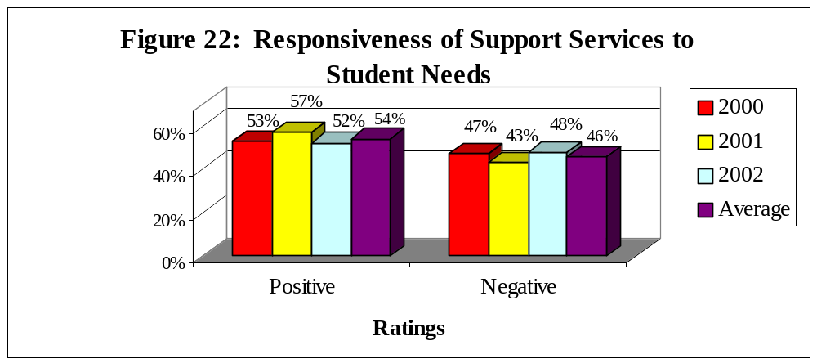

Graduating senior respondents at FIU also reported relatively low positive ratings towards the responsiveness of support services to student needs from 2000-2001. Respondents who reported that the response of the support services was ‘Excellent’ (12%, 12%, and 11%, respectively) or ‘Good’ (41%, 45%, and 41%, respectively) ranged from 52-57% for the three-year period. Respondents who reported ‘Fair’ (34%, 29%, and 35% respectively) or ‘Poor’ (13%, 14%, and 13% respectively) ratings ranged from 43-48% for the three-year period.

Quality of Courses Prepared for Employment

Please note that the wording of this item was slightly different in 1999, than for 2000 and 2001.
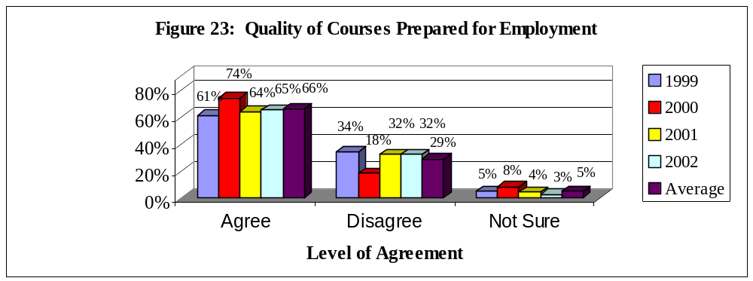

Graduating senior respondents at FIU reported varying levels of agreement from 1999-2002 that the quality of their courses prepared them for employment. Respondents who ‘Strongly Agreed’ (24%, 20%, 20%, 24%, respectively) or ‘Agreed’ (37%, 54%, 44%, 41%, respectively) with this item ranged from 61-74% for the four-year period. Respondents who ‘Disagreed’ (23%, 14%, 22%, 22%, respectively) or ‘Strongly Disagreed’ (11%, 4%, 10%, 10%, respectively) ranged from 18-34% for the four-year period. Respondents who made a response of ‘Not Sure’ ranged from 3-8% for the four-year period.

Quality of Courses Prepared Me for Graduate School

Please note that the wording of the item was slightly different in 1999, than for 2000 and 2001. 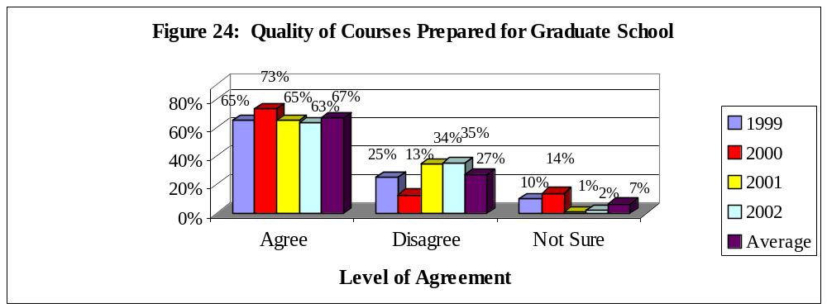

Graduating senior respondents at FIU reported varying levels of agreement from 1999-2002 that the quality of courses prepared them for graduate school. Respondents who ‘Strongly Agreed’ (22%, 19%, 20%, 20%, respectively) or ‘Agreed’ (43%, 54%, 45%, 43%, respectively) with this item ranged from 63-73% for the four-year period. Respondents who ‘Disagreed’ (21%, 11%, 27%, 29%, respectively) or ‘Strongly Disagreed’ (4%, 2%, 7%, 6%, respectively) ranged from 3-35% for the four-year period. Respondents who made a response of ‘Not Sure’ ranged from 1-14% for the four-year period.

Conclusions

When looking at data over time, it is helpful to keep several issues in mind. When ratings are consistent over a time period, it is usually an indication that those ratings are a true measure of the item -- that is the measure is a reliable one. However, when ratings are not consistent over time it is possible to draw multiple conclusions. One conclusion would be that the ratings are inconsistent because of flaws in the representativeness of the sample over the time period. A second conclusion would be that there have been true fluctuations in the graduating respondents’ experiences over the time period. It is premature to discuss trends in the responses because the data exists over a four-year time period. Typically, it is necessary to have data over a five to ten-year period in order to assess a trend.

Positive ratings were relatively consistent over the four-year period for perceptions of overall experience at FIU, whether the respondent felt challenged to do their best at FIU, whether the respondent would recommend FIU to a friend or relative considering college, and whether the quality of courses prepared them for graduate or professional school. Positive ratings decreased over the four-year period for perceptions of overall academic experience, responsiveness of the Administration to student academic problems (three-year data) and ratings of satisfaction with department of major. Positive ratings fluctuated over the four-year period for the respondents’ ratings of professors as good teachers, professors availability outside of class, the perceived quality of other undergraduates, whether the quality of courses prepared them for employment, and responsiveness of support services to student needs (three-year data).

APPENDIX A: GRADUATING SENIOR SURVEY

APPENDIX A
Graduating Senior Survey: Fall 2000 – Summer 2001
Questions on all versions of survey: Principle indicators of student satisfaction
In general, how satisfied are you with |  |  | I am satisfied with how well the department of
your overall experience at FIU? | % |  | my major has met its goals and objectives | %
Very Satisfied | 28.4 |  | Strongly Agree | 21.0
Satisfied | 62.9 |  | Agree | 49.0
Dissatisfied | 6.8 |  | Disagree | 21.0
Very Dissatisfied | 1.0 |  | Strongly Disagree | 7.2
 |  |  | Not Sure | 1.8
What was your primary reason for
attending FIU? | % |  | Please rate the quality of other
Academic reputation | 12.3 |  | undergraduates at FIU. | %
Cost | 23.0 |  | Excellent | 13.0
Location | 42.5 |  | Good | 63.0
Type of Program Available | 14.5 |  | Fair | 21.0
Other | 7.5 |  | Poor | 2.7
What was your status when you first entered |  |  | Please rate the responsiveness of FIU’s
FIU? | % |  | administration to student academic problems. | %
Recent high school graduate | 33.3 |  | Excellent | 9.9
Transfer from Community College or |  |  | Good | 41.0
University | 61.0 |  | Fair | 35.0
Other | 5.5 |  | Poor | 14.2
When you reflect upon your time at FIU, have |  |  | Please rate the responsiveness of FIU’s
you been challenged to do the very best you |  |  | support services to undergraduate
could? | % |  | student needs | %
Most of the time | 53.2 |  | Excellent | 11.2
Sometimes | 38.5 |  | Good | 41.0
Seldom | 6.6 |  | Fair | 35.0
Never | 0.8 |  | Poor | 12.6
Would you recommend FIU to a friend or |  |  | In my major my professors were good
relative considering college? | % |  | teachers | %
Yes, without reservations | 53.0 |  | Strongly Agree | 31.8
Yes, with reservations | 39.5 |  | Agree | 53.0
No, probably not | 6.0 |  | Disagree | 11.2
No, under no circumstances | 1.0 |  | Strongly Disagree | 3.1
 |  |  | Not Sure | 1.0
Please rate your academic experience |  |  | In my major my professors were
at FIU. | % |  | available outside of class to help me | %
Excellent | 28.6 |  | Strongly Agree | 29.7
Good | 56.6 |  | Agree | 52.0
Fair | 13.0 |  | Disagree | 13.1
Poor | 1.0 |  | Strongly Disagree | 3.7
 |  |  | Not Sure | 0.9
In my major, the quality of courses I took
prepared me for graduate or professional |  |  | In my major, the quality of courses I
school | % |  | took prepared me for employment | %
Strongly Agree | 20.0 |  | Strongly Agree | 23.8
Agree | 43.0 |  | Agree | 40.7
Disagree | 29.0 |  | Disagree | 22.4
Strongly Disagree | 6.2 |  | Strongly Disagree | 9.5
Not Sure | 1.7 |  | Not Sure | 2.5
Version A: Academic Issues
Did you develop a professional relationship(s) |  |  | In my major, my classes were too large | %
with faculty that is close enough to ask for a |  |  | Strongly Agree | 7.9
letter of recommendation? | % |  | Agree | 19.3
Yes | 78.2 |  | Disagree | 22.0
No | 21.8 |  | Strongly Disagree | 39.0
 |  |  | Not Sure | 11.8
Did you develop a professional relationship(s)
with faculty that is close enough to ask for |  |  | In my major, the classes I needed
advice about career decisions? | % |  | were available | %
Yes | 78.8 |  | Strongly Agree | 16.7
No | 21.2 |  | Agree | 50.5
 |  |  | Disagree | 11.6
Did you develop a professional relationship(s) |  |  | Strongly Disagree | 16.3
with faculty that is close enough to ask for |  |  | Not Sure | 4.9
advice about personal issues? | %
Yes | 36.0 |  | In my major, there were a good range
No | 64.0 |  | of courses available | %
 |  |  | Strongly Agree | 12.4
Please rate your social experience at FIU | % |  | Agree | 42.9
Excellent | 17.1 |  | Disagree | 16.6
Good | 51.4 |  | Strongly Disagree | 22.4
Fair | 26.7 |  | Not Sure | 5.8
Poor | 4.8
 |  |  | In my major, I was provided the opportunity
Please rate the safety measures on campus | % |  | to develop appropriate computer skills | %
Excellent | 26.4 |  | Strongly Agree | 17.9
Good | 55.1 |  | Agree | 40.6
Fair | 16.6 |  | Disagree | 19.1
Poor | 1.9 |  | Strongly Disagree | 17.0
 |  |  | Not Sure | 5.4
Version B: Quality Issues
In my major, my training in computer skills |  |  | Please rate the quality of Student
prepared me for today’s technology | % |  | Grants | %
Strongly Agree | 14.6 |  | Excellent | 13.3
Agree | 35.5 |  | Good | 17.6
Disagree | 22.1 |  | Don’t Know | 54.7
Strongly Disagree | 21.4 |  | Fair | 10.1
Not Sure | 6.4 |  | Poor | 4.3
In my major, lower division courses |  |  | Please rate the quality of Student
adequately prepared me for upper division |  |  | Loans | %
courses | % |  | Excellent | 10.4
Strongly Agree | 14.9 |  | Good | 19.4
Agree | 47.8 |  | Don’t Know | 58.4
Disagree | 26.1 |  | Fair | 8.2
Strongly Disagree | 9.1 |  | Poor | 3.6
Not Sure | 2.1
 |  |  | How often have you used the FIU
In my major, I was satisfied with my practicum |  |  | Library at University Park? | %
or internship experiences | % |  | Frequently | 42.0
Strongly Agree | 25.8 |  | Occasionally | 35.8
Agree | 30.3 |  | Seldom | 13.5
Disagree | 31.7 |  | Never | 8.8
Strongly Disagree | 6.6
Not Sure | 5.6 |  | How often have you used the FIU
 |  |  | Library at Biscayne Bay Campus? | %
In my major, I was satisfied with the fairness |  |  | Frequently | 13.4
of grading in my courses | % |  | Occasionally | 17.3
Strongly Agree | 20.7 |  | Seldom | 17.0
Agree | 62.5 |  | Never | 52.3
Disagree | 8.2
Strongly Disagree | 7.0 |  | How often have you used the Counseling
Not Sure | 1.6 |  | and Psychological Services Center? | %
 |  |  | Frequently | 3.2
Courses to meet general education |  |  | Occasionally | 11.8
requirements were available to me | % |  | Seldom | 12.5
Strongly Agree | 20.1 |  | Never | 72.4
Agree | 60.0
Disagree | 14.2 |  | How often have you used the Testing
Strongly Disagree | 4.7 |  | Center? | %
Not Sure | 0.9 |  | Frequently | 0.7
 |  |  | Occasionally | 5.0
 |  |  | Seldom | 12.2
Courses in other departments, but required |  |  | Never | 82.1
by my major were available to me | %
Strongly Agree | 14.6 |  | How often have you used Recreational
Agree | 60.2 |  | Services? | %
Disagree | 17.6 |  | Frequently | 9.3
Strongly Disagree | 6.4 |  | Occasionally | 13.6
Not Sure | 1.2 |  | Seldom | 20.4
 |  |  | Never | 56.8
How often have you used Health Services? | %
Frequently | 5.7 |  | How often have you used on-campus
Occasionally | 13.6 |  | student employment? | %
Seldom | 22.6 |  | Frequently | 6.1
Never | 58.1 |  | Occasionally | 16.8
 |  |  | Seldom | 15.4
How often have you used Academic Advising: |  |  | Never | 61.6
Lower Division? | %
Frequently | 11.9 |  | Please rate the quality of the University
Occasionally | 24.1 |  | Park library | %
Seldom | 28.1 |  | Excellent | 49.1
Never | 36.0 |  | Good | 31.9
 |  |  | Don’t Know | 11.8
How often have you used Academic Advising |  |  | Fair | 7.2
in your major? | %
Frequently | 28.9 |  | Please rate the quality of the Biscayne
Occasionally | 34.3 |  | Bay library | %
Seldom | 21.3 |  | Excellent | 18.6
Never | 15.5 |  | Good | 30.1
 |  |  | Don’t Know | 41.6
How often have you used the Computer |  |  | Fair | 7.2
Laboratories/Services? | % |  | Poor | 2.5
Frequently | 43.6
Occasionally | 34.2 |  | Please rate the quality of Counseling
Seldom | 18.9 |  | and Psychological Services | %
Never | 3.3 |  | Excellent | 4.3
 |  |  | Good | 16.5
How often have you attended Cultural |  |  | Don’t Know | 70.9
Activities such as speakers, concerts, |  |  | Fair | 6.1
movies, etc.? | % |  | Poor | 2.2
Frequently | 20.7
Occasionally | 28.0 |  | Please rate the quality of the Testing Center | %
Seldom | 29.1 |  | Excellent | 2.2
Never | 22.2 |  | Good | 9.7
 |  |  | Don’t Know | 84.2
How often have you been involved in |  |  | Fair | 3.6
intramural activities? | % |  | Poor | 0.4
Frequently | 5.0
Occasionally | 17.2 |  | Please rate the quality of Recreational | %
Seldom | 19.4 |  | Services
Never | 58.4 |  | Excellent | 11.5
 |  |  | Good | 29.5
How often have you used SASS? | % |  | Don’t Know | 50.7
Frequently | 39.4 |  | Fair | 7.2
Occasionally | 20.4 |  | Poor | 1.1
Seldom | 12.2
Never | 28.0 |  | Please rate the quality of Intramural
 |  |  | Activities | %
Please rate the quality of on-campus Student |  |  | Excellent | 3.7
employment | % |  | Good | 16.1
Excellent | 2.9 |  | Don’t Know | 74.4
Good | 14.0 |  | Fair | 5.1
Don’t Know | 73.0 |  | Poor | 0.7
Fair | 7.2
Poor | 2.9 |  | Please rate the quality of SASS | %
 |  |  | Excellent | 29.8
Please rate the quality of Health Services | % |  | Good | 49.1
Excellent | 7.6 |  | Don’t Know | 10.2
Good | 30.8 |  | Fair | 9.5
Don’t Know | 53.6 |  | Poor | 1.5
Fair | 6.5
Poor | 1.4
 |  |  | Please rate the quality of the FIU catalog | %
Please rate the quality of Academic Advising: |  |  | Excellent | 19.2
Lower Division | % |  | Good | 62.0
Excellent | 4.3 |  | Don’t Know | 4.7
Good | 28.1 |  | Fair | 11.2
Don’t Know | 35.3 |  | Poor | 2.9
Fair | 24.1
Poor | 8.3 |  | Please rate the quality of the General
 |  |  | Education program | %
Please rate the quality of Academic Advising |  |  | Excellent | 12.3
in your major | % |  | Good | 52.3
Excellent | 20.7 |  | Don’t Know | 18.8
Good | 43.8 |  | Fair | 15.9
Don’t Know | 3.6 |  | Poor | 0.7
Fair | 20.7
Poor | 11.2 |  | Please rate the quality of New Student
 |  |  | orientation | %
Please rate the quality of the Computer |  |  | Excellent | 8.2
Laboratories | % |  | Good | 35.5
Excellent | 24.2 |  | Don’t Know | 39.4
Good | 51.6 |  | Fair | 13.3
Don’t Know | 9.4 |  | Poor | 3.6
Fair | 13.4
Poor | 1.4 |  | Please rate the quality of Admissions | %
 |  |  | Excellent | 8.6
Please rate the quality of Cultural |  |  | Good | 56.8
Activities | % |  | Don’t Know | 5.8
Excellent | 7.3 |  | Fair | 22.3
Good | 28.1 |  | Poor | 6.5
Don’t Know | 55.8
Fair | 7.7 |  | Please rate the quality of Student
Poor | 1.1 |  | Scholarships | %
 |  |  | Excellent | 10.8
Please rate the quality of FIU Class Schedules |  |  | Good | 18.8
Schedules | % |  | Don’t Know | 55.2
Excellent | 9.7 |  | Fair | 9.4
Good | 42.8 |  | Poor | 5.8
Don’t Know | 0.7
Fair | 30.6 |  | Please rate the quality of Student
Poor | 16.2 |  | Transcripts | %
 |  |  | Excellent | 11.5
Please rate the quality of Registration | % |  | Good | 44.4
Excellent | 12.4 |  | Don’t Know | 27.6
Good | 51.5 |  | Fair | 12.2
Don’t Know | 0.4 |  | Poor | 4.3
Fair | 27.7
Poor | 8.0 |  | Please rate the quality of Student
 |  |  | Records | %
Please rate the quality of Student Judicial |  |  | Excellent | 12.6
Services | % |  | Good | 50.0
Excellent | 1.1 |  | Don’t Know | 18.7
Good | 4.7 |  | Fair | 12.6
Don’t Know | 88.7 |  | Poor | 6.1
Fair | 3.3
Poor | 2.2
Please rate the quality of the Drop and Add
procedure | %
Excellent | 16.5
Good | 52.9
Don’t Know | 4.3
Fair | 17.3
Poor | 9.0
Version C: Personal Growth and Advising Issues
How much did FIU contribute to your personal growth in each area below?
Writing effectively? | % |  | Learning another language? | %
Very Much | 40.9 |  | Very Much | 14.3
Somewhat | 44.6 |  | Somewhat | 25.9
Very Little | 14.5 |  | Very Little | 59.8
Speaking effectively? | % |  | Understanding different philosophies
Very Much | 41.0 |  | and cultures? | %
Somewhat | 45.5 |  | Very Much | 44.8
Very Little | 13.4 |  | Somewhat | 43.7
 |  |  | Very Little | 11.6
Understanding written information? | %
Very Much | 43.4 |  | Gaining a broad education about
Somewhat | 44.9 |  | different fields of knowledge? | %
Very Little | 11.6 |  | Very Much | 37.6
 |  |  | Somewhat | 49.2
Working independently? | % |  | Very Little | 13.2
Very Much | 52.3
Somewhat | 40.2 |  | Becoming more aware about the
Very Little | 7.5 |  | importance of ethical practices? | %
 |  |  | Very Much | 39.3
Learning on your own? | % |  | Somewhat | 45.7
Very Much | 62.1 |  | Very Little | 15.0
Somewhat | 33.1
Very Little | 4.8 |  | Understanding and appreciating the arts? | %
 |  |  | Very Much | 26.9
Working in a group? | % |  | Somewhat | 48.9
Very Much | 54.7 |  | Very Little | 24.3
Somewhat | 36.6
Very Little | 8.7 |  | Ability to express your thoughts? | %
 |  |  | Very Much | 40.5
Organizing your time effectively? | % |  | Somewhat | 43.9
Very Much | 37.5 |  | Very Little | 15.5
Somewhat | 50.9
Very Little | 11.5 |  | Learning to listen more closely to others? | %
 |  |  | Very Much | 44.6
Leading and guiding others? | % |  | Somewhat | 44.9
Very Much | 33.8 |  | Very Little | 10.5
Somewhat | 49.4
Very Little | 16.7 |  | Critical thinking? | %
 |  |  | Very Much | 56.4
Leading a productive life? | % |  | Somewhat | 37.6
Very Much | 33.0 |  | Very Little | 6.0
Somewhat | 50.2
Very Little | 16.9 |  | Thinking logically? | %
 |  |  | Very Much | 55.3
Improving your computational skills? | % |  | Somewhat | 37.2
Very Much | 45.8 |  | Very Little | 7.5
Somewhat | 42.4
Very Little | 11.7 |  | Ability to conceptualize and solve
 |  |  | problems? | %
Ability to solve analytical problems? | % |  | Very Much | 38.6
Very Much | 43.8 |  | Somewhat | 55.7
Somewhat | 43.4 |  | Very Little | 5.7
Very Little | 12.8
 |  |  | Gaining more respect for the principles of
Desiring intellectual challenges? | % |  | moral living? | %
Very Much | 49.2 |  | Very Much | 34.5
Somewhat | 42.0 |  | Somewhat | 41.2
Very Little | 8.7 |  | Very Little | 24.3
Prepared me to pursue life-long learning? | % |  | Ability to develop the skills necessary to
Very Much | 50.0 |  | give effective, professional presentations? | %
Somewhat | 40.3 |  | Very Much | 48.7
Very Little | 9.7 |  | Somewhat | 39.6
 |  |  | Very Little | 11.7
Understanding and applying scientific
principles and methods? | %
Very Much | 36.5
Somewhat | 46.2
Very Little | 17.3
Sources from which I received beneficial academic advising during my last two years at FIU?
(Please check all that apply)
 | % |  |  | %
Advisors in my major | 25.6 |  | Professors not assigned as advisors | 3.1
Central advisors in my college | 16.6 |  | SASS | 4.6
Friends | 21.7 |  | Student advisors | 12.7
I did not seek help from advisors | 1.9 |  | Other | 2.6
Printed material including the catalog | 12.3
If you received advising from University, College or Departmental sources, please answer
the following questions:
In general the advisors were helpful | % |  | The advice I received was very useful
Strongly Agree | 22.1 |  | for my educational goals | %
Agree | 40.7 |  | Strongly Agree | 18.1
Neutral | 19.4 |  | Agree | 41.7
Disagree | 9.7 |  | Neutral | 23.6
Strongly Disagree | 8.1 |  | Disagree | 8.5
 |  |  | Strongly Disagree | 8.1
The advisors were available when needed | %
Strongly Agree | 15.1 |  | The advice I received was very useful
Agree | 35.7 |  | for my career goals | %
Neutral | 23.3 |  | Strongly Agree | 16.2
Disagree | 15.9 |  | Agree | 36.5
Strongly Disagree | 10.1 |  | Neutral | 25.4
 |  |  | Disagree | 13.1
Sufficient time was available during |  |  | Strongly Disagree | 8.8
the advising session | %
Strongly Agree | 21.4
Agree | 38.9
Neutral | 19.5
Disagree | 11.7
Strongly Disagree | 8.6
DEMOGRAPHIC INFORMATION: All Respondents
While school was in session, about how |  |  | What is your age? | %
many hours did you work per week |  |  | Less than 24 | 46.2
for pay? | % |  | 24-29 | 35.0
I was not employed | 15.6 |  | 30-39 | 13.0
1-10 hours | 6.4 |  | 40-49 | 3.7
11-20 hours | 23.3 |  | 50 or older | 0.6
21-34 hours | 27.3
35 hours or more | 26.2 |  | Overall, what was your enrollment
 |  |  | status in college? | %
I participated in the following activities |  |  | Full time | 81.2
while working on my degree |  |  | Part time | 16.9
(Check all that apply) | %
Student Government | 3.0 |  | For your first two years of college,
Intercollegiate Athletics | 2.1 |  | where did you live? | %
Student Publications | 2.1 |  | With parents or relatives | 61.3
Greek System | 4.8 |  | On campus housing | 8.1
Political Activities | 2.2 |  | Other private dwelling | 28.6
Community Service | 24.4
Church Activities | 10.5 |  | For your last two years of college
Performing Arts | 4.0 |  | where did you live? | %
Intramural Sports | 7.5 |  | With parents or relatives | 51.6
Honor Societies | 15.2 |  | On campus housing | 4.1
Organizations related to my major | 24.1 |  | Other private dwelling | 40.5
What is the highest degree you expect to |  |  | About how far do you live from the campus
attain? | % |  | of FIU that you primarily attend? | %
No further study intended | 7.0 |  | I live on campus | 3.0
Masters degree | 55.5 |  | I live within one mile of campus | 5.8
Specialist degree | 9.7 |  | I live 1-10 miles from campus | 37.7
Doctorate | 24.0 |  | I live 11-25 miles from campus | 33.5
Other | 2.4 |  | I live over 25 miles from campus | 18.4
What is your overall Grade Point |  |  | Please indicate your college/school | %
Average? | % |  | Architecture | 0.7
3.5-4.0 | 27.4 |  | Arts & Sciences | 27.7
3.0-3.4 | 41.6 |  | Business | 21.2
2.5-2.9 | 26.6 |  | CHUA | 6.2
2.0-2.4 | 3.6 |  | Education | 20.1
Don’t know | 0.8 |  | Engineering | 5.2
 |  |  | Hospitality Management | 9.8
 |  |  | Journalism & Mass Communication | 9.1
Please indicate your major | N |  |  | N
Accounting | 6 |  | Human Resources Management | 1
Advertising | 7 |  | Industrial Engineering | 2
Architecture | 2 |  | International Business | 13
Art Education | 4 |  | International Relation | 5
Art History | 1 |  | Journalism | 6
Athletic Training | 2 |  | Liberal Arts | 7
Biology | 11 |  | Linguistics | 1
Broadcast | 4 |  | Management Information Systems | 15
Business Management | 4 |  | Management | 10
Business Administration | 2 |  | Marketing | 7
Chemical Engineering | 2 |  | Mathematical Sciences | 2
Chemistry | 4 |  | Mechanical Engineering | 2
Civil Engineering | 3 |  | Modern Language | 1
Communication | 3 |  | Music | 2
Computer Engineering | 2 |  | Nursing | 3
Computer Science | 5 |  | Occupational Therapy | 2
Construction Management | 1 |  | Parks & Recreation Management | 1
Criminal Justice | 9 |  | Philosophy | 2
Dance | 1 |  | Physical Education | 2
Dietetics & Nutrition | 2 |  | Physical Therapy | 2
Early Childhood Education | 3 |  | Physics | 2
Economics | 2 |  | Political Science | 3
Education | 10 |  | Psychology | 7
Electrical Engineering | 7 |  | Public Administration | 4
Elementary Education | 15 |  | Public Relations | 4
English | 8 |  | Religious Studies | 1
Environmental Studies | 2 |  | Social Work | 1
Exercise & Sport Science | 3 |  | Sociology & Anthropology | 6
Family & Consumer Sciences | 1 |  | Spanish | 2
Finance | 11 |  | Special Education | 34
French | 2 |  | Sport Management | 4
Geology | 1 |  | Television Production | 3
Health Information Management | 2 |  | Theater | 2
Health Services Administration | 4 |  | Travel & Tourism Management | 7
History | 2 |  | TV Production | 3
Hospitality Management | 27 |  | Visual Arts | 1
Please indicate your racial/ethnic group | % |  | If you are not finishing your degree in 4 years,
American Indian/Alaskan Native | 0.2 |  | please indicate all of the reasons why not | %
Asian | 3.5 |  | 5 year degree program | 2.4
Black/African American | 9.3 |  | I had to withdraw during a semester | 10.4
Hispanic | 52.2 |  | I took a semester off from school | 12.7
Native Hawaiian/Other Pacific |  |  | Job caused me to take reduced course loads | 15.5
Islander | 0.1 |  | I voluntarily took reduced course loads | 15.7
White | 17.5 |  | I changed majors | 10.4
International Student/Non-Resident |  |  | I had some financial problems | 8.5
Alien | 6.4 |  | I had personal or family issues | 11.3
Biracial/Multiracial | 10.7 |  | I was misadvised by advisors | 6.0
 |  |  | My required courses were not available | 5.7
At which campus did you take most of your
coursework? | % |  | What is your gender? | %
Biscayne Bay | 22.6 |  | Female | 63.8
Broward | 0.5 |  | Male | 35.2
University Park | 78.9

